Element D - Document 6234

Portfolio ID: 47c247da17e0
Document ID: 6234
Project Name: Andean Bear Puzzle Feeder 1
Date Submitted: 2024-05-17 23:53 GMT
Scorer: Abigail Bergman

SCORING TABLE - ELEMENT D

D1: 2
D2: 3
D3: 3
D4: 1

SCORER COMMENTS:
D1. The process of generating ideas was described, and it appears that four ideas were developed: 1) The Twin Drum, 2) Dodecahedron, 3) Trash Can, and 4) Screw. However, none of these ideas were presented visually nor described, though students do acknowledge having created CAD models and moving from low- to high-fidelity prototypes. A viable design is assumed but can't be confirmed based on the information provided.
D2. A decision matrix is provided, but it is unclear what the range of scores was. Further, the criteria do not exactly match the design requirements provided in Element C, but no explanation for this discrepancy is provided because there are no definitions for the criteria used to judge each idea.
D3. Students provided a high-level timeline that they followed and the major steps of the process they conducted. However, information is missing related to materials, techniques, and other sub-tasks that would make replication by others challenging.
D4. Students provided a short description of their selected idea, but there is not enough information for someone to understand what the "Spin Barrel" solution is.

STUDENT SUBMISSION:

Page 1
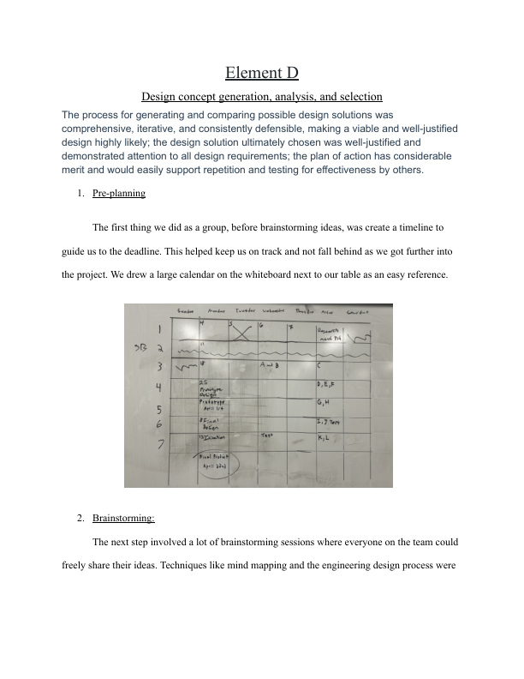
Page 2
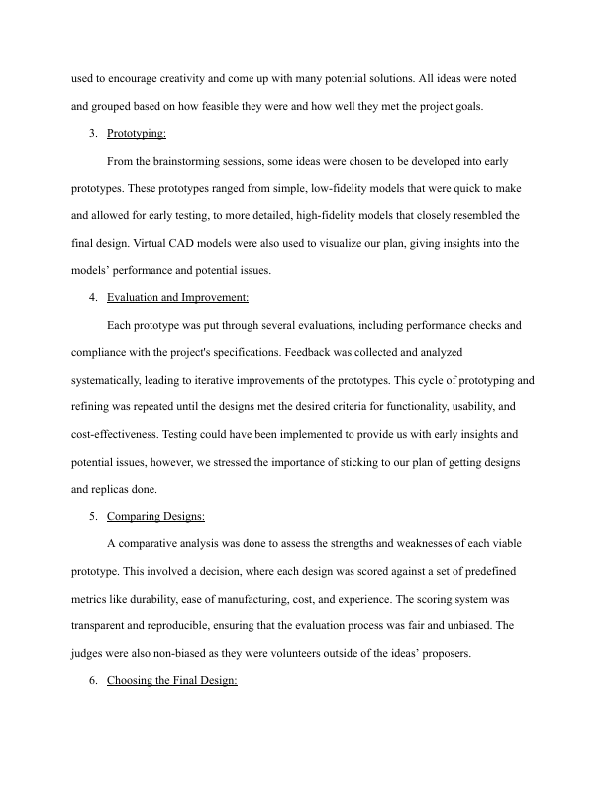
Page 3
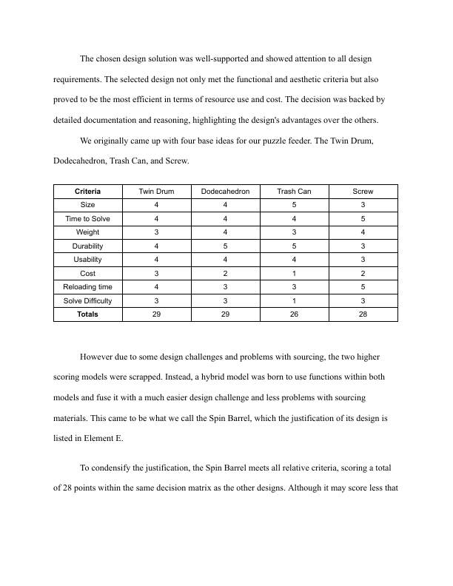
Page 4
