Element D - Document 7982

Portfolio ID: a76b7fdc02cb
Document ID: 7982
Project Name: Unit 7 Personal Project
Date Submitted: 2024-06-07 16:28 GMT
Scorer: Jessica Lemieux

SCORING TABLE - ELEMENT D

D1: 3
D2: 2
D3: 4
D4: 5

SCORER COMMENTS:
There is evidence of idea generation and evaluation but I am confused as to why they decided on their final solution as the glove box compartments doesn't seem to solve the problem of the car seat gap.
The blueprints are well drawn and include necessary details.

STUDENT SUBMISSION:

Page 1
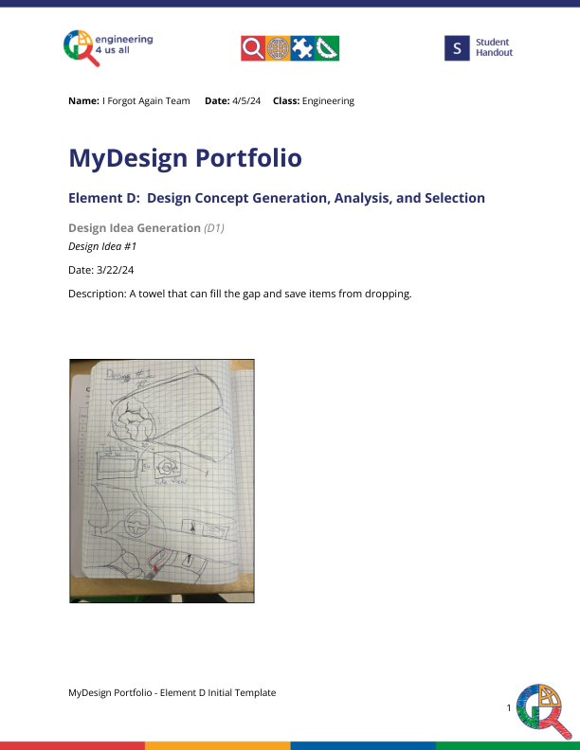
Page 2
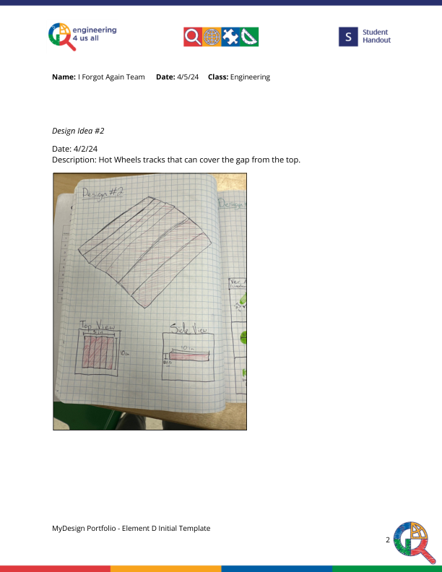
Page 3
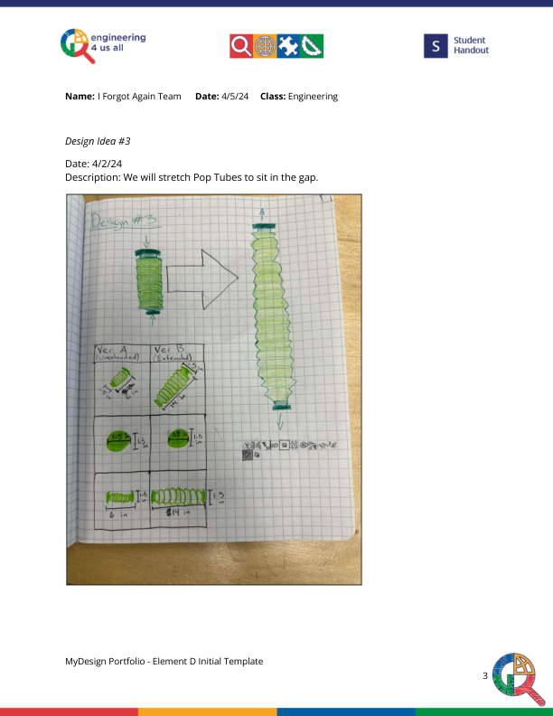
Page 4
