Element D - Document 6329

Portfolio ID: a398ca72a5c2
Document ID: 6329
Project Name: Dust Management
Date Submitted: 2024-05-21 16:48 GMT
Scorer: Heather Morley

SCORING TABLE - ELEMENT D

D1: 3
D2: 3
D3: 4
D4: 2

SCORER COMMENTS:
Your decision matrix and Gantt chart were well implemented. The design pictures could use additional details including accurate dimensions.

STUDENT SUBMISSION:

Page 1
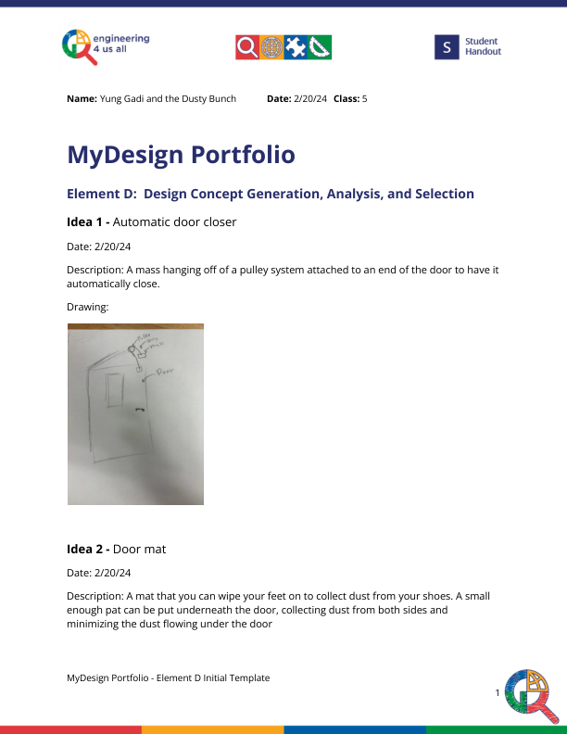
Page 2
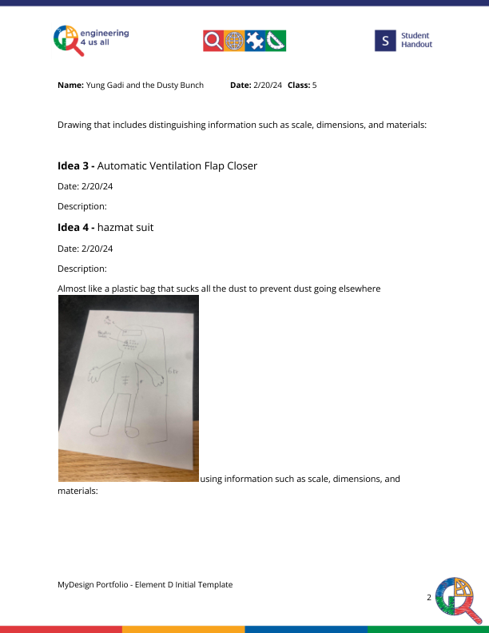
Page 3
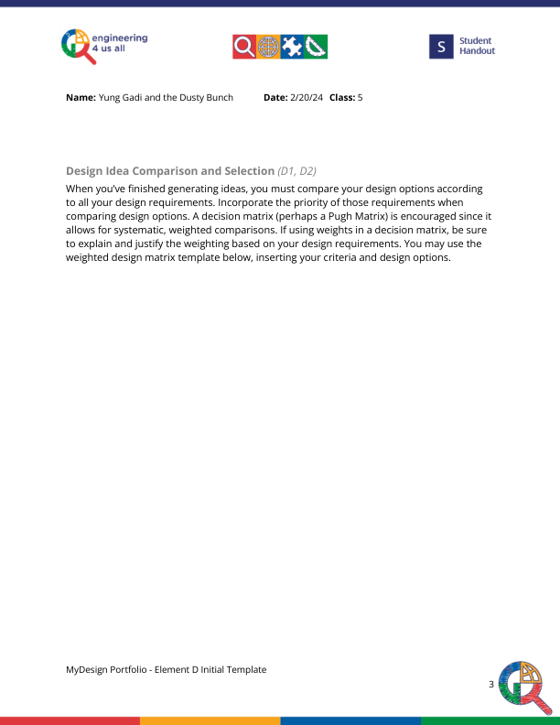
Page 4
