Element D - Document 6329

Portfolio ID: a398ca72a5c2
Document ID: 6329
Project Name: Dust Management
Date Submitted: 2024-05-21 16:48 GMT
Scorer: Carly Brown

SCORING TABLE - ELEMENT D

D1: 3
D2: 4
D3: 3
D4: 0

SCORER COMMENTS:
D1: There are four possible design solutions that are outlined in Element D (though there are 5 in the comparison matrix). To improve this section, identify other specifics, like materials, dimensions, etc.)
D2: There is a clear decision matrix. To improve this section, justify the weighting of the decision matrix (why is "contains dust at source" weighed more than ease of use?)
D3: There is a chart that lays out a general process moving forward. To improve this section, give more details such that someone could follow your efforts on their own.
D4: There isn't a design blueprint of the chosen design - it isn't clear what design was chosen, and what materials, dimensions it will have.

STUDENT SUBMISSION:

Page 1
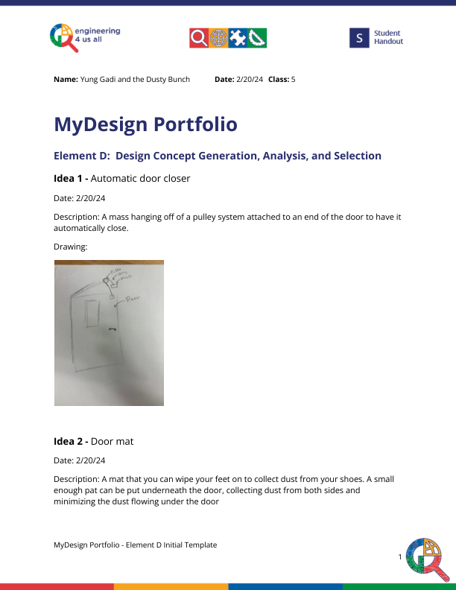
Page 2
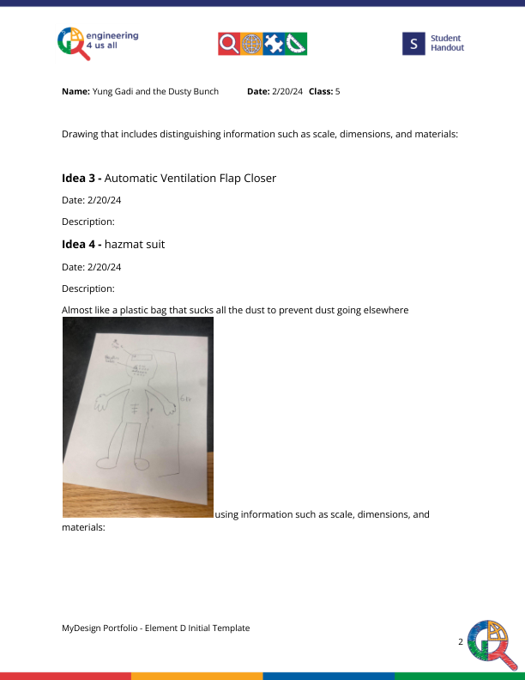
Page 3
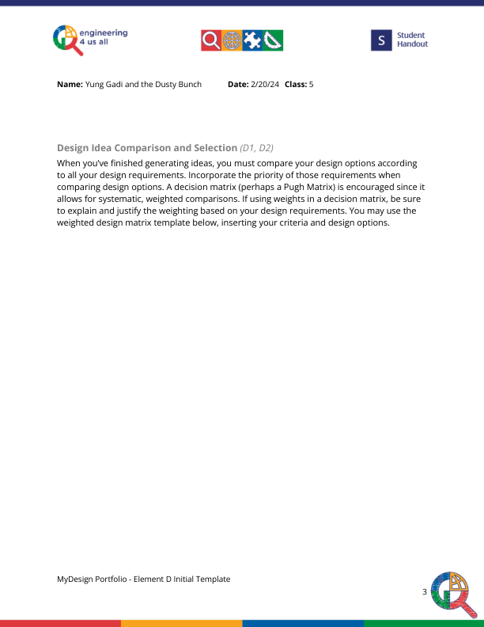
Page 4
