Element D - Document 5843

Portfolio ID: 0ba6372e1d5c
Document ID: 5843
Project Name: Unit 3-4
Date Submitted: 2024-04-02 12:13 GMT
Scorer: Jessica Lemieux

SCORING TABLE - ELEMENT D

D1: 4
D2: 0
D3: 4
D4: 5

SCORER COMMENTS:
Each design was evaluated and compared thoroughly for the design requirements, but it's not clear which design they chose.
They have the selection process as part of their action plan.
Blueprints for each design are sufficiently detailed.

STUDENT SUBMISSION:

Page 1
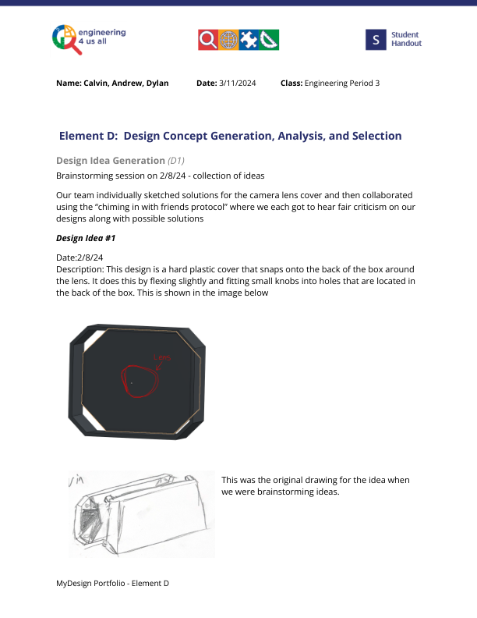
Page 2
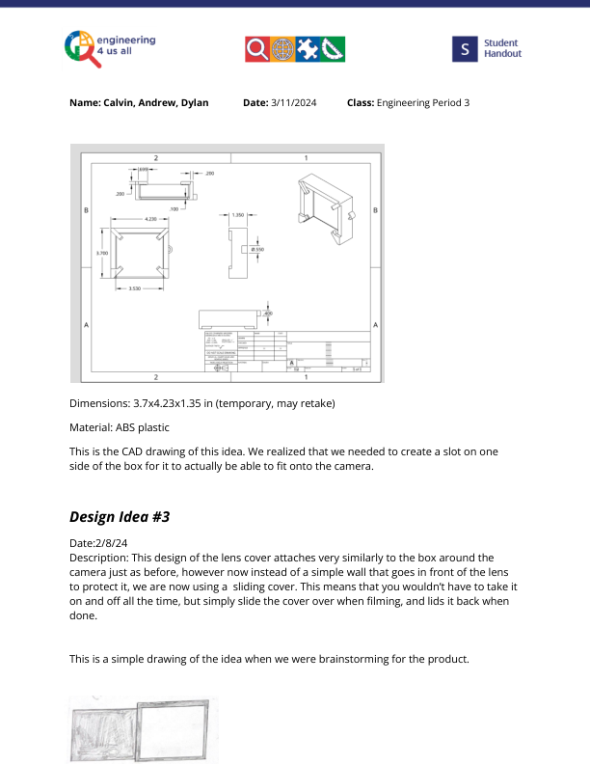
Page 3
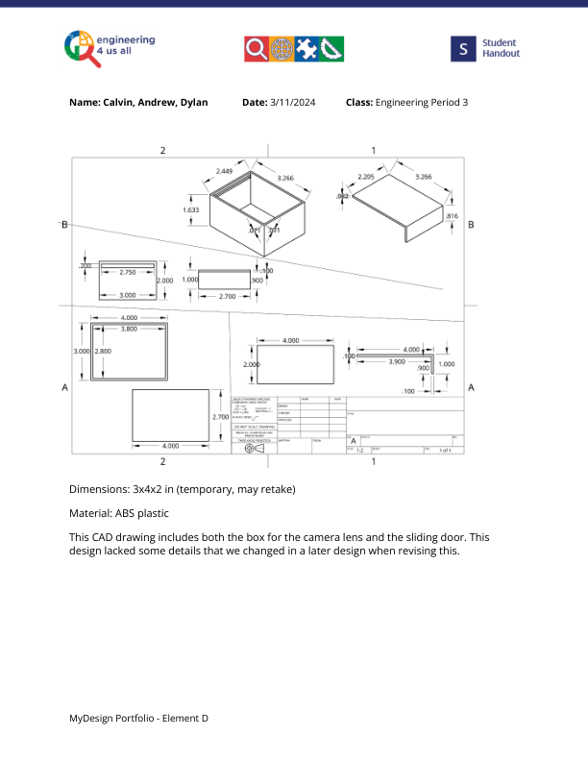
Page 4
