Element G
Date: | Process Details/Achievements: | Evidence
February 26, 2024 | - Sketch digitally constructed utilizing Onshape  - Arduino Coding for the light and sound effect of the design is in the works  - 2/4 sides of design finishing lasering process (Acrylic Sheet) | 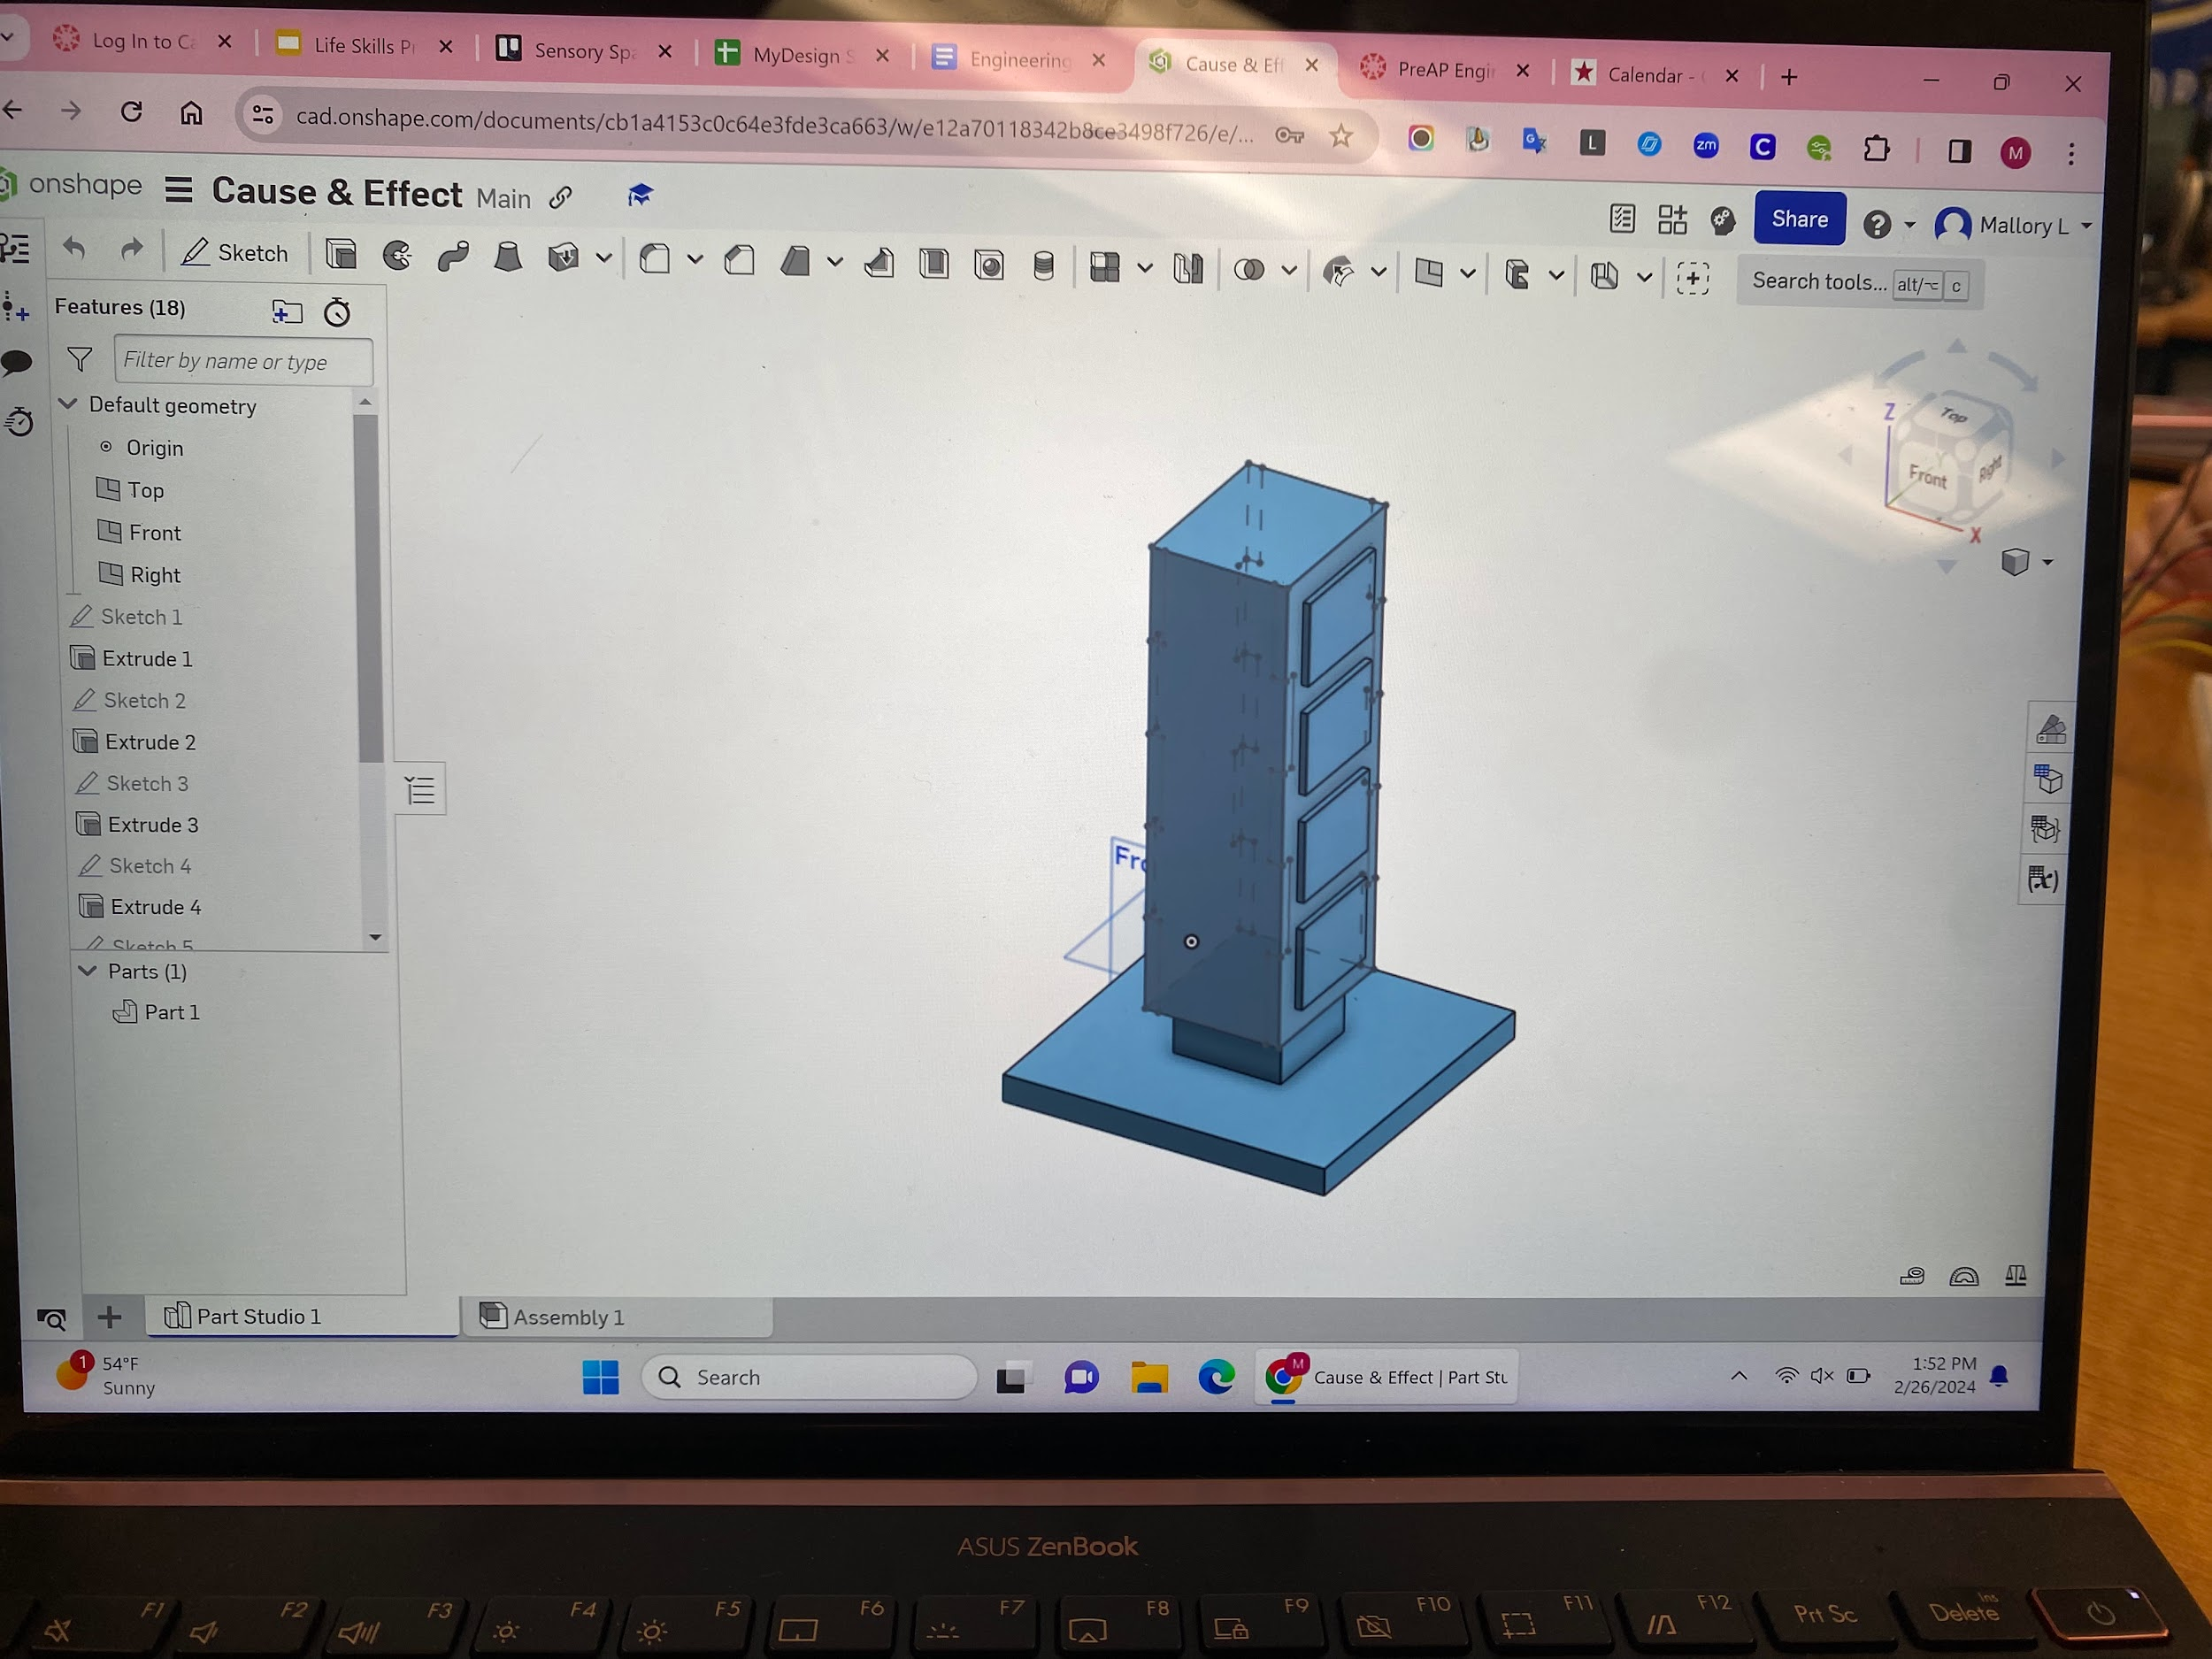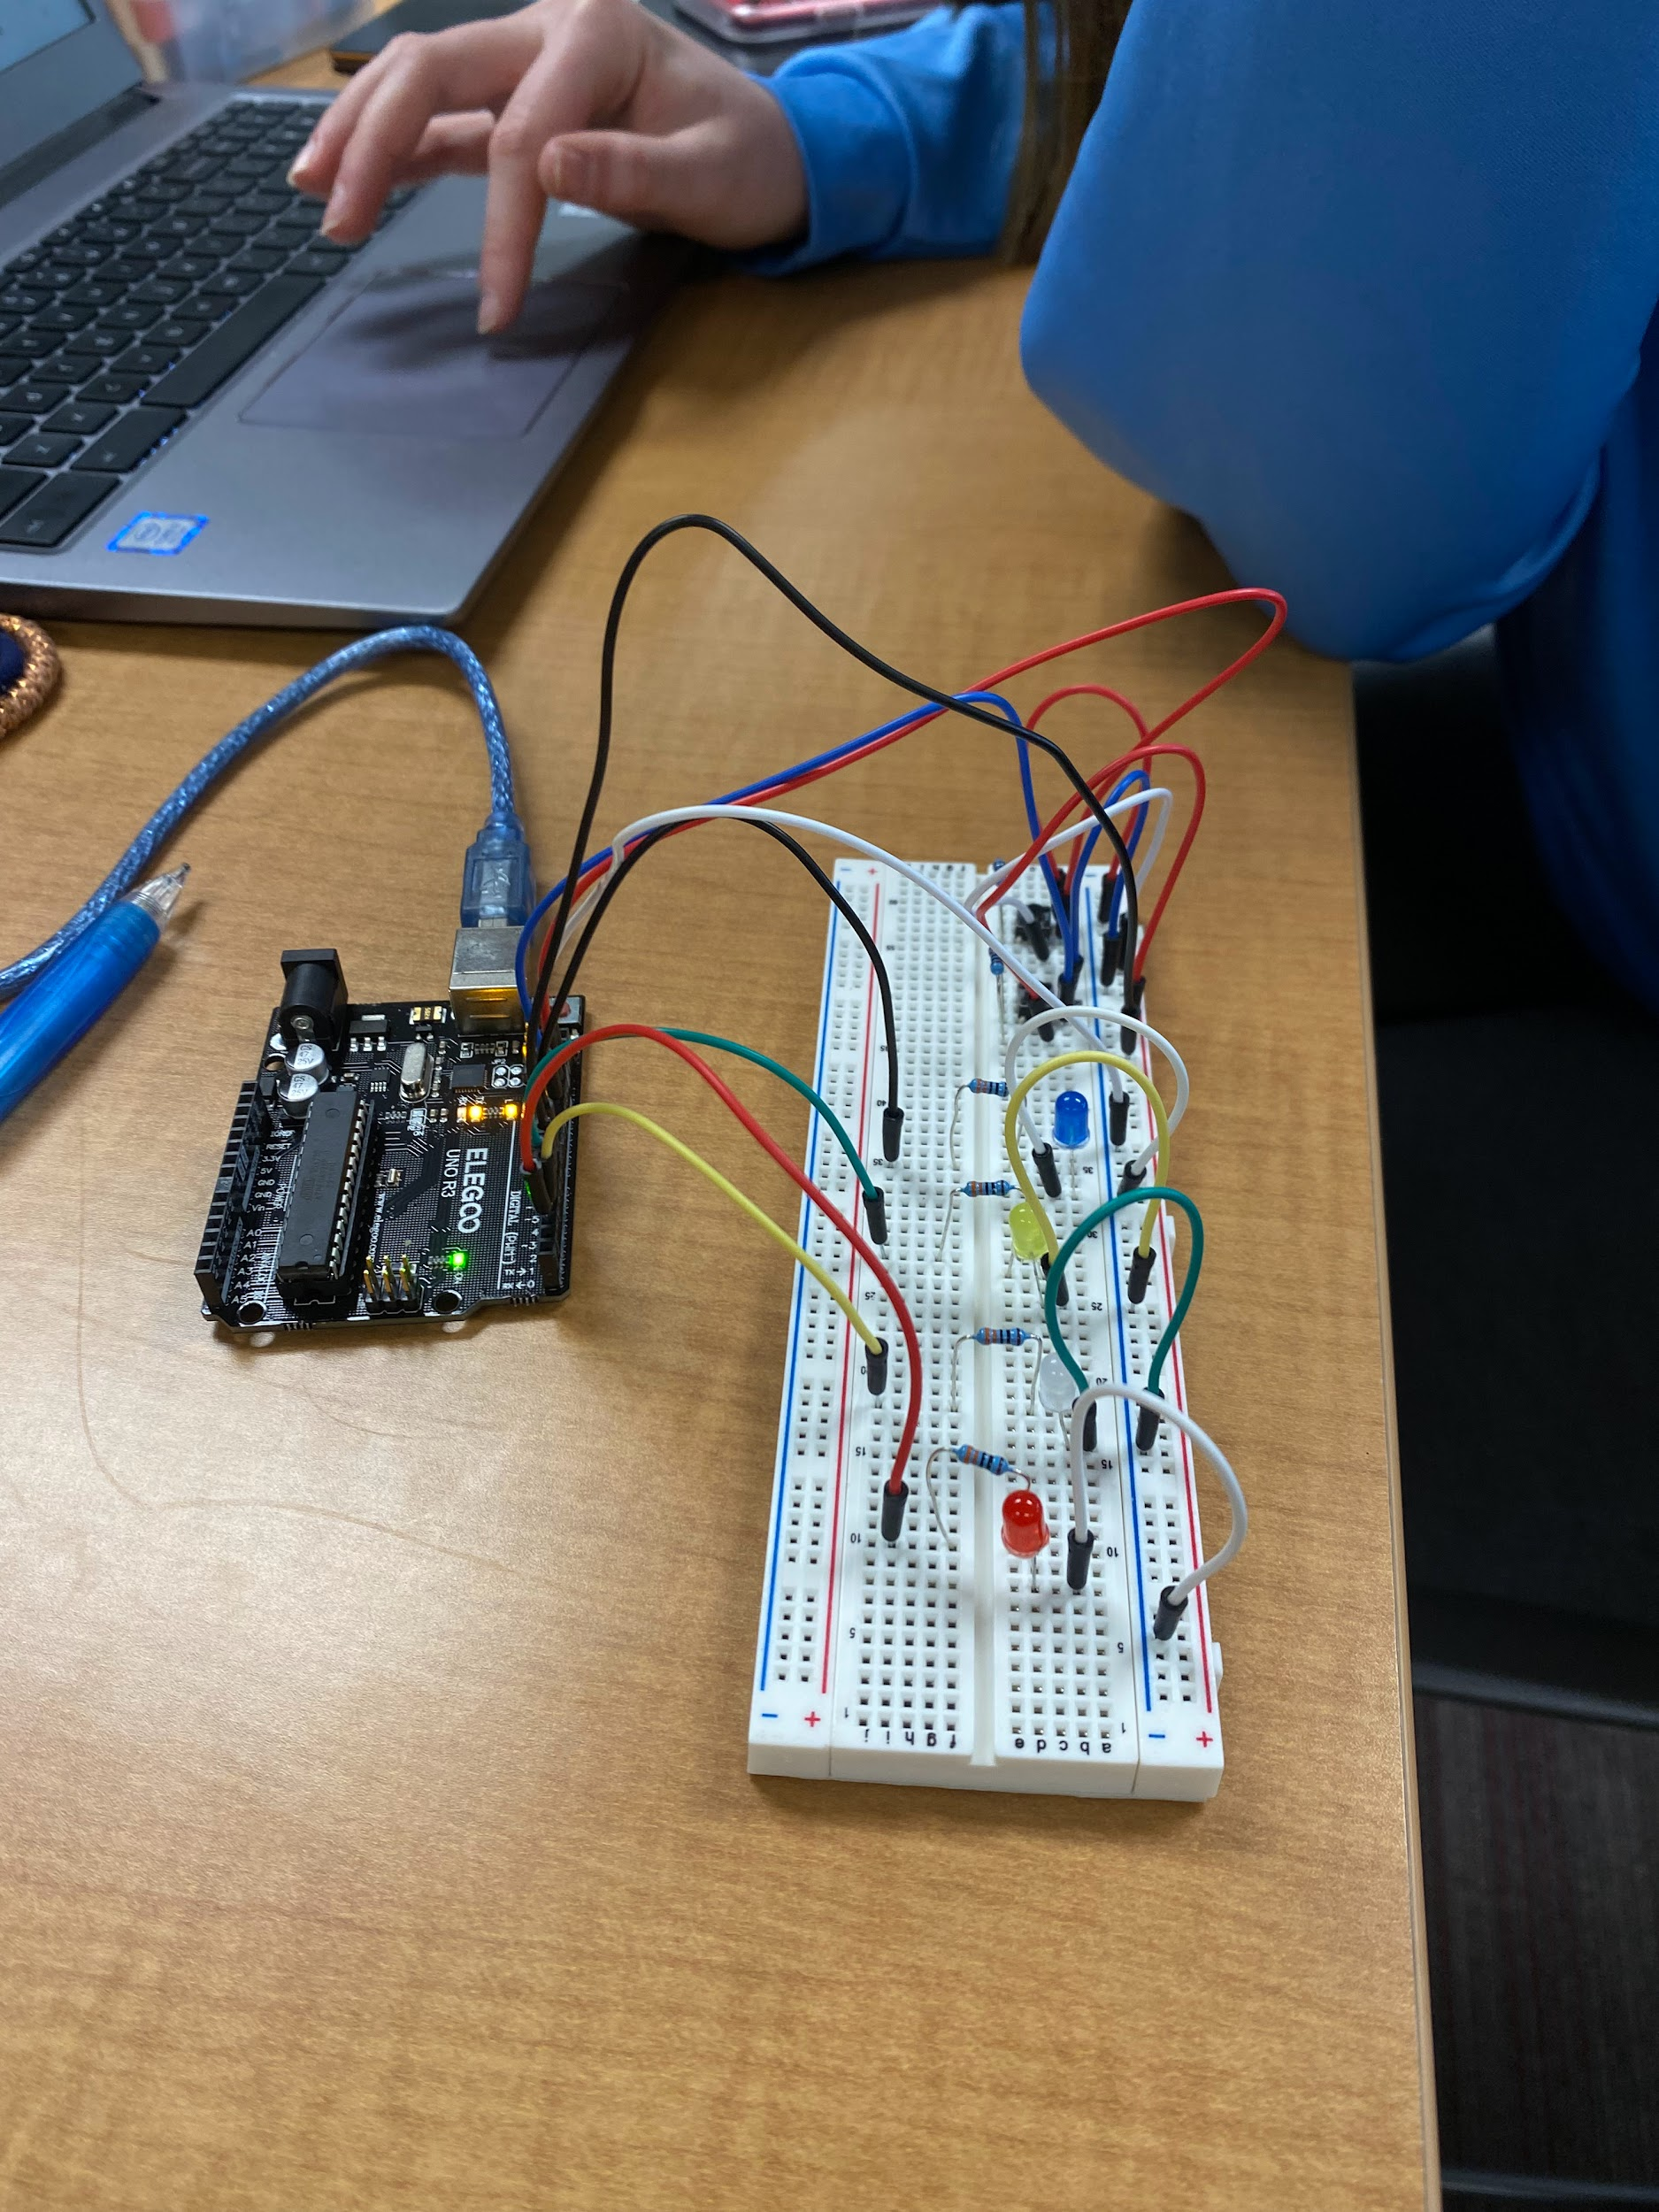  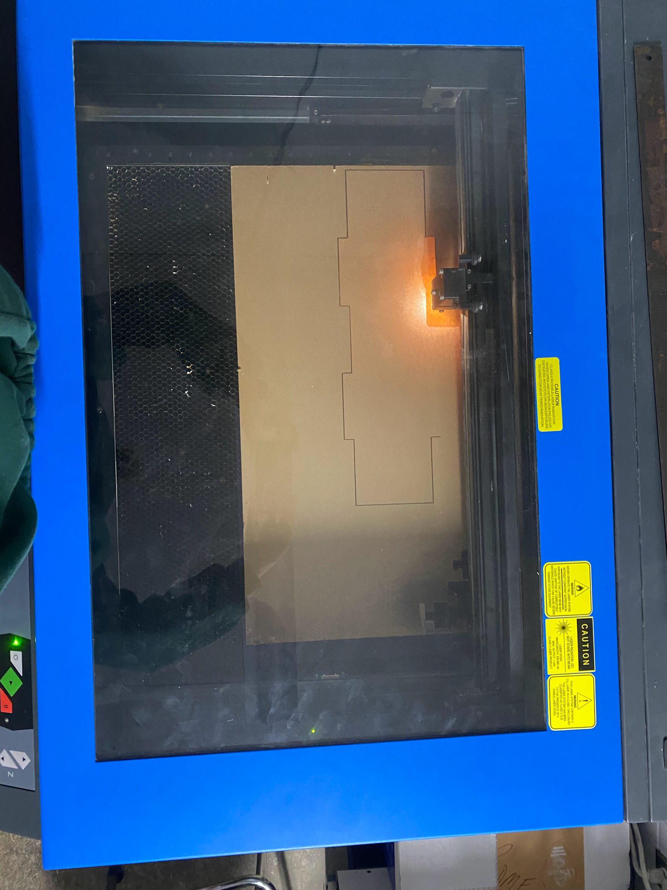
February 27, 2024 | - Lasered 3/4 of side pieces, 4/8 of buttons (acrylic sheet)  - Continuation of Arduino work | 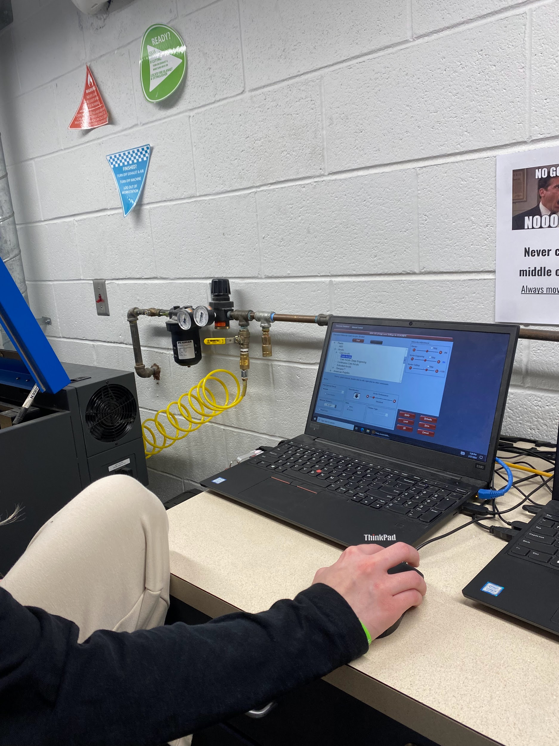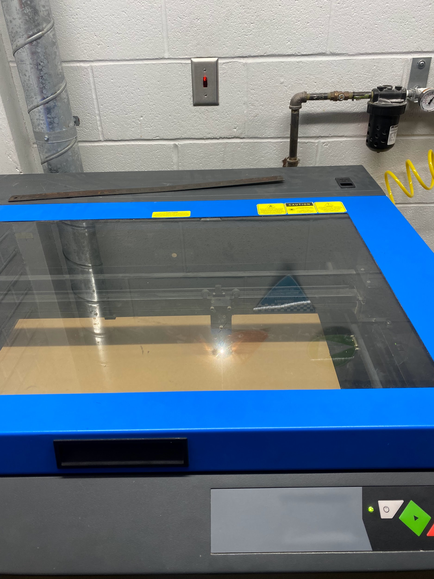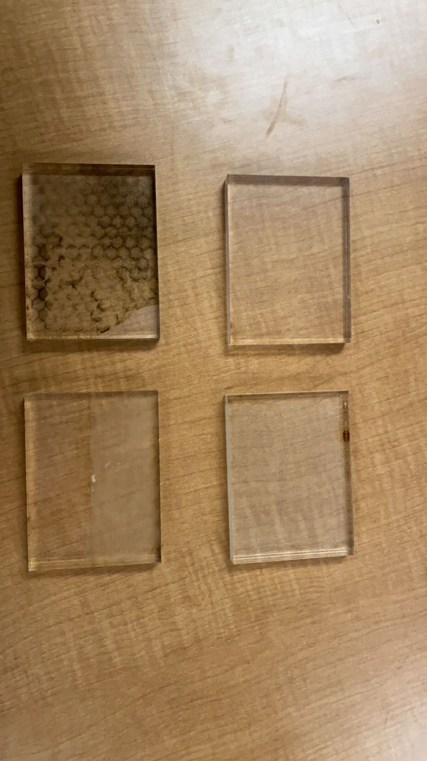
February 28, 2024 | - Combating issues we were experiencing with Arduino | 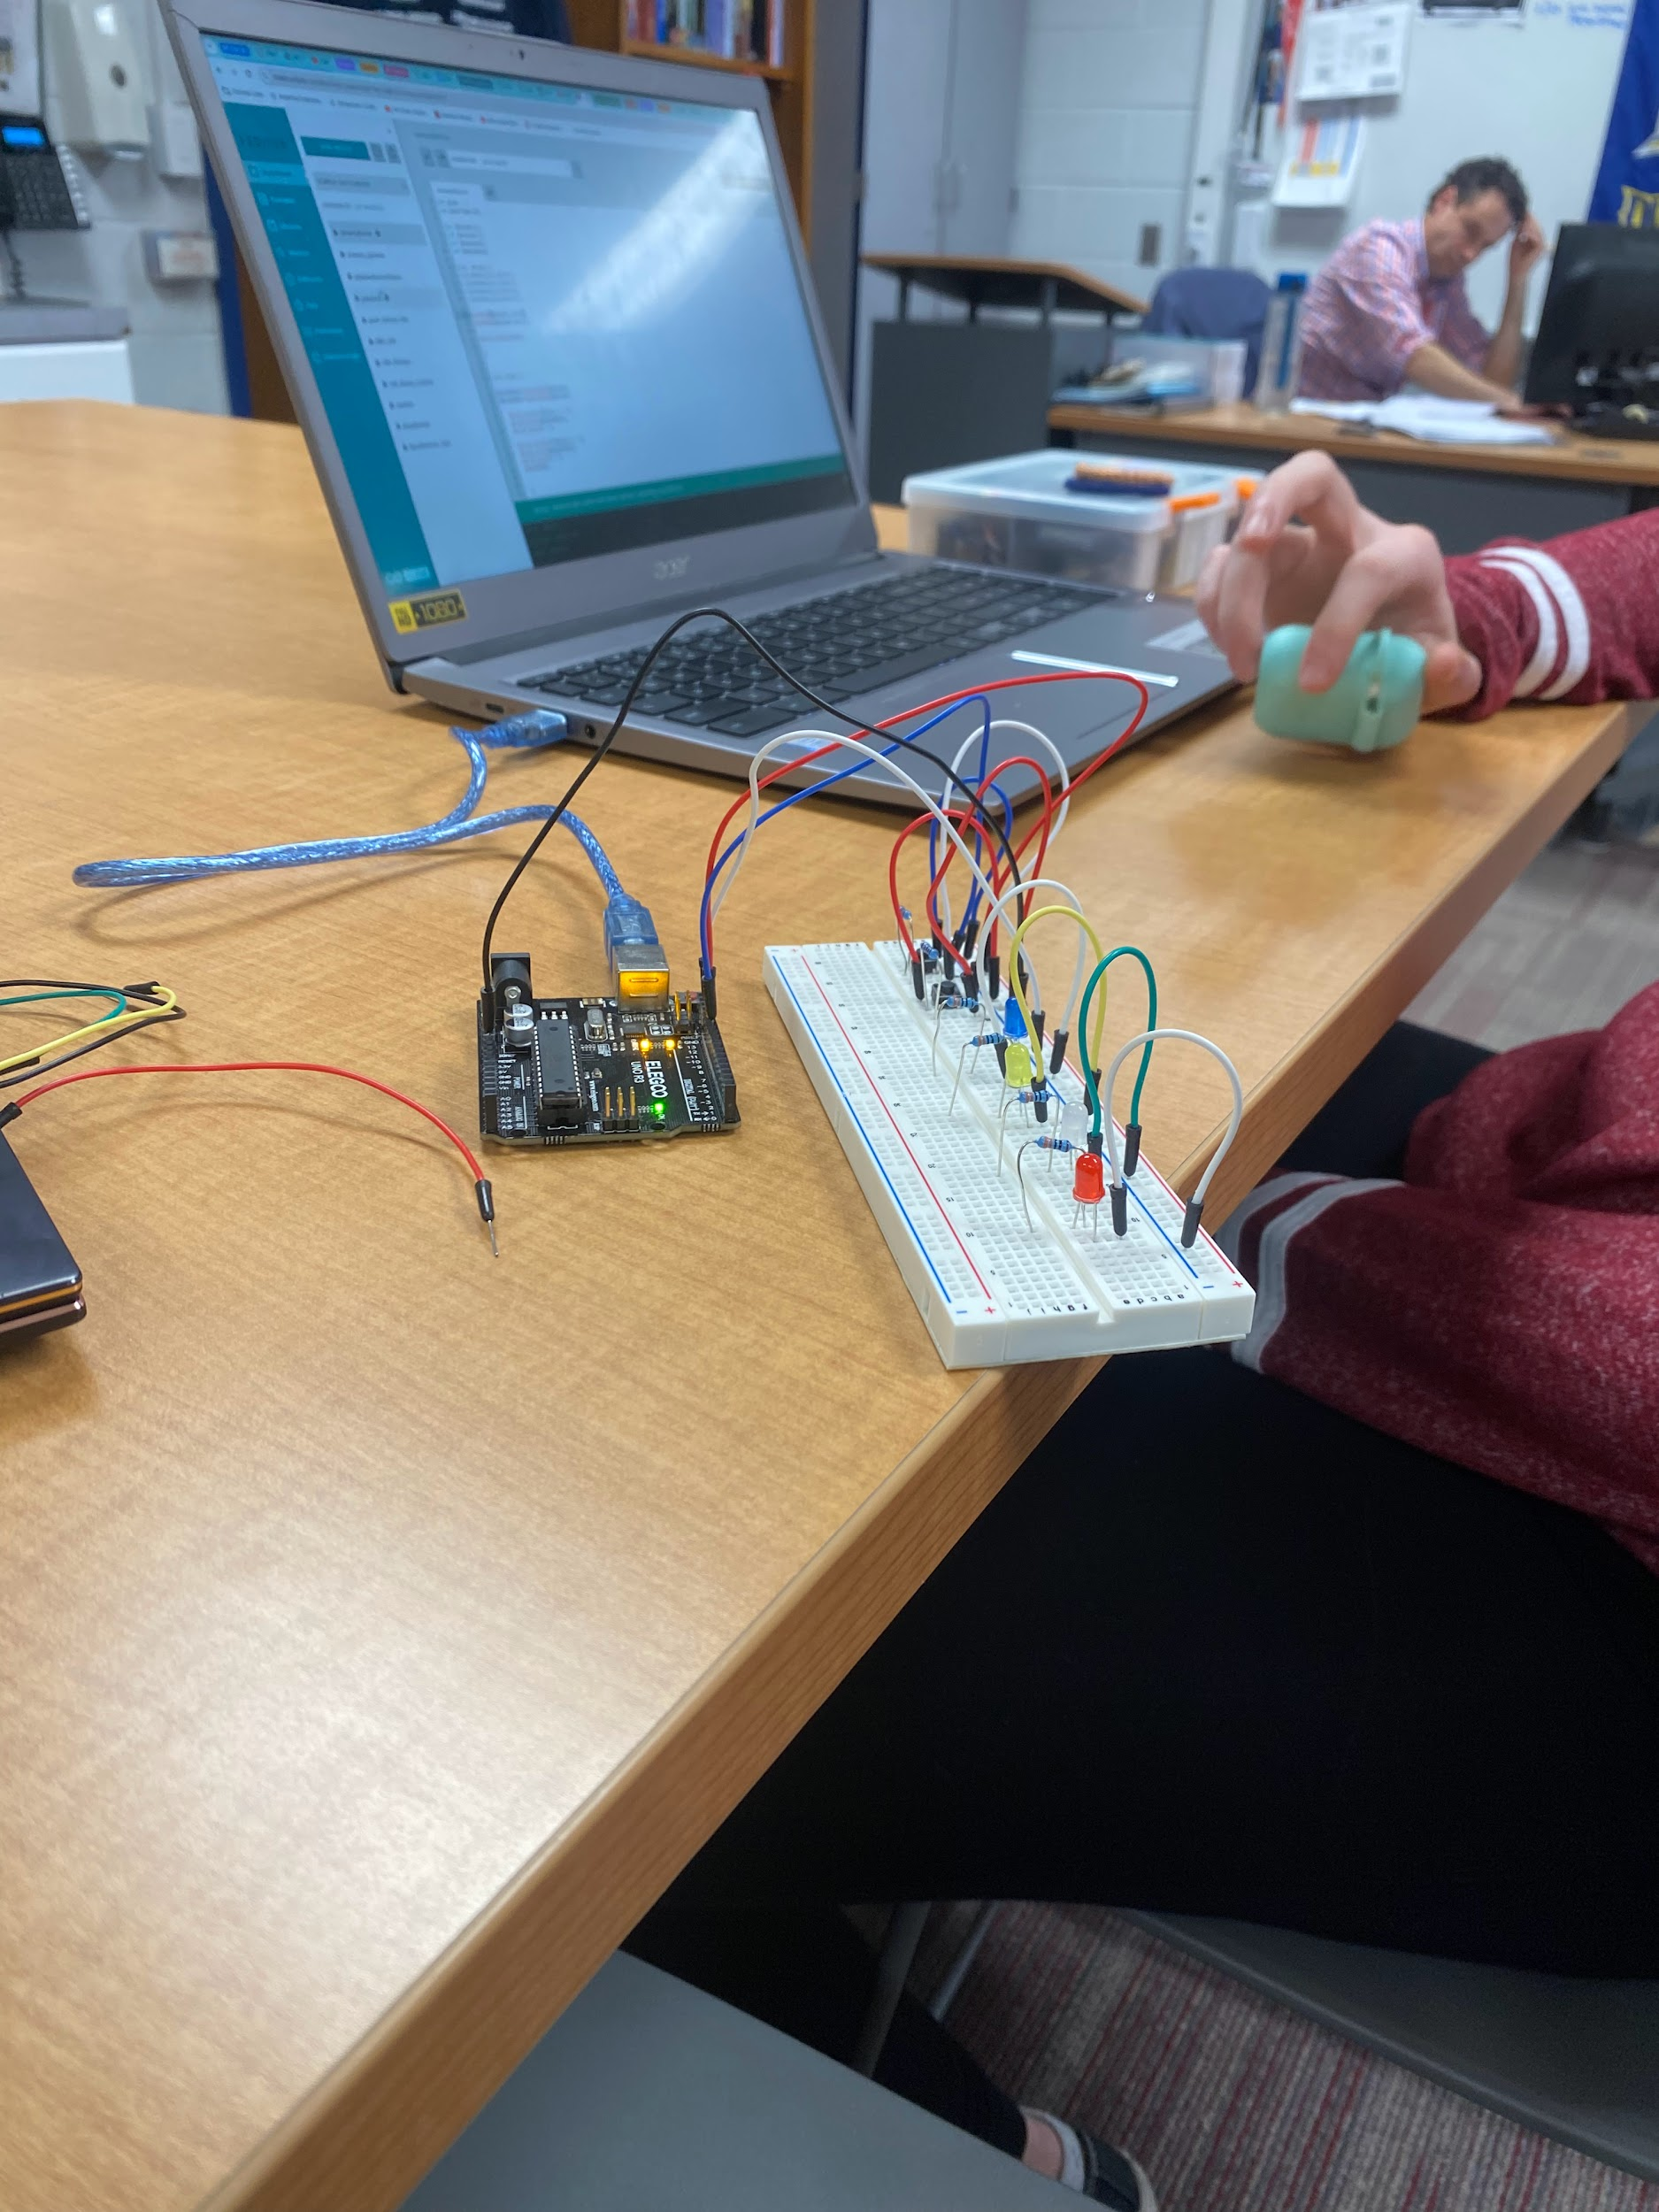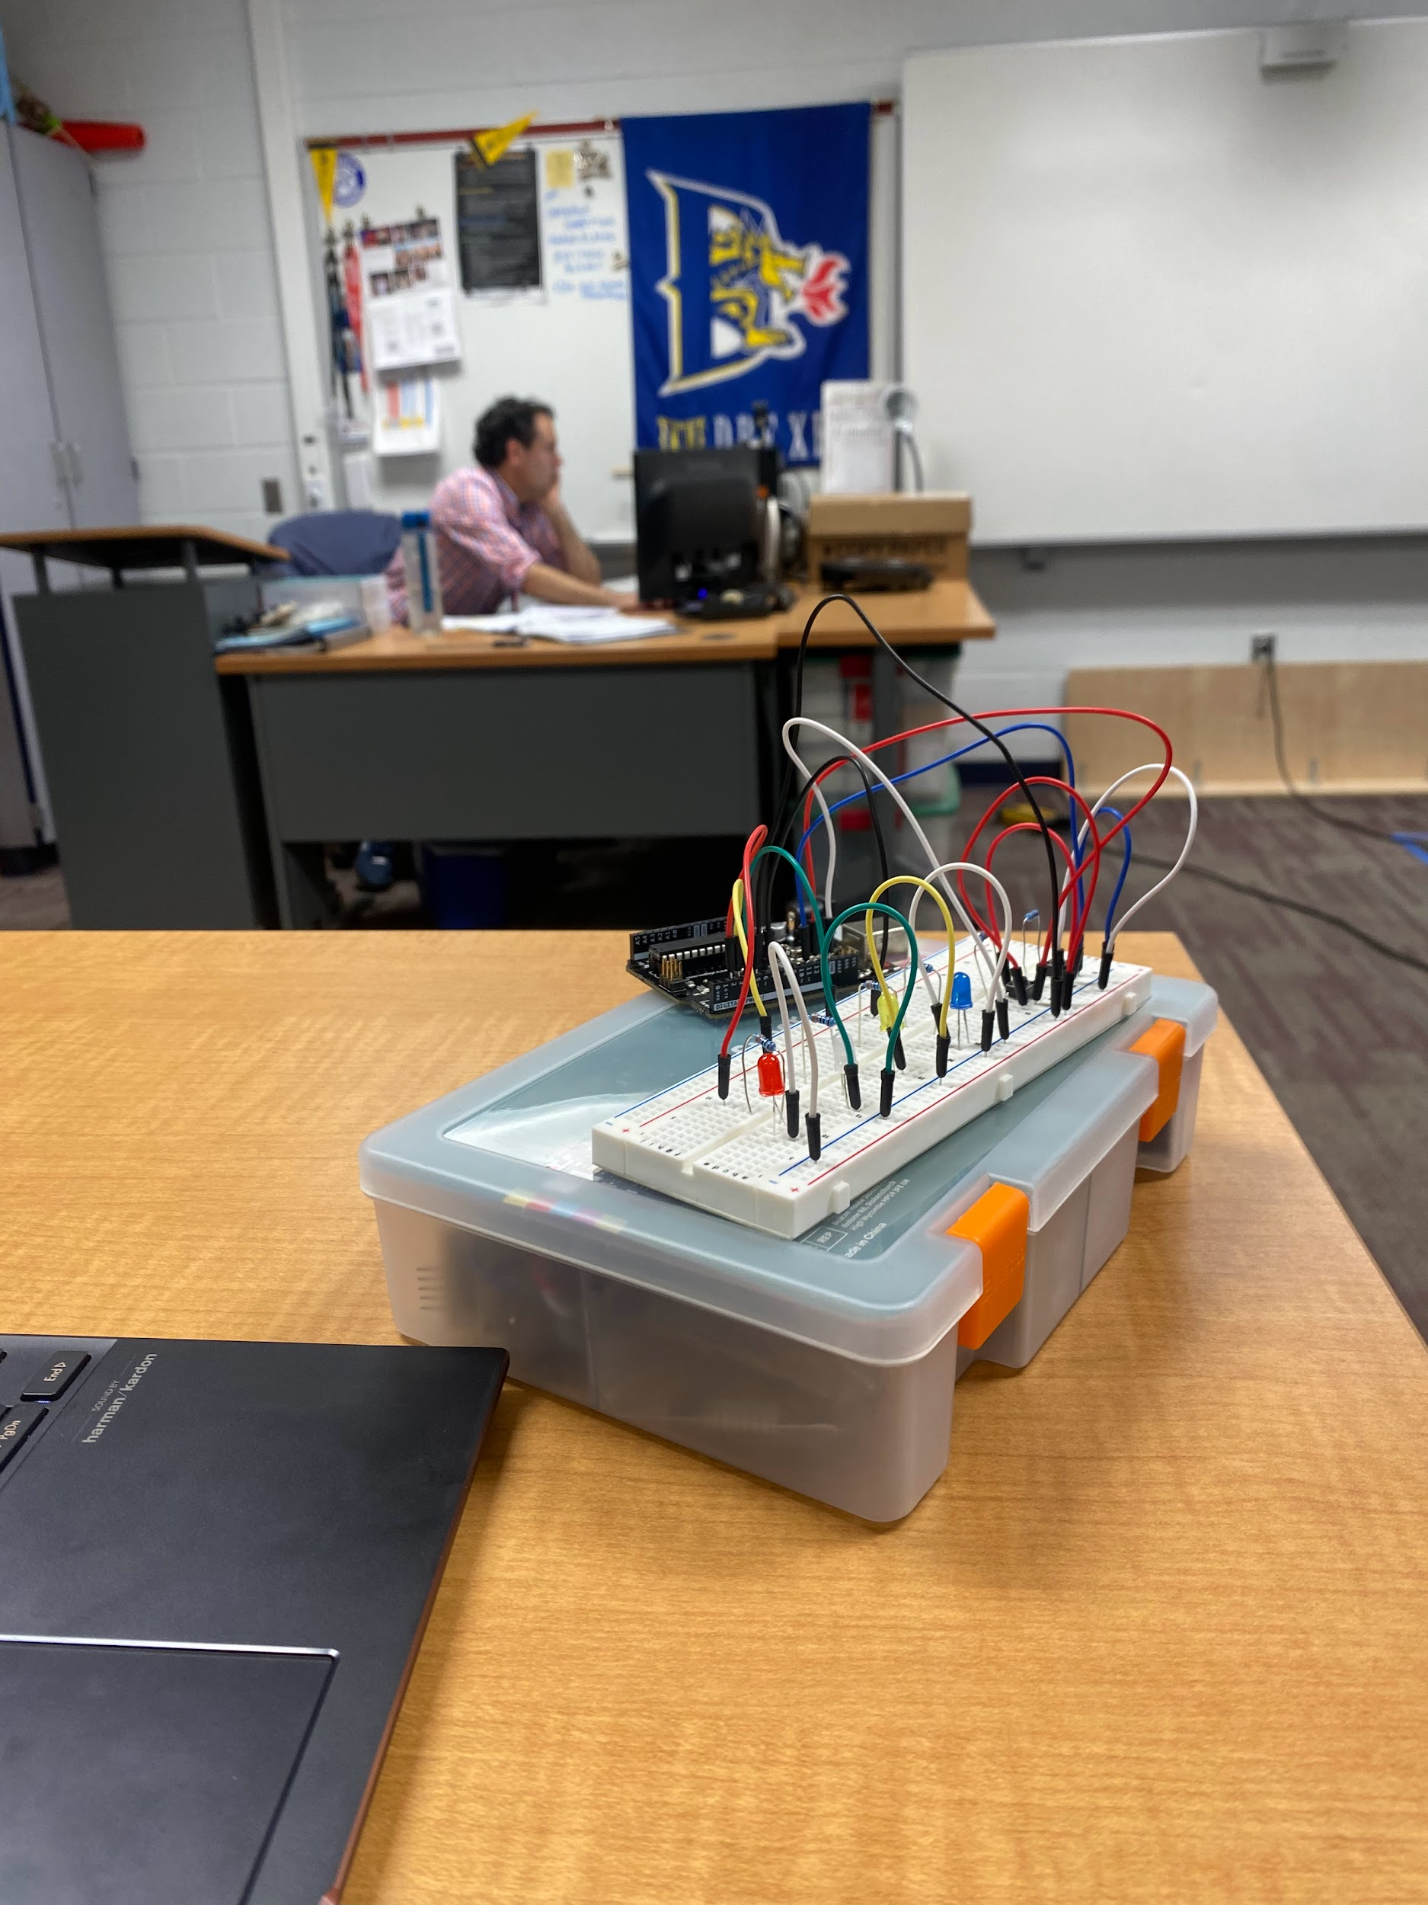
February 29, 204 | - Cleaned buttons in the sink to get rid of burnt residue  - Worked on Arduino  - Preparing on OnShape to laser next side piece (will be 4/4)  - Preparing on ONshape to laster top and bottom piece | 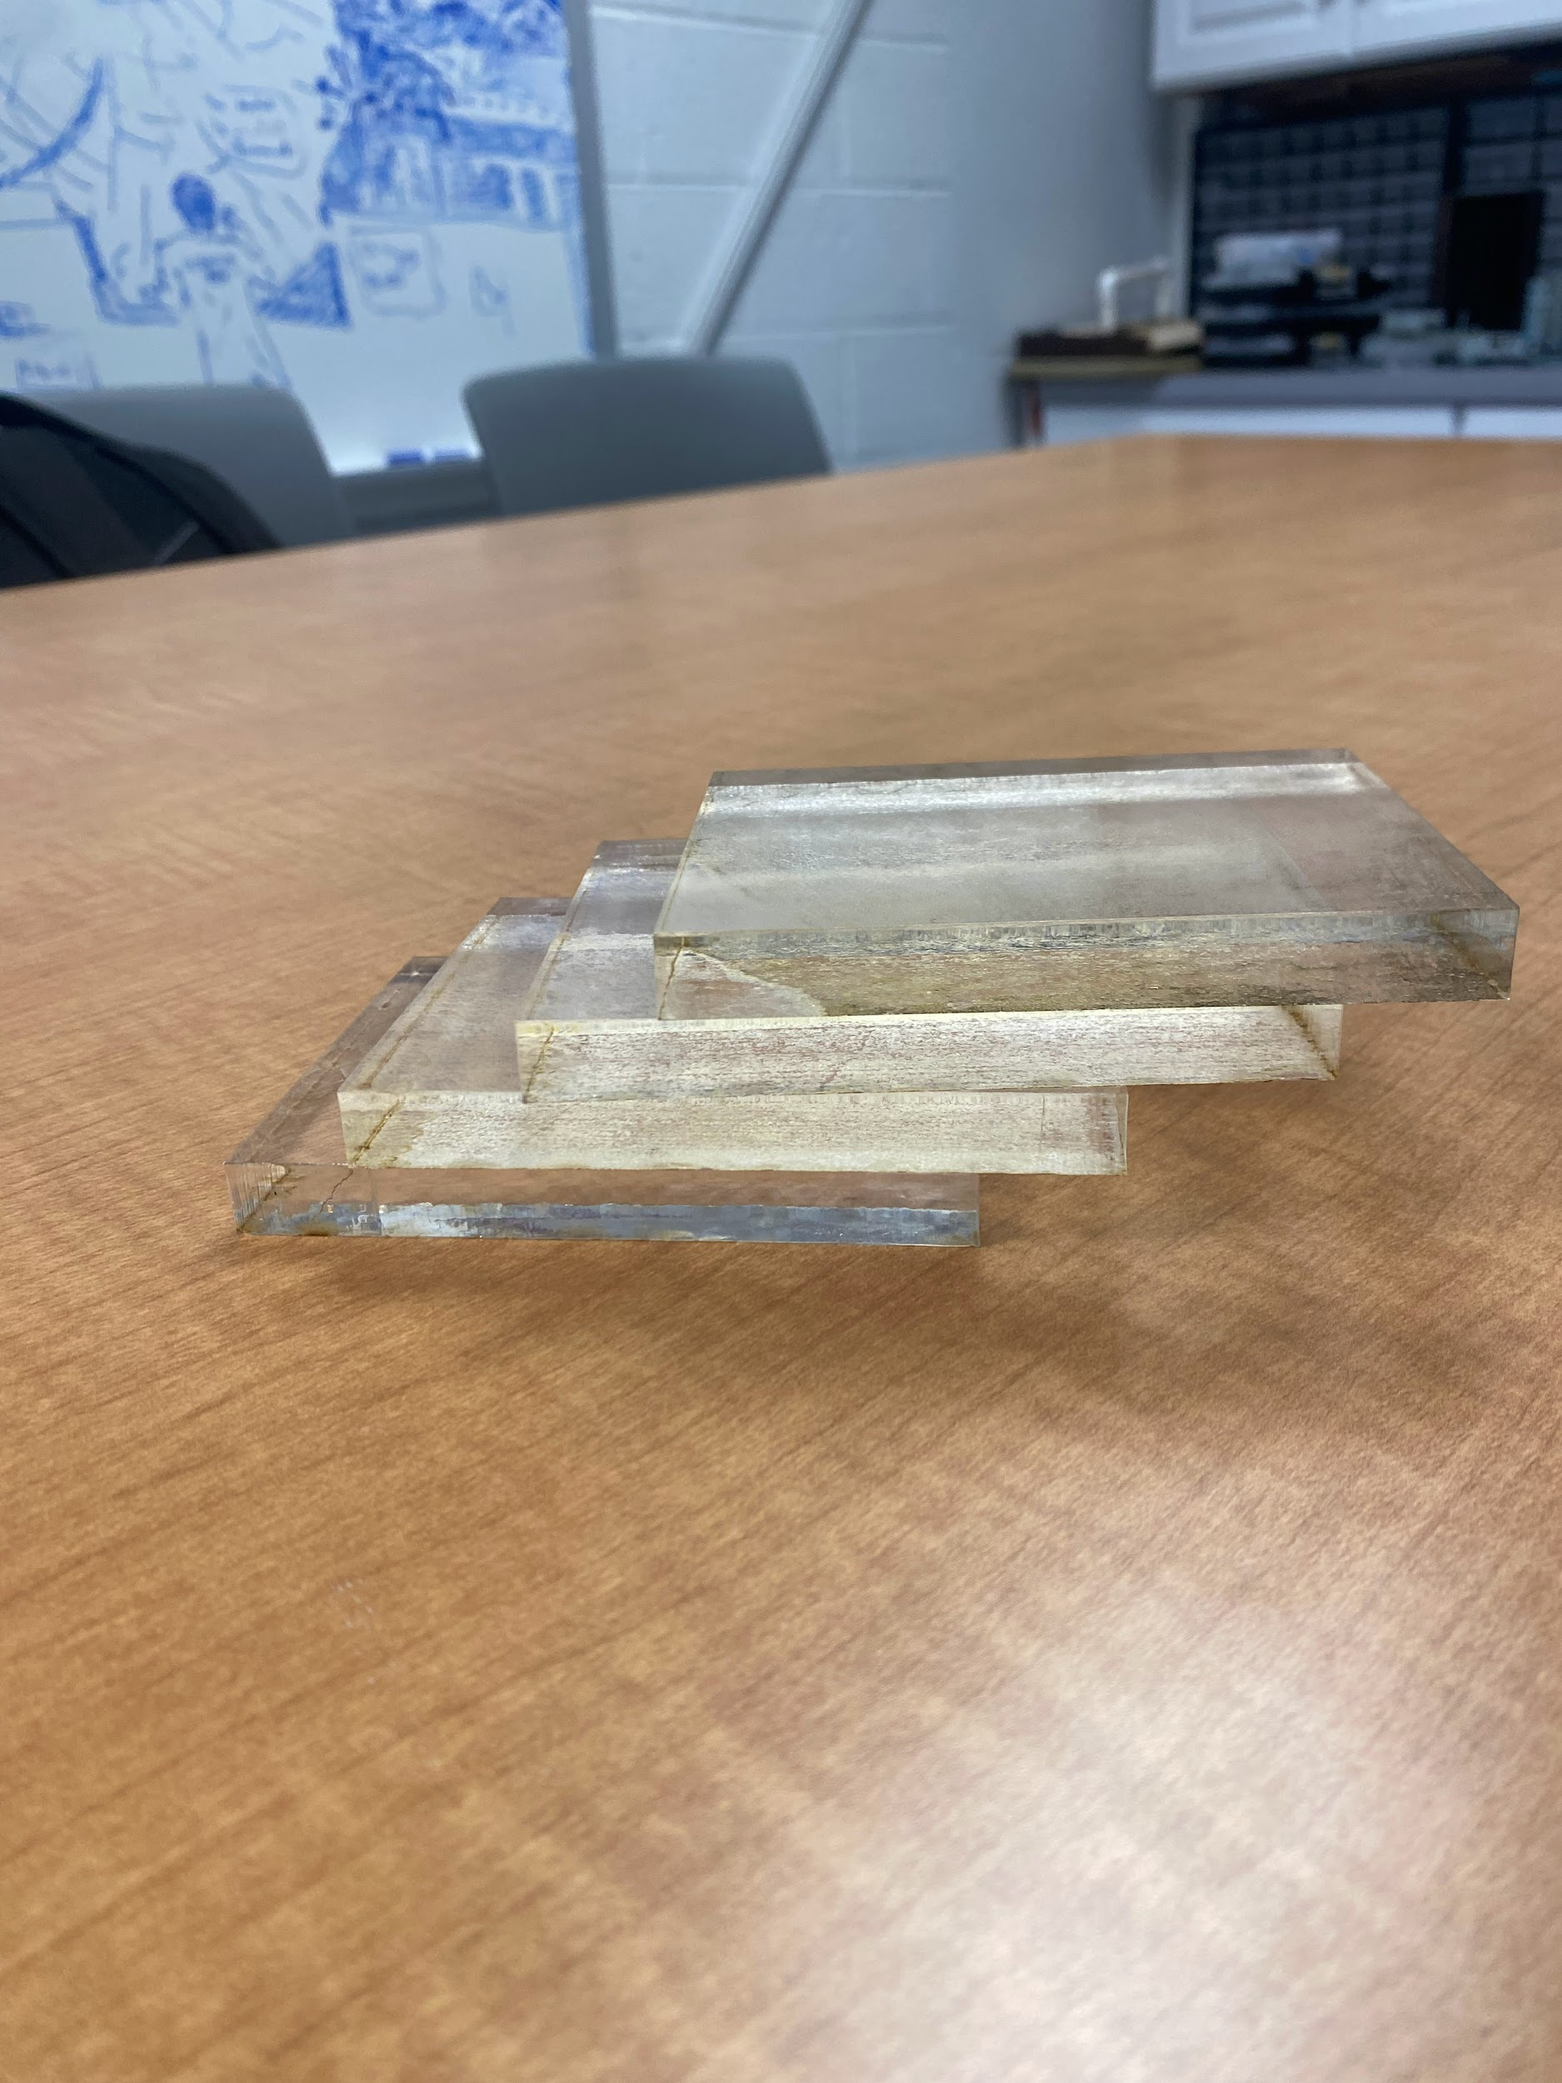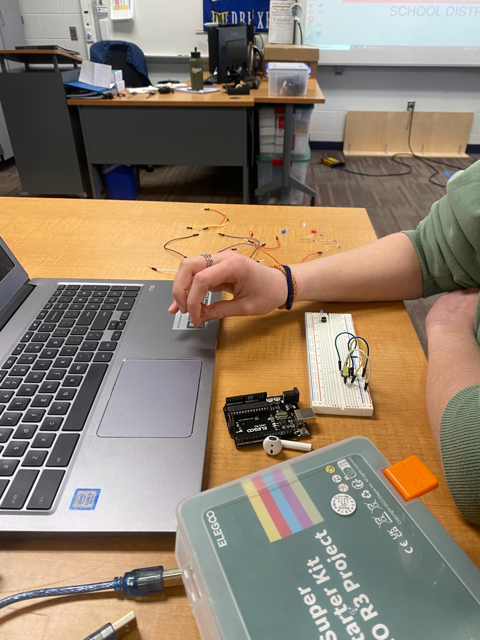
March 1, 2024 | - All teammates absent from class | N/A
March 4, 2024 | - Perfected arduino  - Organized the laser to be able to print last side piece on acrylic sheet | 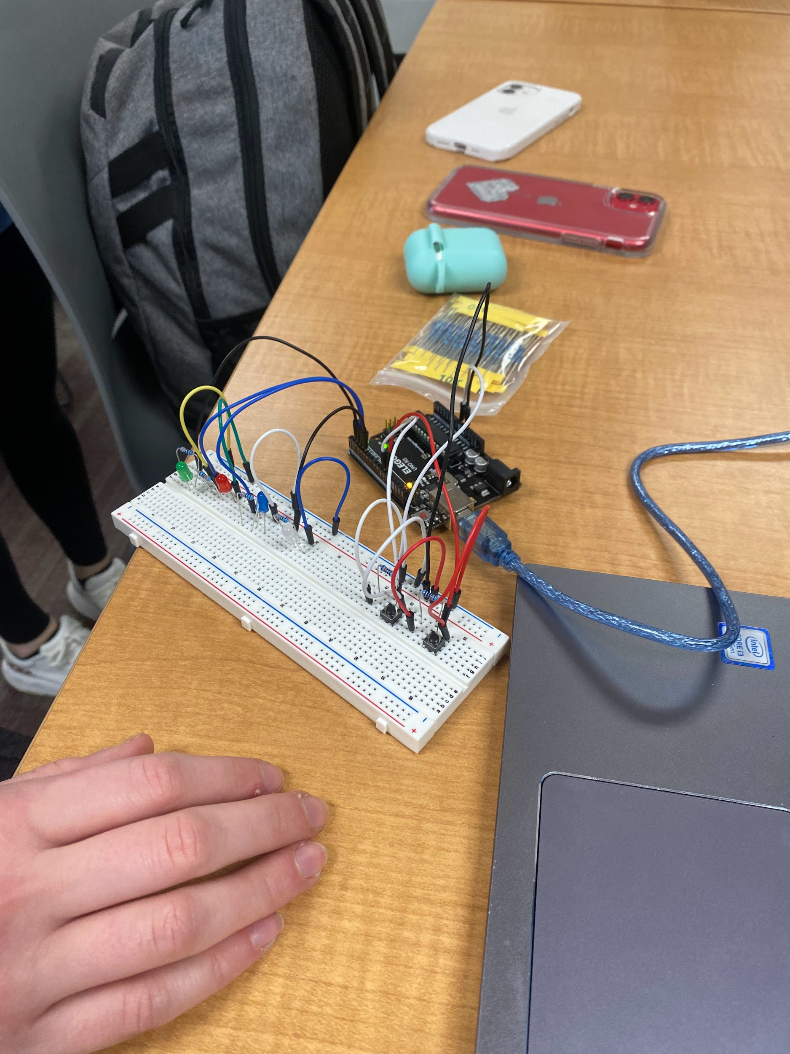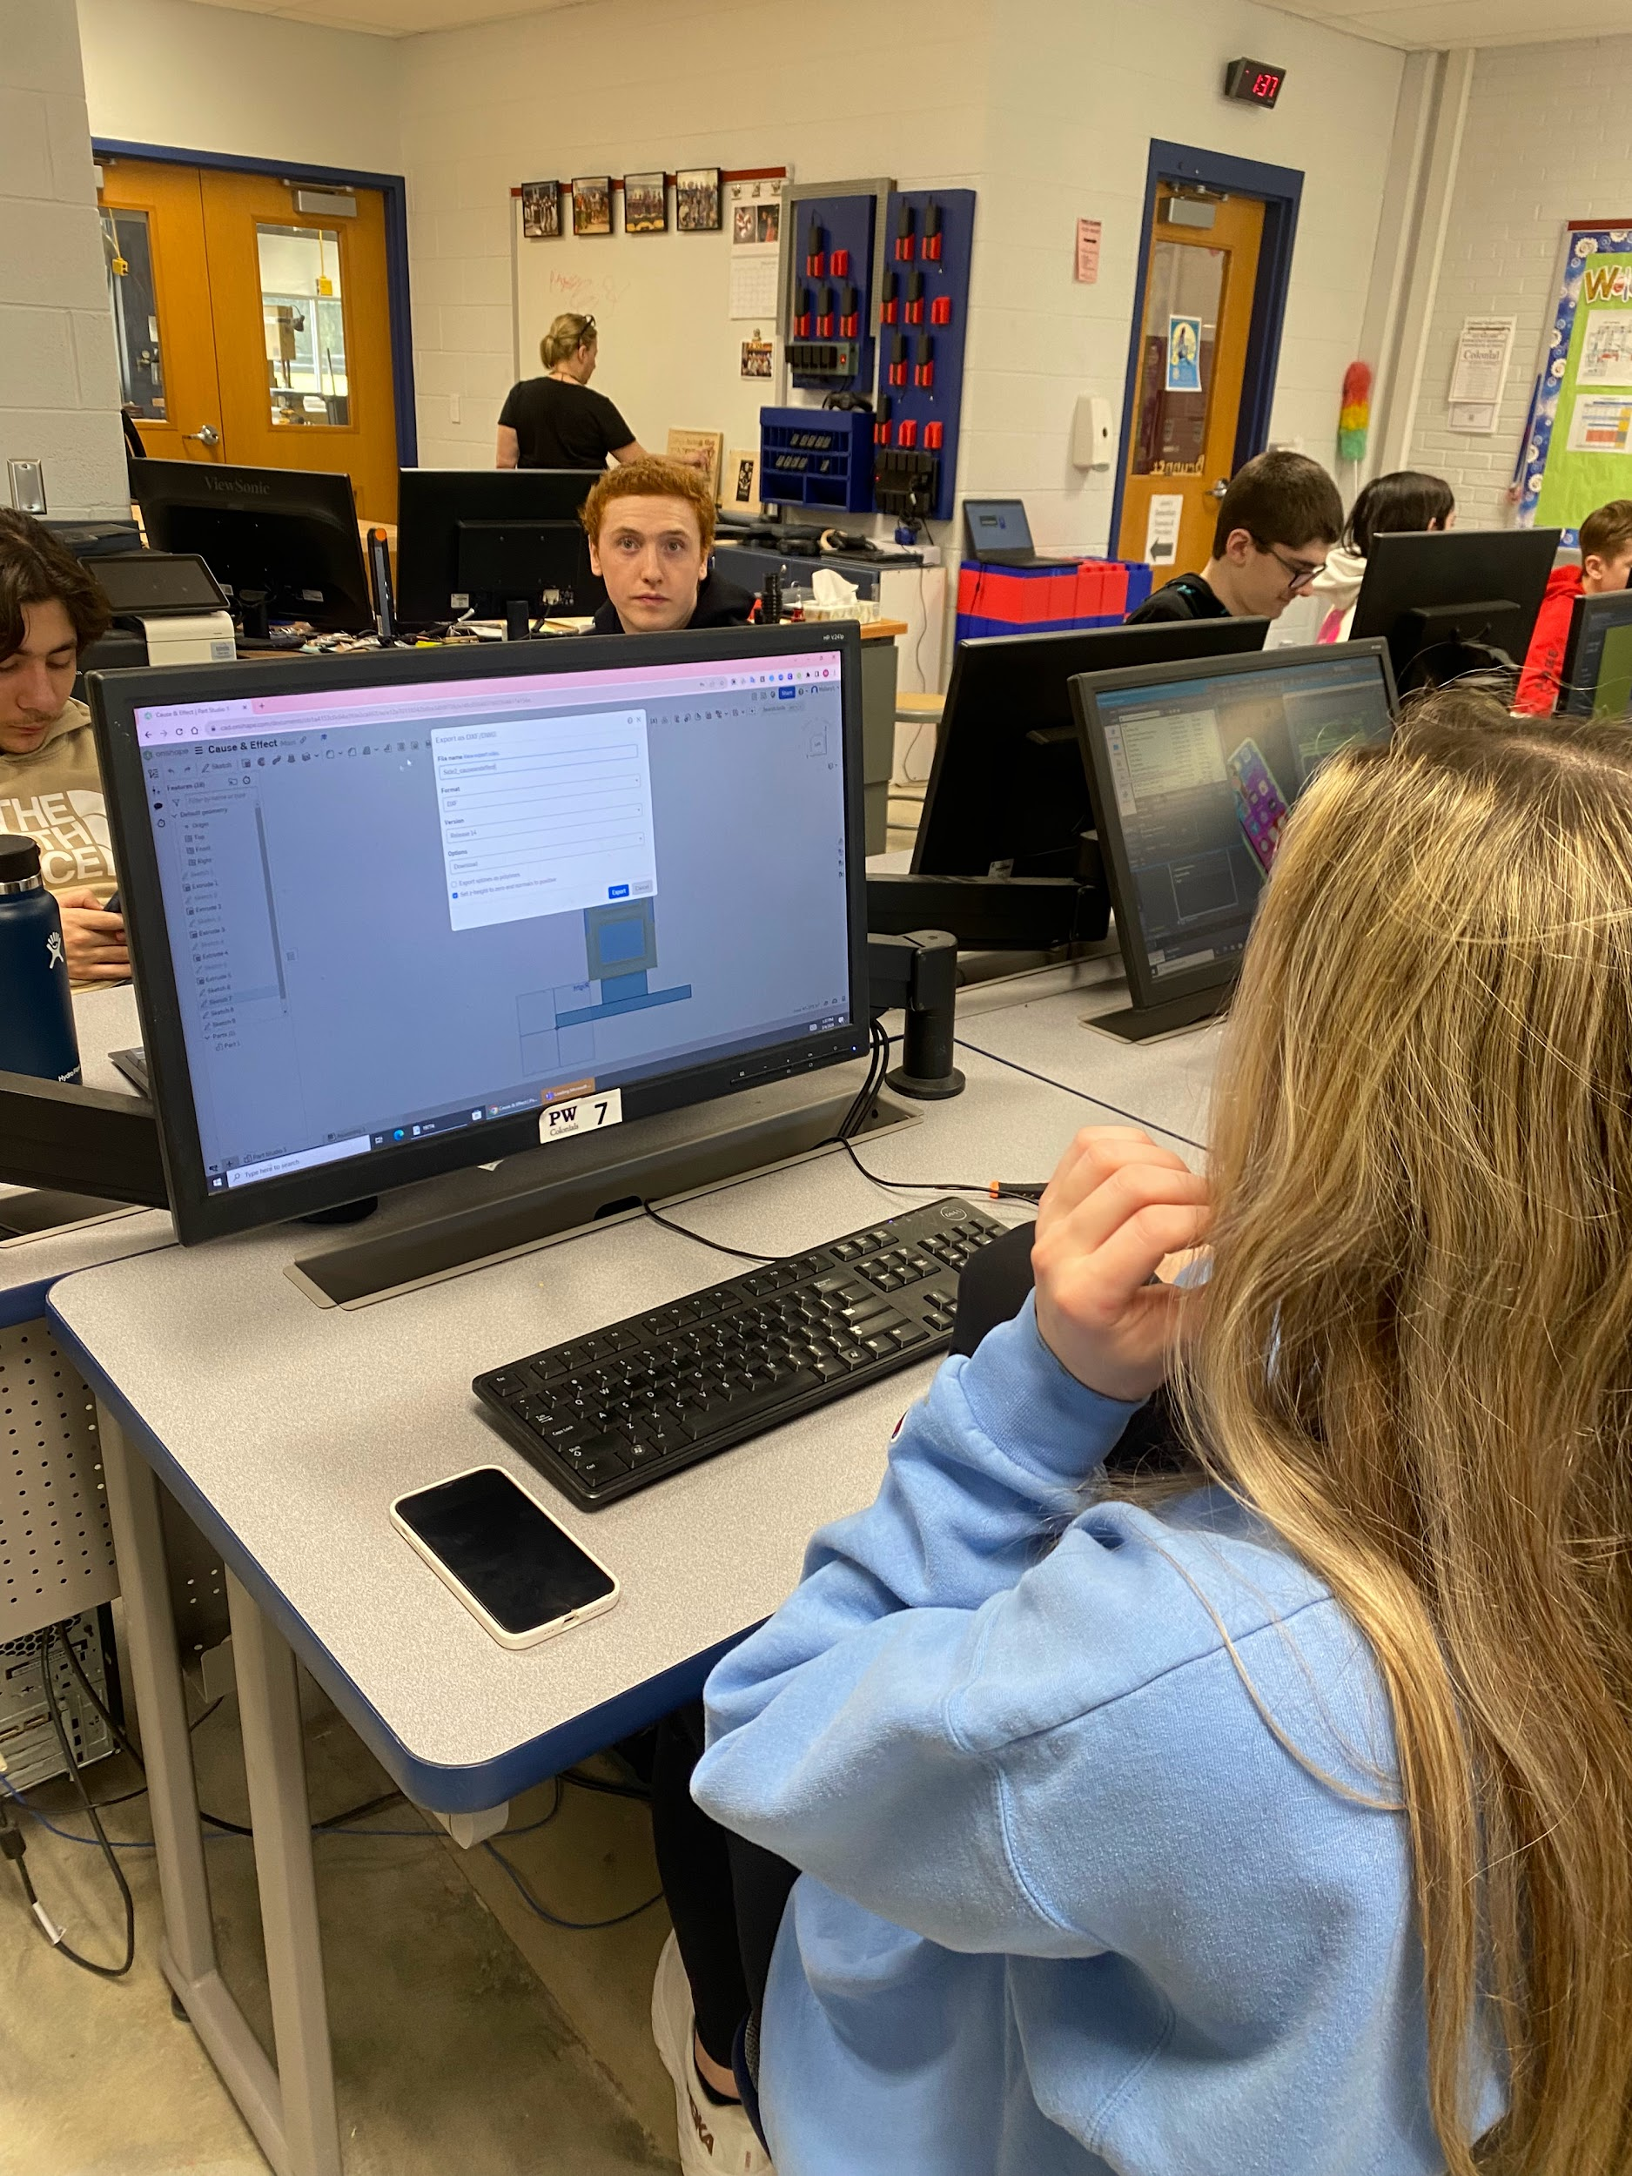
March 5, 2024 | - Copying/repeating the successful code | 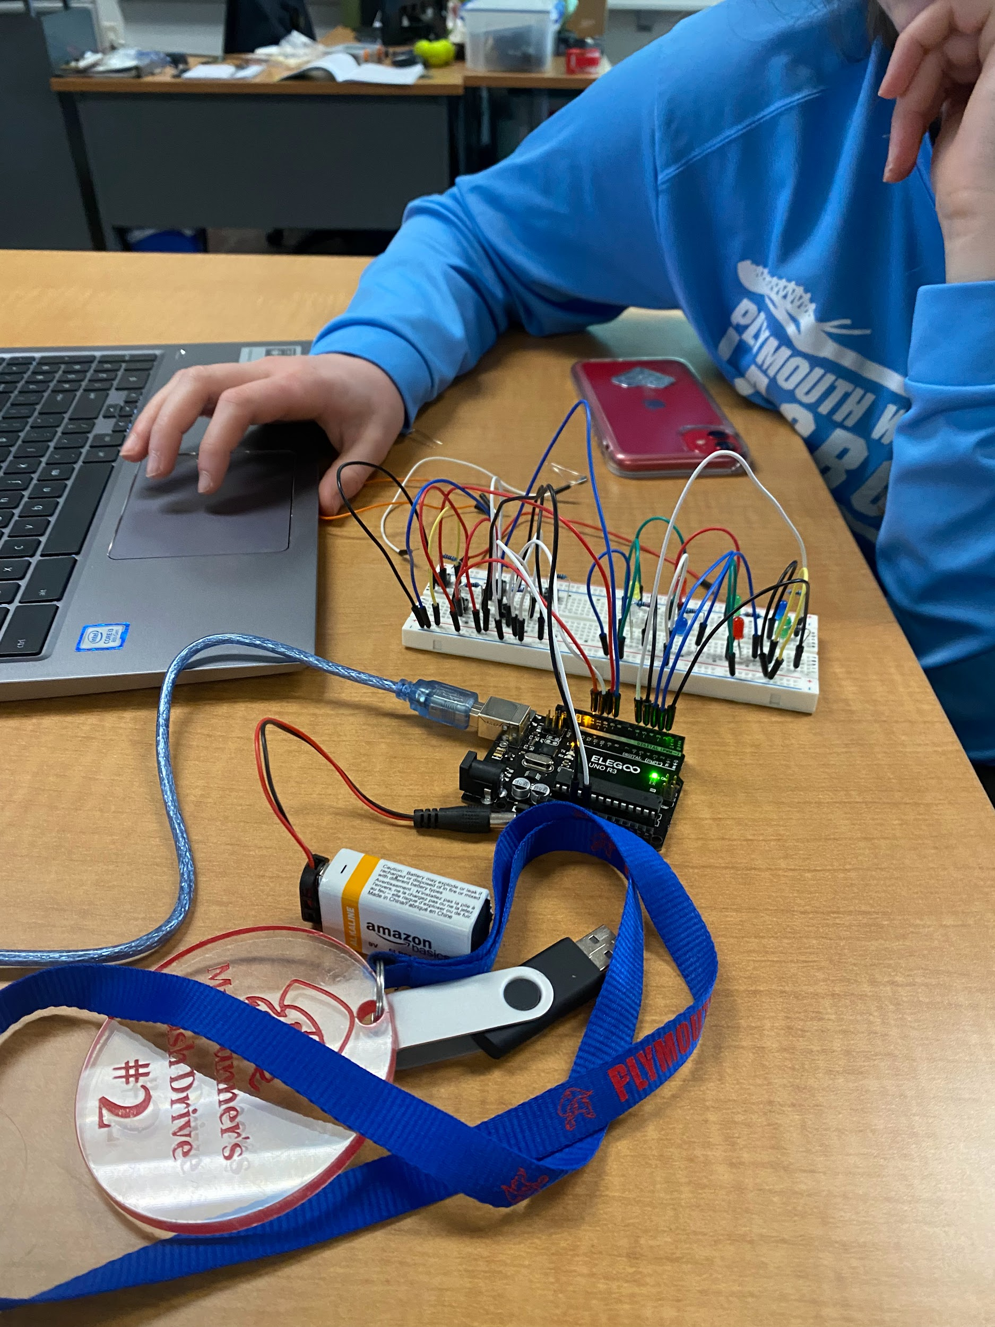
March 6, 2024 | - Everything is lasered out of the acrylic sheet besides base and back plate | 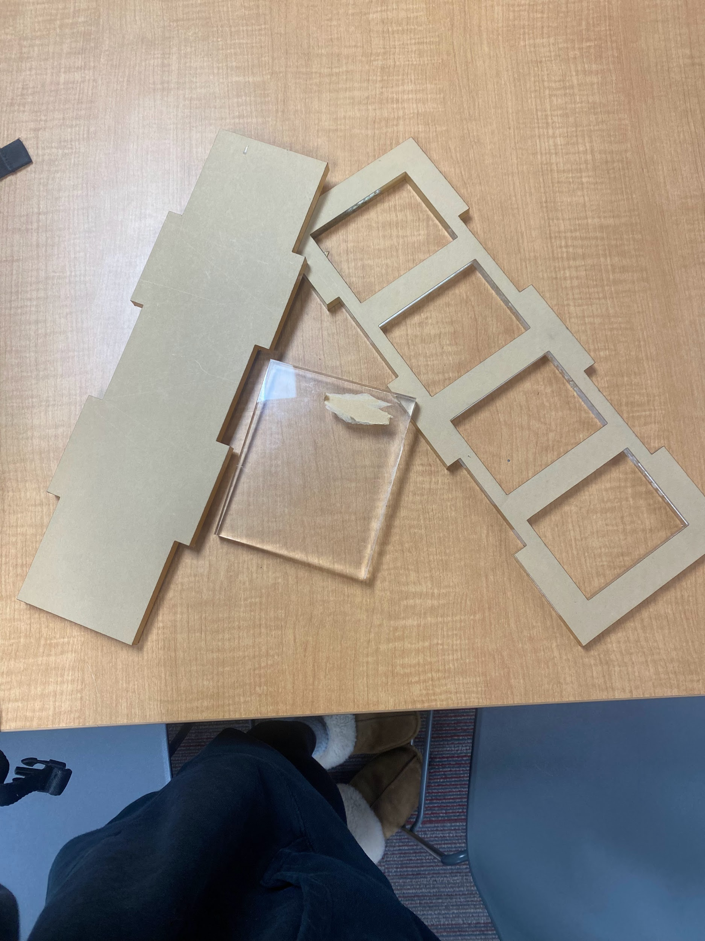
March 7, 2024 | - Laser pieces placed together to see design’s structure | 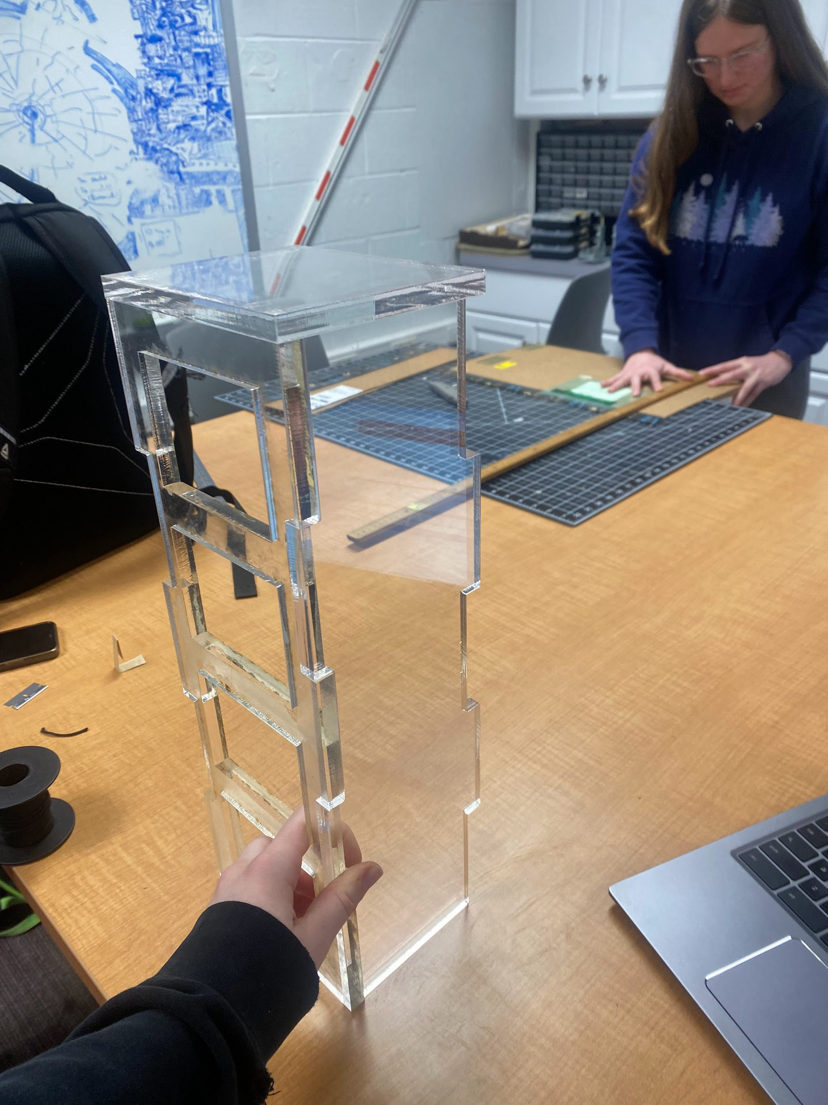
March 11, 2024 | - All pieces lasered  - Base construction being planned  - Arduino being replicated/copied | 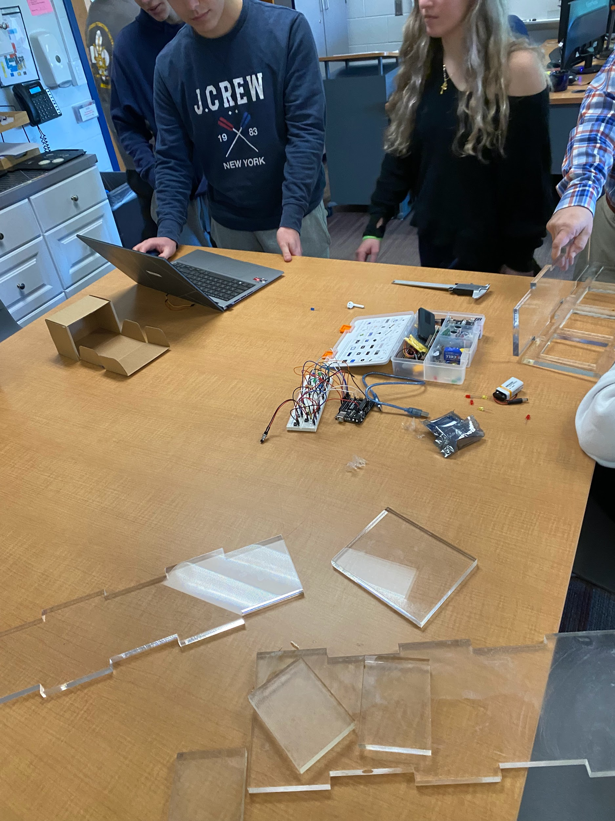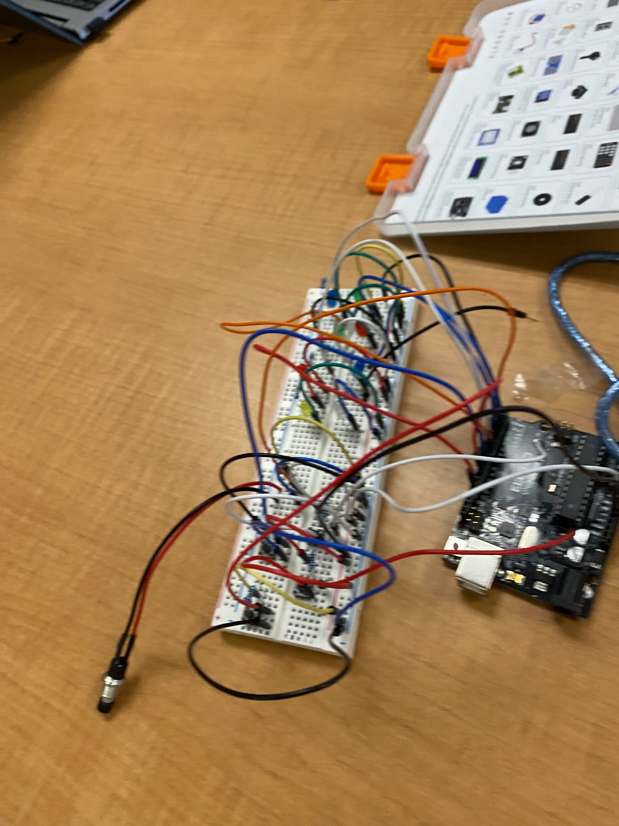
March 12, 2024 | - Measuring the device  - Designing a ledge for Adruino to sit on within the device | 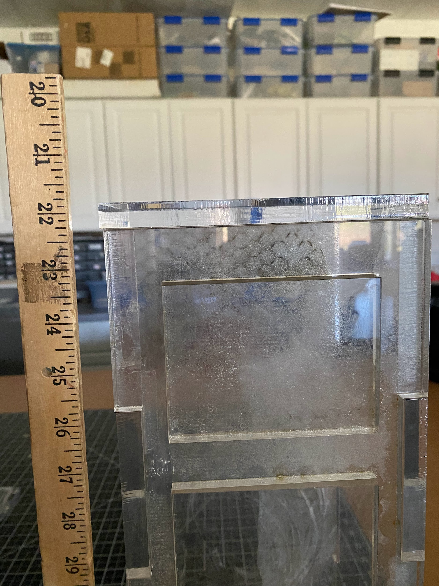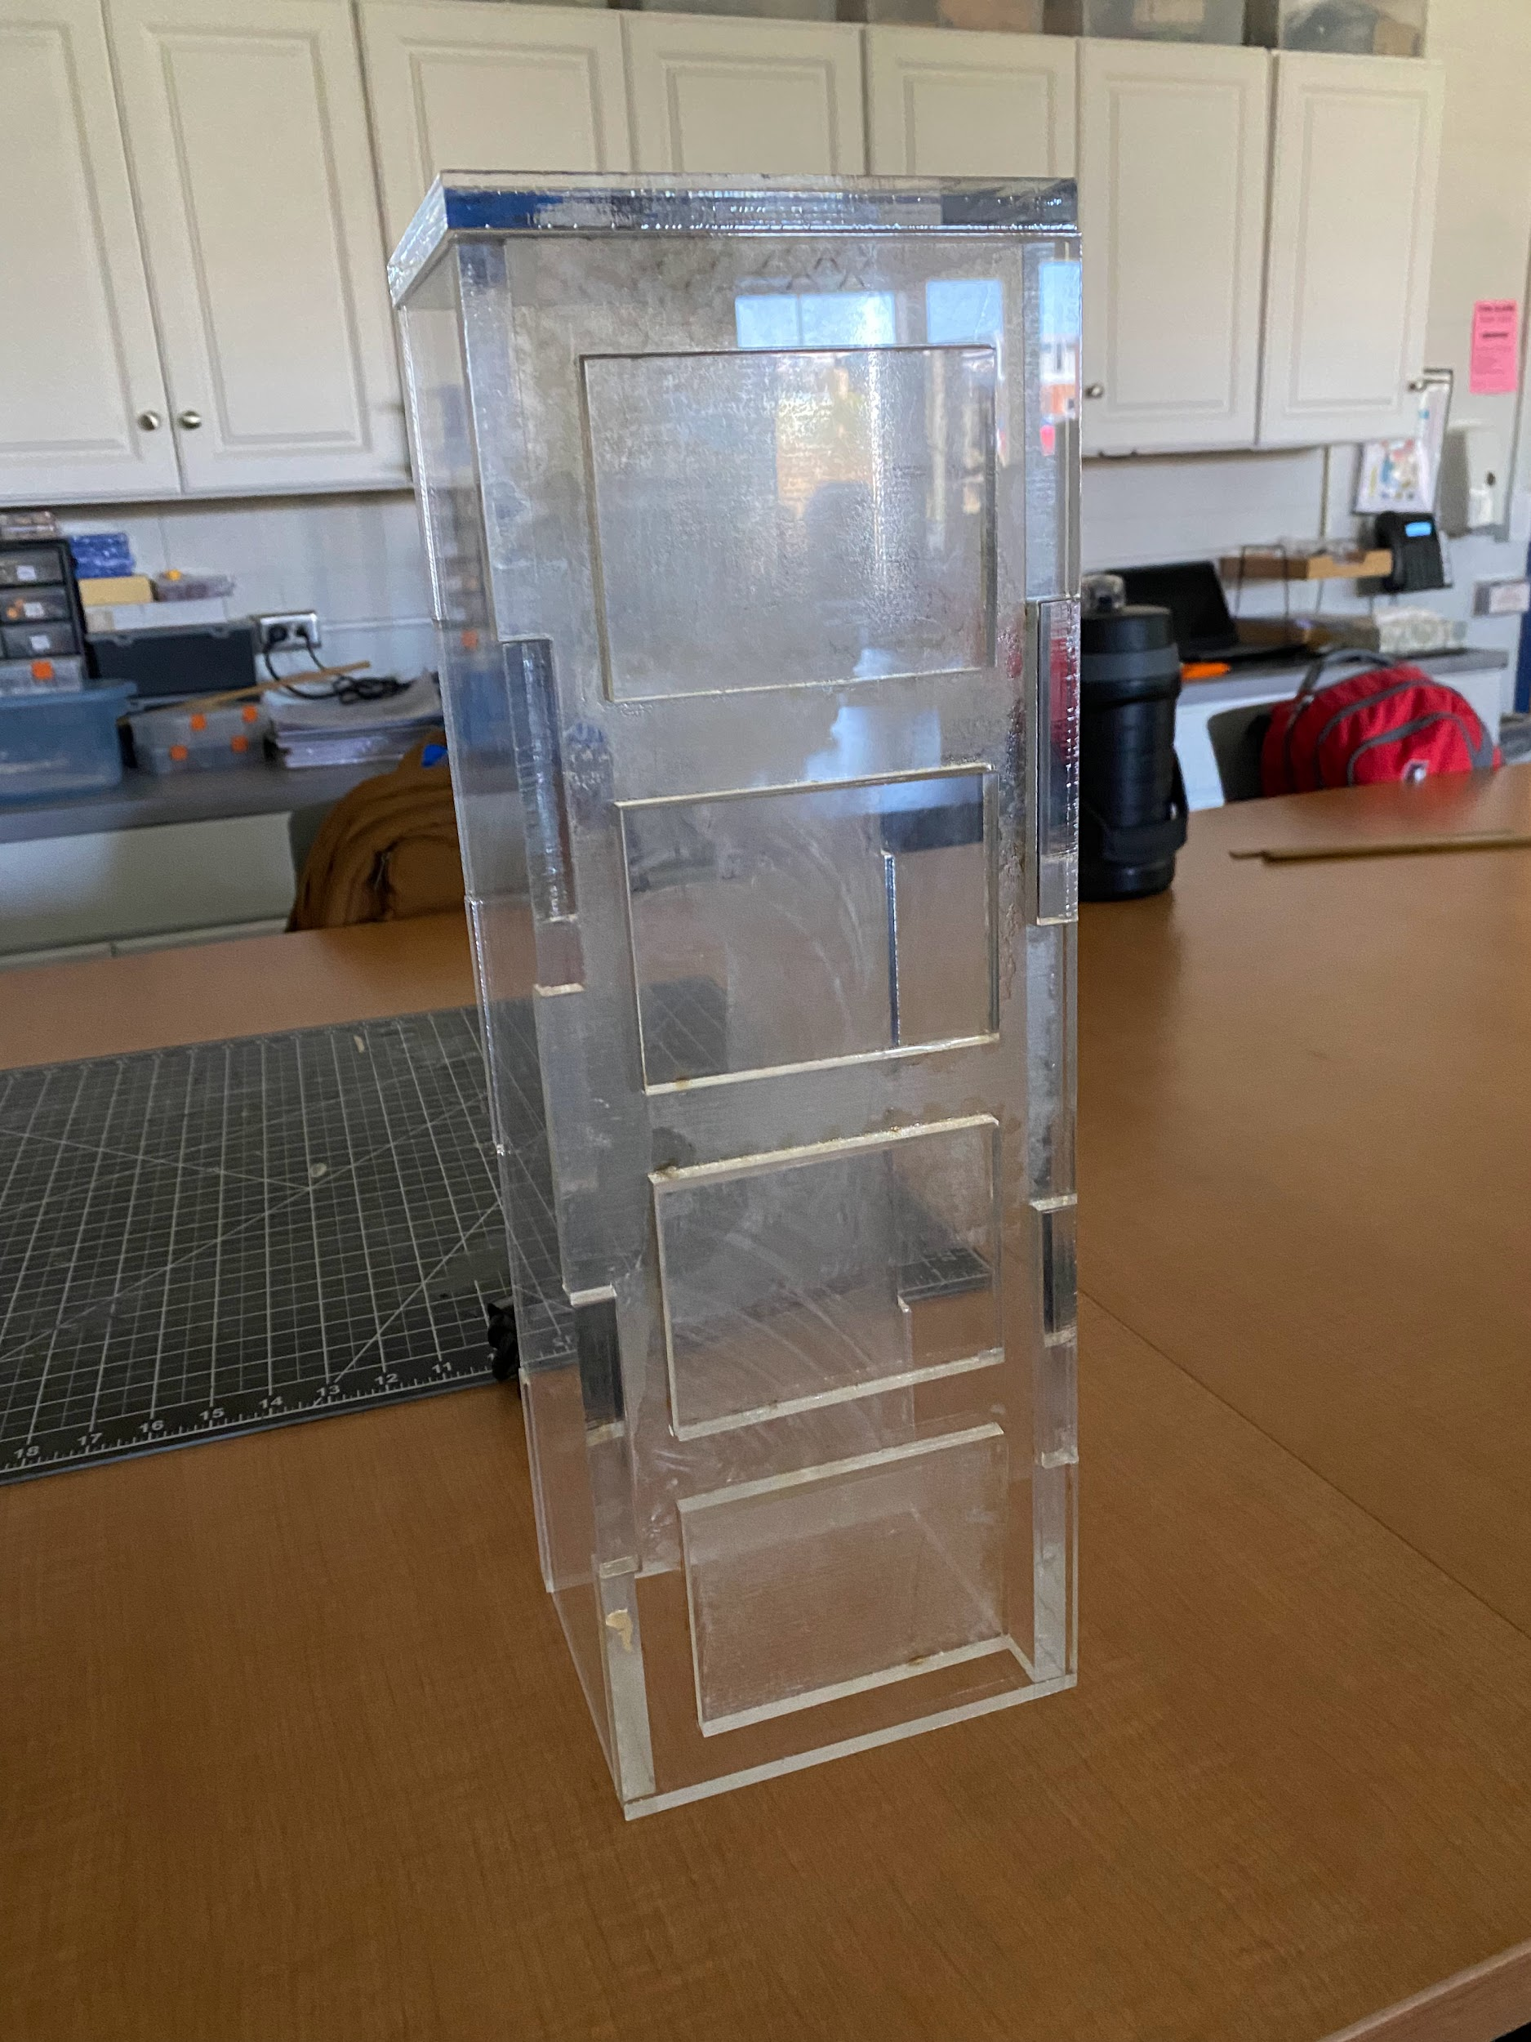
March 13, 2024 | - Starting a new code for the new light/cable that we are using for the reward | 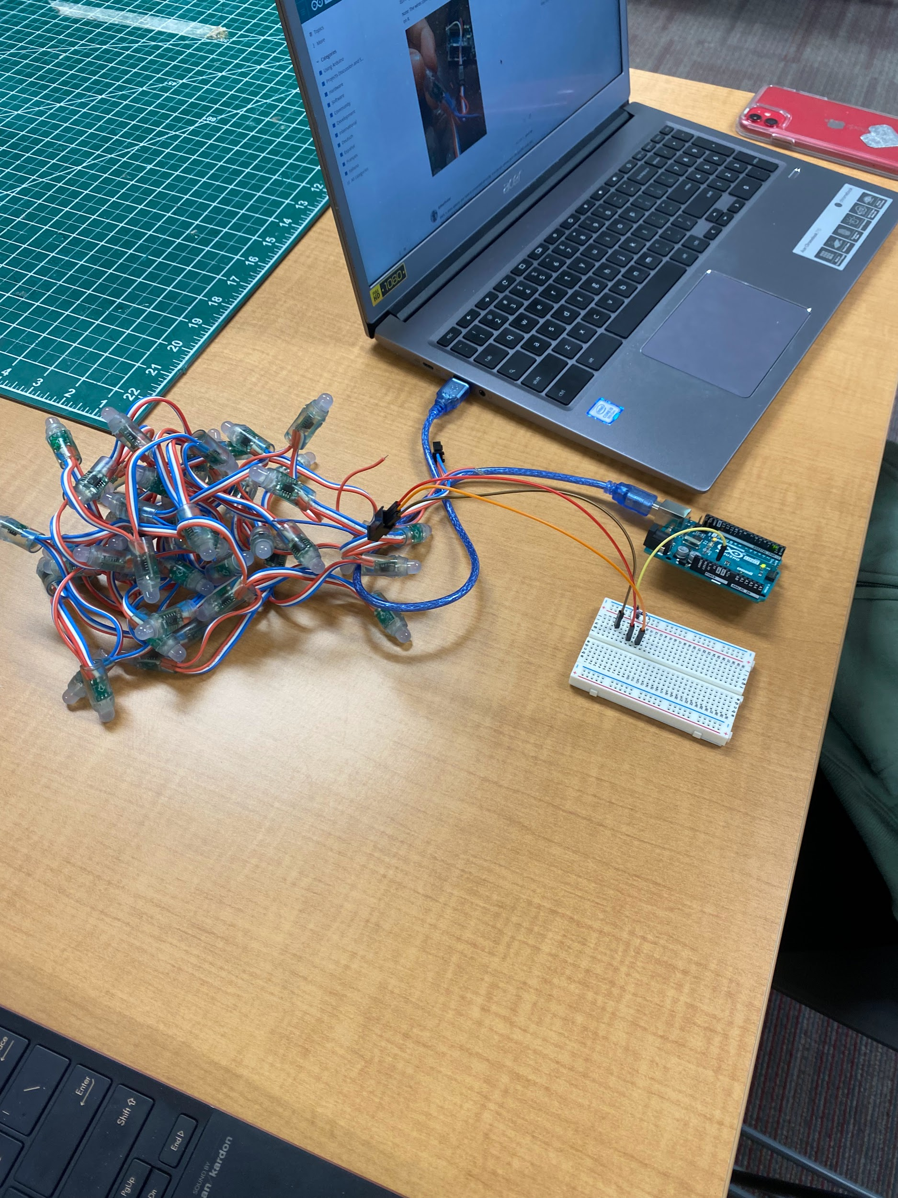
March 21, 2024 | - Back from senior trip, spring break takes over till april 21  - Working on visualize of our design  - Addressing issues with the code of the new light cables (Arduino)
April 1, 2024 | - New buttons arrived for our device  - Sanded and prepared all acrylic pieces to be painted  - Working on the coding for the new buttons | 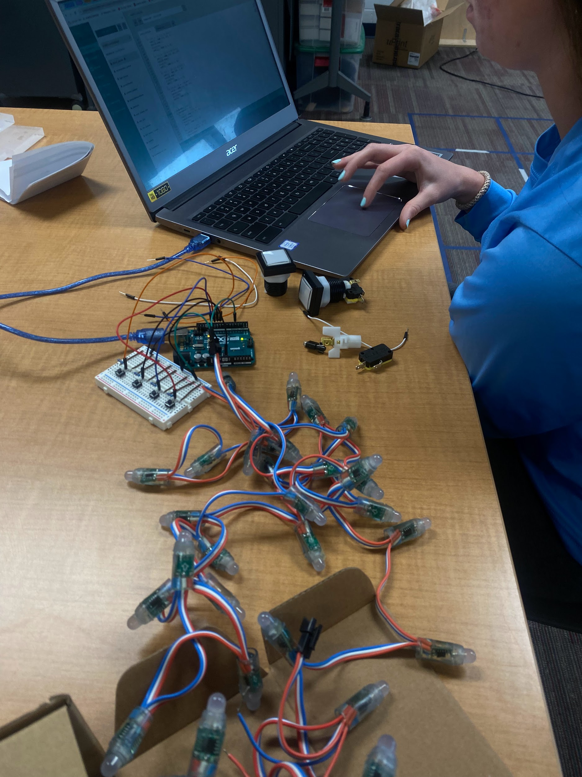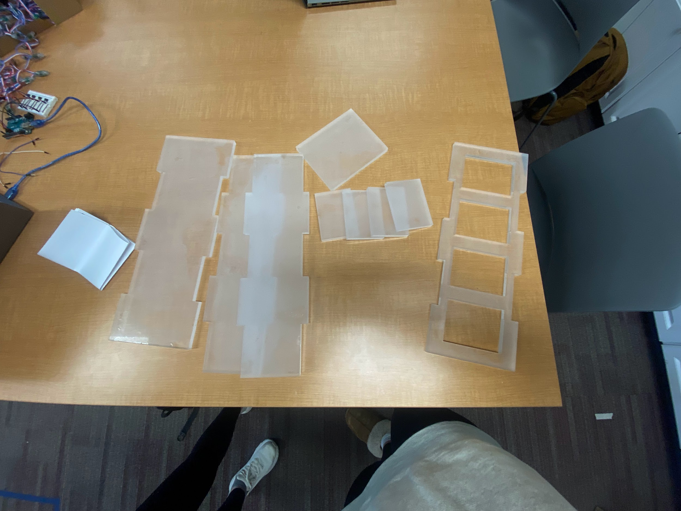
April 2, 2024 | - Experimenting with new buttons  - Cut out wooden piece that is going to be used inside the device to hold the buttons in place | 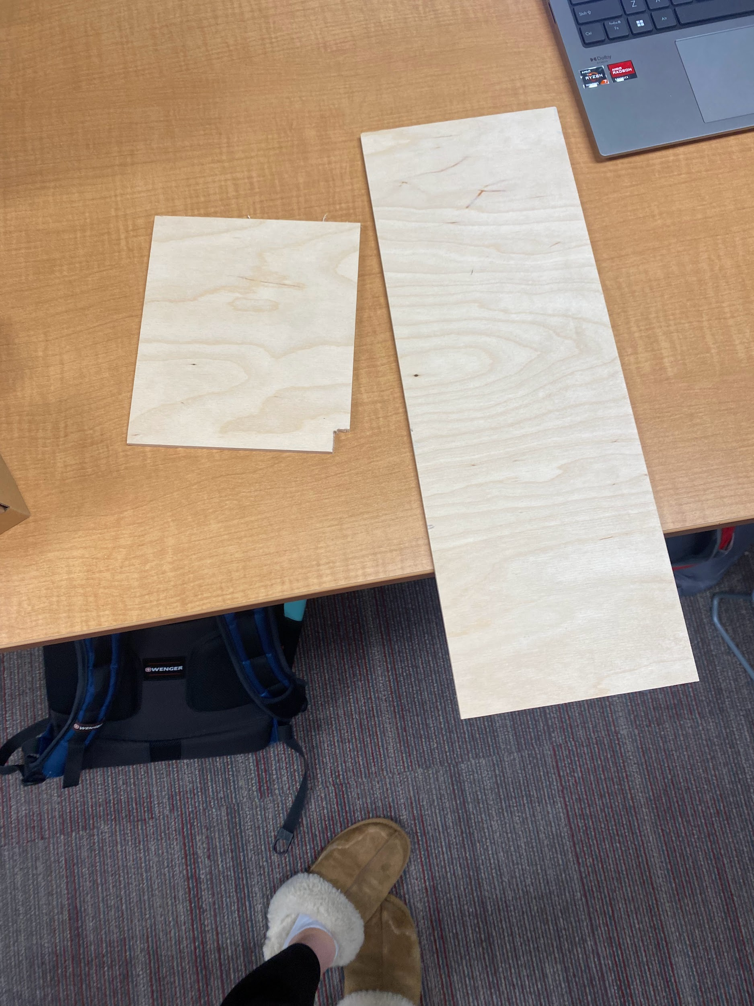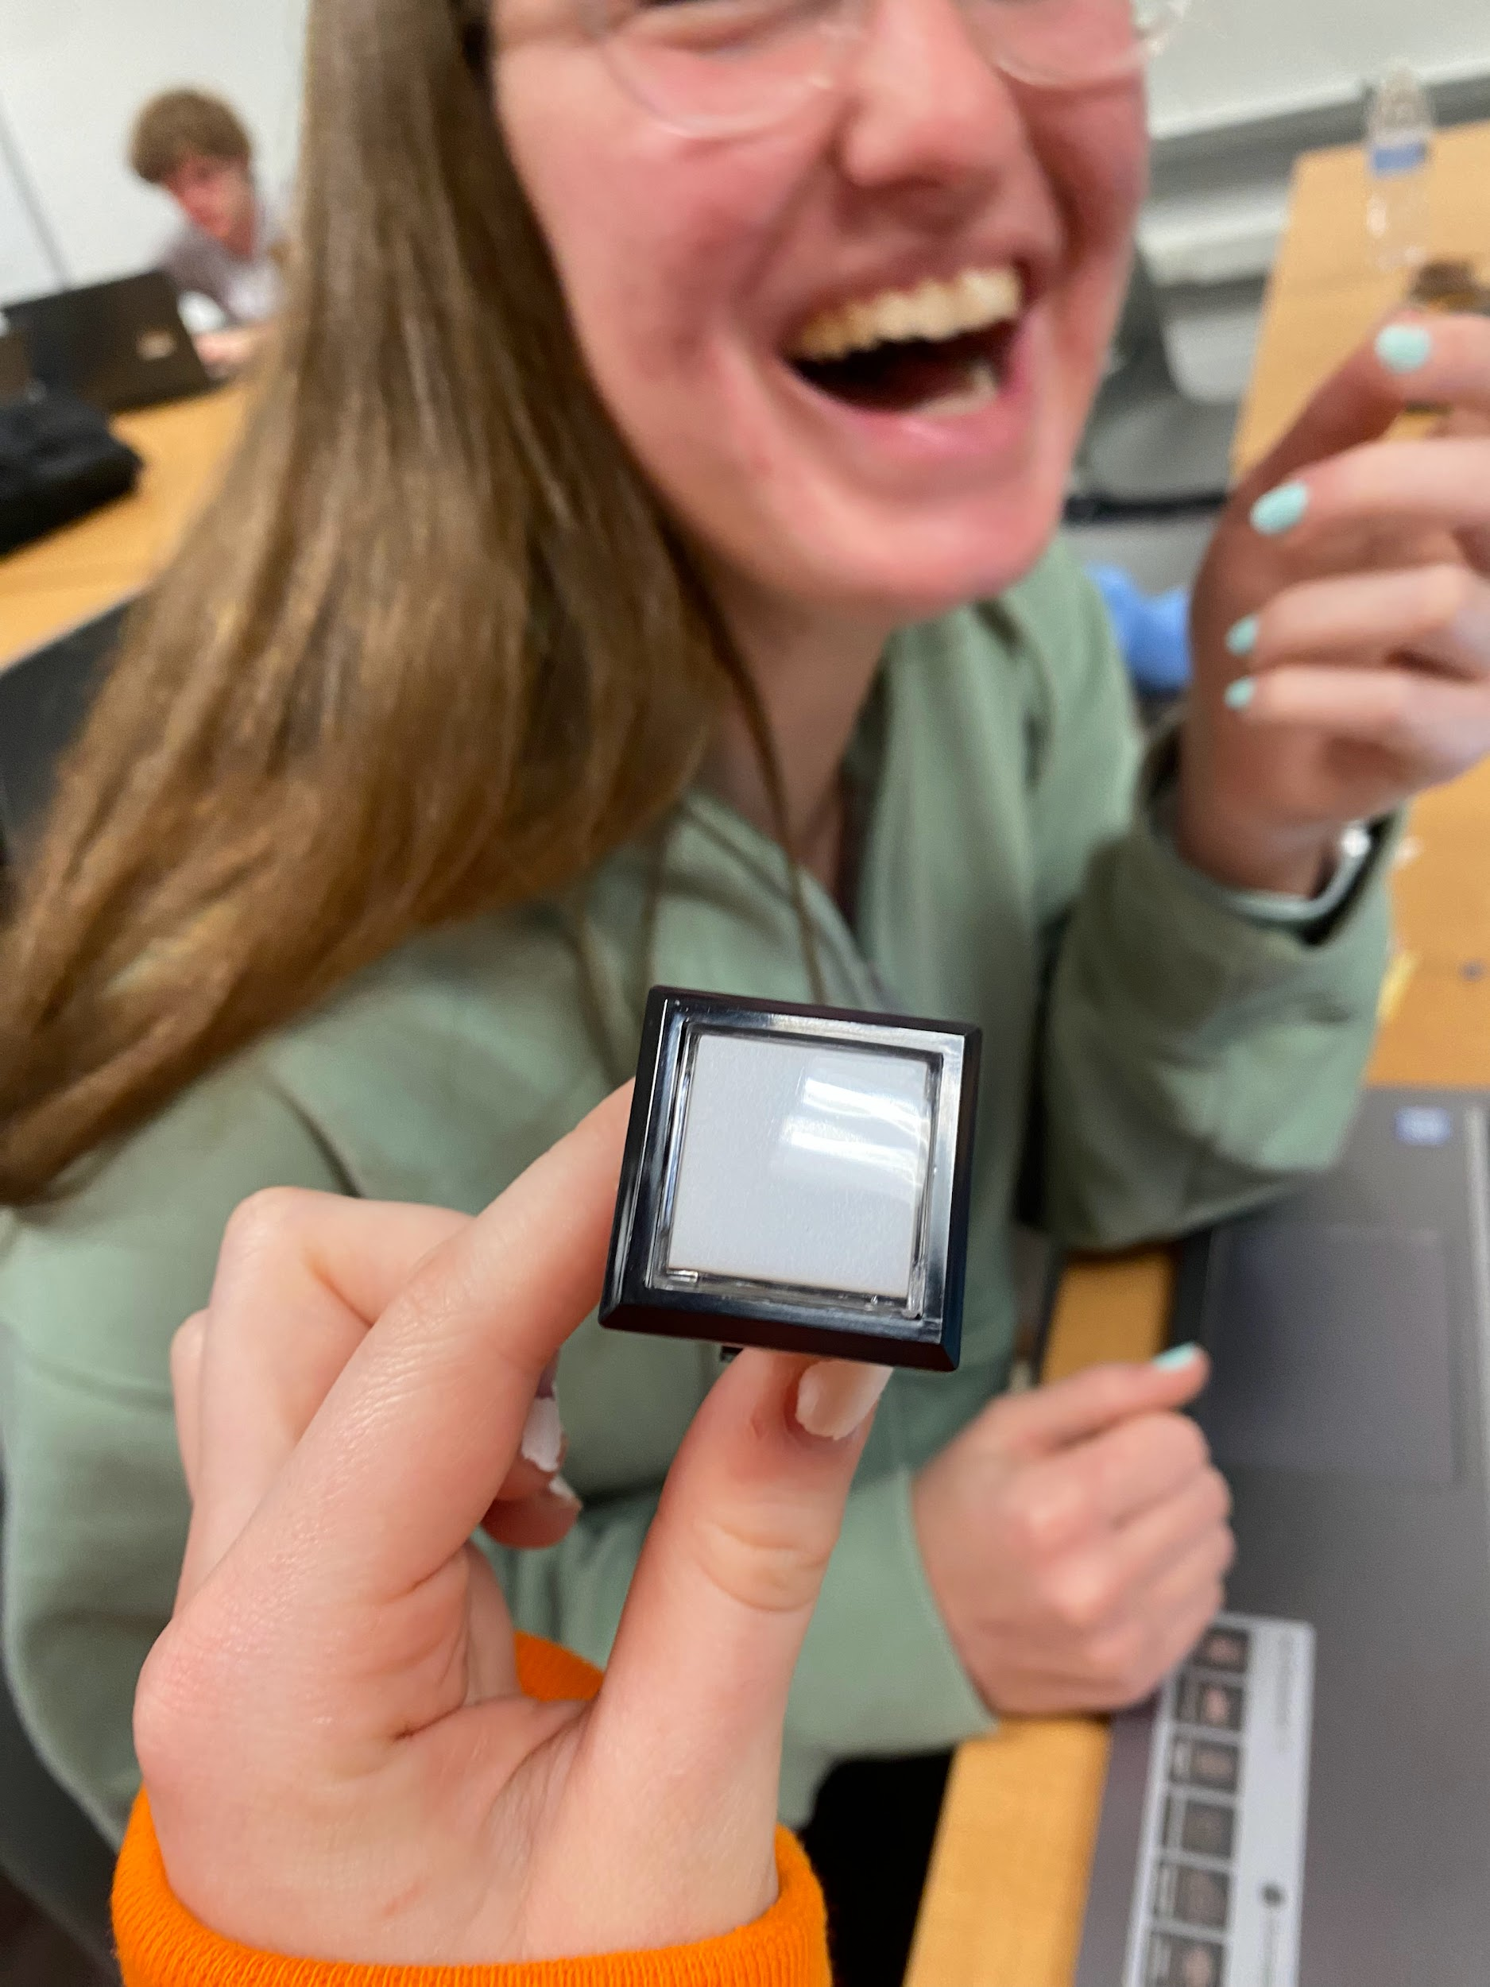
April 3, 2024 | - Soldered wires to attach the new buttons to the arduino
April 4, 2024 | - 2 team members absent, marked placement of light strand in arduino on front and back  - Consider how the external button will work with the rest of the device
April 8th - April 15 | - Created half-holes  (indents) in the  Acrylic glass that the  LED light strings will  thread through.  - This allows the lights to shine brighter  - We cut, sanded, and bent holes/curves into our project’s base to allow for arduino shelving | 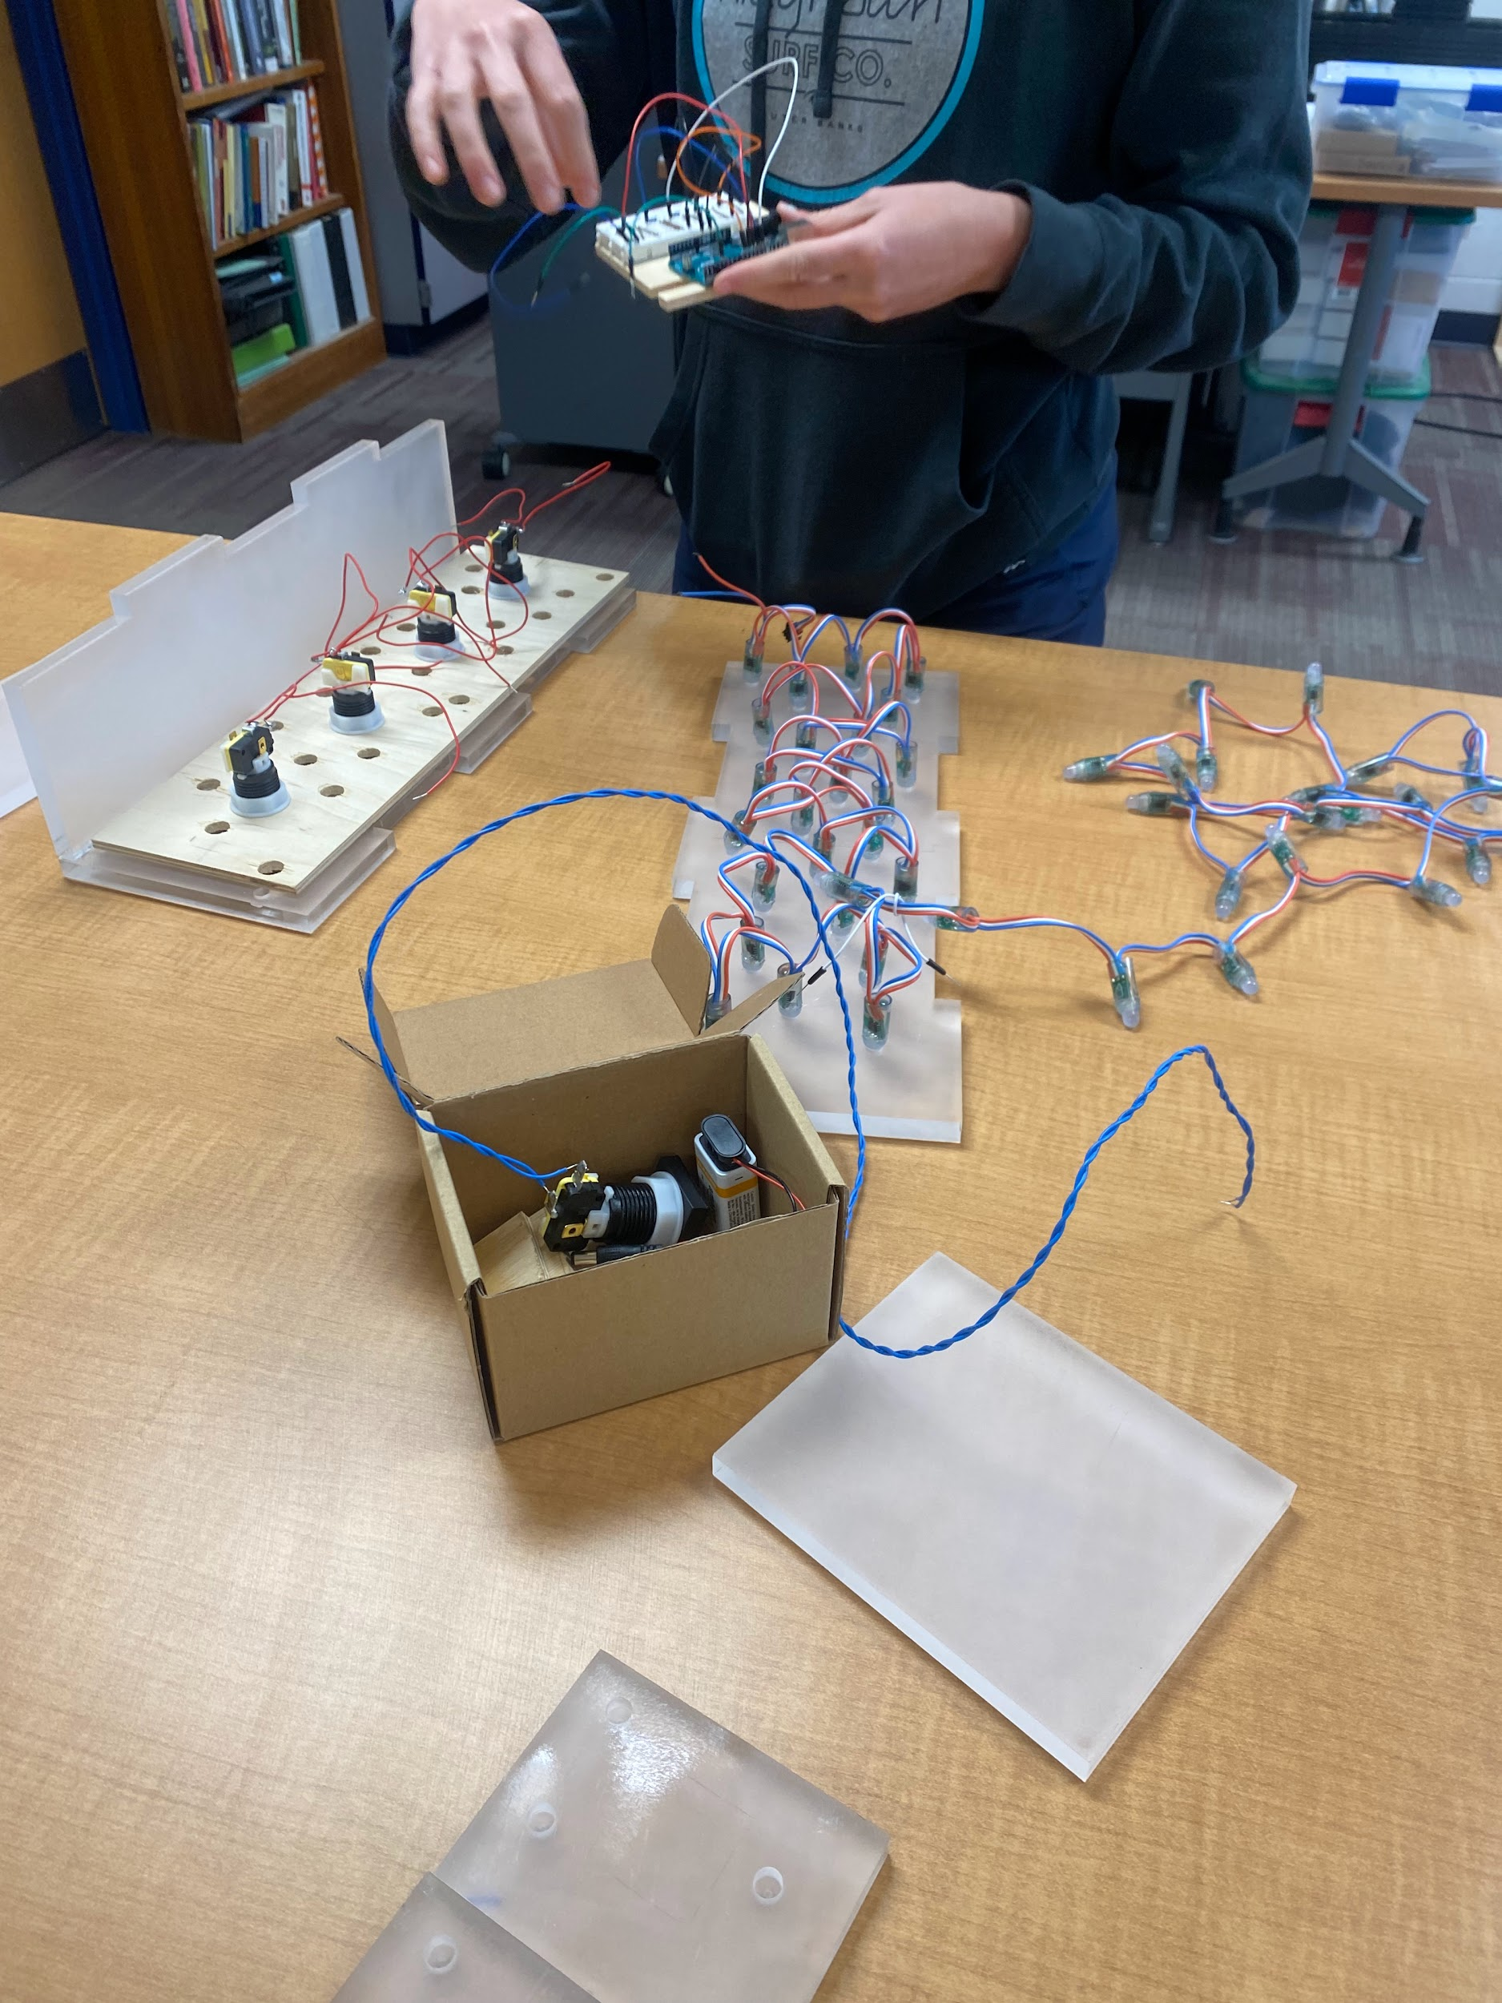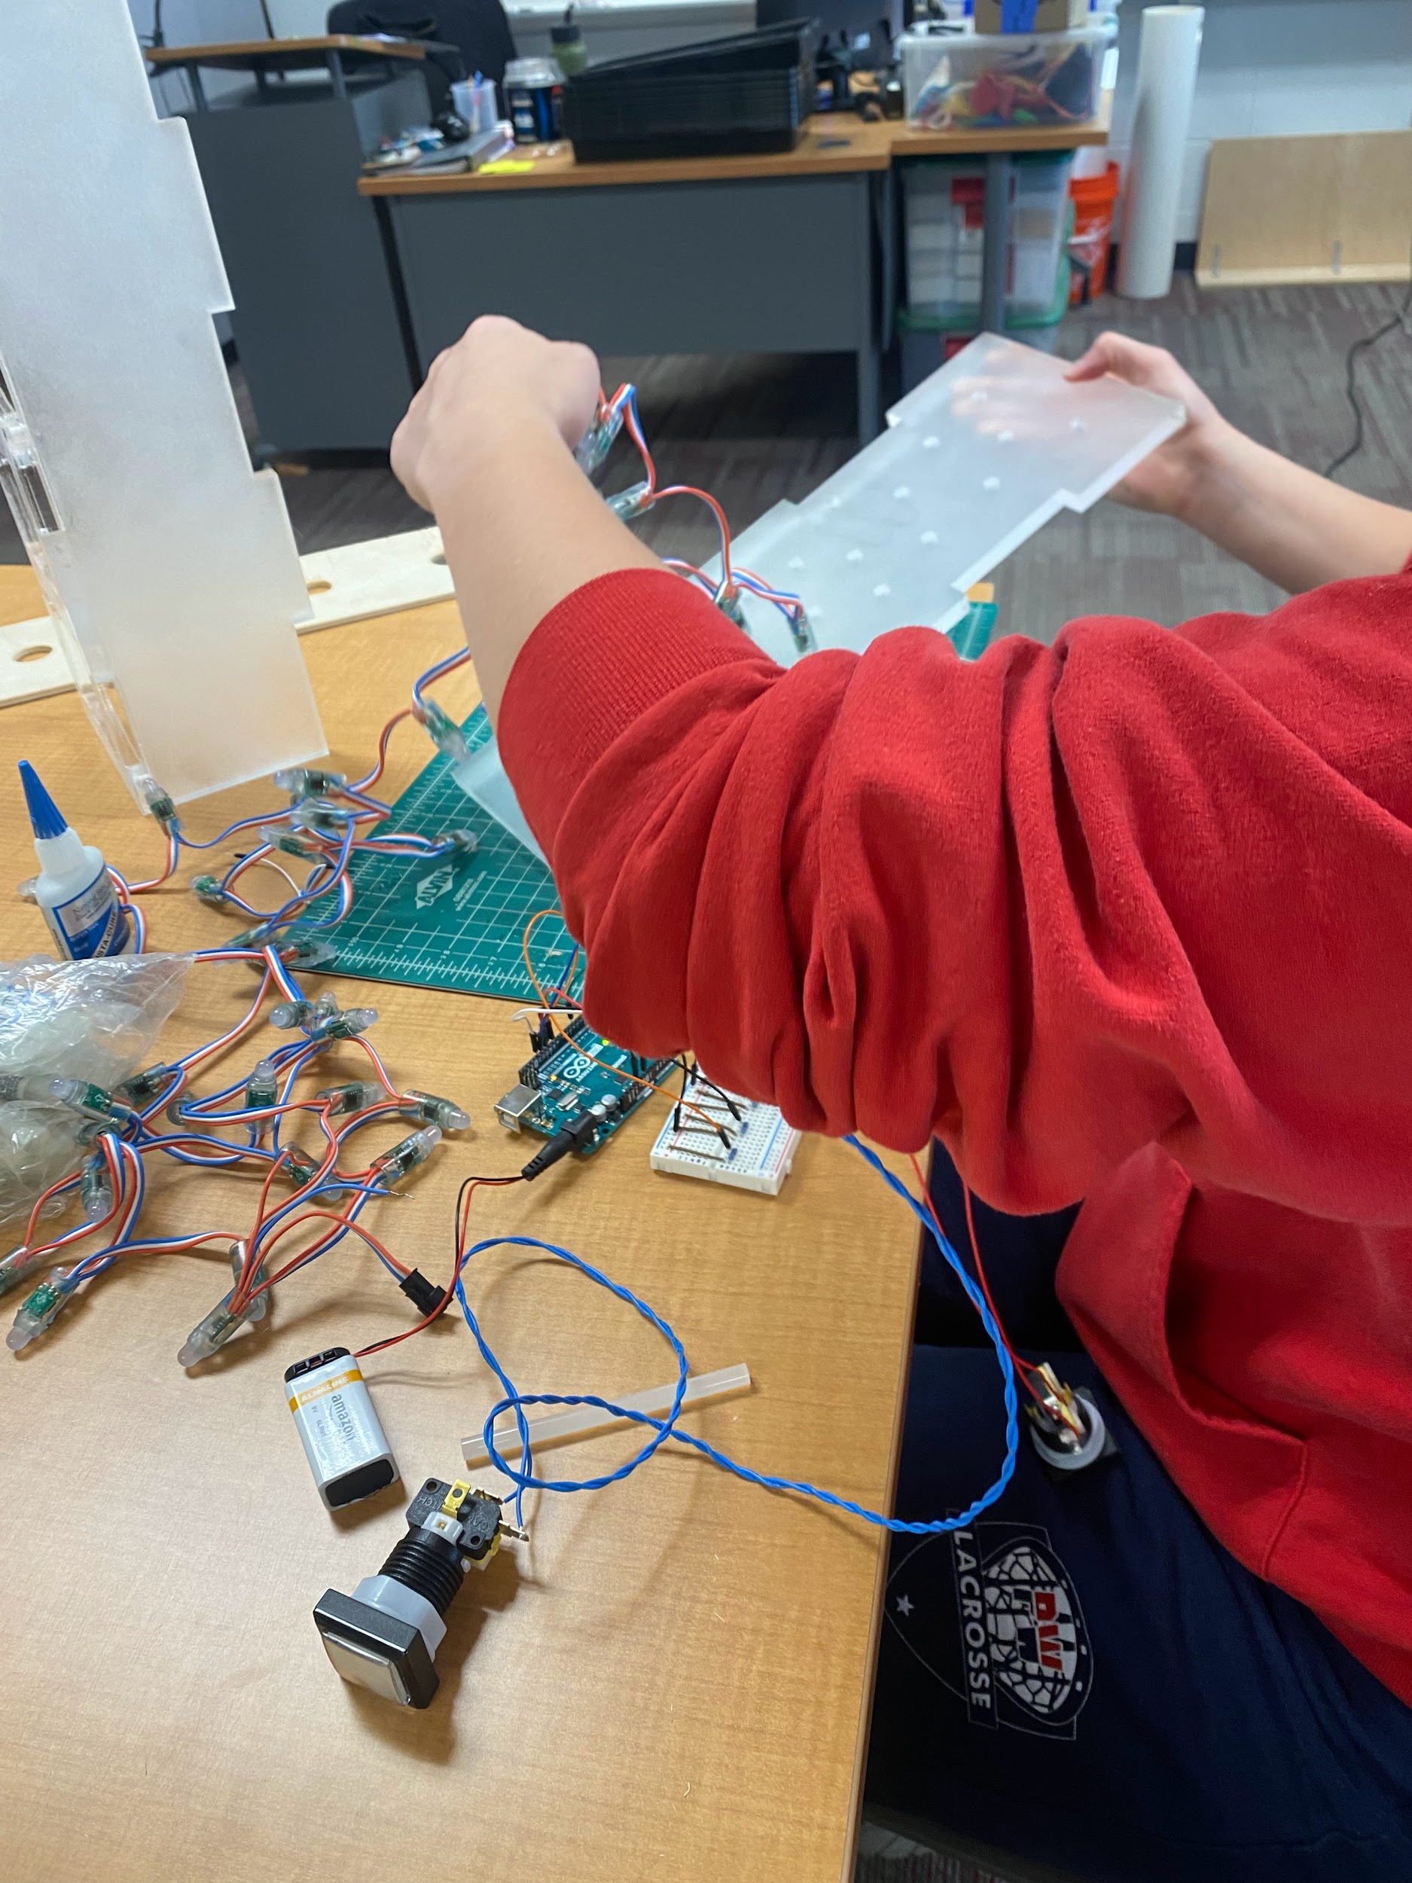
April 19, 2024 | - Device heading towards completion  - Putting all the completed parts together to finish the device | 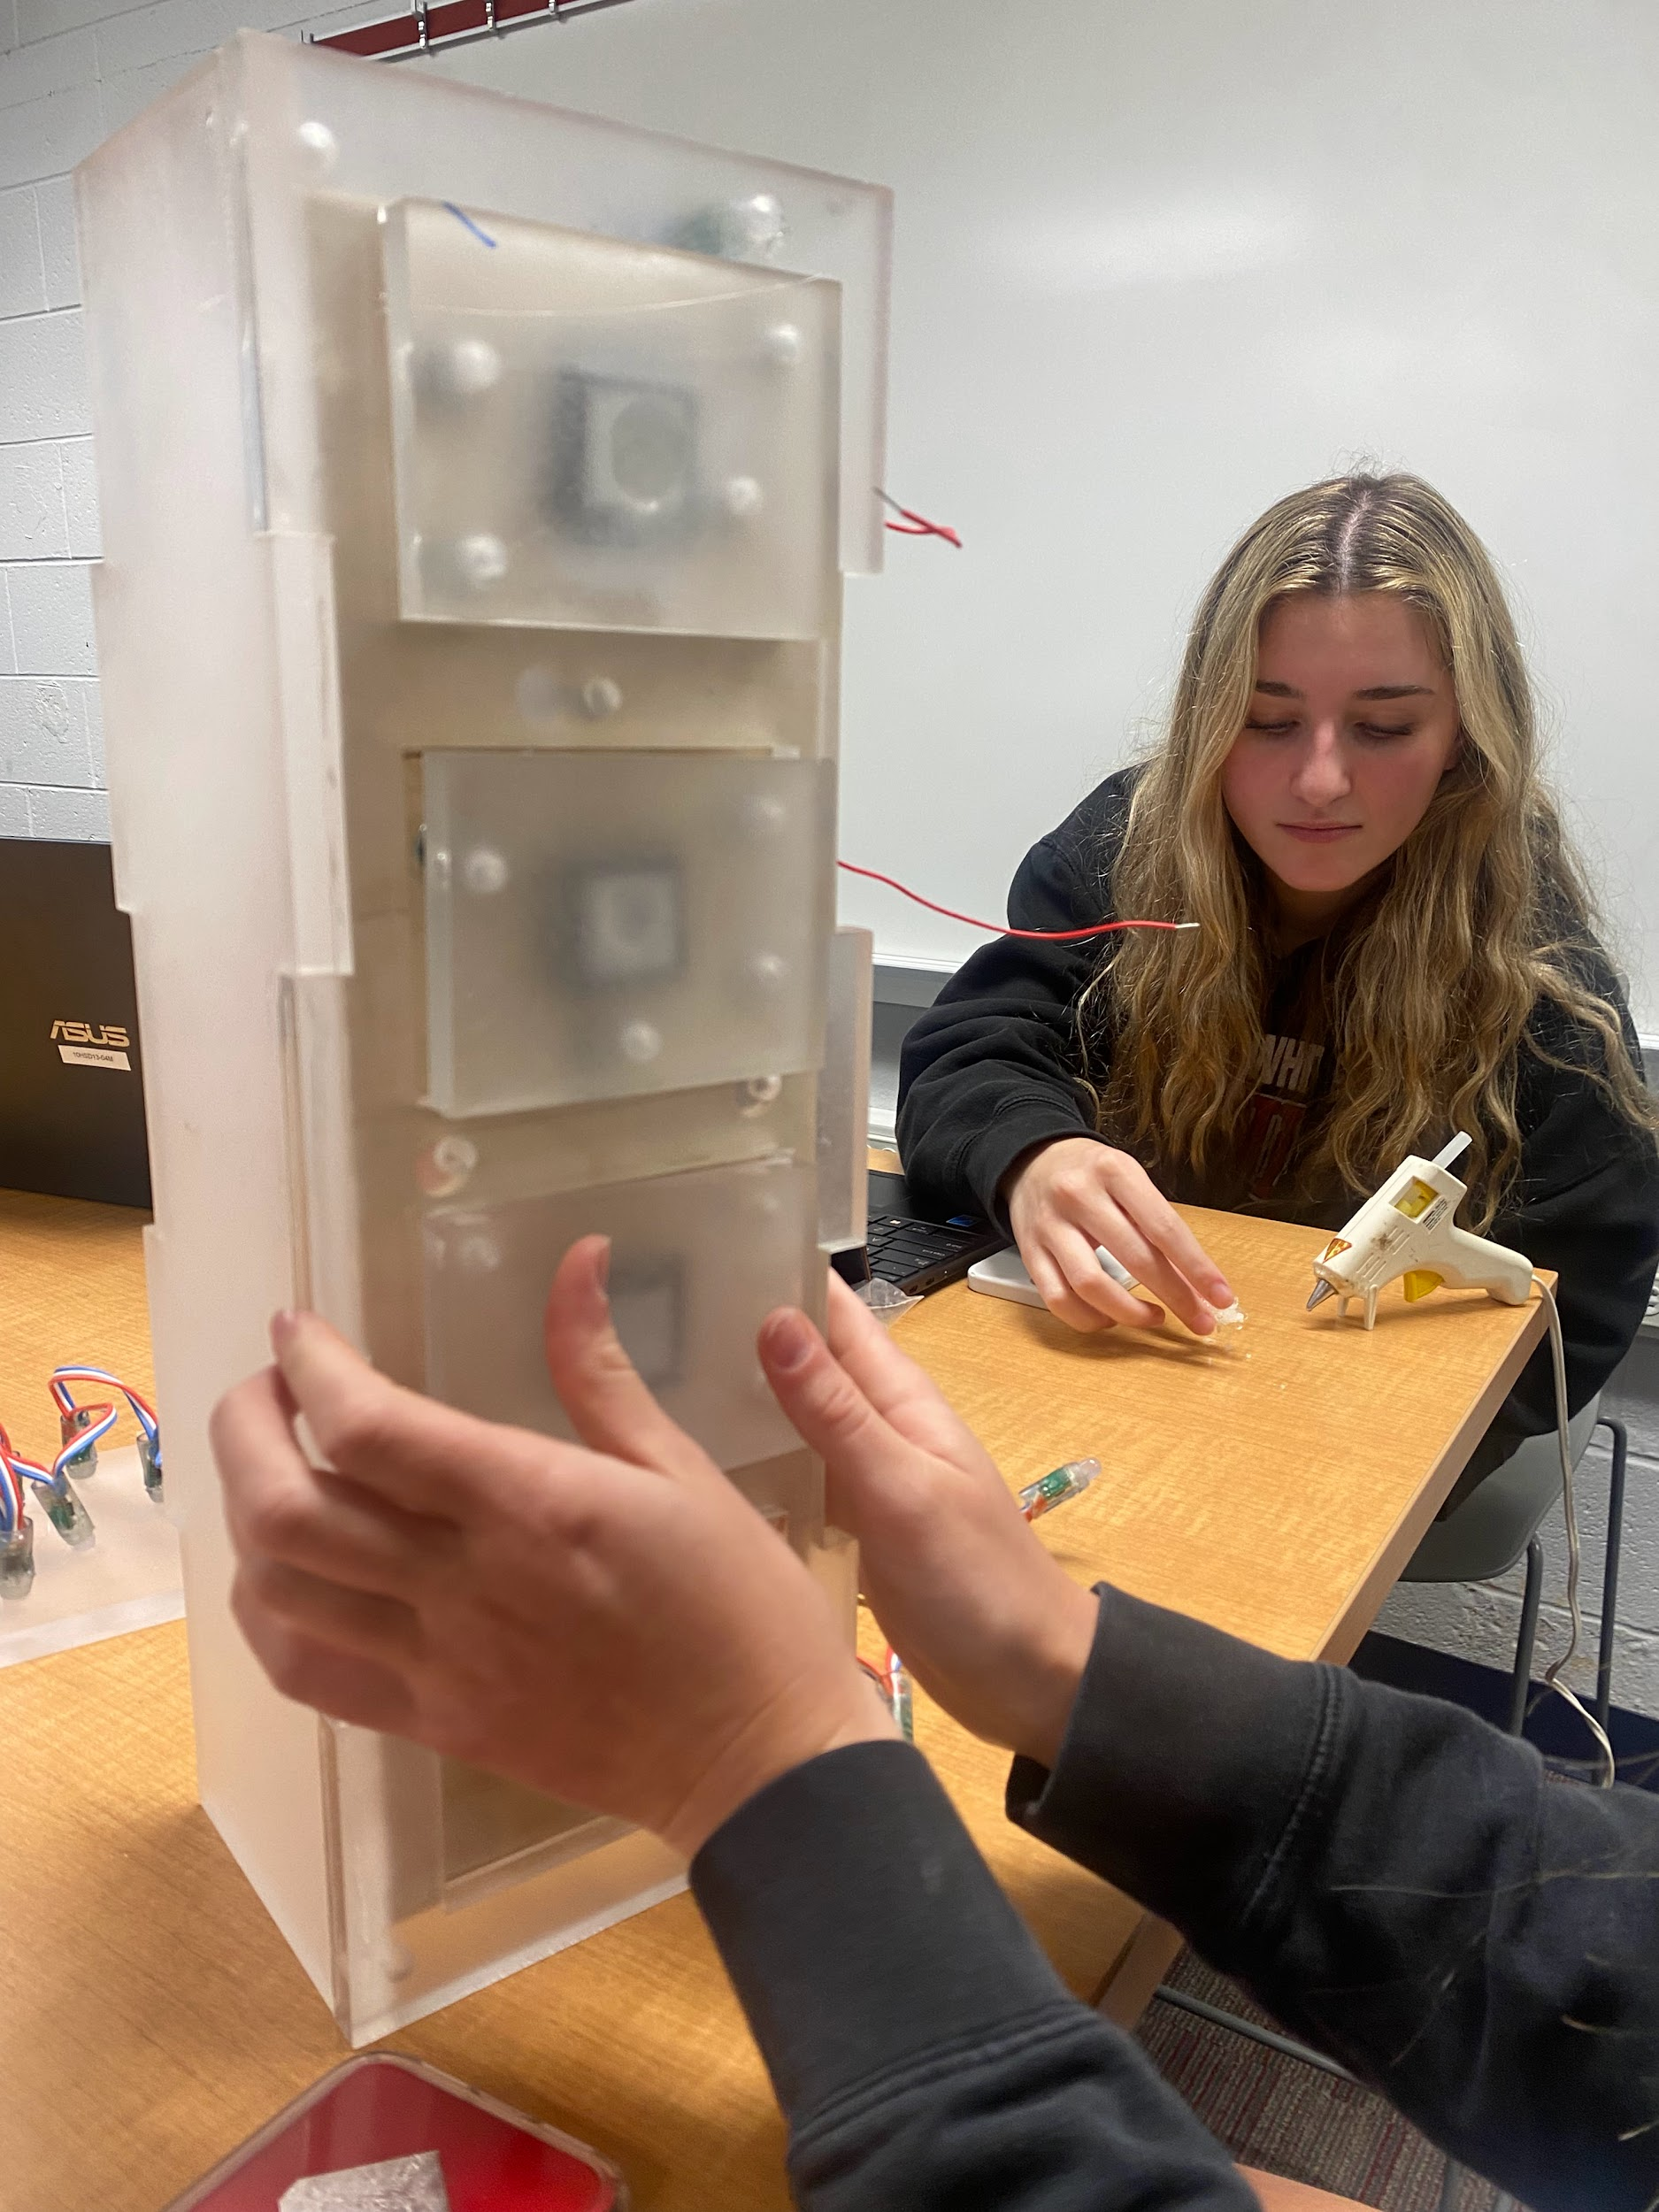
April 19 - Further | - Device Completed

In our original blueprint for the cause and effect design we included certain aspects that didn't end up making it into our final prototype iteration. When doing research on how different colors affect students efficiently in learning, we had originally decided in the initial prototype that painting our device was important in making sure it was engaging for the students. As our project developed we realized that different colors would make the device confusing and over stimulating for the children. By creating our device the neural color of white, it is still aesthetically pleasing and allows the incorporated LED lights to be more vibrant.
Another aspect of our original blueprint we decided to alter was changing the device from being slightly raised above its base. After completing the construction of our design, we realized the device had more weight than we had originally expected. To ensure the structure was secure, it ended up being more beneficial that the device was atop a firm, sturdy, and flat surface.

Final Prototype Material Details:
Material Details/Item Name: | Description: | Place of Purchase: | Cost per unit: | # of units: | Total Cost:
Acrylic Sheet | Semi-thin Sheet of clear Acrylic/Plexiglass | Engineering Workshop | $1.49 | 3 | $4.47
Wooden Sheet | Thin sheet of wood | Engineering Workshop | $2.18 | 1 | $2.18
LED Light String | String of LED lights connected and controlled by Arduino | Amazon | $14.95 | 1 | $14.95
Arduino Starter Set | open-source hardware and software single-board microcontroller | Arduino Company | $93.75 | 1 | $93.75
Buttons | Buttons used to activate Arduino | LED Illuminated Pushbutton - 30mm Square | $3.95 | 5 | $19.75
Total Cost: |  |  |  |  | $135.01

While constructing our final prototype our priority was to ensure that our design requirements were properly incorporated into the project. The requirements are that the device has a stimulating reward, educational value, is adjustable (buttons can be specialized for students), safe, and mobile. The stimulating reward is produced by the 50 LED lights connected to the Arduino inside, when this reward is activated, it can confirm an educational match from the student. The exterior of the buttons have velcro on their surface so different subjects are easily interchangeable by simply ripping off a previous sticker/image/letter and replacing it with a new one. The corner edges of the design are sanded to make sure that no student is going to be scratched or poked, and all electrical wires are properly controlled and not exposed. Lastly, we made sure the device was a manageable weight and when it needs to be moved an adult will be able to move it.

In our initial design, an attribute that was called for was buttons that are able to be pressed to create the reward of lights. The light reward encourages the student to learn and memorize the correct educational matches. In our final prototype the idea of buttons stayed similar to what was proposed in the blueprint. The arrangement of how the buttons are pushed was altered so that they are able to be more easily clicked by students with motor issues. We found it necessary that the buttons were spaced equal distances away from one another, and made their top surfaces wide (3” by 4”). There are 4 buttons; which was the recommended amount from Ms. Brennan, the Whitemarsh Elementary teacher we are working with. The efficiency of the buttons was tested by pressing two of the matching pairs, seeing if they click down, and if the light reward followed the physical action. The buttons passed the test and are able to adequately aid a student with his or her learning. Materials used in the project are mouth safe and non toxic, they are also easy to clean and sanitize between uses by simply spraying and wiping them down. The individual pieces of the device are secure and all the wiring is kept within the design, this was tested by using our device multiple times to test its durability. Despite the complexity of the design, it was important that it was mobile and could be picked up by an adult. We could test this attribute by asking fellow classmates to pick up the device and move it without fail.

After considering all design attributes, we concluded that there is nothing “un-testable” or unable to be physically prototyped or mathematically modeled within the scope and limits of our classroom.

