GPTScorer – Element C Scoring Application
This repository contains the validated scoring application for MyDesign – Element C (Presentation and Justification of Solution Design Requirements).

The system uses deterministic GPT-based evaluation combined with post-processing calibration to generate rubric-aligned sub-scores (C1–C6), a calibrated element score, and structured narrative feedback suitable for educator review.

The application supports both:
Current documents (2025–present)
Legacy documents (pre-2025)

This release represents a validated and stabilized baseline following model drift testing and calibration alignment with expert scoring.
System Architecture
The Element C scoring pipeline follows a consistent structure:
Student Document
↓
GPT Model (Deterministic Prompt, temperature=0)
↓
Structured JSON Output (C1–C6 + rationales)
↓
Raw Element Score (mean of subscores)
↓
Mode-Dependent Calibration
↓
Narrative Feedback Generation
↓
UI Display or CSV Output
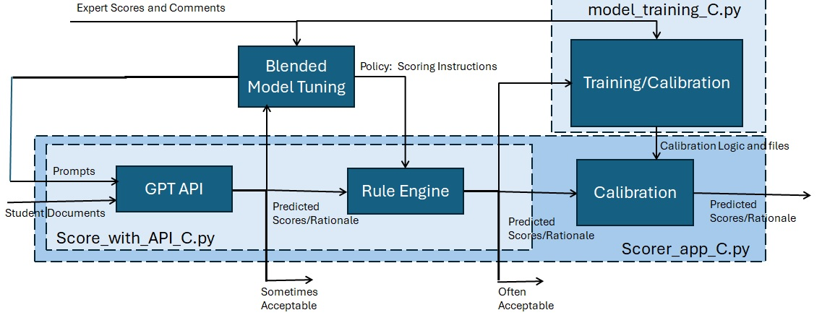

SYSTEM BLOCK DIAGRAM
This block diagram illustrates the general system flow for each element model. Element C does not use the Rule Engine or lightweight ML training model; therefore, related files are not included in this repository. Element C uses a simple linear model for calibration.

Key Design Principles
- Deterministic evaluation (temperature = 0)
- Strict JSON parsing
- Mode-specific calibration
- Transparent bias correction
- Narrative feedback for instructional value
- Drift monitoring capability (in progress)

Modes
Current Mode
- Uses latest validated GPT model (see scorer_app_C.py)
- Calibration: linear or intercept correction depending on validation results
- Designed to align with expert scoring on recent Current documents
Legacy Mode
- Uses GPT model validated for Legacy documents
- Applies fixed bias offset:
LEGACY_BIAS_OFFSET = 0.72
- Ranking stability validated against expert scoring
- Intercept-only correction (no slope scaling)

Running the Application
1️⃣ Environment Setup
Python 3.10+ recommended.
Install dependencies:
pip install -r requirements.txt
Set your OpenAI API key:
set OPENAI_API_KEY=your_key_here
(Or use environment variables in your system.)

2️⃣ CLI Mode
score_with_API_C.py can be used to score documents and generate both raw GPT outputs and calibrated scores. The app scores documents in an input directory:
cd c:\GPTScorer_Element_C
python -m elements.element_C.score_with_API_C ^
--folder elements/element_C/current_api_scoring_documents ^
-- elements/element_C/scored_results.csv ^
--blended-model v1.15
Supported models:
- v1.15 → Current
- v1.13 → Legacy
scored_results.csv include the following for each document scored:
- Metadata
- C1-C6 raw API scores
- C1_api – C6_api scores through rule engine (rule engine not used for Element C)
- C1-C6 Flags used internally
- C1-C6 Bulleted rationale
- Narrative rationale

3️⃣ UI Mode
Scorer_app_C.py is the backend. Scripts.js and index.html are the frontend.
cd c:\GPTScorer_Element_C
uvicorn elements.element_C.scorer_app_C:app --reload

Then open the local server in your browser, http://127.0.0.1:8000/.
UI Features:
- Upload documents
- View calibrated C1–C6 scores
- View narrative feedback
- Download CSV results
The UI mode can be used to upload one or more documents for scoring through the API or alternatively, a csv input file that includes previously scored data from the score_with_api_C.py app. The csv input file includes:
- Metadata for each document row
- C1_expert – C_expert scores
- C1 – C6 scores output from score_with_api_C.py
- C1 – C6 flags from score_with_api_C.py
- C1 – C6 bulleted rationale from score_with_api_C.py
- Narrative rationale
- Element_score_raw, the average of the api scores
Whether uploading a csv file or document files, the UI output is sub-element scores and narrative rationale. A downloadable csv contains the following outputs:
- Filename
- C1 – C6 outputs from score_with_API_C.py (aka C1_api-C6_api)
- C1_final – C6_final calibrated scores for output
- element_score_raw
- element_score_calibrated
- calibration_delta
- C1 – C6 flags
- C1 – C6 bulleted rationale
- Narrative rationale

Calibration Philosophy
Calibration is applied after raw GPT scoring, because large language models may:
- Drift slightly over time
- Shift scale upward or downward
- Compress certain score ranges
Instead of rewriting prompts repeatedly, we apply:
- Intercept correction to offset bias (Legacy)
- Linear correction to offset bias and adjust variance (Current)
This maintains:
- Rank stability
- Interpretability
- Alignment with expert scoring
Calibration values are derived from validation against expert-scored samples.

Narrative Feedback
Each document includes a narrative paragraph that:
- References specific C1–C6 scores
- Explains strengths and weaknesses
- Provides improvement guidance
- Uses educator-friendly language
This is intended for teacher-facing use and instructional support.
Sub-element rationales are preserved in CSV output for diagnostic review.

Drift Monitoring (Planned)
A “Check Saved Results” feature will allow:
- Comparison of new scoring runs to a saved baseline
- Detection of mean shifts
- Subscore drift analysis
- Rank stability monitoring
This ensures ongoing model reliability.

Repository Structure
root/
│
├── core/
├── elements/
│ └── element_C/
│ ├── score_with_API_C.py
│ ├── scorer_app_C.py
│ ├── Current_GPT.csv
│ ├── Legacy_GPT.csv
│ ├── current_api_scoring_documents/
│ └── legacy_api_scoring_documents/
│
├── scripts/shared/utils.py
├── simple_ui/
├── requirements.txt
└── train_env_setup.bat
Training scripts, model artifacts, and experimental calibration files are intentionally excluded from this release. This element is not currently using lightweight ML, having opted for the linear calibration technique described above.

Validation Summary (Element C)
During validation against expert scoring:
- Rank correlation (Spearman) remained stable
- Within-one agreement > 90%
- Bias controlled through intercept calibration
- Narrative feedback reviewed for educator clarity
Note: Validation sample sizes are moderate; future re-baselining will use expanded Current document sets.

Known Limitations
- Small validation sample may cause ICC variability
- GPT models may drift over time
- Narrative feedback is AI-generated and should be reviewed before formal reporting
- Calibration values may require periodic adjustment

Future Work
- Rebaseline with expanded Current document corpus
- Align Element A and D with this architecture
- Implement drift monitoring comparison tool
- Improve narrative feedback consistency

Contact / Internal Use
This repository is intended for instructional review and internal evaluation.
For questions regarding calibration methodology or validation metrics, contact the project lead.

