The problem that we are trying to solve currently is making a space to store the mojigangas. The mojigangas are important because they are a part of hispanic heritage night here at kent islam high school it represents the hispanic students here and shows others their culture. This problem matters and needs to be solved because the mojigangas take a while to make and we want to keep them safe to be able to use when hispanic heritage day comes around. This causes other problems at the school because since there is no space to store them they may be taking up space since they are out in the hallway for display. The stakeholders are Mrs Lopez Miller and Mr Jody Ward. They want us to be able to make a display case to have the mojigangas in a safe space where they can be put anywhere for display and they want them to have easy access to.

The First stakeholder is Mrs Lopez Miller. She is looking for a stylish place to be able to store the Mojigangas in the school that doesn't take up space and that can be stored anywhere on display. She wants them not to get dusty and for the display to be safe and durable so they don't break when moving. She also wants them to have easy access to the people that have to warn them. The second stakeholder is Mr Jody Wad he wants the display to be able to fit into doors and to be able to fit both of the mojigangas so they don't take up that much space. He also wants them to be able to fit anywhere and be able to be moved so the display should have wheels on them and be durable just in case it falls or anything while in the moving process. Their job is to be able to make a display to fit their requirements.

The process as a class is going to take a few but first we are going to measure the doll to see how big the display needs to be and we need to see how tall the door is to make sure that the display will be able to fit through the door somehow. Then in our group we are going to make the dolls themselves to see how they are built and after we will all start planning a display for the dolls then pick which one we will think is the best and start building it making sure it fits all the requirements and we are going to have to have good communication skills for this project so we all can be on the same path while doing it. We are also going to have to make sure that the stakeholders like the display we are thinking of and see what we can get with the budget that we are given by the school to make it. As a class we are all going to take a part in building this display for the school and figuring it out together . During this process it's going to take a lot of teamwork skills like good communication and listening skills so that we can understand what everyone is thinking of. As a result we should have a complete display for the dolls.

Large puppet displays and storage are important because it provides a space where the puppets can be safe and not get destroyed and to keep them from piling with dust. The designs have helped the puppets because it helps them last longer. Some challenges that may occur while building these large displays are materials. You may not have enough money to get enough materials and you may also not be able to find the right strong materials or the puppets to be safe while in storage. Another challenge is finding the right climate for the puppets because they want to be stored in a dry climate and not near the sun because it can cause damage to the color of the puppets.While doing research I have found some designed that may help with building a space for the puppets one is a clear box that you can easily see the puppet, another one is a locker that will be good for storage, the last display that i have found is a wall that has places to hang the puppets up so the will be out of the way but still displayed.

The first display that i have found is a clear case that you can easily store the puppet in and be able to see it and keep it space. The purpose of this design is to be able to store the puppet but still have it on display where it can't collect dust or get hurt. This helps solve problems because you can see how it's easy to store the puppets and how it doesn't take that much material which is a problem some people have when creating storages. Materials that would be used for this design is glass or maybe hard plastic for the clear box and some padding in the box for the puppet to sit on while on display so it's prevented from breaking. Some limitations this display may have is not having enough space to be able to keep this big box on display and another limitation is not being able to find enough hard plastic for the puppet to be surrounded by so it doesn't break. One last limitation it may have is the puppet may not be able to get out and be as easy as it would for other designs that have been created.
Aitor Hernández-Morales. (2022, June 9). Living Cities: New European Bauhaus fest — Early Danes — Is Brussels terrible? POLITICO. https://www.politico.eu/newsletter/global-policy-lab/living-cities-new-european-bauhaus-fest-early-danes-is-brussels-terrible/
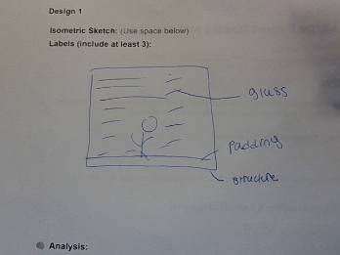

Another display case that I have found is this locker that is metal and has a lock on it to keep others from grabbing it. The purpose of this design is to keep the puppet safe and stored away till they need to be used next. Some limitations for this display is not being able to have the puppet on display and people may not have enough to get the metal for the locker case. The main idea when i picked thai design was because of how safe it would be for the puppet and how they are going to be able to keep safe and if anything happens they won't be able to get damaged.Also since they wont have light shining at them their color won't get damaged.
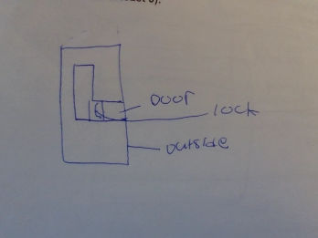
[So] They Won’t Be Scared”: Why the Kickapoo Childcare Center Chose a Monolithic Dome. (2025, November 10). Monolithic Dome Institute. https://monolithicdome.com/childcare-center-keeps-children-safe-in-tornadoes

This design is a thing on the wall that you can place the puppets on so they can be on display. This puppet design solves challenges because it's a storage place and they are easy to access. They are also able to be easily seen, materials that can be used are maybe wood blacks to hang the puppets on and screws to mount them in the wall for safety and to make sure they don't fall. Limitation that could be is not having enough space on the wall for them or maybe not being strong enough to hold the puppets.

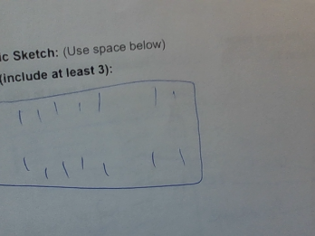

https://picryl.com/media/puppets-ventriloquist-doll-42dd29

I think the first design would be better because it's clear,this allows us to be able to see the puppet more visually.and it looks really durable so that it can keep the puppets safe. It will also be easy to get the puppets out easily if the opening is in the back. I learned that designing a display can be very hard and they have many different ways that you can make it. Some are going to be challenging to make with materials that you may not have and with the budget you are given. But at the end it will all come together and be a good durable display. This design can be improved with making a border around it and making it look all cute with colorful decoration around it. I think that if we make the design durable and colorful and fit all the requirements, it will be good. Maybe it will look like others that have already been made.

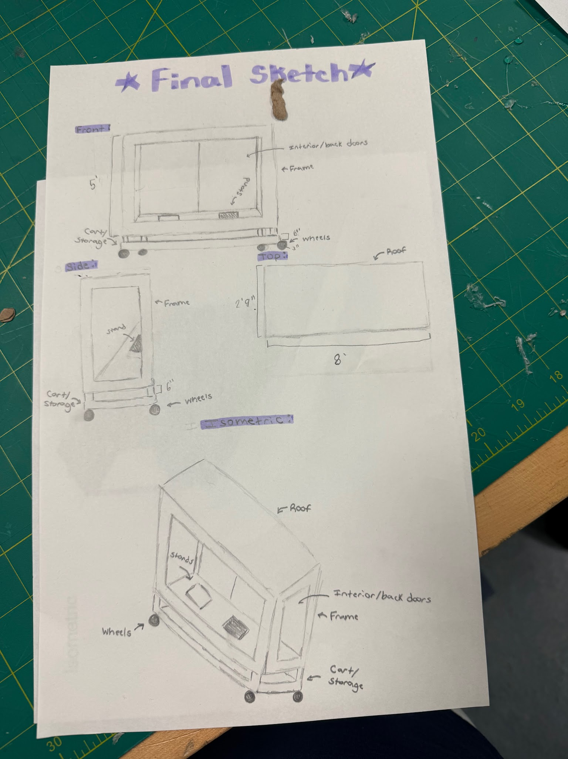

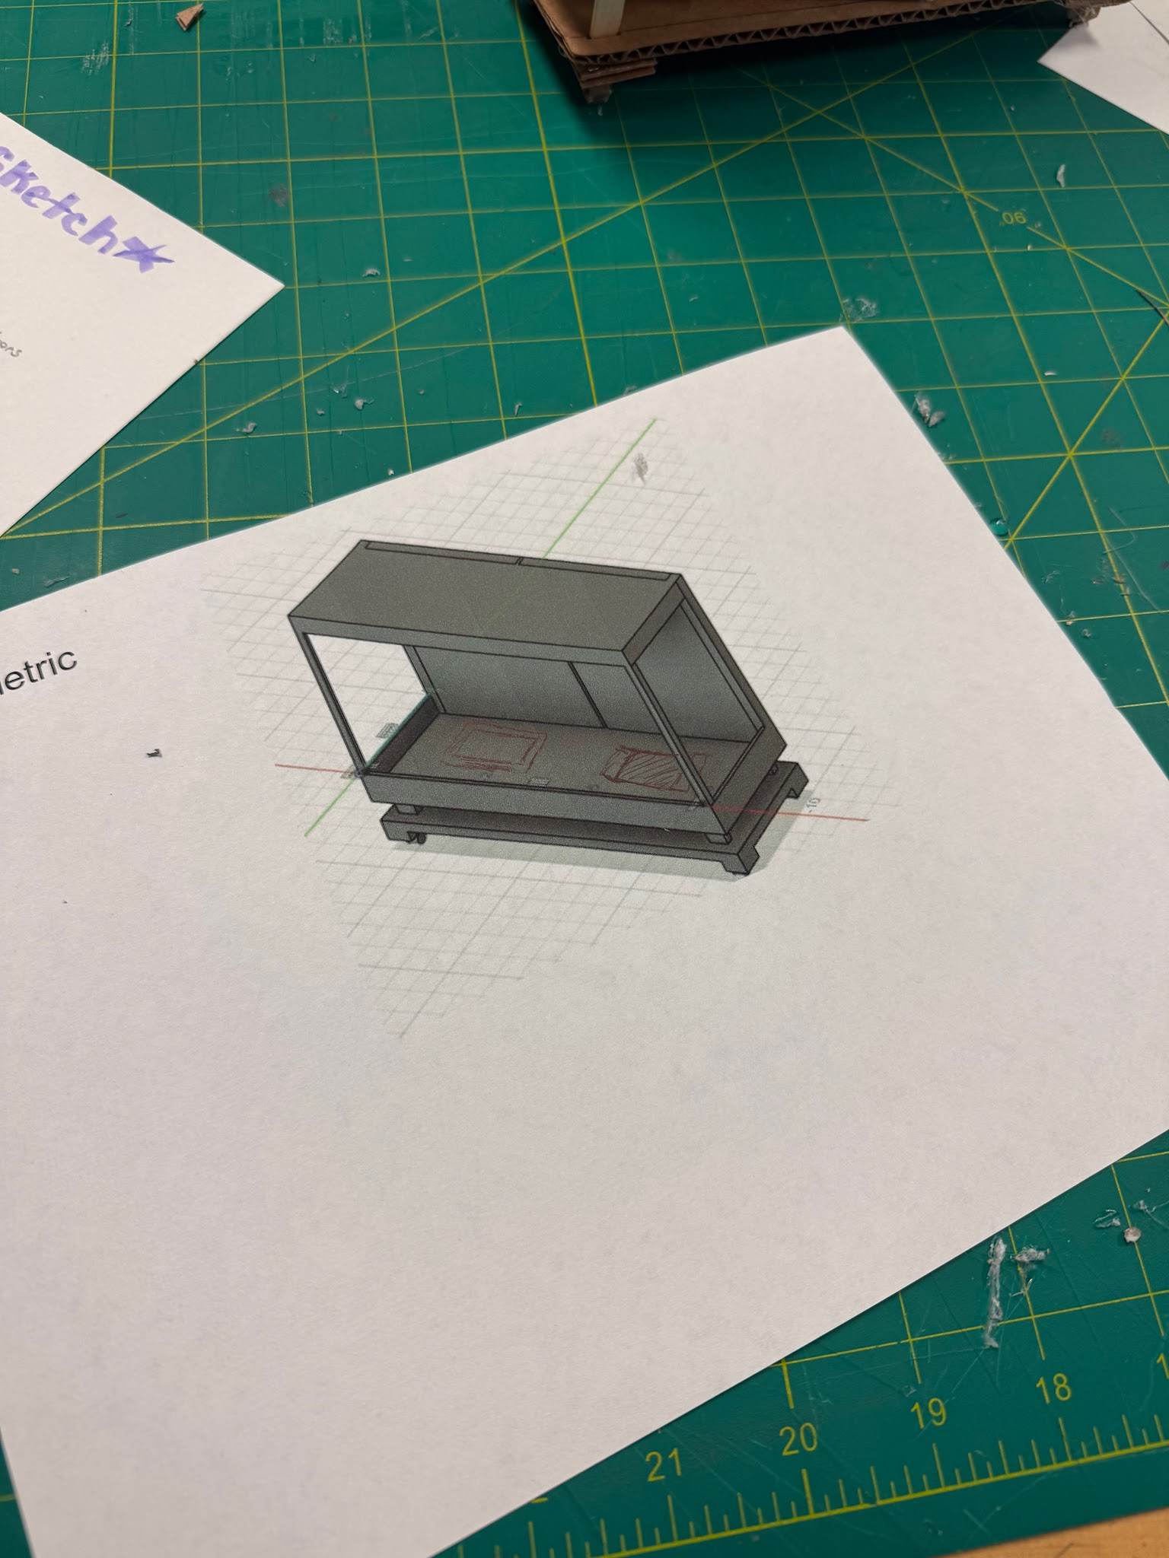

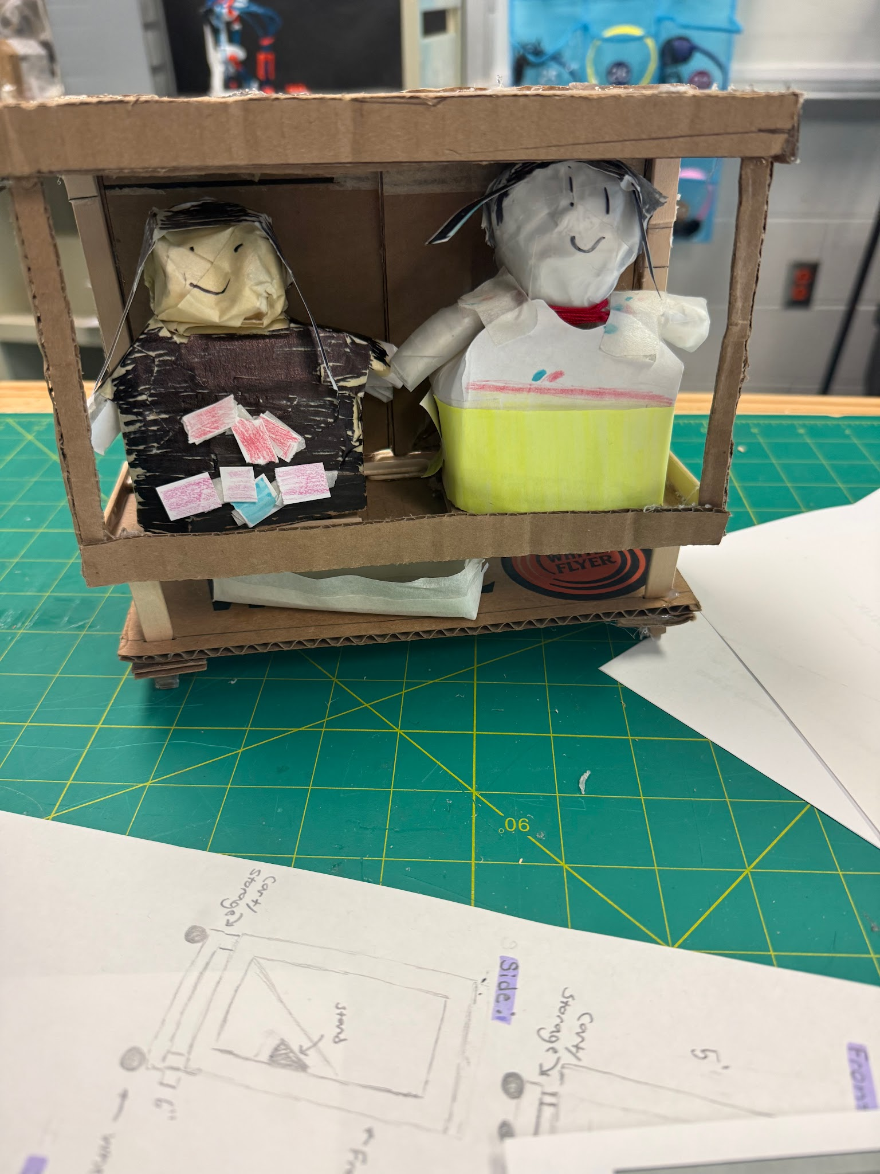

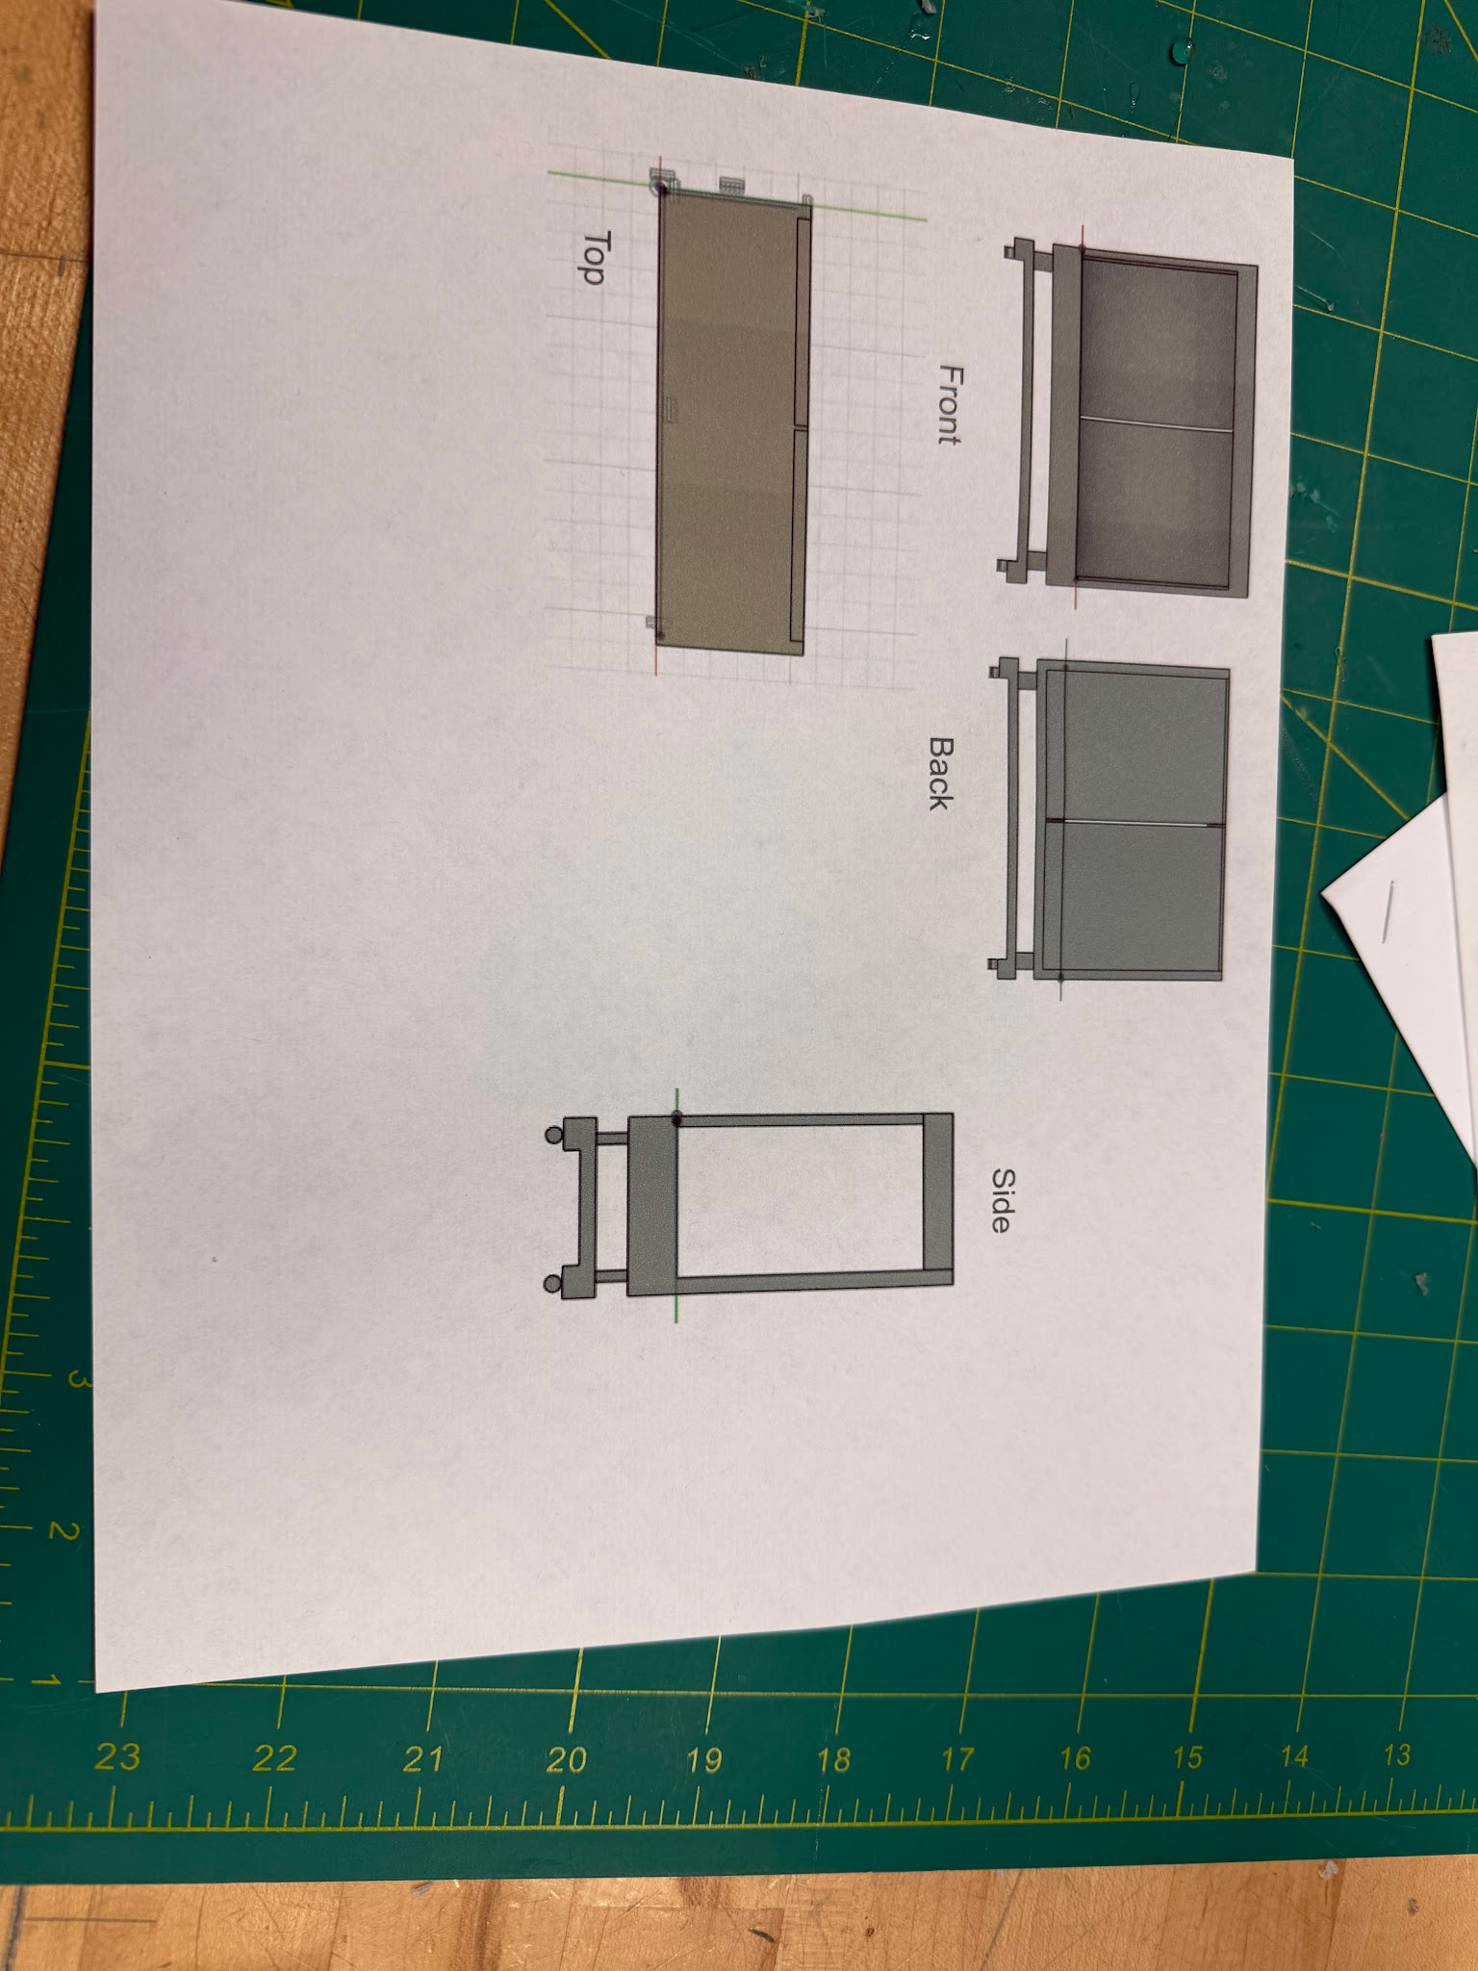

This is one of my initial designs because it's a good display and keeps the puppets protected, and this display also comes with enough storage like the stakeholders have asked for. This design also allows the puppets to be easily accessible because the door in the back, they open and close allowing for the puppets to be moved. This design also has wheels for mobility just like the stakeholders have asked for. The sketch of this design shows all the views and the measurements of the display and it shows that this design will fit through the door. It shows all the parts that we have used and with the picture of the final display and the pictures from Fusion shows that the dolls have enough room, while still having enough room for storage for everything else that the stakeholders want to store. The design best meets the requirement of having a good display and having enough storage for other things that we need. Some things that we need to work on is trying to find out a coast that we need to be able to get all of the materials that we need. This design was selected because we figured that it had the most requirements that we were given.

Step one was to look up designs and dig into them to see how they may help the re-design process be faster and we also came together as a group and we all made the design we liked that we picked and added all of the rest together and made the final design. The materials that we used are cardboard, hot glue and paper. We used cardboard to make the puppets and the display and the paper was used to add accessories to the puppets and the display if we needed to and we also used both to make the wheels on the display. The drawing shows that the dimensions are 2 by 2 and that it shows that they fit through the door and the display will be able to sit anywhere that they will think to put it we took about 6 days to do this whole process we took 3 or 4 to be able to look up designs that we could find and to see how much we already know about this design. The next 3 days we took to build the design and to try and find out what works best for the display. Then stakeholders came in to see if that display had reached all of their requirments.

This solution meets the requirements because it shows the puppets and fits through the doors and the display also is movable like the stakeholders wanted. The display also fits both of the puppets. We also have doors on the back side for easy access like they wanted. This model is testable because it's not a final solution and people can look at it and tell us what's wrong with the design and how we can improve it. Overall this design shows us that we can build things that may be great but can still need changing like we thought that the design was all done but then we found out that we forgot to add the coast so we can get points taken off for that. We have also learned how to work together and to make agreements even though it may be hard to. We have also seen that this project was important because it shows us what we need for all the requirements and how much measurements and changing things after the stakeholders come are important..

My team name is the Spice Girls and in this group it's me, Maggie and Adylan. The purpose of the design of a Thon project is to be able to show are displays to others and to be able to see others display to see others prospective on this project The purpose of the stakeholders are to be able to see what we need for are design that they are asking us to make for them and their feedback is also important because it shows us what they like and what we need to improve for this design that they want. It also has a big significance on how we work on projects because it shows us how well we can handle feedback whether it's bad or good. In our group the highest category was if it was able to fit into the door and the mobility was bad. We performed well because we measured the door and made sure that the design would fit into the door while building it and we made sure that we included the wheels because that was a requirement that the stakeholders wanted.the category that scored the lowest was cost because we didn't really display how much we want to spend on the designs lot of the comments where saying that are design was well throughout and well disigned. The stakeholders agreed that the group had strong strengths like a good thought out design and that we reached most of the requirements that were asked for from the stakeholders. One feedback that stood out was from Mrs Lopez. She gave us the lowest score for coast because we didn't add a coast to the design. Mrs Lopez's feedback will help us with our next design because it will have us remember to have a cost of everything that we need so we can have a budget for others to know.

One feature that should remain the same when building the design is how well we work together and the structure that we made because it really wasn't bad. It got a good rating on it from all the state highholders that saw it. A feature that would be improved is making sure we add the cost to the design that we make. A future that we want to change is the price we want to try and make it cheap but enough to wear we can get enough product that we need to make this design come to life.One strength that i have had while working on this is being able to communicate well and hard working even when i am not in class the next time i come in a work hard. One area that I can improve is being able to come in and work with my group and not rush.One challenge we have come across was when some of us weren't here and we didn't know what to do or when we didn't agree on things we had to find in between areas. Communication can improve better by telling the team when we won't be here or talking out why we think we should do it one way then another and finding a good in between spot like we have been doing. One personal goal I will work on is having a bigger impact on the design and making the design look all colorful and trying to come to school more to work harder then I have already to make the project good.

Overall I think stakeholders feedback is important because it shows us how we can improve the design next time and it helps us learn how to take feedback whether it's good or bad. Peer feedback is good too because it shows us what others are thinking and it shows us how we can help them so this design can affect more than just the stakeholders. Feedback and help the project because it shows the engineer how to make it better so the project will turn out good after making changes and it helps the team because it shows then how they really did and shows them their mistakes and how they can change it for the future and so they can improve this in the next ensign they make together or anywhere else.Are next steps for improving this design is making the design have coast like the stakeholder mentioned. We have learned the importance of having stakeholder feedback and how to handle what others have to say about design because it shows us how we can make it better for the future projects we make.

This project we started off by looking at the puppets and hearing the requirements from the stakeholders when they came into class. The next thing that we did was start researching designs so we can start thinking about how we want design to be. The next thing we did was start to build the design and during that building we made sketches and started doing fusion. Are successes that we had during thai was making the design that represented all the requirements that we were given from the stakeholders. Another one that we had was working well together and understanding the directions better than others did. A challenge that we had during this was having enough time to work.It feels like we kinda rushed it but at the same time we took our time and got it done. The group had a good outcome of this project because we all worked together and did enough research to find a good display that we can use as a starting point for his project. We also had a good outcome because we made sure to keep the requirements that we need to meet in our heads and build the display with them before we did anything else. A lesson that we have learned through this project is to see failure as a good thing because in this project we failed a few times but at the end it all comes together and dint effects are displayed at all. All groups have their own strengths and weaknesses. Our group's strength while doing this project was communicating well. We talked about what we thought of each person's design that they researched and we talked out problems that we had. A weakness that we had was not listening to each other completely. We had trouble finding a meeting point for our design but in the end we found one and the project turned out wonderful.

Improvement that we need to make is finding out a cost for a project that was one recommendation from stakeholders. The stakeholders came in class and saw all the displays and they wrote down on a paper what groups need to work on and the thing we got told to work on is finding a cost for the project so when we need to build it again we know how much to spend on materials. What we are keeping is how well decorated the puppets are and how well structured the display is. We are also keeping how much space and storage we added into the display like the stakeholders asked for. One thing that we may need to add is more decoration on the display so it's more appealing to the eye. We will also be adding the price of our design.When we decorate the display more it will improve the design because it's adding more color and it will stand out more when we put it out on display when it's all finished. The materials that we used for this were cordboard and paper and hot glue. We used cardboard to make the display and hot glue to hold it all together and we made the puppets out of cardboard and we used paper to recreate them to make them more realistic and colorful. How we can benefit from the recommendation that we got is in the future when we add a price others can maybe get the supply and start making more displays. When we make more displays this recommendation can also improve the score that we get because we will have a price and all the other things the design needs. Overall recommendations can help show engineers their failure and show them how they can improve their thinking in the next project that they work on.

Overall this project has shown how teamwork is important during the process of making a design. In addition it has shown how stakeholders' opinions are important because if you don't think about what they want and just build something, you may have to restart or they may not like it because it's not what they wanted. This project has helped up with making sure measurements are right and learning how to use teamwork skills like communication. I believe that this has also shown how well people care about the cultures around the world. Since we are spending so much time on making a storage spot for the puppets which are part of the hispanic heritage. I think this has shown me how hard engineering is and how much work it takes to create a design that will have an important impact on others lives.

