MyDesign Portfolio
Element D Initial Template

How to use this template
Teachers: You may customize this document before providing it to students.
Students: The template below is one way to present your design ideas, but the specific assignment given by your instructor may require a different structure or dictate different details. If you make a copy of this template to edit for your own design ideas, be sure to delete the instructions.

Guidance before filling out the template on the next page:
Because you will iterate on your design multiple times, you will need to create multiple copies of these sections. Think of Element D as a diary that you will date and keep adding to throughout your work until your final iteration. It’s critical that iteration shines through in this Element.
You should begin with many design ideas that reflect the individual ideas of your group members and then the group ideas. Number these ideas and include a date, description, drawing, and details for each.
After you have created an initial set of ideas, document your decision making on which design to include, ideally with a design matrix. Create a plan of work, ideally using a Gantt chart that may be housed in this document or in a different day-to-day document. Generate a design blueprint with enough details that someone else not familiar with your project could also build your design.
You will then proceed forward to build and test this design, returning to Element D afterwards when you are ready to create more design ideas. Fill out each of these steps again.

Element D: Design Concept Generation, Analysis, and Selection

Design Idea Generation (D1)
This section focuses on the process of generating solutions. The initial rounds should include every idea you come up with but the subsequent rounds of ideation should lead to viable options. Each idea should include not only words, but also a picture. Use as many copies of this sub-template as needed.
Design Idea #1

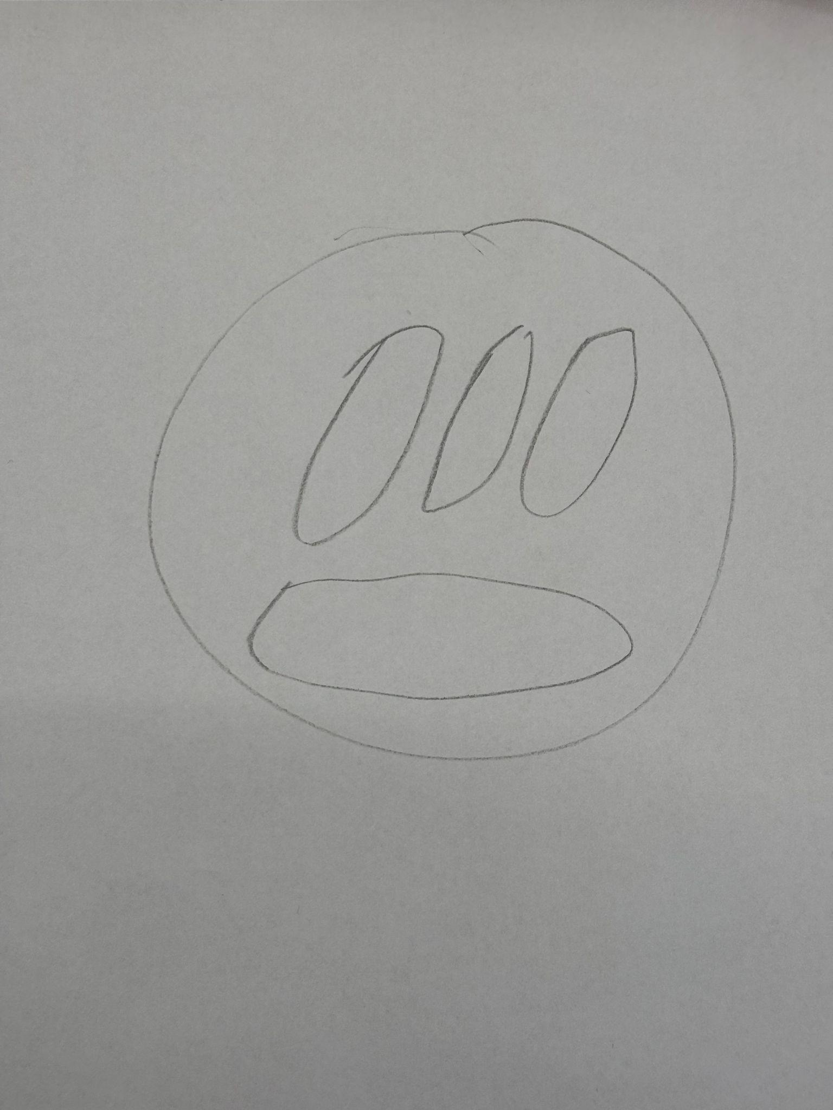
Date: March 23, 2026
Description: The design focuses on the base of the heat sensor detector. The base is designed to support the structure and hold the activation components in place. It must be lightweight but stable enough to remain fixed when installed in the home environment.
Design Idea #2
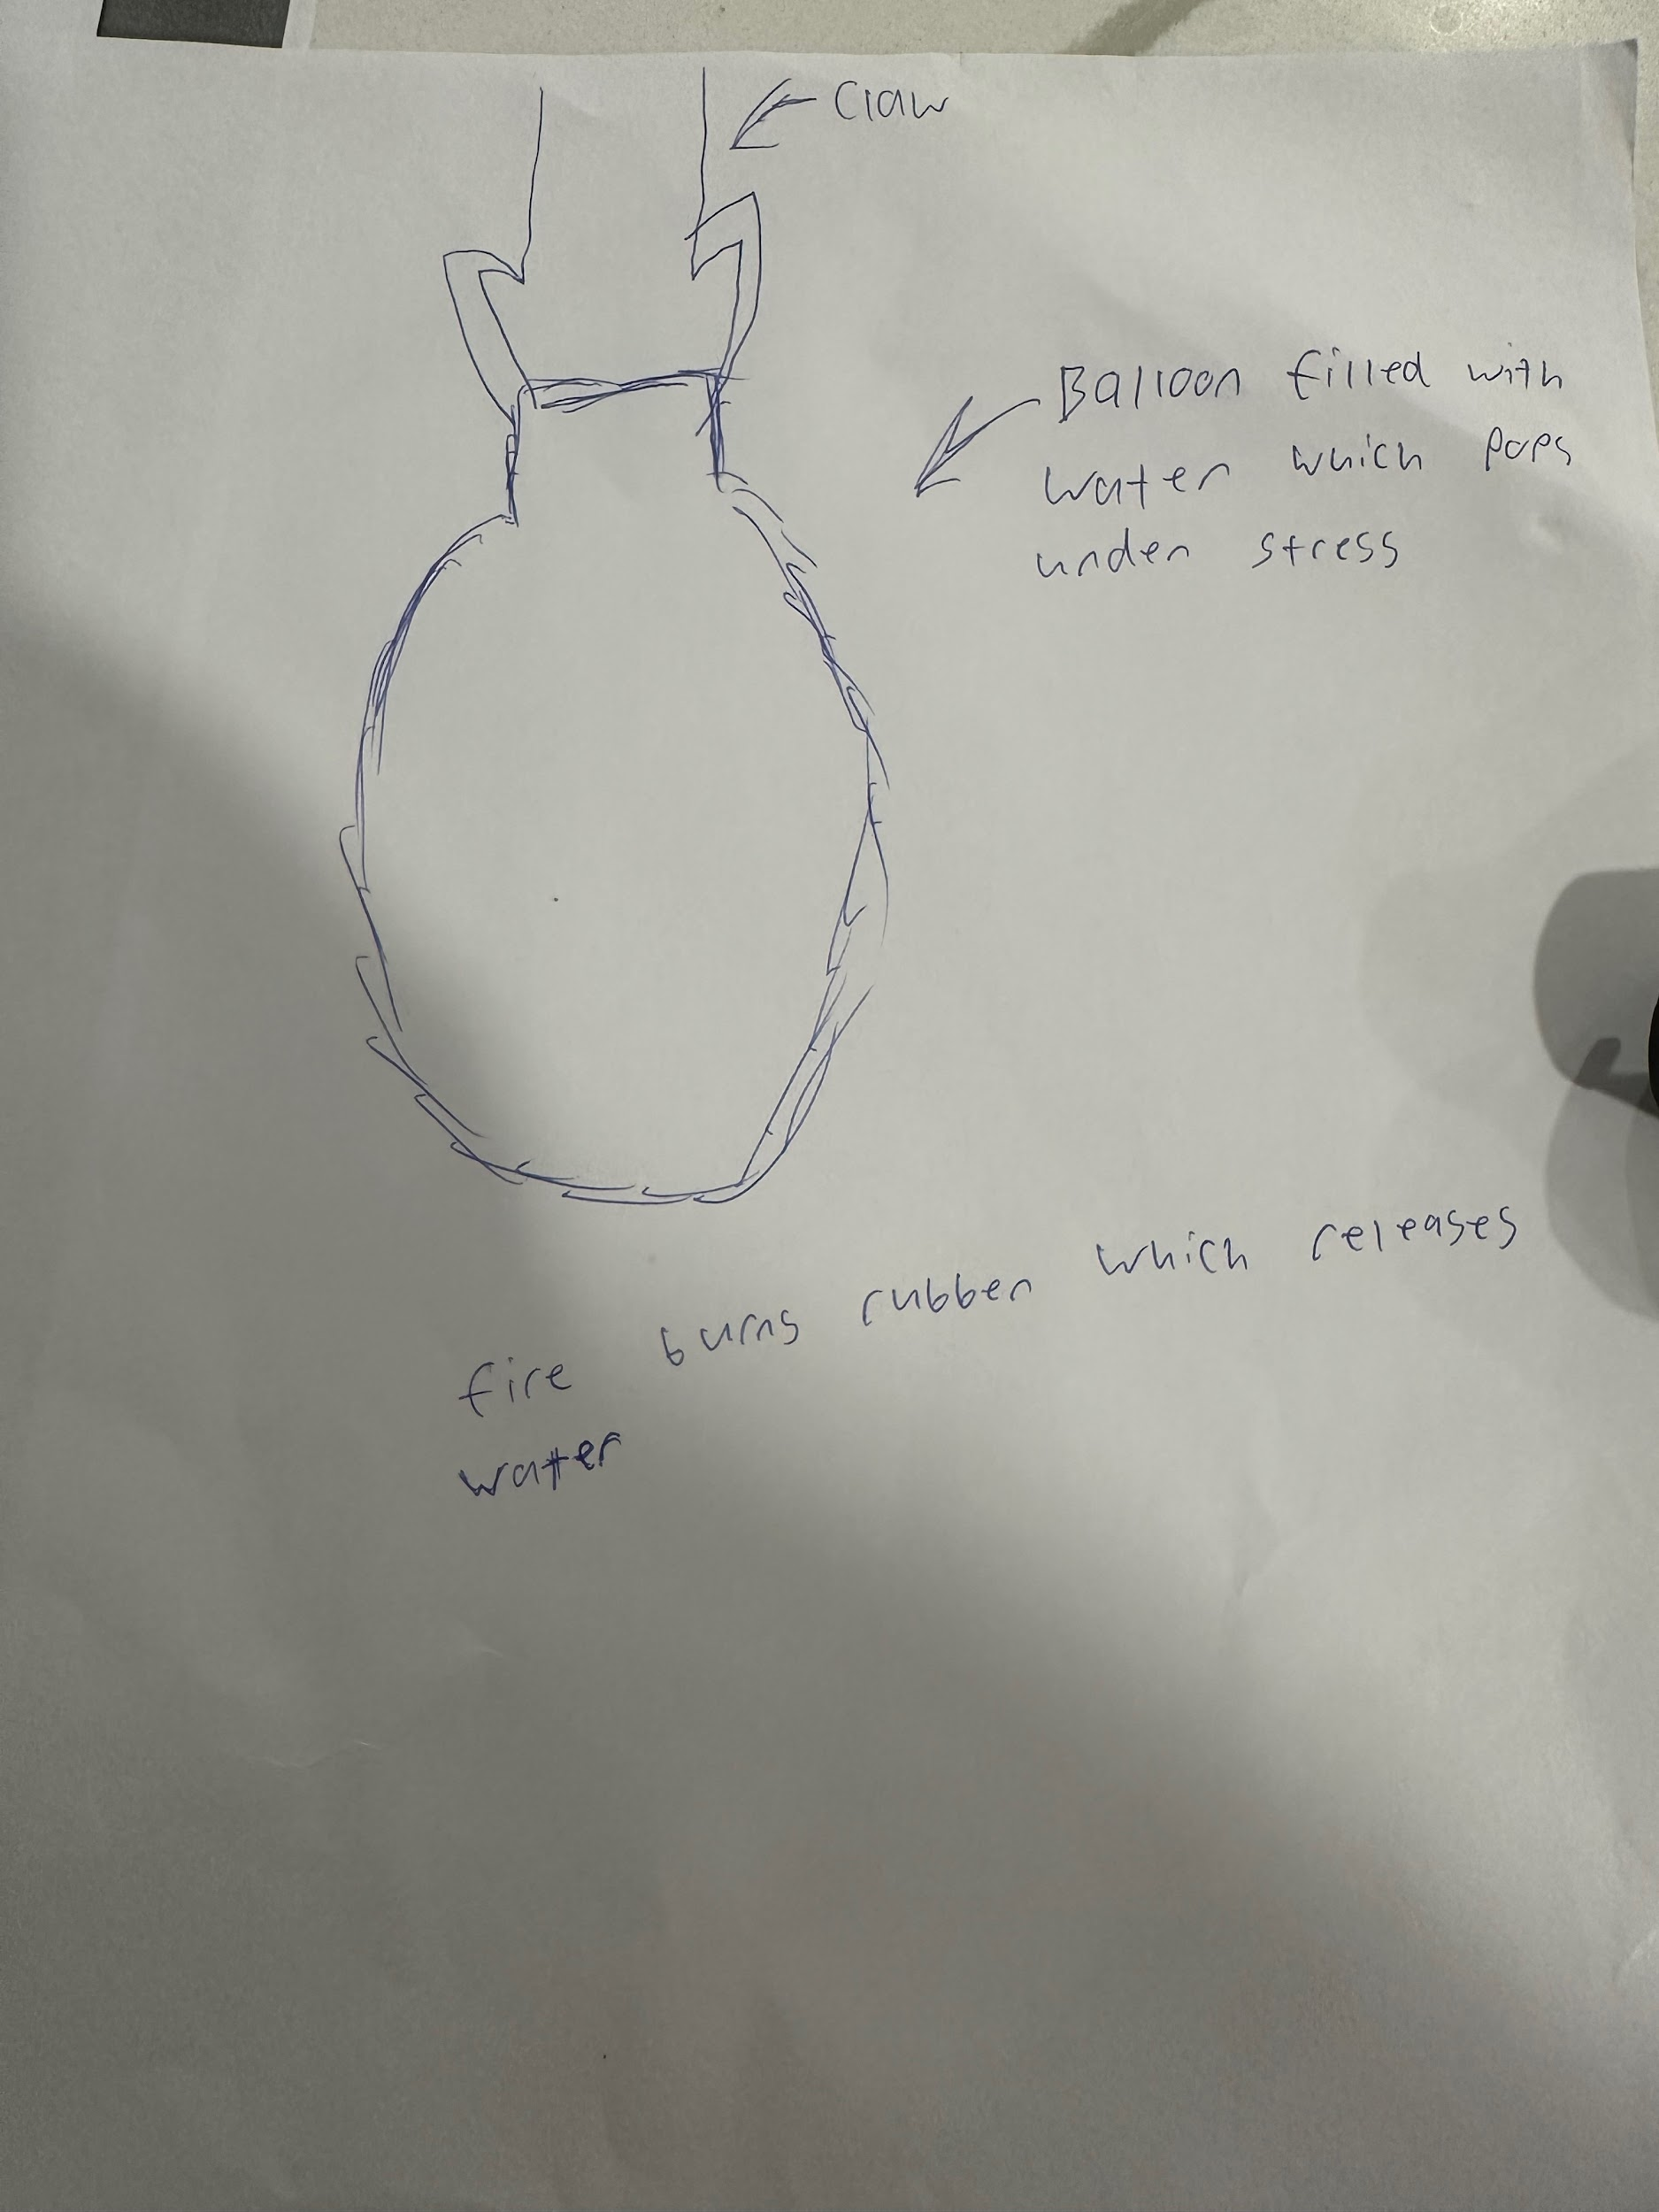

Date: March 25, 2026
Description: We use a claw that holds the balloon filled with water and once the fire burns the rubber water is released and extinguishes the fire.
Drawing that includes distinguishing information such as scale, dimensions, and materials: 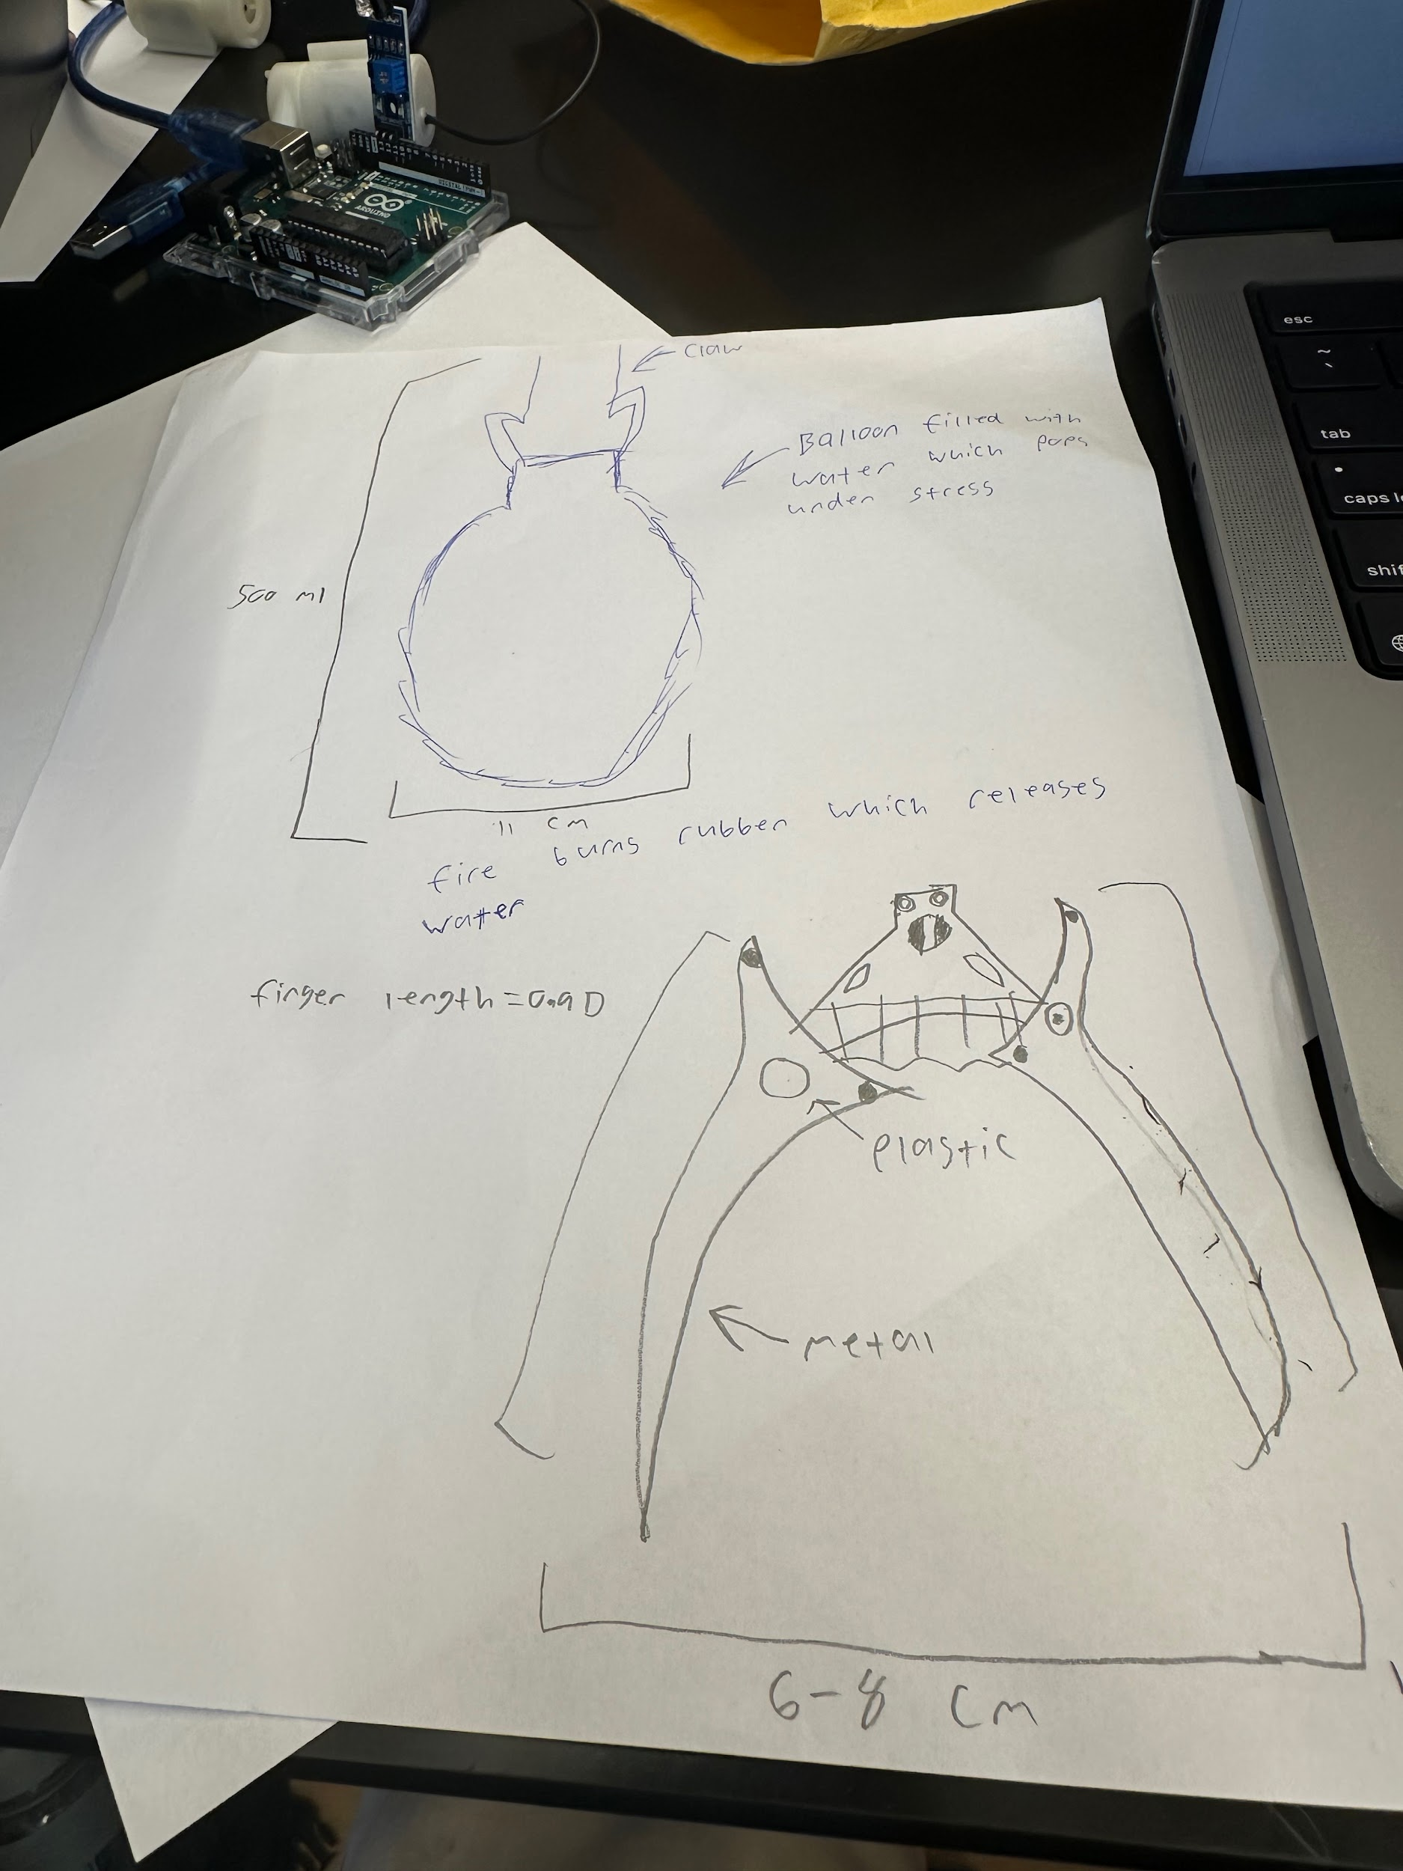
Design Idea #3
Date:
Description:
Drawing that includes distinguishing information such as scale, dimensions, and materials:

Design Idea Comparison and Selection (D1, D2)
When you’ve finished generating ideas, you must compare your design options according to all your design requirements. Incorporate the priority of those requirements when comparing design options. A decision matrix (perhaps a Pugh Matrix) is encouraged since it allows for systematic, weighted comparisons. If using weights in a decision matrix, be sure to explain and justify the weighting based on your design requirements. You may use the weighted design matrix template below, inserting your criteria and design options.

-The weight on the design requirements is different because the bottom of the heat sensor is like 5-10 pounds and I feel like if we add weight to it, it's gonna make it heavier. I feel if we add more weight it might end up falling apart when you add weight and try to put into the house, it might cause the heat sensor to fall

 | weight | Option 1 | Option 2 | Option 3 | Option 4
Criterion A | 3-5 pounds | Use the pumps to take out the fire
Criterion B | 5 | Drop a claw and drop the balloon
Criterion C | 5 | Catapult the balloon
Criterion D
Criterion E
score

Design Blueprint (D4)
Describe all of your design's details such that someone unfamiliar with your project could build your prototype. Include sketches, dimensions, CAD (if taught in your class), manufacturing methods, material choices, supply lists, and costs.
Design Blueprint #1


Date: 3/23/26
Sketch: see above
Manufacturing Methods:
Step 1: Figure how much stuff we need like do we need 2 of everything
Step 2: Figure how much it cost
Step 3: Install the items
Supply List and Costs:
Item | Cost each | # needed | Total
Water Pump | 12.99 | 1 | $12.99
Heat Sensor | 42.97 | 1 | $42.97
Heat sensor wires | 24.99 | 1 | $24.99
Total Cost | 80.95 | 0 | $80.95

Plan of Action (D3)
A Gantt chart is encouraged to lay out the primary steps expected on a visual timeline. Larger tasks from the Gantt chart should be broken down further into detailed sub-tasks, which may be housed in a different day-to-day document. Discrete tasks should include enough detail such that others could replicate the efforts, such as procedures, materials, tools, status, etc.
Criteria: detection(0-5) 5/5 activation speed(how long it takes to start making noise and/or putting out the fire)(0-5) ⅘ pumping/extinguishing power(0-5)5/5 shut-off time(0-5)-5
Multi-sensor detector: Detection-5/5 Activation speed-4/5 Pumping/extinguishing power-0/5 shut-off time-3/5
Wet pipe sprinkler system: Detection-5/5 Activation speed-5/5 Pumping/extinguishing power-4/5 shut-off time-1/5

