MyDesign Portfolio
Element D Initial Template

How to use this template
Teachers: You may customize this document before providing it to students.
Students: The template below is one way to present your design ideas, but the specific assignment given by your instructor may require a different structure or dictate different details. If you make a copy of this template to edit for your own design ideas, be sure to delete the instructions.

Guidance before filling out the template on the next page:
Because you will iterate on your design multiple times, you will need to create
multiple copies of these sections. Think of Element D as a diary that you will date and keep adding to throughout your work until your final iteration. It’s critical that iteration shines through in this Element.
You should begin with many design ideas that reflect the individual ideas of your group members and then the group ideas. Number these ideas and include a date, description, drawing, and details for each.
After you have created an initial set of ideas, document your decision making on which design to include, ideally with a design matrix. Create a plan of work, ideally using a Gantt chart that may be housed in this document or in a different day-to-day document. Generate a design blueprint with enough details that someone else not familiar with your project could also build your design.
You will then proceed forward to build and test this design, returning to Element D afterwards when you are ready to create more design ideas. Fill out each of these steps again.

Element D: Design Concept Generation, Analysis, and Selection

Design Idea Generation (D1)
This section focuses on the process of generating solutions. The initial rounds should include every idea you come up with but the subsequent rounds of ideation should lead to viable options. Each idea should include not only words, but also a picture. Use as many copies of this sub-template as needed.
Design Idea # 1 Plastic cover
Date: 2/11/26
Description: This plastic cover will consist of a flexible material that is reusable for all sizes of cleats. This will provide separation from the floor and your cleats. This will be accessible to all athletes that play a sport that include cleats. While this raises concerns of durability this will consist of a reinforced plastic to ensure its longevity. While specialized plastics like Polycarbonate offer up to 200 times the impact resistance of glass.With this information suggest that this will be an effective design for the issue of no cleats in the fine arts center.
Drawing that includes distinguishing information such as scale, dimensions, and materials:
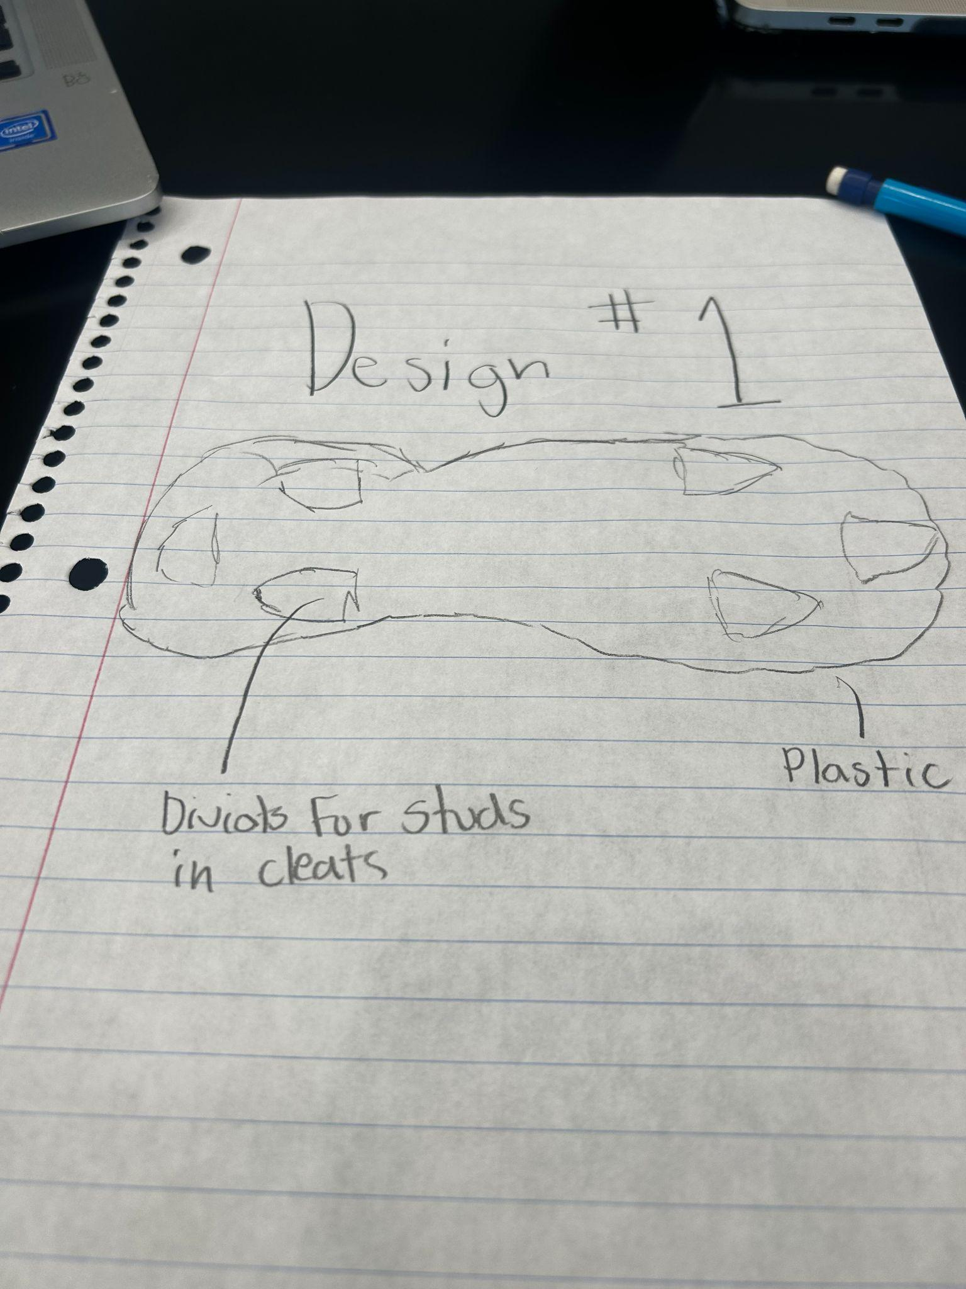

Design Idea #2
The Carbon-Guard is a sleek, ultra-durable overshoe that lets athletes walk indoors without removing their cleats. It features a lightweight carbon fiber frame for maximum strength and a high-traction rubber sole to prevent slipping on smooth floors. The interior is specially cushioned to level out the studs, providing a stable, sneaker-like feel while protecting both the floor and the expensive cleat hardware.
Date: 2/11/26
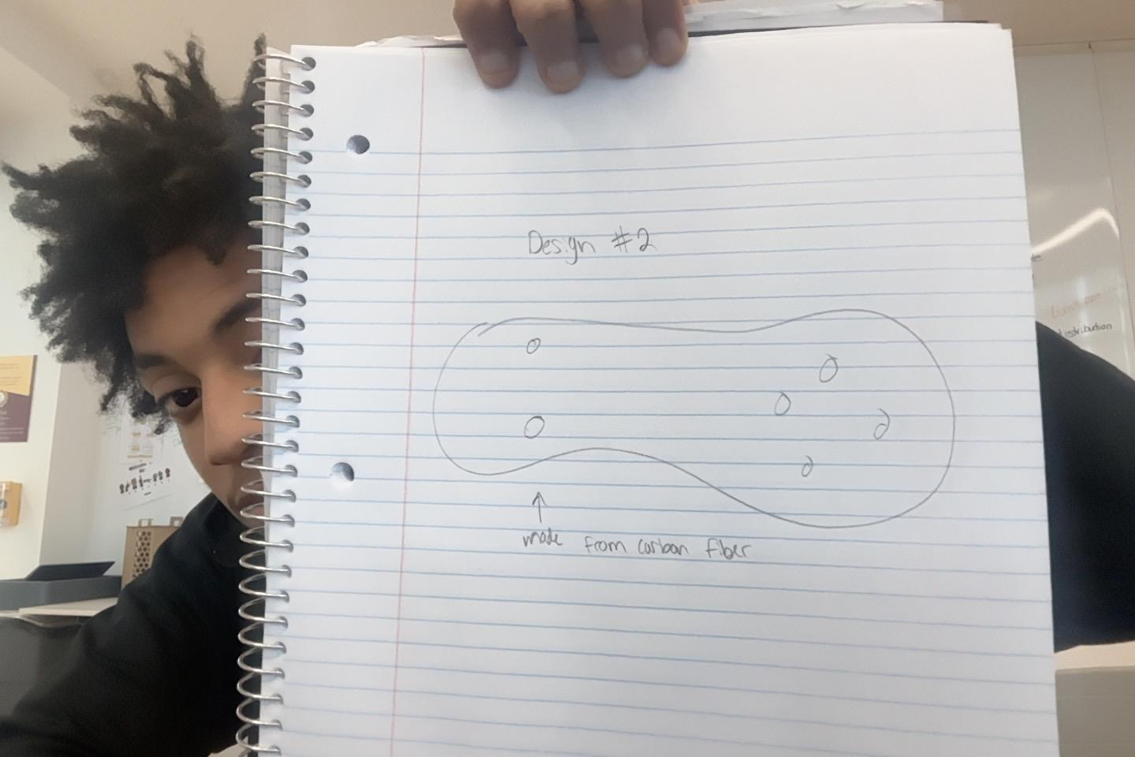specially cushioned to level out the studs, providing a stable, sneaker-like feel while protecting both the floor and the expensive cleat hardware.stable, sneaker-like feel. The flexible design easily stretches over any cleat, protecting both the building's floors and the athlete's expensive gear.
Drawing that includes distinguishing information such as scale, dimensions, and materials:
Design Idea #3
Date: 2/11/26
Description: This cotton cover will be a more durable design that will take longer to clean.. The design will be accessible to all sports that include cleats and all sizes. This design is also softer than others so athletes wouldn’t have to roughly put their foot in the cover. This design raises concerns on the possibility of the cover shrinking, so we will use pre-shrunk cotton, where the manufacturers pre-wash the cotton to ensure it has already shrunk, or we could make clients wash in cold water. We will also use spandex for the design so it can latch onto the side of the shoe.
Drawing that includes distinguishing information such as scale, dimensions, and materials:
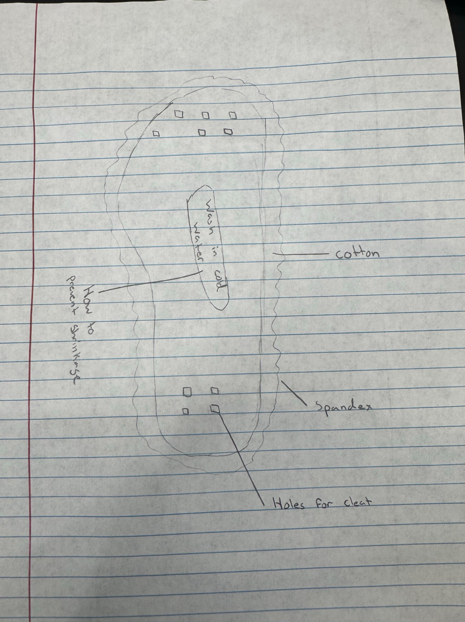

Design Idea Comparison and Selection (D1, D2)
When you’ve finished generating ideas, you must compare your design options according to all your design requirements. Incorporate the priority of those requirements when comparing design options. A decision matrix (perhaps a Pugh Matrix) is encouraged since it allows for systematic, weighted comparisons. If using weights in a decision matrix, be sure to explain and justify the weighting based on your design requirements. You may use the weighted design matrix template below, inserting your criteria and design options.

 | weight | Plastic cover | Cotton cover
Durable | 5 | 5 | 5
Easy to put on | 5 | 4 | 4
Cover shoe to ankle | 3 | 5 | 2 |  | 23
Reusable | 5 | 3 | 2
Go in a box where it cleans itself | 2 | 4 | 1
score |  | 23/25 | 14/25

Design Blueprint (D4)
Describe all of your design's details such that someone unfamiliar with your project could build your prototype. Include sketches, dimensions, CAD (if taught in your class), manufacturing methods, material choices, supply lists, and costs.
Design Blueprint #1
Date: 2/11/26
Sketch:
Manufacturing Methods:
Step 1:Find a factory9
Step 2:make the plastic
Step 3:distribute it to the athletes.
Supply List and Costs:
Item | Cost each | # needed | Total
plastic | $3.50 | 84 | $294
latex | $3.75 | 84 | $315
Natural rubber | $0.21 | 84 | $17.64
Total Cost | $7.56 | 84 | $626.64

Plan of Action (D3)
A Gantt chart is encouraged to lay out the primary steps expected on a visual timeline. Larger tasks from the Gantt chart should be broken down further into detailed sub-tasks, which may be housed in a different day-to-day document. Discrete tasks should include enough detail such that others could replicate the efforts, such as procedures, materials, tools, status, etc.
Planning/Research: :this phase focuses on defining the requirements of the project. We will research the materials that we need. Also in this phase will be finding a factory. Our goal is to make a document that connects the athletes' needs and the factory’s limits for production. Jan 11, 2026- Mar 20, 2026
Design:during this phase we will be going from just the idea of the product to the actual creation of it. In the process we will have to make the plastic that will be used for the design. This starts with 3d printing so make sure that the design can be manufactured. Mar 20, 2026- Jun 5, 2026
Present: once we have manufactured and tested the product we will have a presentation to showcase it. We will bring real athletes who will be affected by the product to test it out. After we complete the presentation our products will be distributed first in out school and then hopefully throughout the nation and eventually the world. Jun 6, 2026

