MyDesign Portfolio
Element D Initial Template

Element D: Design Concept Generation, Analysis, and Selection
Design Idea #1
Date: 2/5/26
Description: A heat pad made up of a hard plastic with a soft side that is nice on the skin, an adjustable band so it can go on the waist/hip area of anyone, and a cart that can hold 10 heat pads and that is portable.
Drawing that includes distinguishing information such as scale, dimensions, and materials: 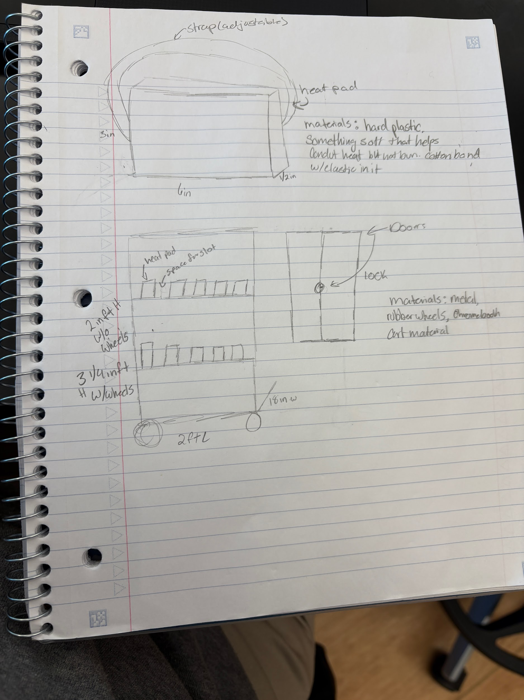
Design Idea #2
Date:2-9-26
Description: A heating pad made of plastic material so it won’t burn your stomach or skin. For the heating Pad cart, we are going to go with a small cart that’s made out of metal with a flap door so it can lock and keep the other heating pads from getting dirty.
Drawing: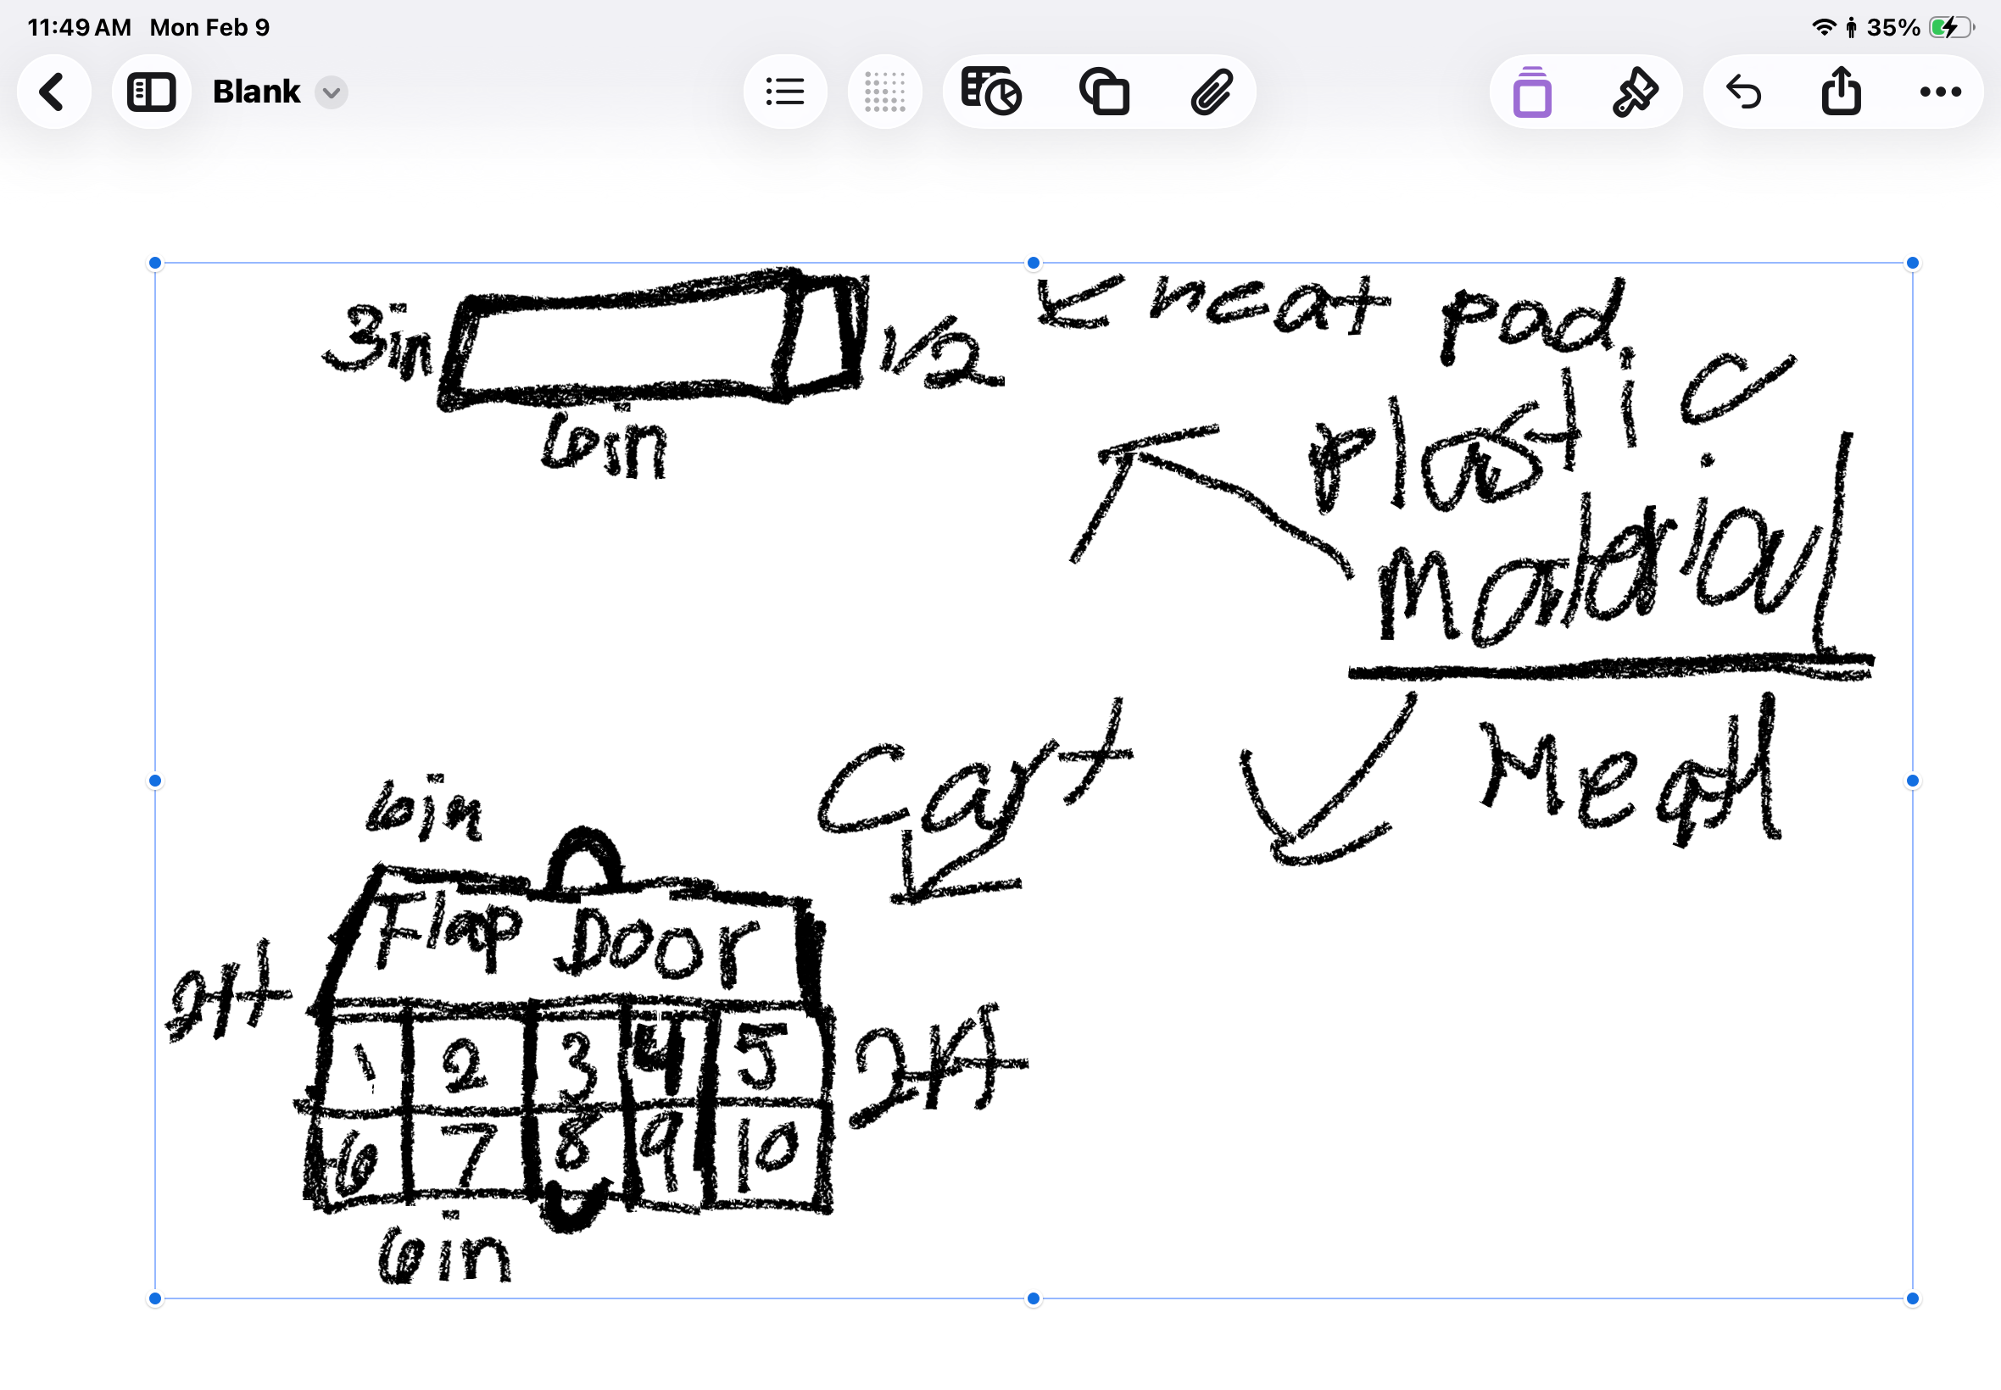

Design Idea #3
Date: 2/9/26
Description:
Heat Pads:
- Cream color
- Band- cotton& elastic/adjustable
- Pad/front: hard plastic& stainless steel fiber
- back: soft material doesn’t burn, keeps heat
- 6 in long, 3 in height, 1.5 in width
- Button to turn on/off and turn up the heat
Heat Pad holding bag:
- Cloth/polyester/ nylon
- Black in color
- Cinch drawstring closure
Heat pad container;
- Metal (same metal as chromebook cart or metal carts around school/metal that does or will not heat up
- Rubber wheel
- Charging port holes and charging port
- Two doors
- Two handles with a lock in the middle
- 3 ft height or 4 ¼ ft w/ wheels
- 18 in width
- 2 ft length
Drawing that includes distinguishing information such as scale, dimensions, and materials:
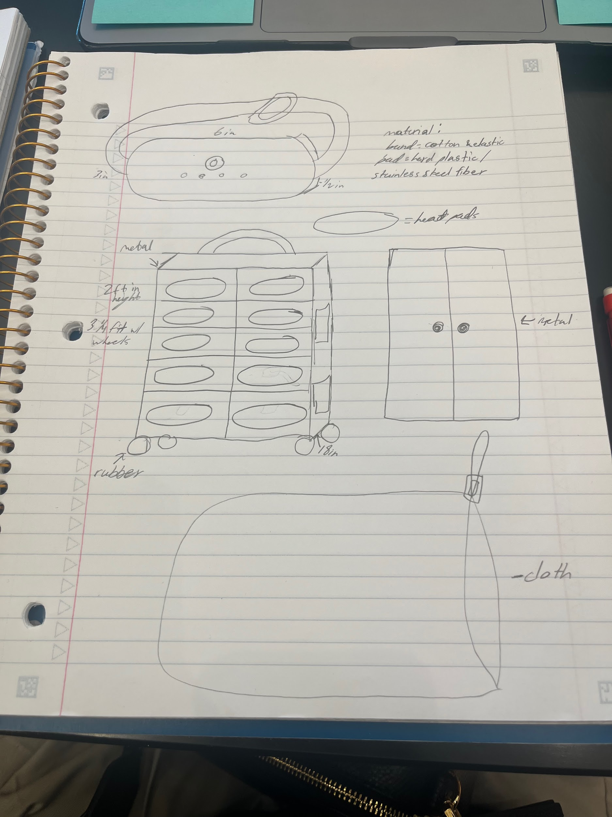

Design Idea Comparison and Selection (D1, D2)

 | weight | Option 1 | Option 2 | Option 3
Safety(cleanliness, heat caution) | 1-5 | 4  - The container for heat pads has a lock, but does not have something to keep the heat pad clean | 4  -container has a lock to keep the heat pad secure/doesn’t have something to keep the pad clean | 5  -has bag to cover it & container can be locked
System to take and return | 1-5 | 0  -No system was created | 0  -No system was created | 0  -No system was created
Discrete | 1-5 | 3  - small enough to be thought to not be a heat pad/ nothing to cover it  /no color specification | 3  - small enough not to be thought of as a heat pad/ a little too long for the area it is needed | 4  -small enough to be thought of not as a heat pad / discrete color/ has a bag to cover it
Portable | 1-5 | 4  -does not need to be attached to an outlet & has a strap to be attached to the body | 3  -small enough to be carried & doesn’t need to be on a wall to be used | 5  -doesn’t need to be plugged into the wall & has a strap to be attached to the body & has a bag to hold it
Rechargeable | 1-5 | 5  -The container has charging ports in it to charge heat pads | 5  -The container has charging ports in it to charge heat pads | 5  -The container has charging ports in it to charge heat pads
Adjustable band | 1-5 | 5  - has an adjustable band | 0  -no adjustable strap | 5  -has an adjustable band
Color | 1-5 | 0  -no color specification | 0  -no color specification | 5  -color specification

Design Blueprint (D4)
Describe all of your design's details such that someone unfamiliar with your project could build your prototype. Include sketches, dimensions, CAD (if taught in your class), manufacturing methods, material choices, supply lists, and costs.
Design Blueprint #1
Date: 2/9/26-2/11/26
Sketch:
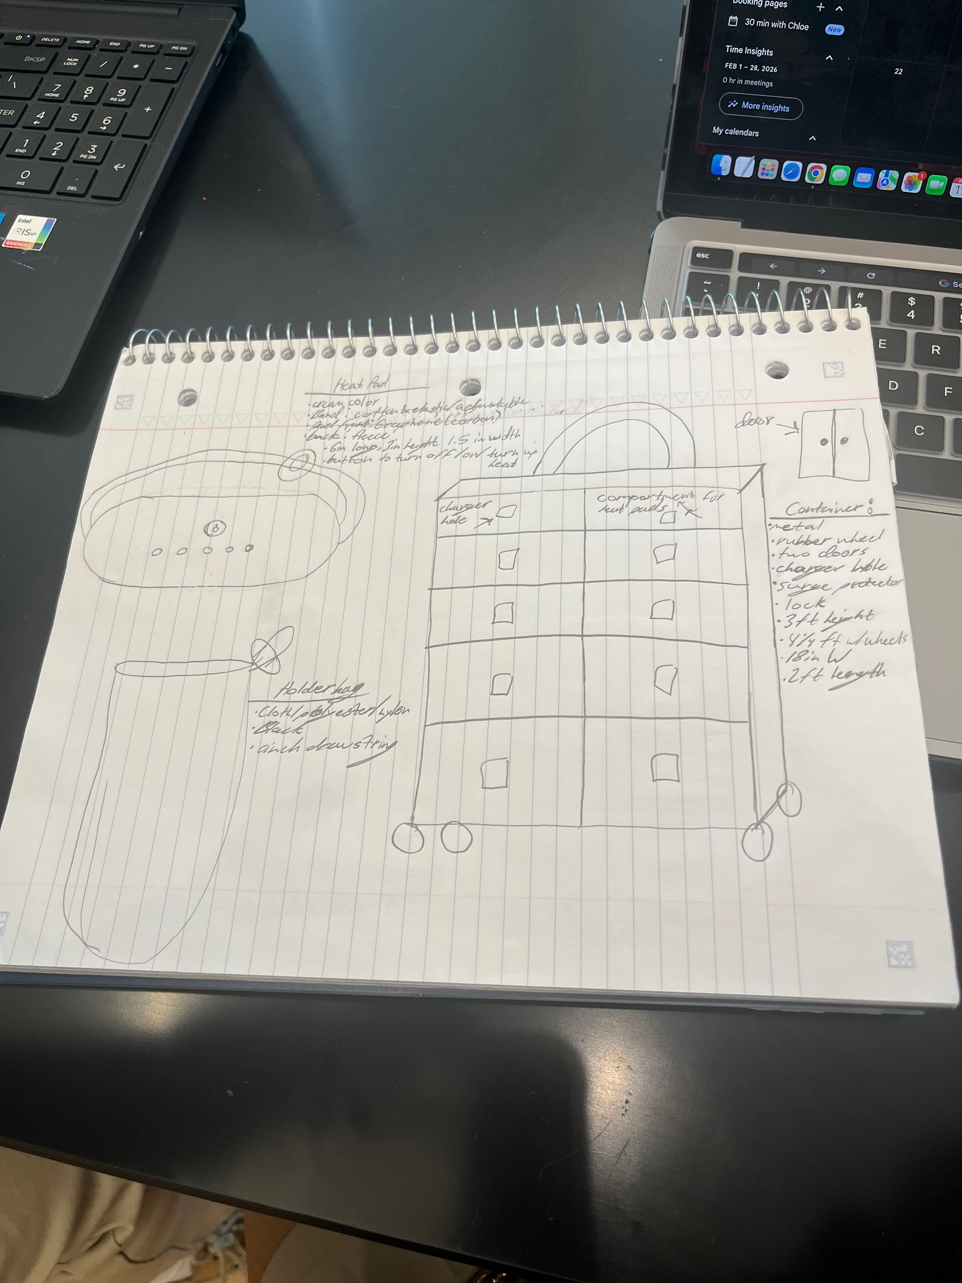
Manufacturing Methods:
Step 1: Create a heat pad
Step 2: Create a container and a holder
Step 3: Create a system
Supply List and Costs:
Item | Cost each | # needed | Total
Cotton fabric | $15 | 1yard | $15
elastic | $4.50 | 1 yard | $4.50
Hard plastic( Graphene) | $200 | 15 pounds | $4500
Stainless steel/ metal? | $3.20 per pound | 20 pounds | $70
Fleece fabric | $10 | 1 yard | $10
Drawstring bag | $27 | 1 | $27
Rubber wheels | $12 | 4 | $48
One-sided handle | $40 | 1 | $40
Surge protector | $16 | 2 | $32
lock | $52 | 1 | $52
Total Cost |  |  | $4,798.50

Plan of Action (D3)
A Gantt chart is encouraged to lay out the primary steps expected on a visual timeline. Larger tasks from the Gantt chart should be broken down further into detailed sub-tasks, which may be housed in a different day-to-day document. Discrete tasks should include enough detail such that others could replicate the efforts, such as procedures, materials, tools, status, etc.
