MyDesign Portfolio
Element D Initial Template

How to use this template
Teachers: You may customize this document before providing it to students.
Students: The template below is one way to present your design ideas, but the specific assignment given by your instructor may require a different structure or dictate different details. If you make a copy of this template to edit for your own design ideas, be sure to delete the instructions.

Guidance before filling out the template on the next page:
Because you will iterate on your design multiple times, you will need to create multiple copies of these sections. Think of Element D as a diary that you will date and keep adding to throughout your work until your final iteration. It’s critical that iteration shines through in this Element.
You should begin with many design ideas that reflect the individual ideas of your group members and then the group ideas. Number these ideas and include a date, description, drawing, and details for each.
After you have created an initial set of ideas, document your decision making on which design to include, ideally with a design matrix. Create a plan of work, ideally using a Gantt chart that may be housed in this document or in a different day-to-day document. Generate a design blueprint with enough details that someone else not familiar with your project could also build your design.
You will then proceed forward to build and test this design, returning to Element D afterwards when you are ready to create more design ideas. Fill out each of these steps again.

Element D: Design Concept Generation, Analysis, and Selection

Design Idea Generation (D1)
This section focuses on the process of generating solutions. The initial rounds should include every idea you come up with but the subsequent rounds of ideation should lead to viable options. Each idea should include not only words, but also a picture. Use as many copies of this sub-template as needed.
Design Idea #1
Date: 2/11/26
Description: I think cloth like shoe cover that fits over the bottom of the cleats with elastic on the top so it stays on while walking. The bottom has a high friction rubber or some type of high friction material that doesn’t wear down easily. The design must stretch easily and not damage the tile by leaving any type of marks.
Drawing that includes distinguishing information such as scale, dimensions, and materials:
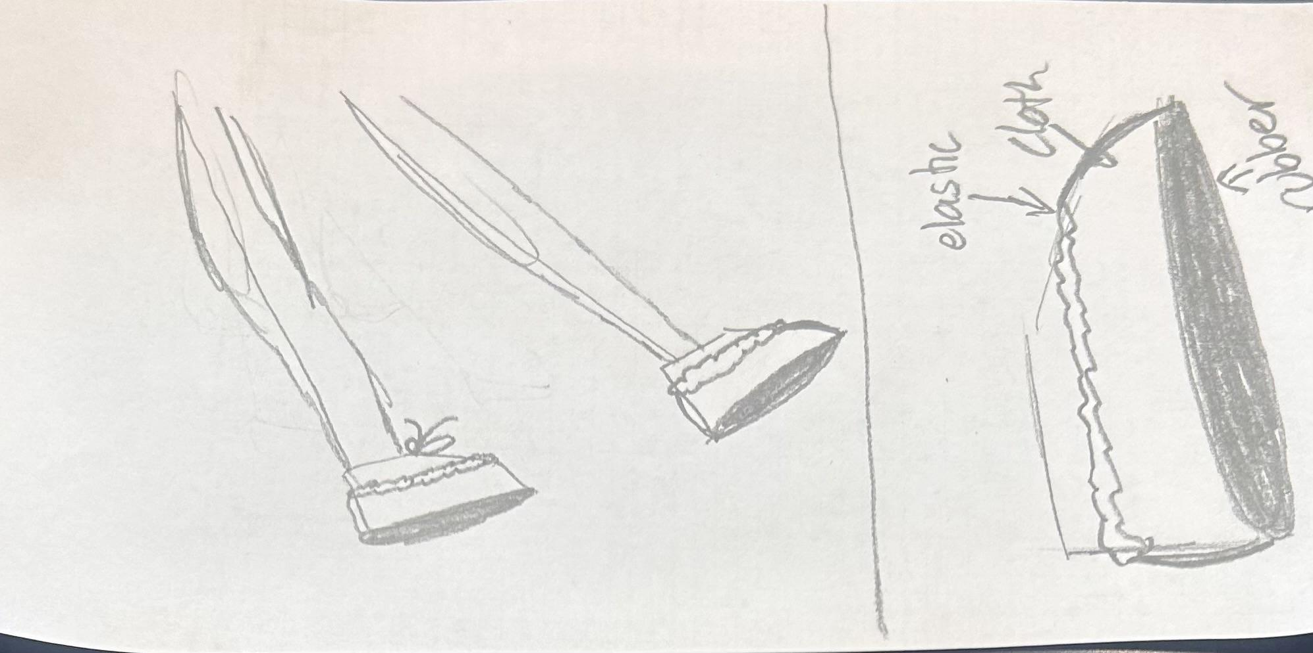
Design Idea #2
Date:2/11/26
Description:a sleeve like cover that you wear around your ankle while you play/practice, when you are about to go in the building you just slide it over your cleat and are ready to go. It must be lightweight/breathable so its still comfortable to wear and be durable so they don’t get torn. Drawing that includes distinguishing information such as scale, dimensions, and materials:
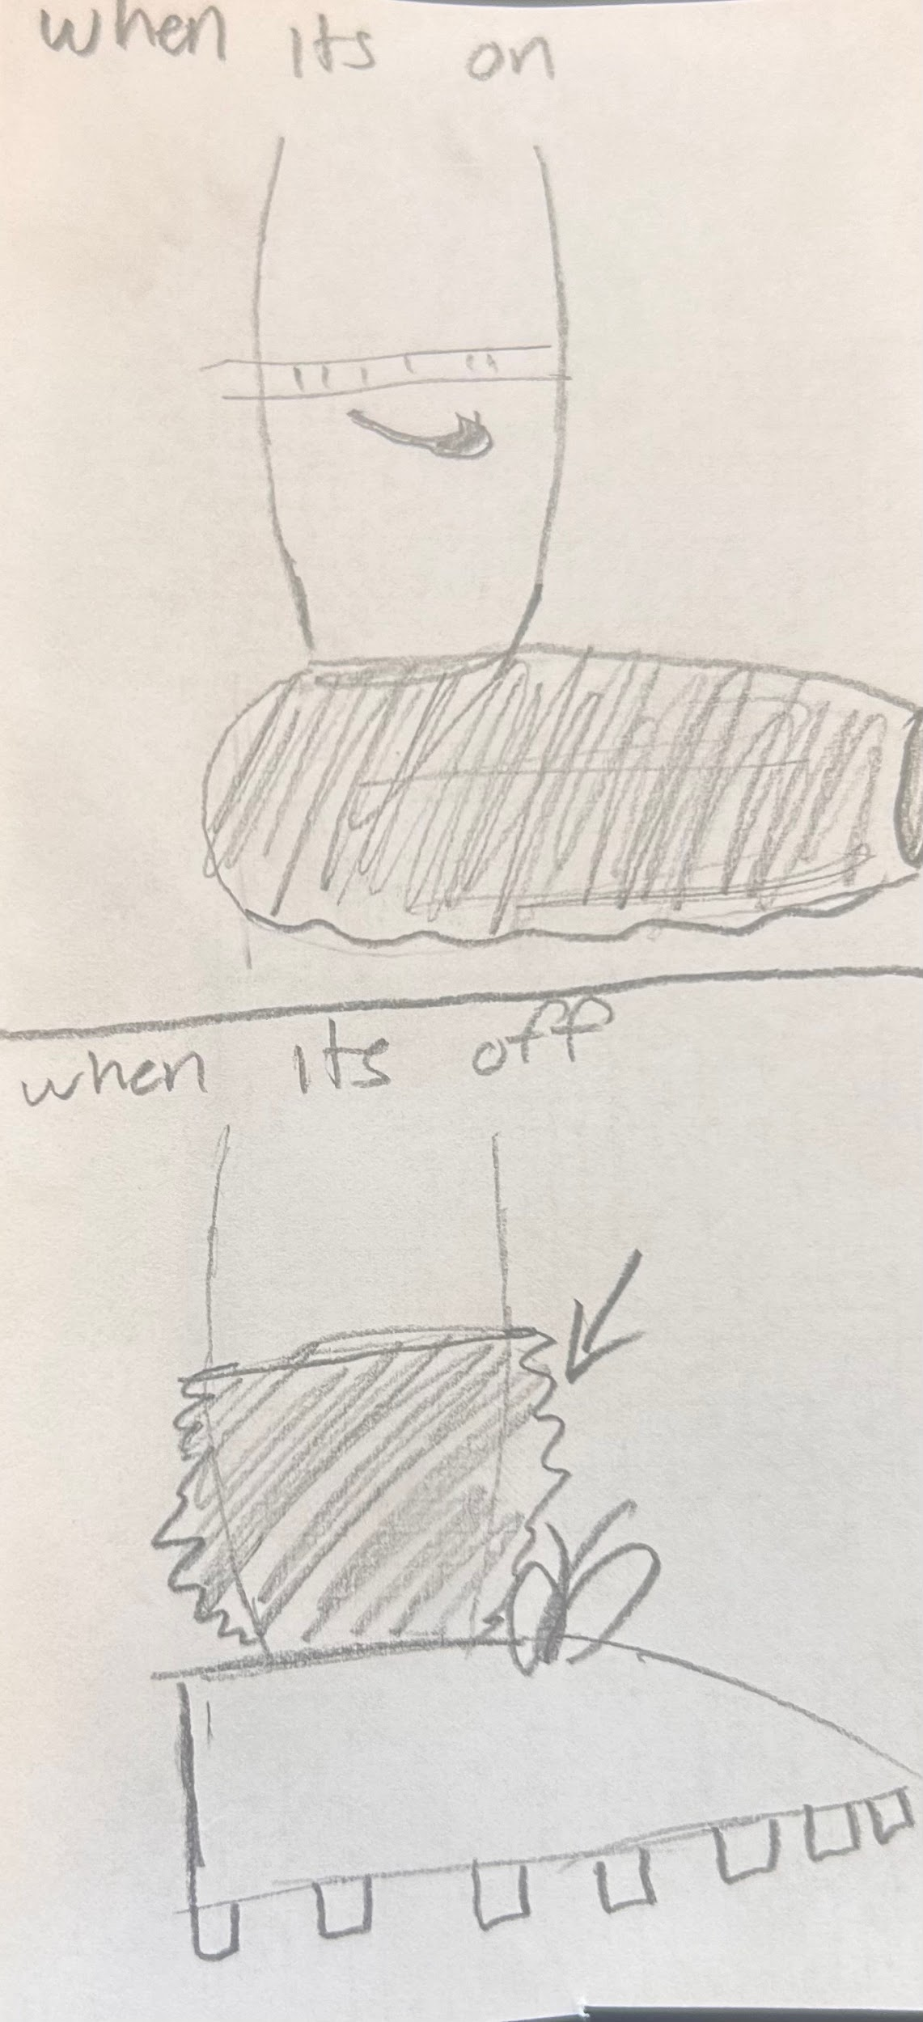
Design Idea #3
Date: 2/11/26
Description: A clip-on pad that the player puts on and snaps onto the shoe, then he walks on the pad and he can move freely through the fine arts building without slipping. It would be bigger to fit more sizes of shoes.
Drawing that includes distinguishing information such as scale, dimensions, and materials:
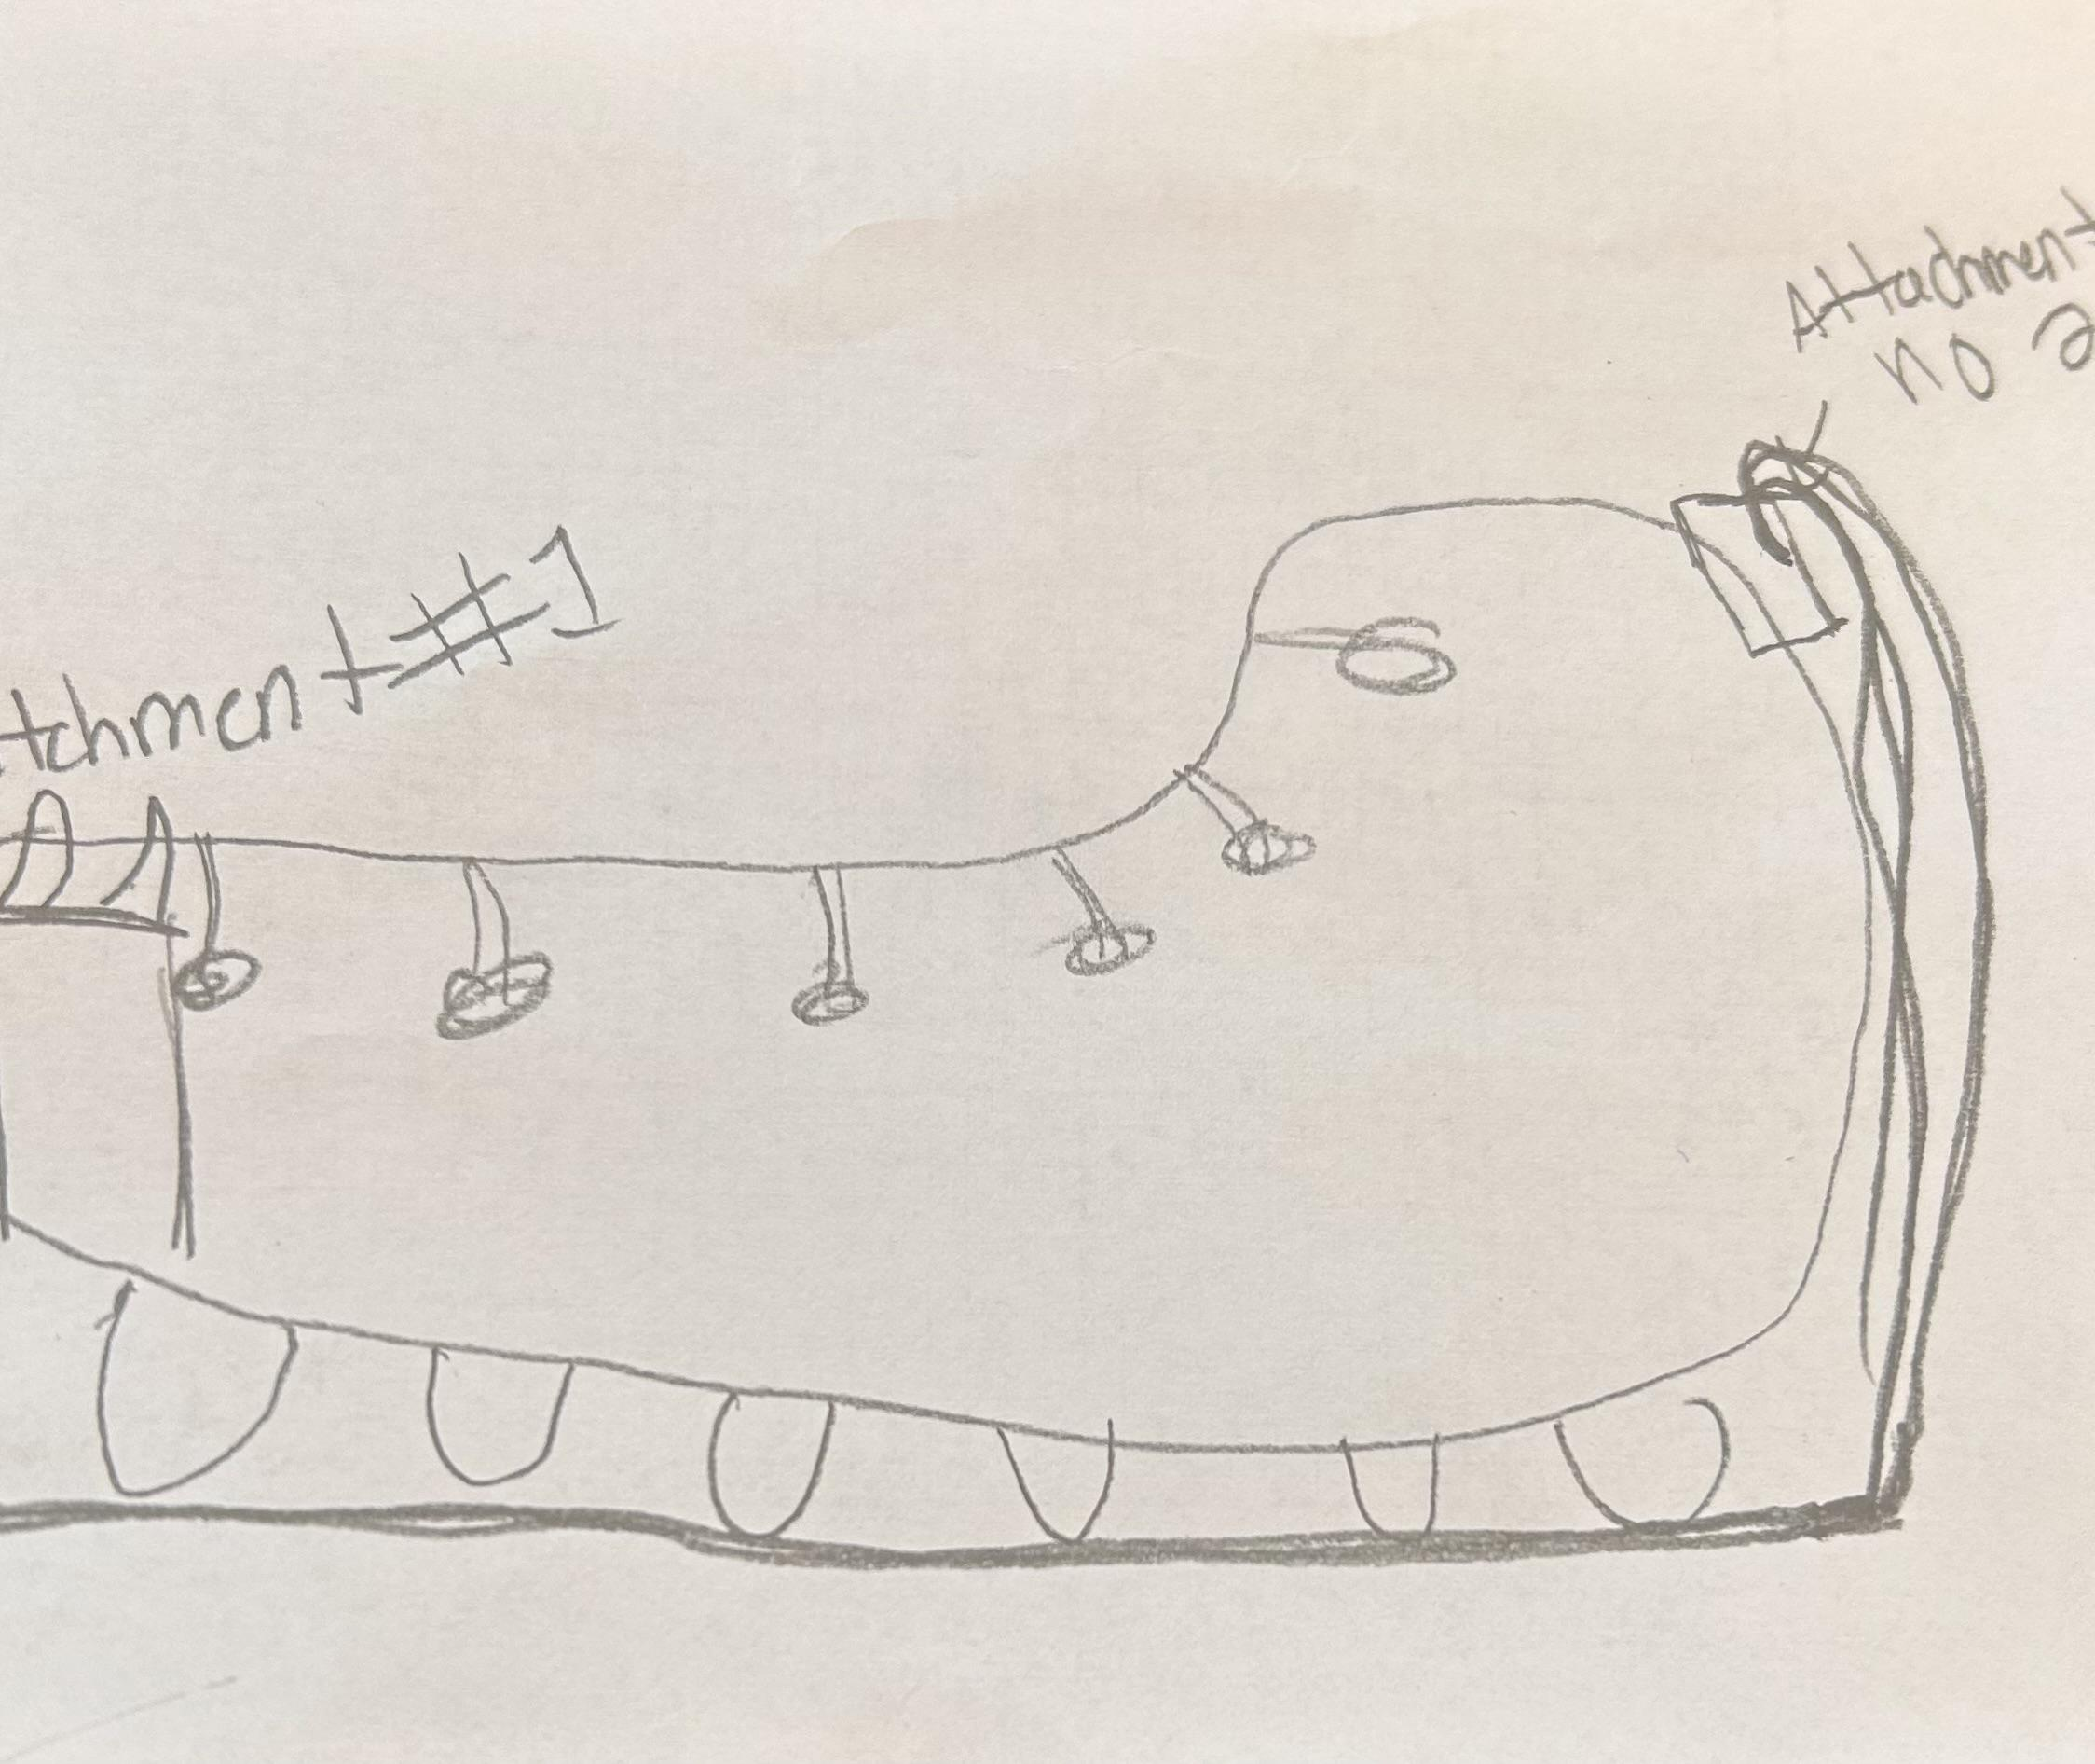

Design Idea Comparison and Selection (D1, D2)
When you’ve finished generating ideas, you must compare your design options according to all your design requirements. Incorporate the priority of those requirements when comparing design options. A decision matrix (perhaps a Pugh Matrix) is encouraged since it allows for systematic, weighted comparisons. If using weights in a decision matrix, be sure to explain and justify the weighting based on your design requirements. You may use the weighted design matrix template below, inserting your criteria and design options.

 | weight | Slip on cover | Slide on sleeve | Clip on plate
Safety on tile | 5 | 5 | 5 | 5
Ease of use | 4 | 3 | 4 | 2
durability | 4 | 4 | 3 | 4
cost | 3 | 3 | 4 | 2
Damage to tile | 3 | 5 | 5 | 5
score | 95 | 77 | 80 | 70

Design Blueprint (D4)
Describe all of your design's details such that someone unfamiliar with your project could build your prototype. Include sketches, dimensions, CAD (if taught in your class), manufacturing methods, material choices, supply lists, and costs.
Design Blueprint #1
Date: 2/11/26
Sketch: This cloth shoe cover
Manufacturing Methods: Made in China or Made in Pakistan
Step 1:
Step 2:
Step 3:
Supply List and Costs:
Item | Cost each | # needed | Total
cloth | 8.00$ | 200 | 1,600$
Rubbery bottom layer | 2.00$ | 200 | 400$
Total Cost | 10.00$ | 400(things) | 2,000$

Plan of Action (D3)
A Gantt chart is encouraged to lay out the primary steps expected on a visual timeline. Larger tasks from the Gantt chart should be broken down further into detailed sub-tasks, which may be housed in a different day-to-day document. Discrete tasks should include enough detail such that others could replicate the efforts, such as procedures, materials, tools, status, etc.
- Brainstorm
1.1 make multiple design ideas
1.2 talk through the pros and cons of each idea
1.3 sketch the designs
- Design camparason
- Blue print making
3.1 make detailed sketch with dimensions
3.2 figure out the materials needed

- Finding materials
- Prototype construction
- Testing product
6.1 test slip resistance
6.2 test fit on shoe
- Redesign based on test
- Finalize product

