MyDesign Portfolio
Element D Initial Template

Element D: Design Concept Generation, Analysis, and Selection

Design Idea Generation (D1)

Design Idea #1
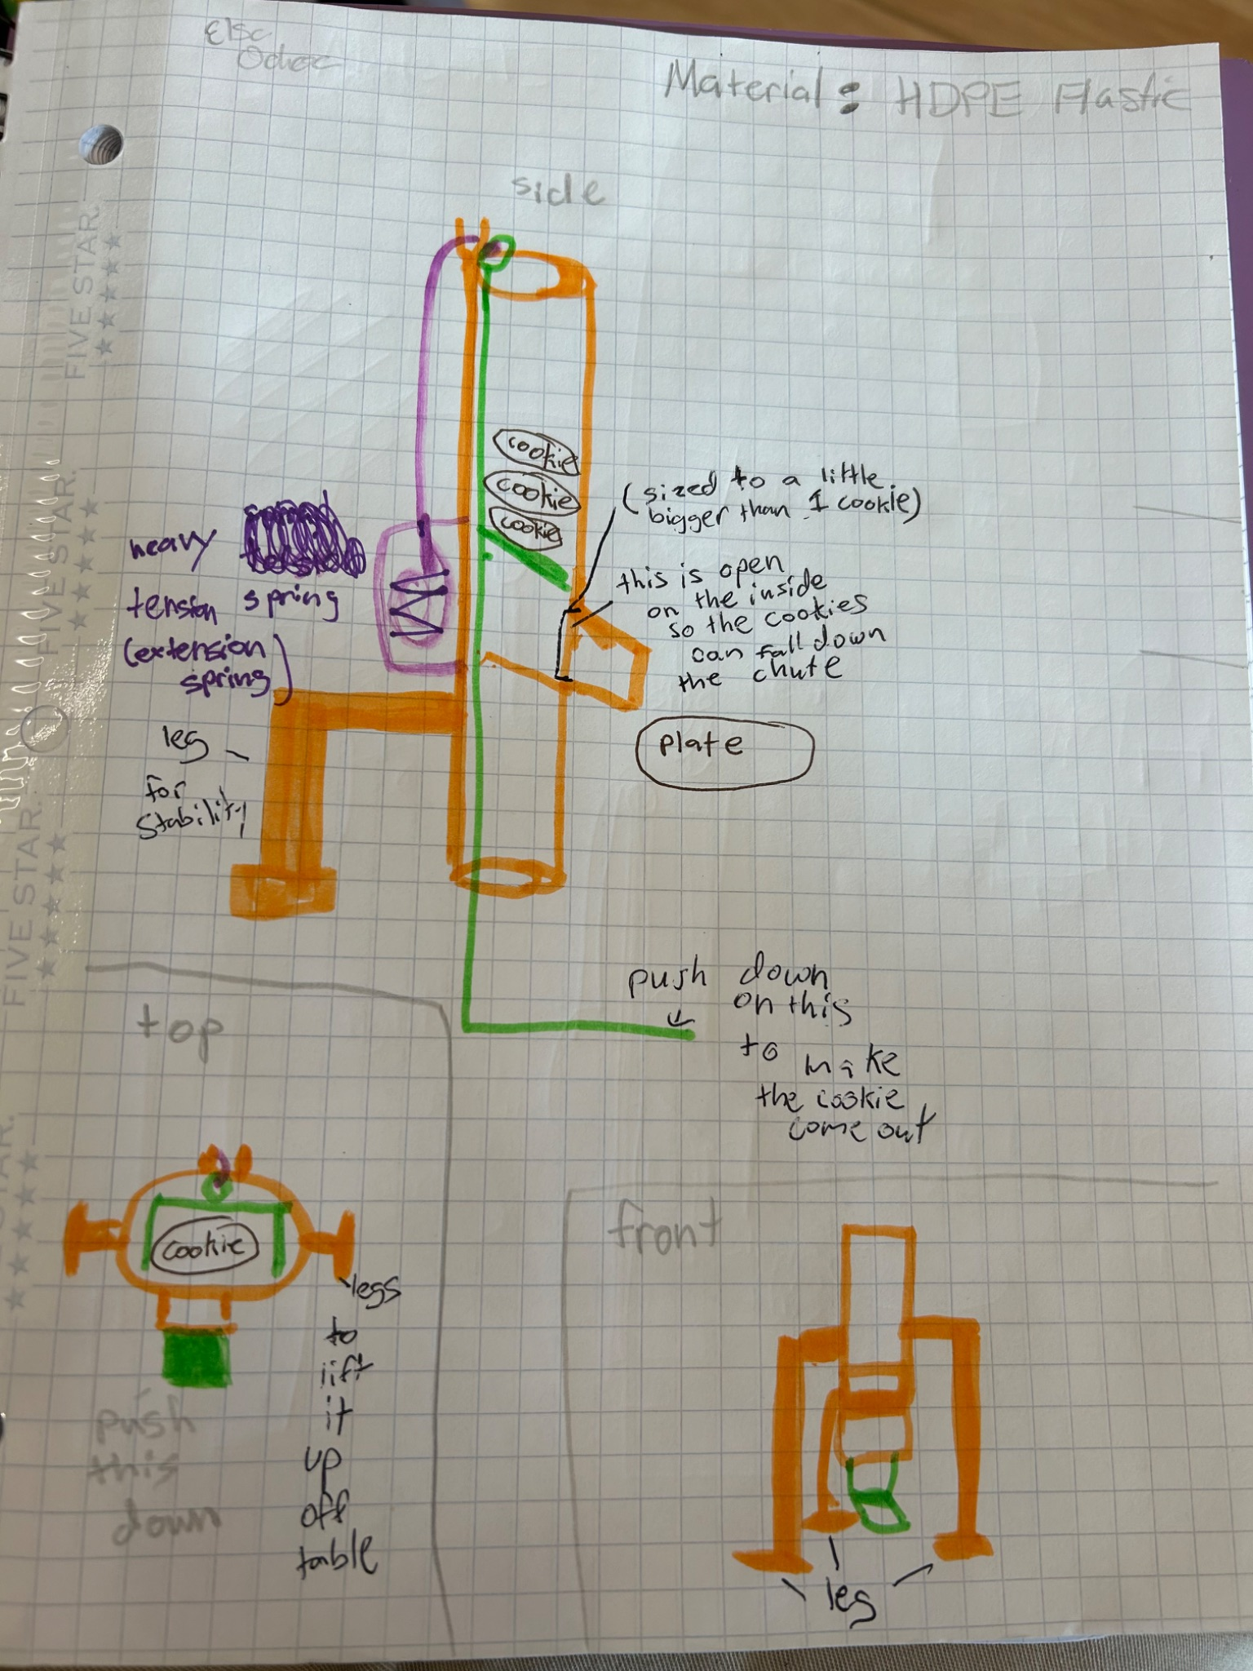
Date: February 11, 2026
Description: This would be a dispenser. It would function where you push down on a lever, and in turn a cookie would fall out onto your plate. This requires two hands, but it could be updated to only use one. This requires a plate to fall onto, but is sanitary because your hands would not be touching the food and only the level which would be able to be easily cleaned. The material would be made out of hdpe plastic. This must be on a table, it cannot be wall mounted or standalone. (Drawing Not To Scale, drawn to show how product works)
Dimensions: 30 inches(height)

Design Idea #2
Date:February 11, 2026
Description: This dispenser would produce prepackaged cookies with the insert of a special coin/ticket and a click of a button. The ticket/coin prevents a person from being able to take more than two cookies. The structure would be made of steel and glass. The glass door would be able to open and close with the use of a key or special card. The opening ensures that the owner is able to clean the inside and replace or add more cookies. Dimensions: 1930x850x830(HxLxW)
Drawing that includes distinguishing information such as scale, dimensions, and materials: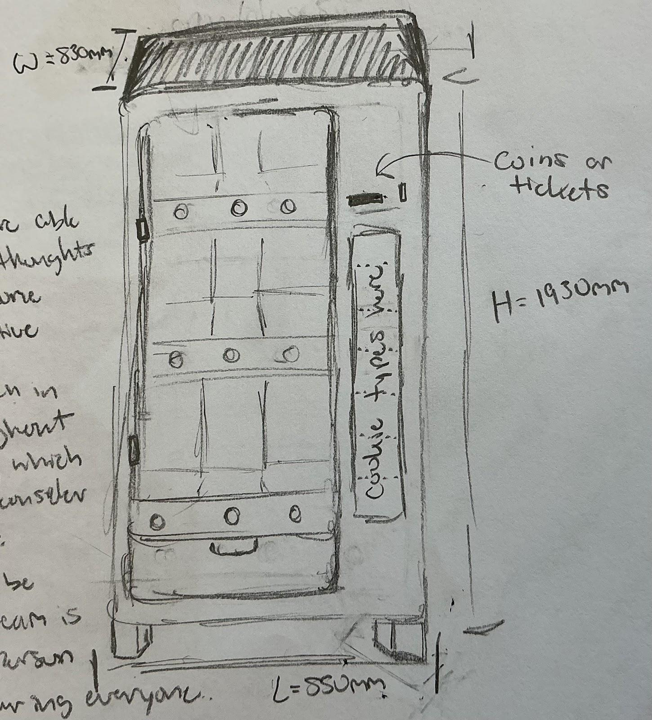

Design Idea #3
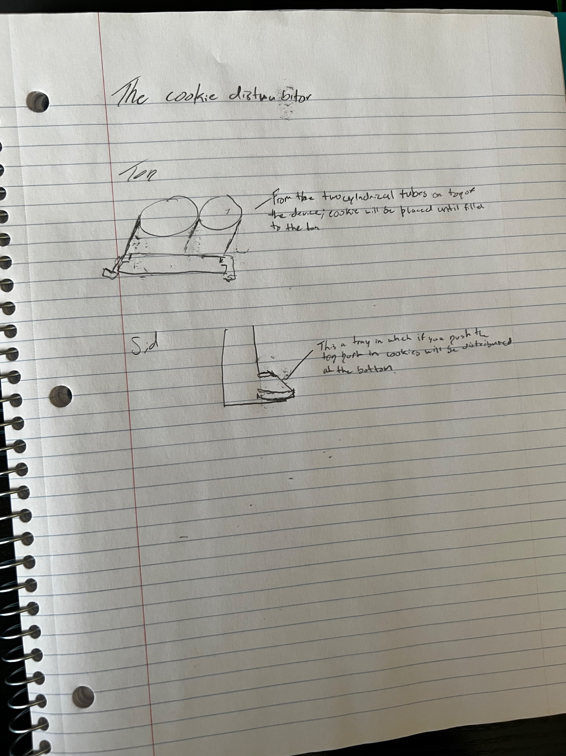
Date:
Description: Within this design it would include a cookie dispenser that is two feet tall and one foot long made through 3d printing with a mechanism that will have the cookies stacked within the tube and distributed with a push in mechanism that will distribute two cookies at a time on a tray so the user can collect the cookies one dispensed.
12 inches width x 8 inches height
Design Idea #4
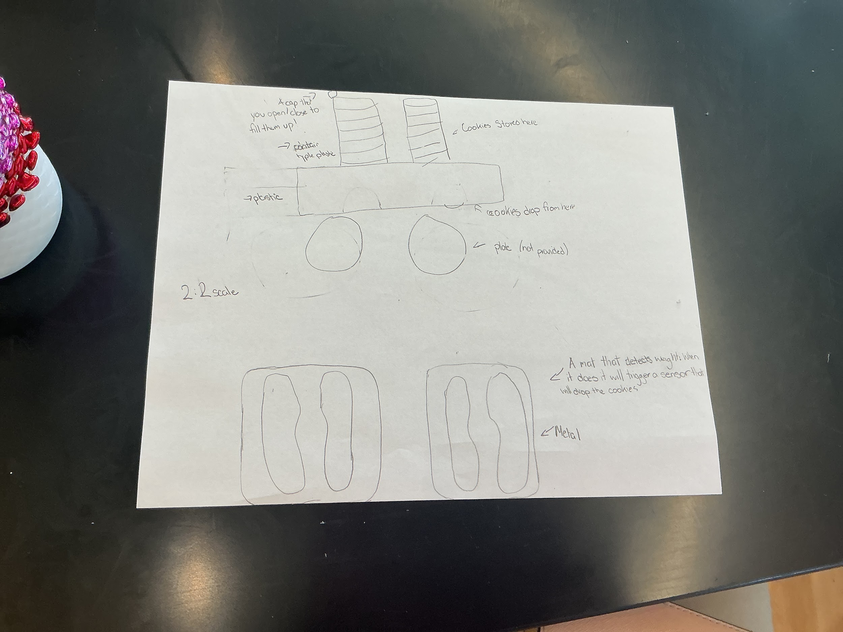
Date: 2/17/2026
Description:
A cookie dispenser made with a combination of plastic and metal. A metal scale will detect the weight of a human standing on it and will trigger a sensor to distribute two cookies onto a plate. The scale will not be able to tell students their weight.
Mat would be a 24 x 24 inch
Cookie stacks 12 inches long

Design Idea Comparison and Selection (D1, D2)
Rating out of 5 for each criterion
 | Option 1 | Option 2 | Option 3 | Option 4
Safety | 5 | 5 | 4 | 5
Speed | 5 | 1 | 5 | 3
Sanitary | 4 | 4 | 3 | 4
Durability | 4 | 4 | 4 | 4
Capacity | 4 | 4 | 3 | 4
score | 22 | 19 | 18 | 19
Option 1:
Rated safety 5 because it is relatively safe and there are no sharp points/pinch points. Rated Speed 5 because it is extremely quick and efficient. Rated Sanitary 4 because it is made out of HDPE plastic, so it is safe at high temperatures. Rated durability 4 because it can be used for a long period of time and does not have many replaceable parts. Rated capacity 4 because it is able to hold many cookies.
Option 2:
Rated safety 5 because it is extremely safe and easy to use. Rated speed one because a vending machine takes a long time to process and would not be quick. Rated sanitary 4 because it is very clean to touch since the cookies would be prepackaged. Rated durability 4 because it would be able to be used over and over again. Capacity is four because it would be able to hold many cookies in the vending machine.
Option 3:
Safety is a four because it is safe to use and there are no pinch points or sharp edges. Speed is a five because it could be processed and distributed very efficiently. Sanitary is a 3 because you would have to pick up the cookies with your hands out of the cup of the dispenser, and durability is a 4 because it would be able to withstand prolonged use. Capacity is a 3 because it would be able to hold many cookies.
Option 4:
Safety is a five since the dispenser is activated by weight. Speed is a 3 since it would take a bit to sense the weight and then distribute. Sanitary is a 4 because there is not a lot of hand to machine contact so not many cross contamination points. Durability is a four since it would be able to be used over and over again. Capacity is also a four because it would be able to hold a lot of cookies.

Design Blueprint (D4)
Design Blueprint #1
Date: February 12
Sketch: Refer to design #1
Manufacturing Methods:
Step 1: Purchase materials
Step 2: Shape them into our creation.
Step 3: Assemble parts.
Supply List and Costs:
Item | Cost each | # needed | Total
HDPE plastic | 0.80/lb | 20 lbs | $16
Heat resistant poly-rope | 2.50/ft | 24 inches | $5.00
Spiral torsion spring | $10 | 1 | $10
Total Cost (estimate) |  |  | $31

Plan of Action (D3)
A Gantt chart is encouraged to lay out the primary steps expected on a visual timeline. Larger tasks from the Gantt chart should be broken down further into detailed sub-tasks, which may be housed in a different day-to-day document. Discrete tasks should include enough detail such that others could replicate the efforts, such as procedures, materials, tools, status, etc.
Week 1:
Day 1: Print/ build the inside part (green part). Made with HDPE plastic. Separate it into two parts, into the part you will push down and the part that holds cookies.
Day 2: Print/ build the outside (orange part). Made with HDPE plastic.
Day 3: Attach the spiral torsion spring.
Day 4: Move the green part inside of the orange part, and attach the rope to it.
Day 5: Attach the rope to the spiral torsion spring.
Day 6: Print the legs.
Day 7: Attach the legs to the side and stand it up.

