MyDesign Portfolio
Element D Initial Template

Element D: Design Concept Generation, Analysis, and Selection
Design Idea #1
Date: February 19th, 2026
Description: Curtains
Drawing that includes distinguishing information such as scale, dimensions, and materials:
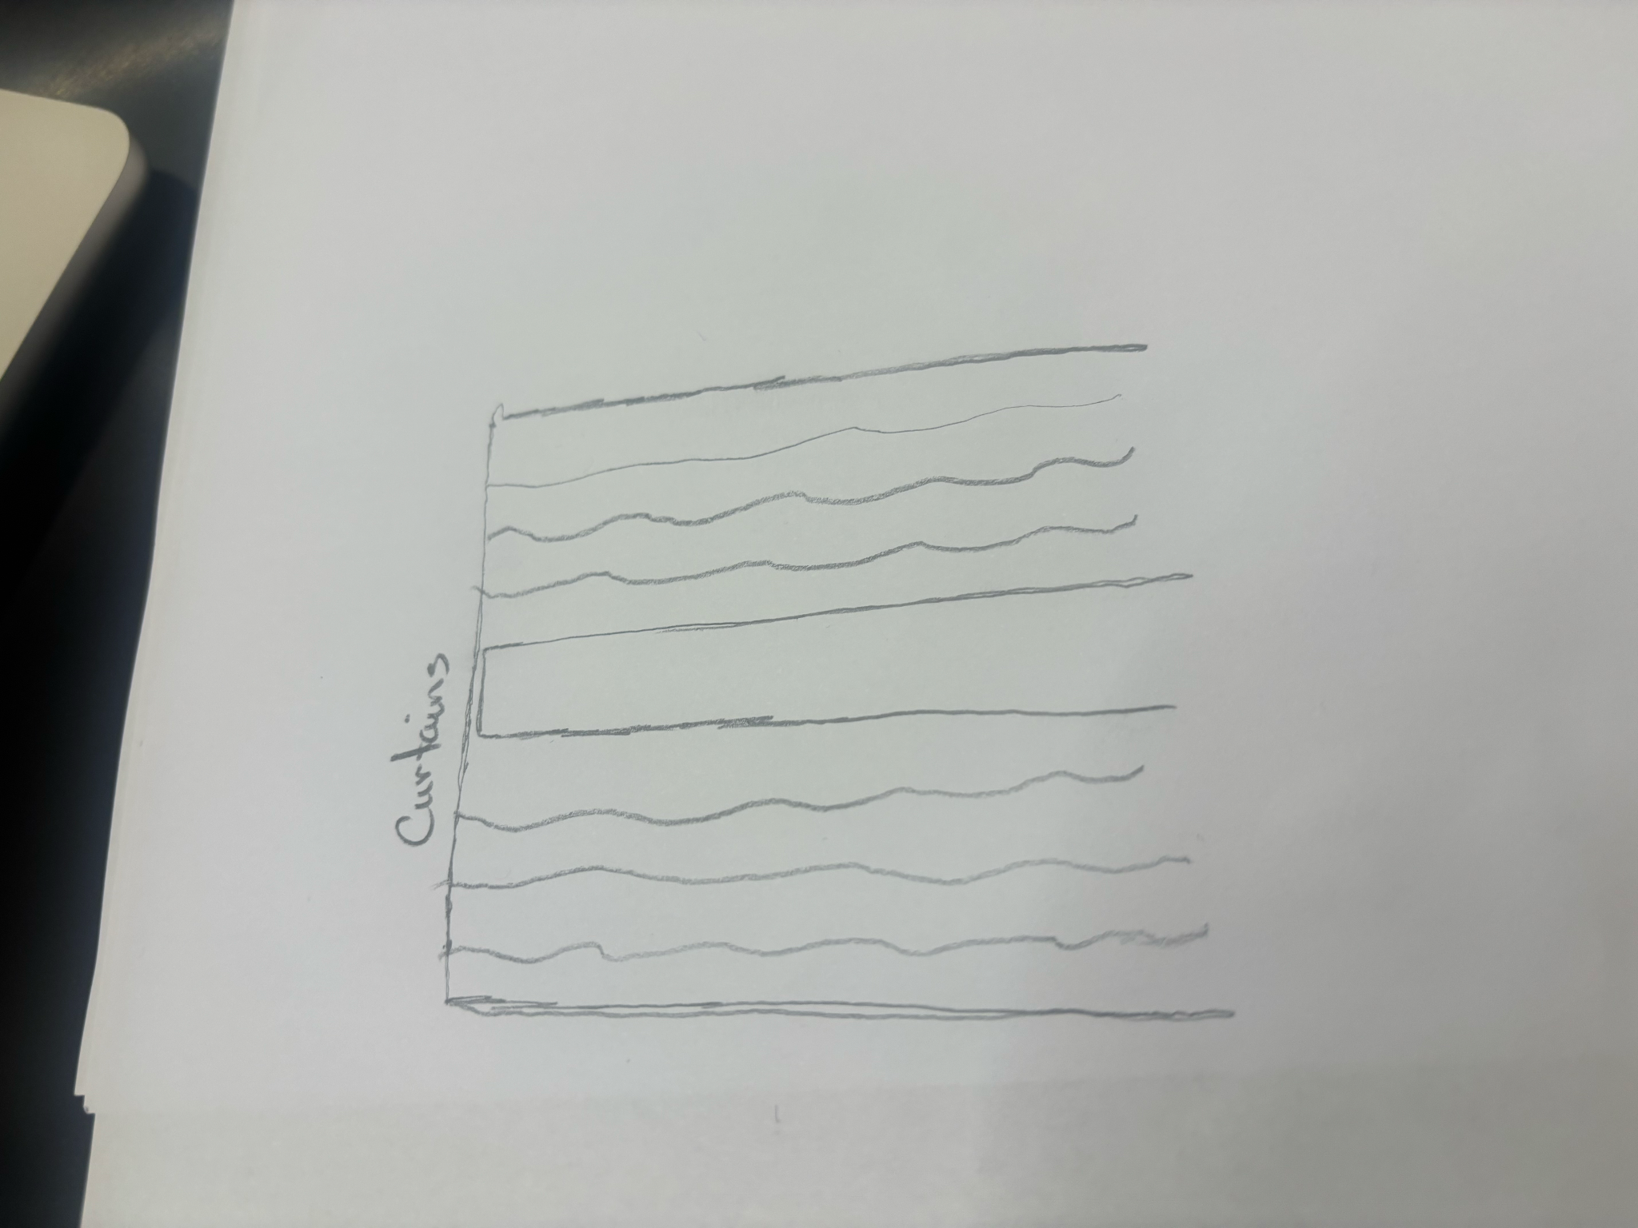

Design Idea #2
Date: February 19th, 2026
Description: Angled Lights
Drawing that includes distinguishing information such as scale, dimensions, and materials:
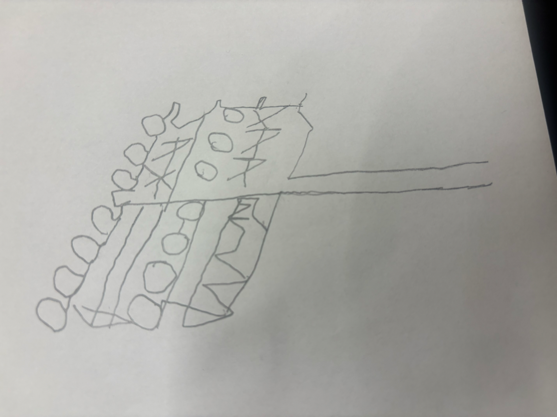
Design Idea #3
Date: February 19th, 2026
Description: Storing lights in between the trees and the field, against the houses so light doesn’t seep through the houses.
Drawing that includes distinguishing information such as scale, dimensions, and materials:
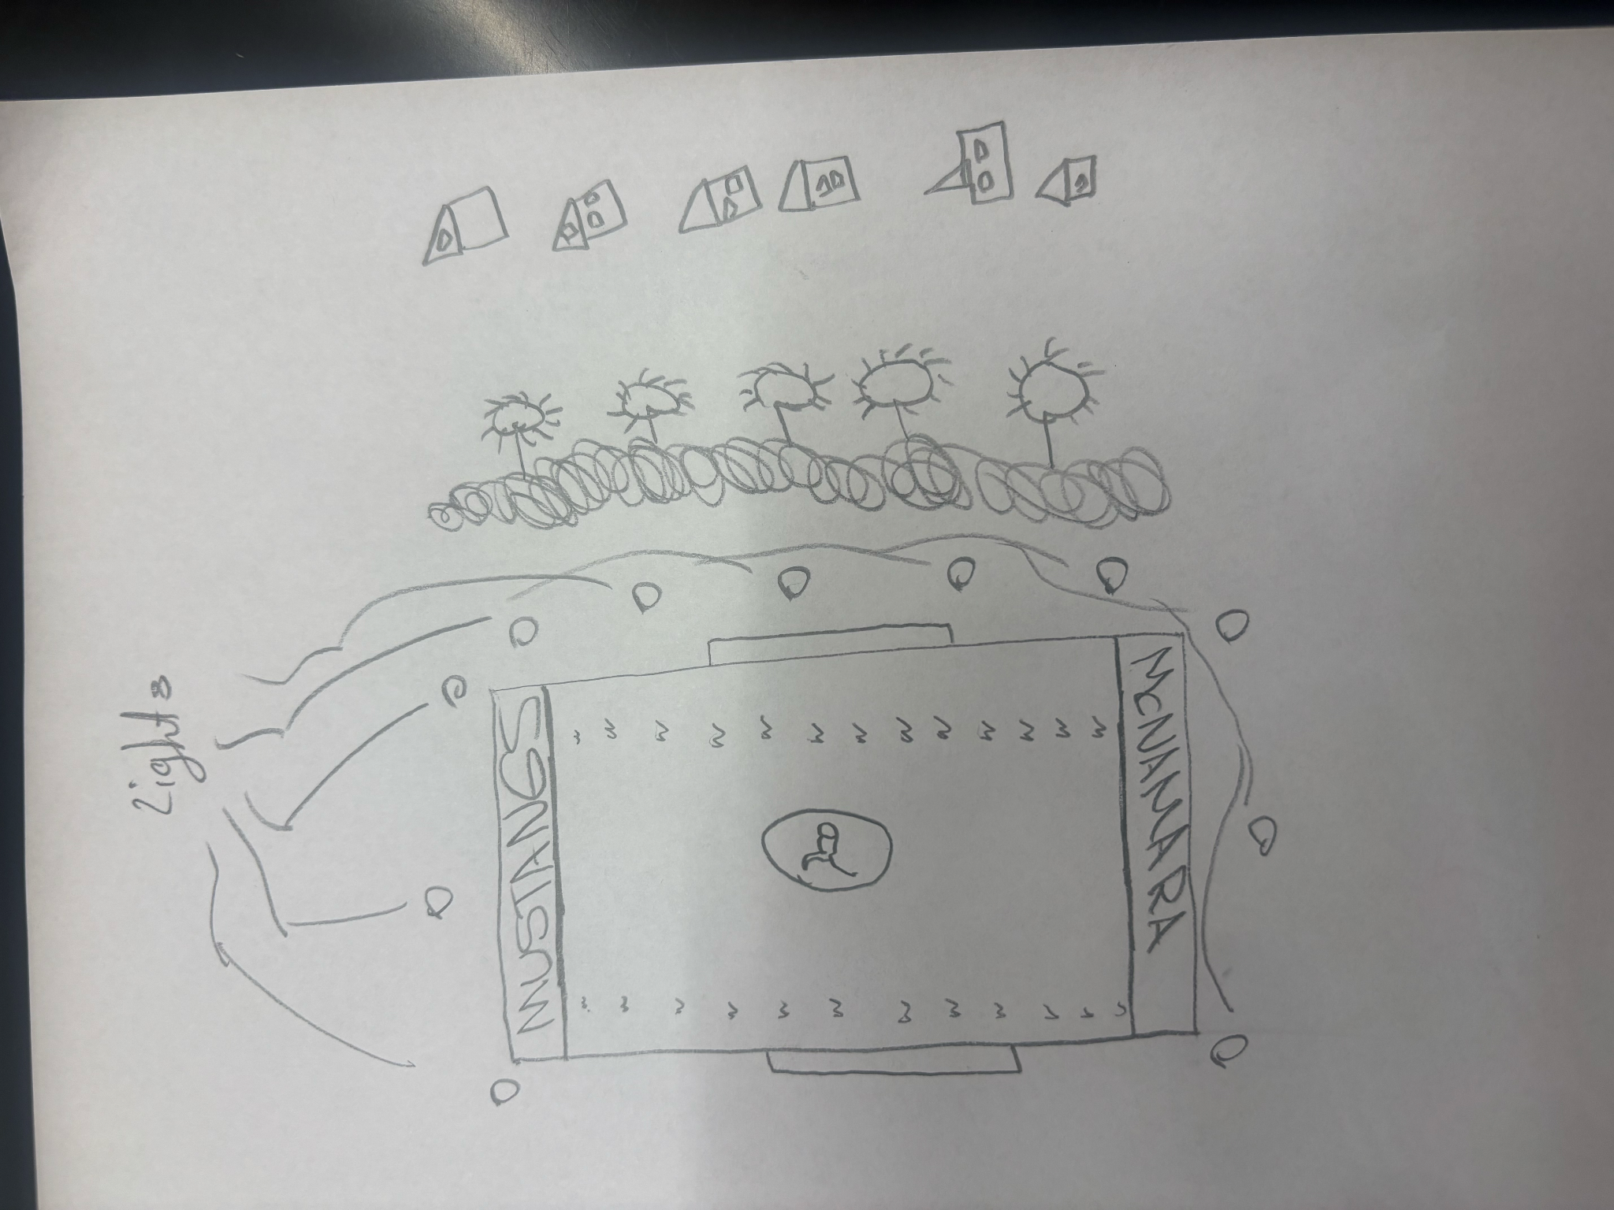

Design Idea Comparison and Selection (D1, D2)

 | weight | Curtains | Angled Lights | Lights in between filed and houses
Safety | /10 | 10 | 10 | 10
Price | /10 | 3 | 10 | 10
Easy to install | /10 | 10 | 10 | 10
score |  | 23 | 30 | 30

Design Blueprint (D4)

Design Blueprint #1
Date: February 19th, 2026
Sketch: 
Manufacturing Methods:
Step 1: Obtain supplies
Step 2: Build Light Blockers
Step 3: Put up the lights
Supply List and Costs:
Item | Cost each | # needed | Total
Rods | $50 | 5 | $250
Tarps | $150 | 5 | $170
Nails | $15 | 10 | $150
Water Proof LED Stadium Lights | $900 | 4 | $3600
180 Yards of polyethylene | $135,000 | 27,000 sq ft | $135,000
Total Cost | Cost: 136,115 | 27,024 | $139,170

Plan of Action (D3)
A Gantt chart is encouraged to lay out the primary steps expected on a visual timeline. Larger tasks from the Gantt chart should be broken down further into detailed sub-tasks, which may be housed in a different day-to-day document. Discrete tasks should include enough detail such that others could replicate the efforts, such as procedures, materials, tools, status, etc.

