MyDesign Portfolio
Element D Initial Template

Element D: Design Concept Generation, Analysis, and Selection

Design Idea Generation (D1)
This section focuses on the process of generating solutions. The initial rounds should include every idea you come up with but the subsequent rounds of ideation should lead to viable options. Each idea should include not only words, but also a picture. Use as many copies of this sub-template as needed.
Compost Bin

Date: 2/10/26
Description: Compost bin(s) next to food disposal trash bins. Doesn’t address the problem of ordering too much food, but helps address food waste by ensuring the food isn’t thrown away to garbage
Design Idea #2
Date: 2/10/26
Description: Different sized plates, ranging from small to big plates. There is evidence smaller plates discourage overeating, so it could reduce the need for food.
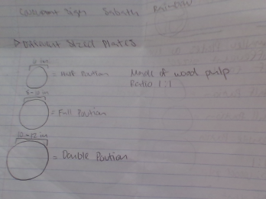

Design Idea #3
Date: 2/10/26
Description: A middle lane of food between where the two line barriers currently are. This makes it easier for people to get foot and thus discourages getting more food than needed, and a built in compost bin can reduce storage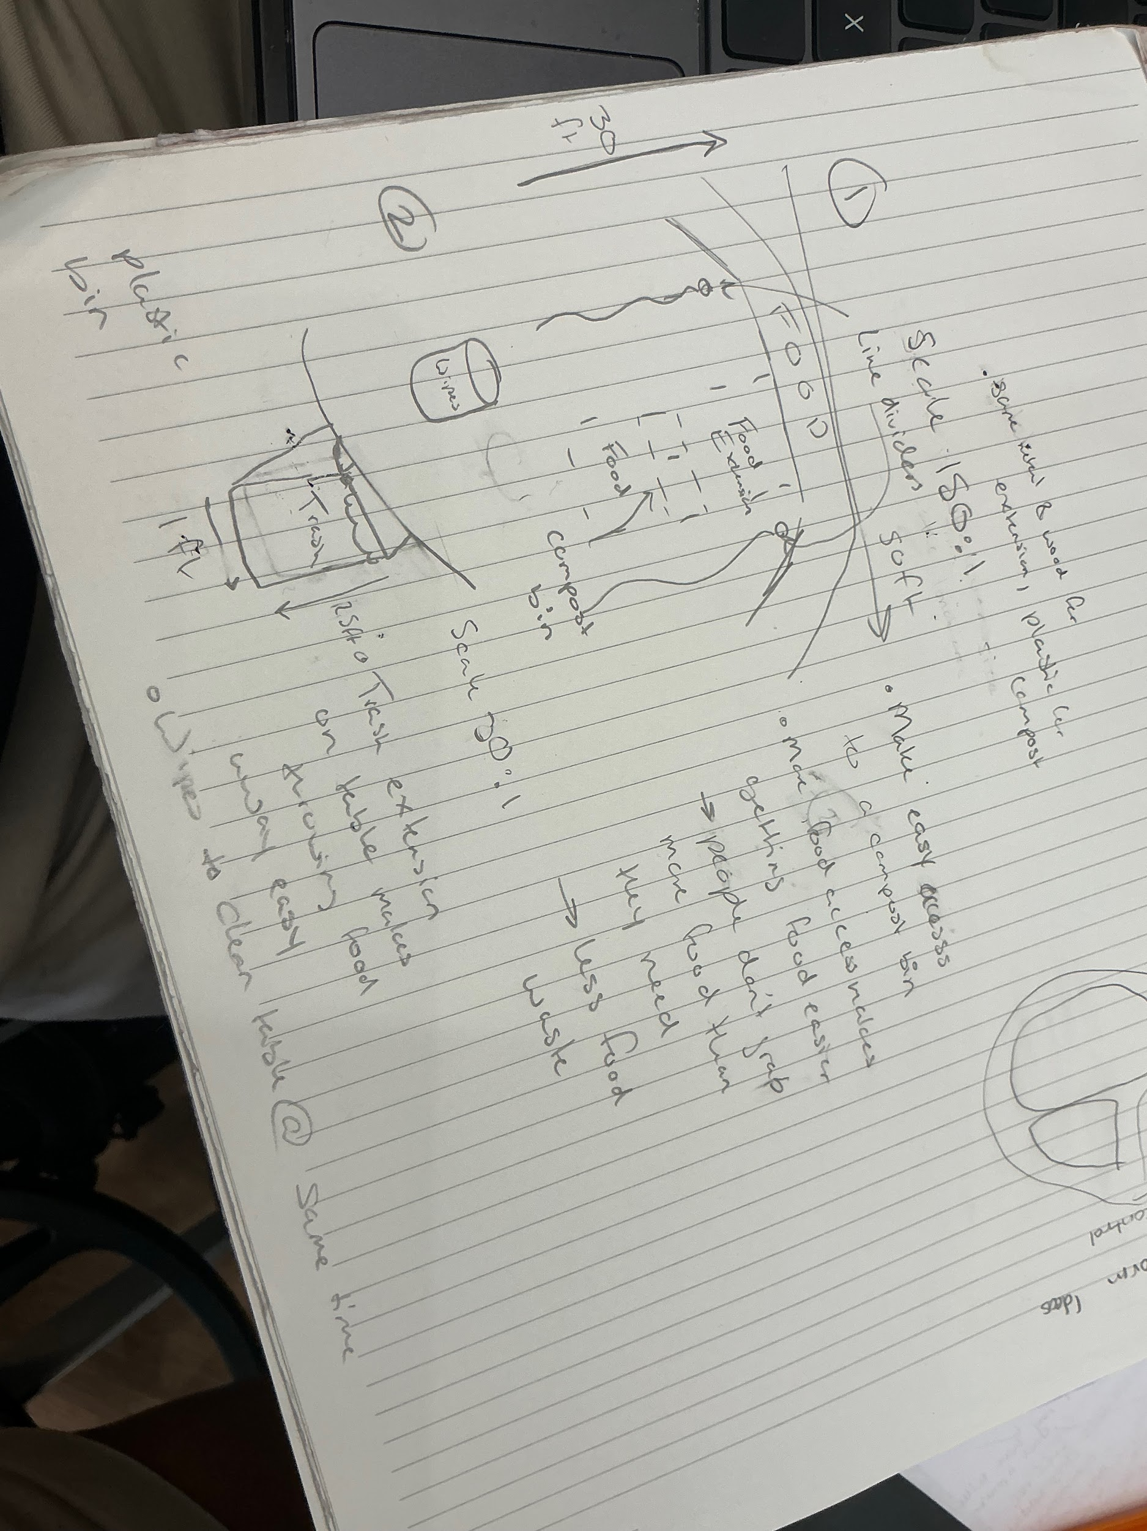
Design Idea #4
Date: 2/10/26
Description: A series of plates that come in different depths that allow students to curate their food intake based on how much food they want.
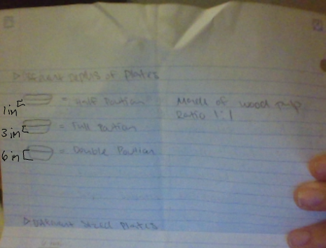

Design Idea Comparison and Selection (D1, D2)
When you’ve finished generating ideas, you must compare your design options according to all your design requirements. Incorporate the priority of those requirements when comparing design options. A decision matrix (perhaps a Pugh Matrix) is encouraged since it allows for systematic, weighted comparisons. If using weights in a decision matrix, be sure to explain and justify the weighting based on your design requirements. You may use the weighted design matrix template below, inserting your criteria and design options.

 | D1 | D2 | D3 | D4
Within School public Health Guidelines -10 |  |  |  | 
Have access to food throughout lunch period -10 |  |  |  | 
Meet Sage institutional standards -10 |  |  |  | 
Appealing to Students -10 |  |  |  | 
Effectively reduce food waste -10 |  |  | 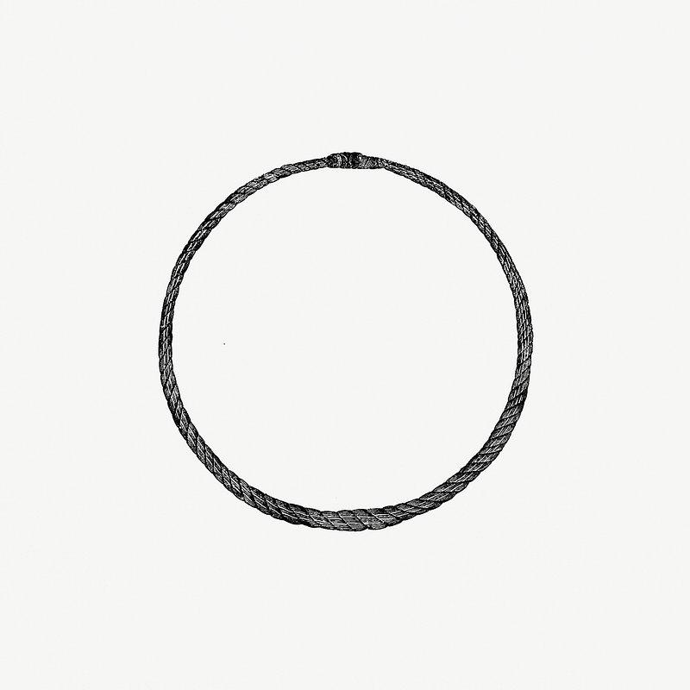 | 
Minimize water usage -5 |  |  |  | 
Rely on greater national initiatives to dispose of food -5 |  |  |  | 
Score of D1: 40 points
Score of D2 : 55 points
Score of D3: 45 points
Score of D4: 30 points

Design Blueprint (D4)
Describe all of your design's details such that someone unfamiliar with your project could build your prototype. Include sketches, dimensions, CAD (if taught in your class), manufacturing methods, material choices, supply lists, and costs.
Design Blueprint #1
Date: 2/10/26
Sketch: 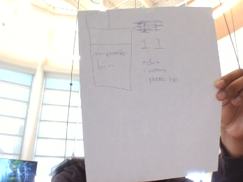
Manufacturing Methods:
Step 1: Buy compost bin
Step 2: buy dirt
Step 3: put next to trash cans in the lunchroom
Supply List and Costs:
Item | Cost each | # needed | Total
Compost bin | $100- $250 each | 4 | $400-$1000
dirt | $10 - $75 each | 10 | $100 - $750
Total Cost | $110 - $1250 |  | $500 - $1750

Design Blueprint #2
Date: 2/10/26
Sketch: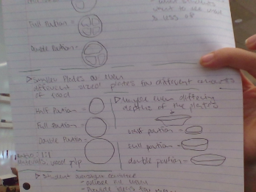
Manufacturing Methods:
Step 1: buy small plates
Step 2: buy medium plates
Step 3: buy large plates
Supply List and Costs:
small plates eco paper plates | 35.99 bulk ¢3.6 per plate | 8 | 320
medium plates | 51.49 bulk ¢5.1 per plate | 8 | 411.92
large plates | 54.49 | 8 | 435.92
Total Cost |  |  | 1,167.84
Design Blueprint #3
Date:2/10/26
Sketch:
Manufacturing Methods:
Step 1: buy another table
Step 2: buy compost bin
Step 3:
Supply List and Costs:
Item | Cost each | # needed | Total
table | 619.39 | 1 | $619.39
compost bin | $100-$250 | 1 | $250
Total Cost
Design Blueprint #4
Date:2/10/26
Sketch: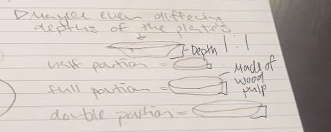
Manufacturing Methods:
Step 1: buy small plates
Step 2: buy medium plates
Step 3: buy large plates
Supply List and Costs:
Item | Cost each | # needed | Total
small plates eco paper plates | 35.99 bulk ¢3.6 per plate | 8 | 320
medium plates | 51.49 bulk ¢5.1 per plate | 8 | 411.92
large plates | 54.49 | 8 | 435.92
Total Cost |  |  | 1,167.84

Plan of Action (D3)
A Gantt chart is encouraged to lay out the primary steps expected on a visual timeline. Larger tasks from the Gantt chart should be broken down further into detailed sub-tasks, which may be housed in a different day-to-day document. Discrete tasks should include enough detail such that others could replicate the efforts, such as procedures, materials, tools, status, etc.

