MyDesign Portfolio
Element D Initial Template

How to use this template
Teachers: You may customize this document before providing it to students.
Students: The template below is one way to present your design ideas, but the specific assignment given by your instructor may require a different structure or dictate different details. If you make a copy of this template to edit for your own design ideas, be sure to delete the instructions.

Guidance before filling out the template on the next page:
Because you will iterate on your design multiple times, you will need to create multiple copies of these sections. Think of Element D as a diary that you will date and keep adding to throughout your work until your final iteration. It’s critical that iteration shines through in this Element.
You should begin with many design ideas that reflect the individual ideas of your group members and then the group ideas. Number these ideas and include a date, description, drawing, and details for each.
After you have created an initial set of ideas, document your decision making on which design to include, ideally with a design matrix. Create a plan of work, ideally using a Gantt chart that may be housed in this document or in a different day-to-day document. Generate a design blueprint with enough details that someone else not familiar with your project could also build your design.
You will then proceed forward to build and test this design, returning to Element D afterwards when you are ready to create more design ideas. Fill out each of these steps again.

Element D: Design Concept Generation, Analysis, and Selection

Design Idea Generation (D1)
This section focuses on the process of generating solutions. The initial rounds should include every idea you come up with, but the subsequent rounds of ideation should lead to viable options. Each idea should include not only words, but also a picture. Use as many copies of this sub-template as needed.
Design Idea #1
Date: February 12, 2026
Description: Individually putting hot sauces on each table (prevents long lines) with permanent retractable connected cords that sprout from the middle of the table. In this model there's a rubber stopper preventing the hot sauces from being pulled out. Its rubber material is tough enough to be hard to destroy but soft enough so it doesn't make a loud clank when hitting the table.
-Some type of 3d printed prototype to connect it to the table ( retractable)
Drawing that includes distinguishing information such as scale, dimensions, and materials:
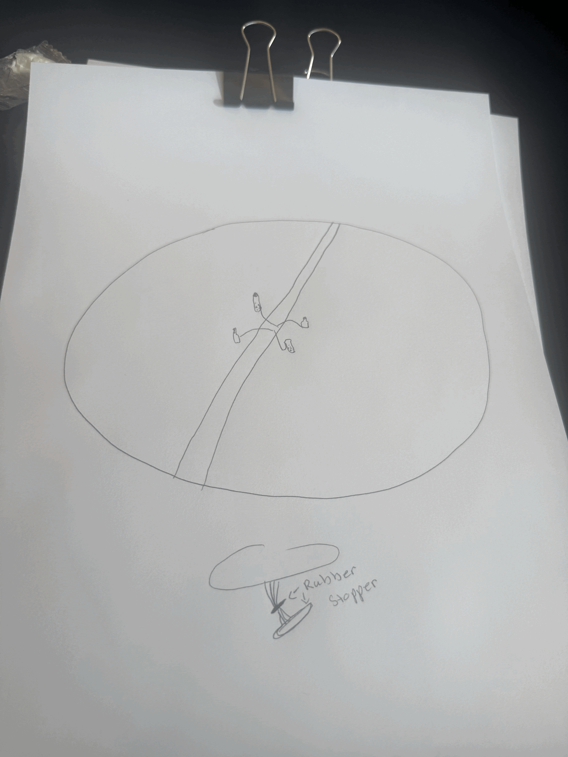
Design Idea #2
Date: February 12, 2026
Description: attaching bottles to the table via a retractable string design or a pump design
Drawing that includes distinguishing information such as scale, dimensions, and materials:
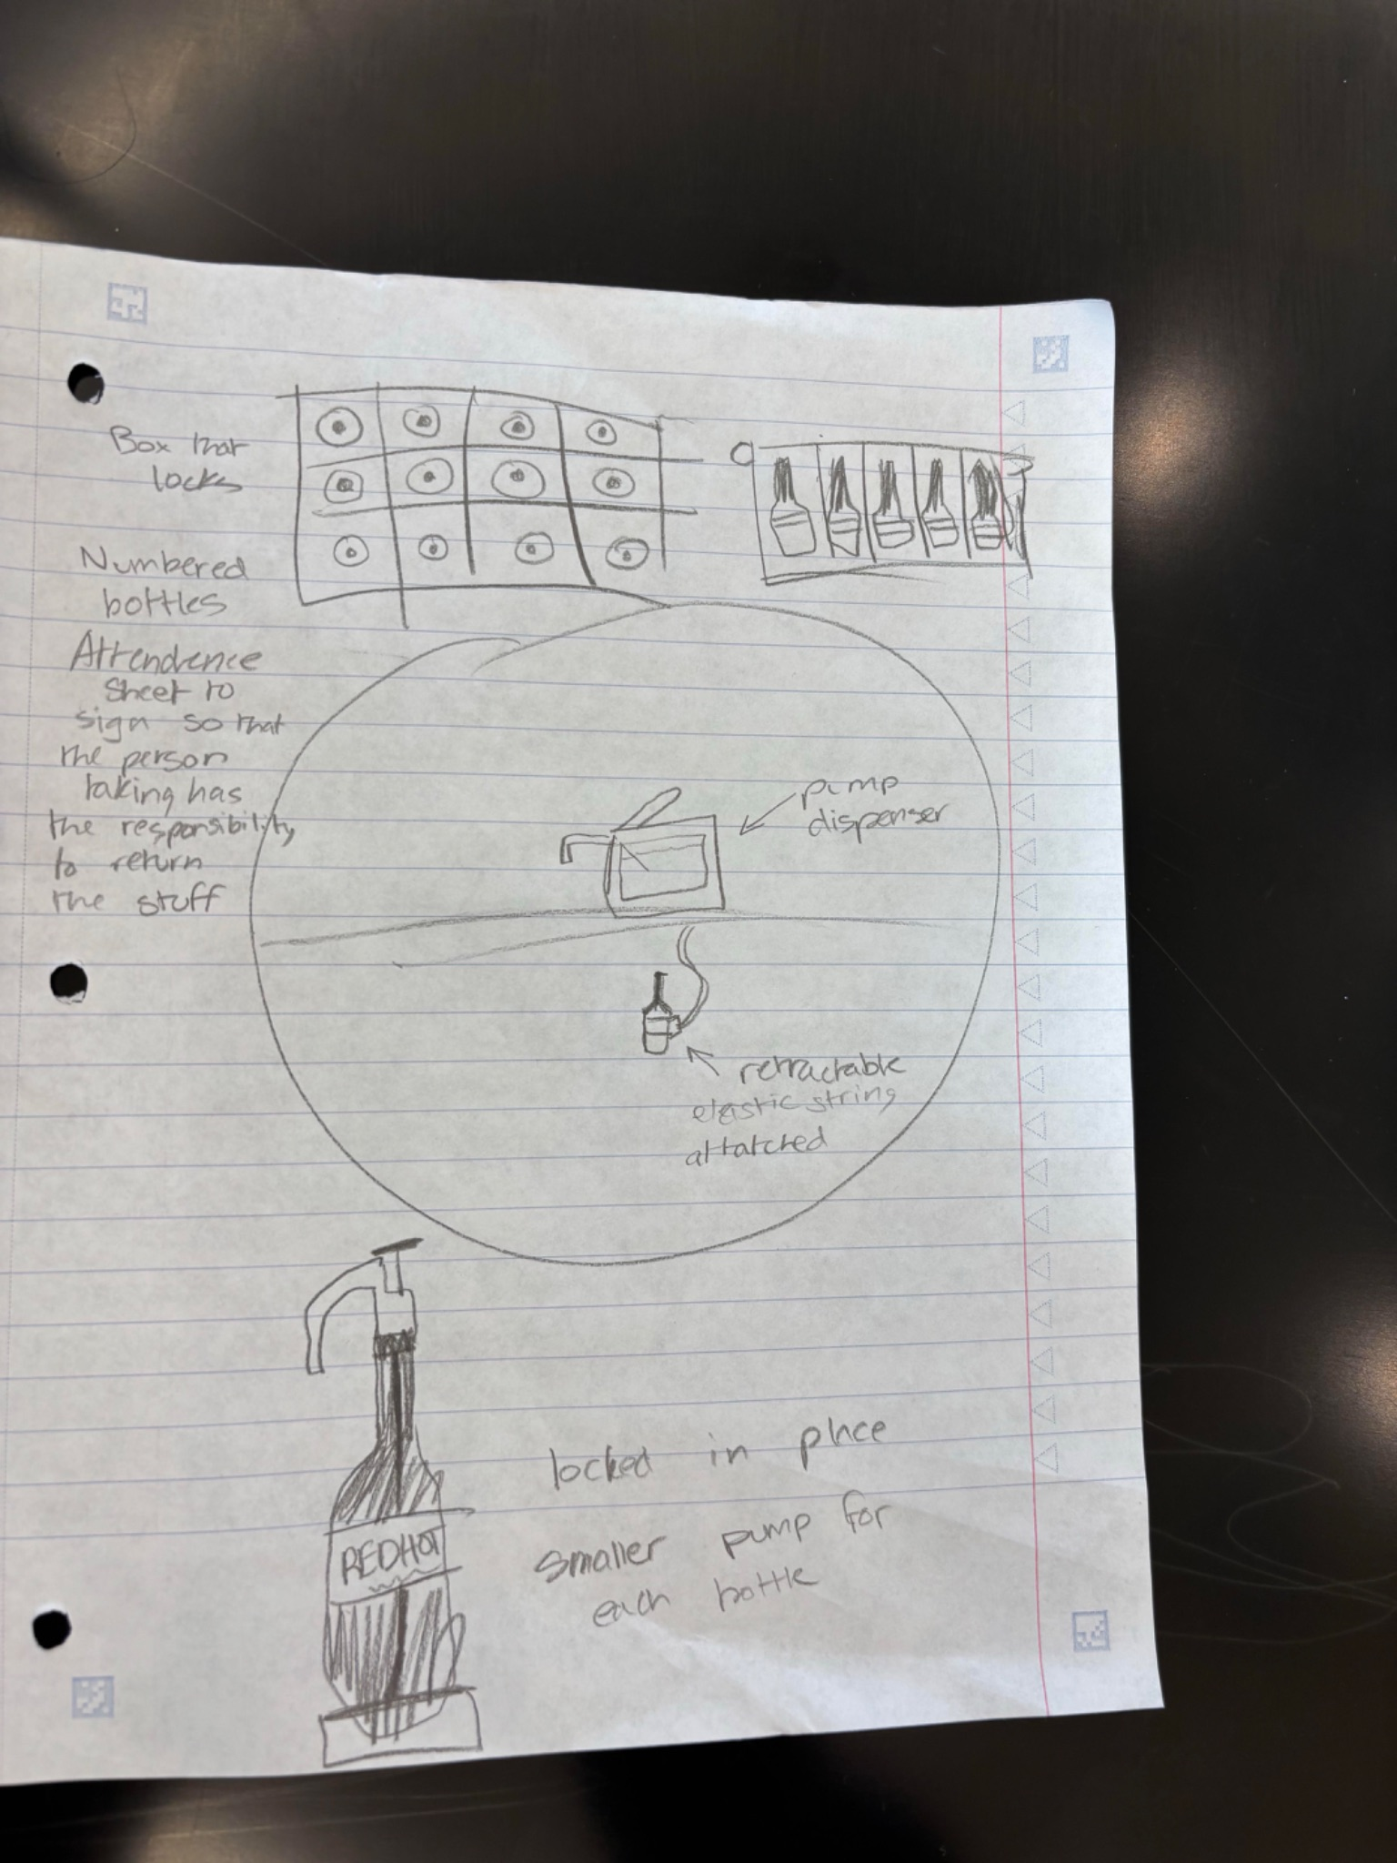
Design Idea #3
Date: 2/18/26
Description: The hot sauce is in the middle of the table. It is on a wire that is underneath the table. This will allow the students to pull it up and move it around without it getting stuck or loose.
Drawing that includes distinguishing information such as scale, dimensions, and materials:
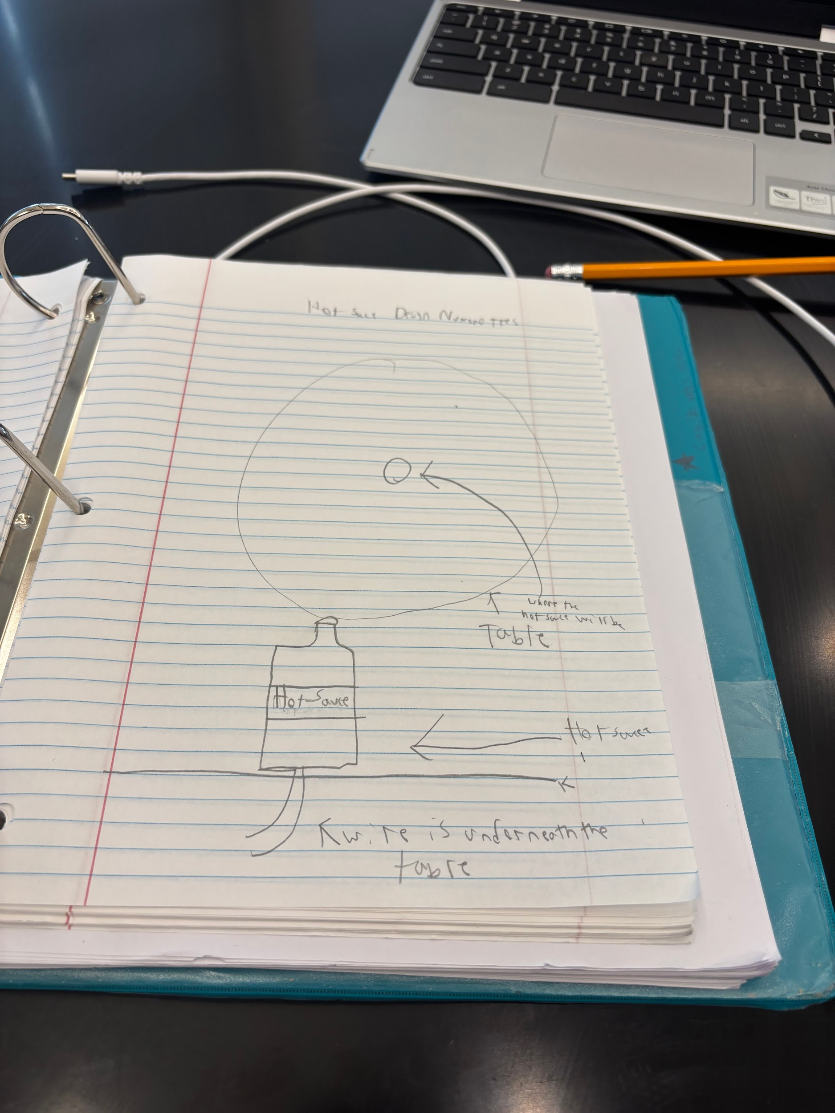

Design Idea Comparison and Selection (D1, D2)
When you’ve finished generating ideas, you must compare your design options according to all your design requirements. Incorporate the priority of those requirements when comparing design options. A decision matrix (perhaps a Pugh Matrix) is encouraged since it allows for systematic, weighted comparisons. If using weights in a decision matrix, be sure to explain and justify the weighting based on your design requirements. You may use the weighted design matrix template below, inserting your criteria and design options.

 | weight | Option 1 | Option 2 | Option 3
Durability |  | 7 | 10 | 9
Elasticity |  | 10 | 1 | 10
How Effective |  | 7 | 8 | 10
Variety |  | 2 | 1 | 2
Length |  | 10 | 7 | 7
score |  | 36 | 27 | 38 | /50

Design Blueprint (D4)
Describe all of your design's details such that someone unfamiliar with your project could build your prototype. Include sketches, dimensions, CAD (if taught in your class), manufacturing methods, material choices, supply lists, and costs.
Design Blueprint #1
Date: 2/19/25
Sketch:

Manufacturing Methods:
Step 1: Made by students with store bought materials
Step 2: Ordered already made to be installed easily
Step 3: 3-D Printed portions to attach to one another
Supply List and Costs:
Item | Cost each | # needed | Total
Non-metallic Sheathed Cable | $1.50 per foot  $3 for 3 feet | At most 4 feet  One for each table | $6  $384
Condiment Pump | $168.49 | One for each table | $21,566
Hot Sauce | Up to $25 per liter | One for each table | $3200
Total Cost |  |  | $28,350

Plan of Action (D3)
A Gantt chart is encouraged to lay out the primary steps expected on a visual timeline. Larger tasks from the Gantt chart should be broken down further into detailed sub-tasks, which may be housed in a different day-to-day document. Discrete tasks should include enough detail such that others could replicate the efforts, such as procedures, materials, tools, status, etc
Detailed plan for the next 10 classes:
Day 1 | Day 2 | Day 3 | Day 4 | Day 5 | Day 6 | Day 7 | Day 8 | Day 9 | Day 10
 |  |  | Taylor:prototype using rubber bands as elastic element |  |  |  |  | Taylor: use the 3D printer for any parts of the design
All: Design Blueprint and draw up designs | All: discuss and critique designs to combine ideas and figure out collective thoughts | All: Choose one design to focus on | Cortez: use string to prototype extending design | All: look over designs and recognize flaws and provide constructive criticism | All: work on fixes to the design that seems most successful | All: decide what final materials we should settle on, and figure out final blueprint on how the final design will look | All: start construction on the final design | Amaiya: create the string that will be attached to the base to stretch for the purpose of easing the products usage | All: continue construction, adapting along the way as the design evolves and starts to fit in to the narrative we wanted to execute
 |  |  | Jonah: use gimp to prototype to create a retractable design |  |  |  |  | Cortez: work on connections and securing the design
 |  |  | Amiaya: create a prototype using balloons and their elastic properties to create a design that can stretch really far |  |  |  |  | Jonah: work on the safety aspects and safety features to ensure the product doesn't doesn’t cause any harm while used

