MyDesign Portfolio
Element D Initial Template

Element D: Design Concept Generation, Analysis, and Selection

Design Idea Generation (D1)
This section focuses on the process of generating solutions. The initial rounds should include every idea you come up with but the subsequent rounds of ideation should lead to viable options. Each idea should include not only words, but also a picture. Use as many copies of this sub-template as needed.
Design Idea #1
Date: 2/18/26
Description: a stadium light pole, can be tall and it is wired to electrical power.
Drawing that includes distinguishing information such as scale, dimensions, and materials: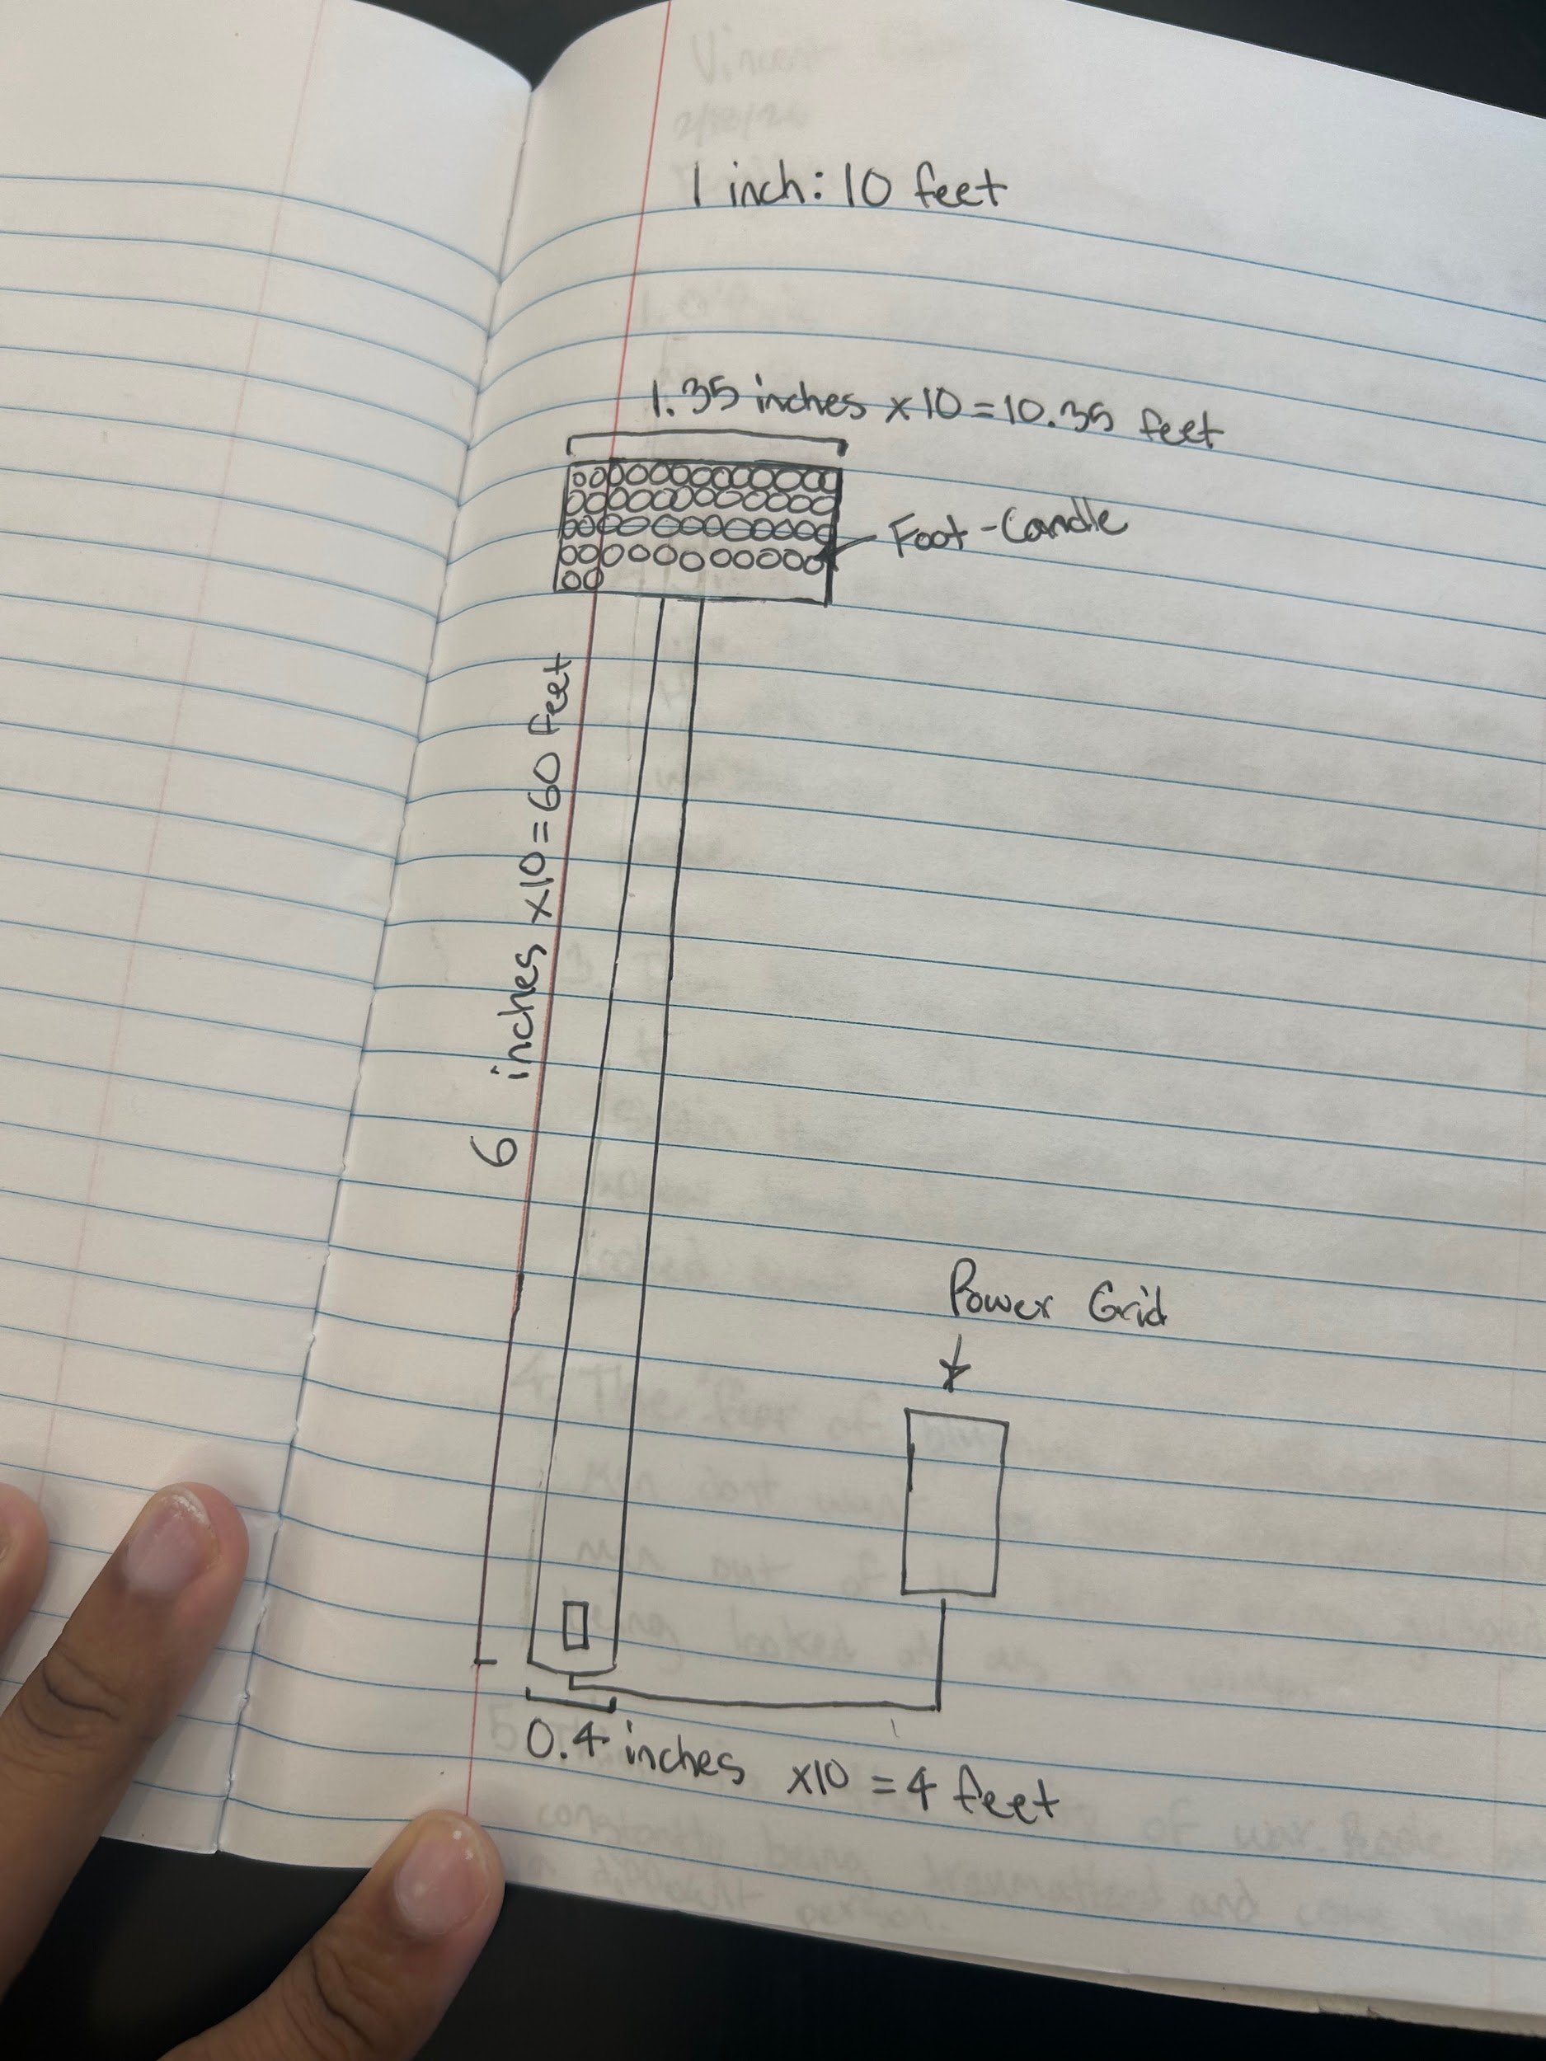
Design Idea #2
Date: 2/18/26
Description: portable lights can be removed when not being used and when they are being used you can bring them back and move them where you like them.
Drawing that includes distinguishing information such as scale, dimensions, and materials: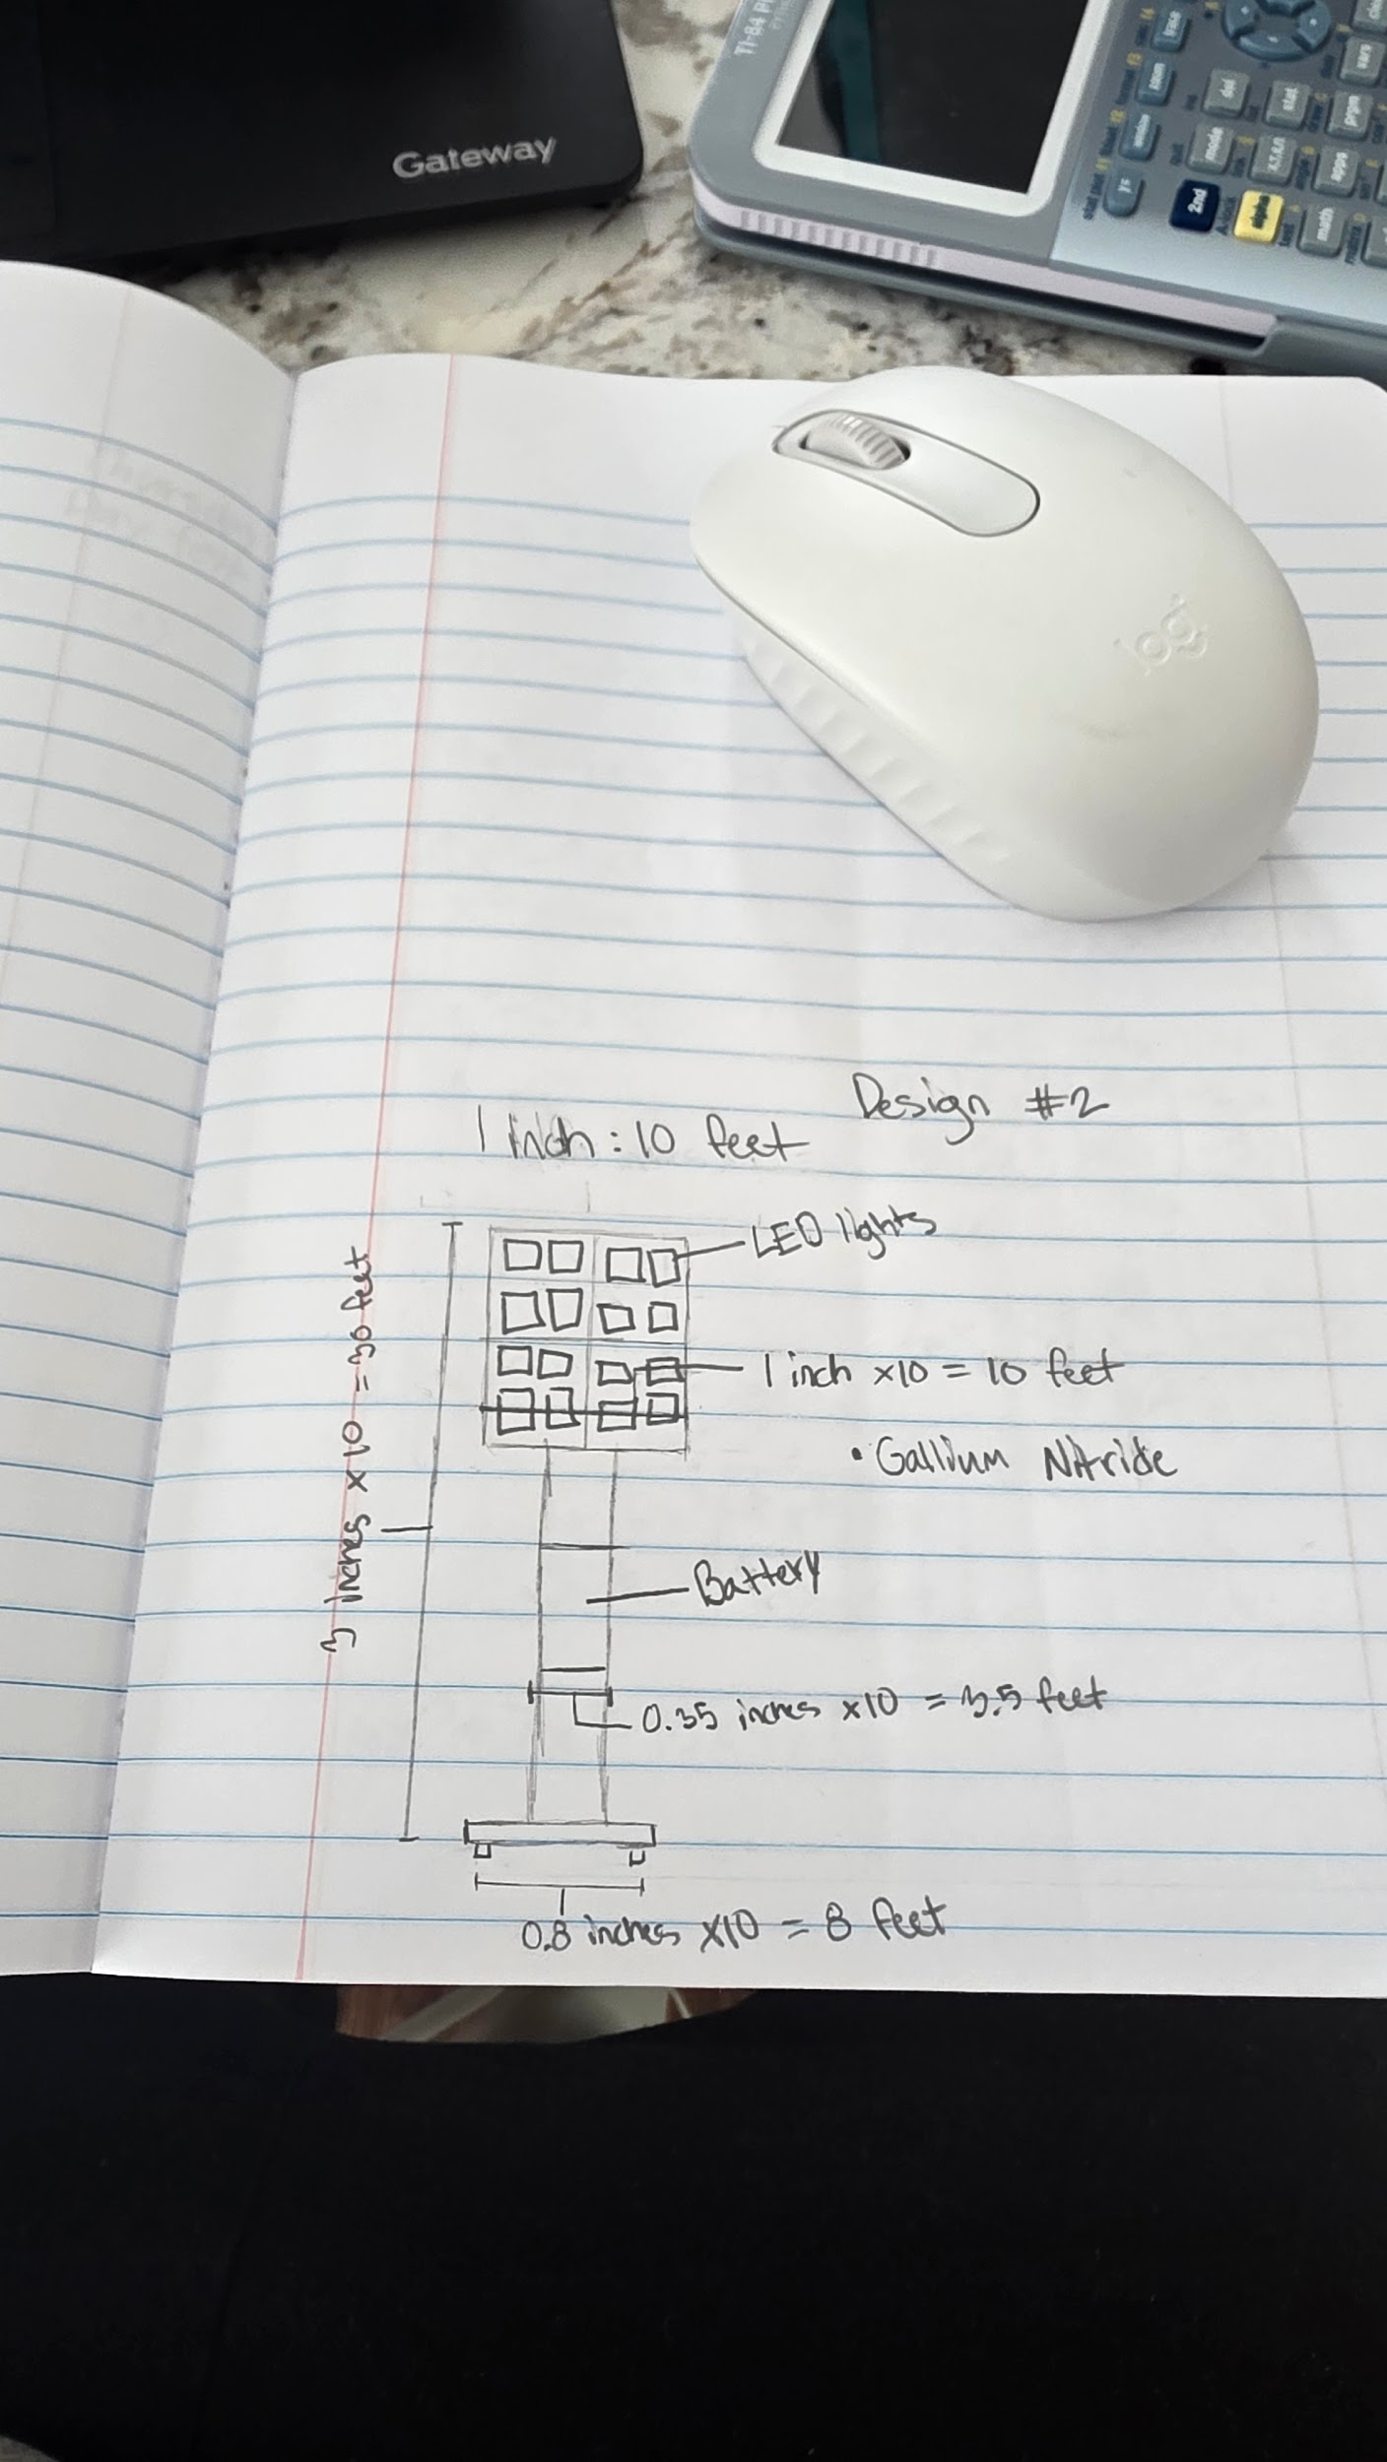
Design Idea #3
Date: 2/18/26
Description: light towers that have batteries inside of them which can last a couple of hours, and so there can be no wires where people trip over them.
Drawing that includes distinguishing information such as scale, dimensions, and materials:
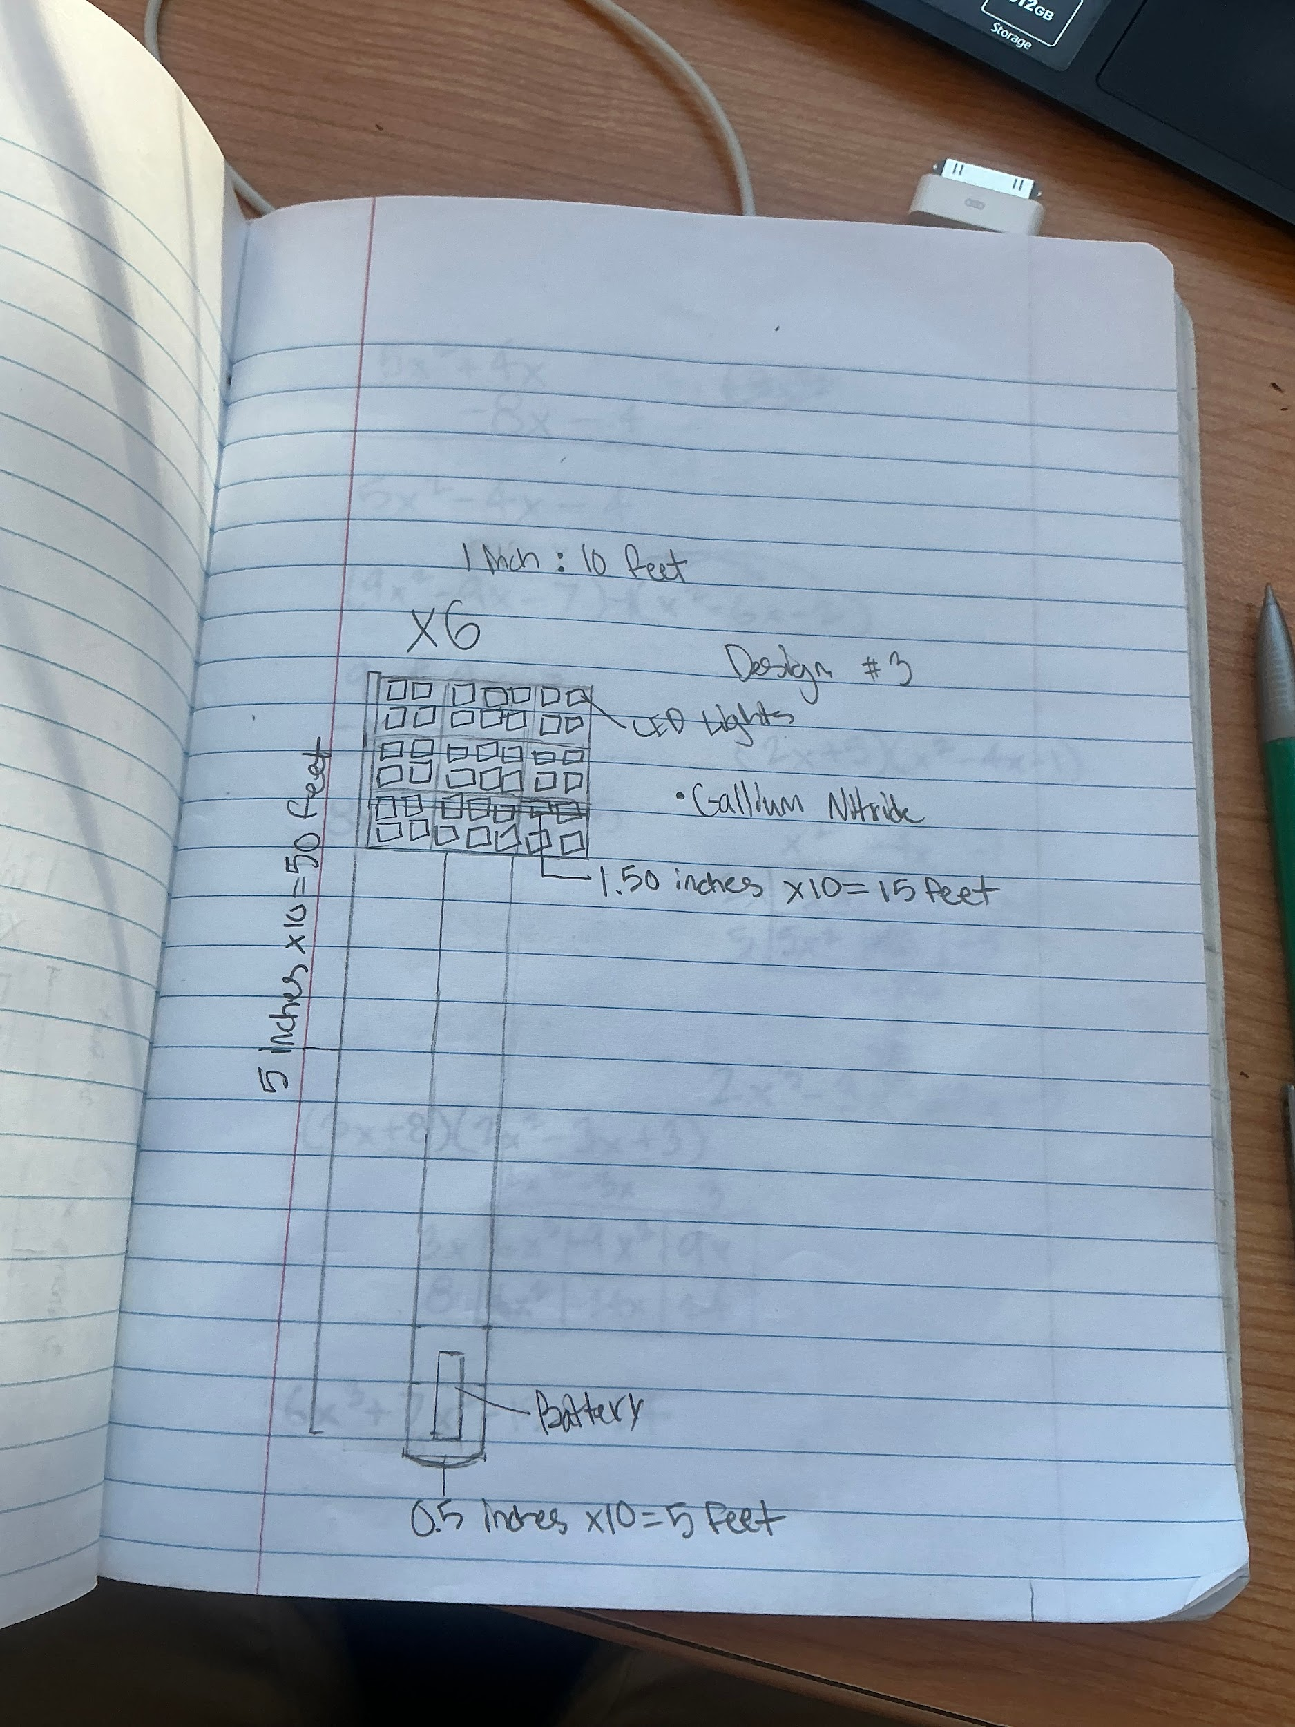

Design Idea Comparison and Selection (D1, D2)
When you’ve finished generating ideas, you must compare your design options according to all your design requirements. Incorporate the priority of those requirements when comparing design options. A decision matrix (perhaps a Pugh Matrix) is encouraged since it allows for systematic, weighted comparisons. If using weights in a decision matrix, be sure to explain and justify the weighting based on your design requirements. You may use the weighted design matrix template below, inserting your criteria and design options.
 | weight | Option 1 | Option 2 | Option 3 | Option 4
Criterion A
Criterion B
Criterion C
Criterion D
Criterion E
score

Design Blueprint (D4)
Describe all of your design's details such that someone unfamiliar with your project could build your prototype. Include sketches, dimensions, CAD (if taught in your class), manufacturing methods, material choices, supply lists, and costs.
Design Blueprint #1
Date: 2/18/26
Sketch:
Manufacturing Methods:
Step 1: pour the concrete to get the base for the poles
Step 2: Add wiring and electrical conduit underground
Step 3: put the poles in the concrete and secure it with bolts
Step 4: Connect the wiring to the panels of the led lights and test lights
Step 5: review the process and see if it works at night time and can last for some time.
Supply List and Costs:
Item | Cost each | # needed | Total
Poles | 1200$ | 6 | 7200$
Led lights | 350$ | 32 | 11,200
Wiring  Concreate  labor | 10$ per ft  1000$ per pole  3000$ per day | 300ft  6  4 days | 3000$  6000$  12000$
Total Cost | 39400$ |  | 39400$

Plan of Action (D3)
A Gantt chart is encouraged to lay out the primary steps expected on a visual timeline. Larger tasks from the Gantt chart should be broken down further into detailed sub-tasks, which may be housed in a different day-to-day document. Discrete tasks should include enough detail such that others could replicate the efforts, such as procedures, materials, tools, status, etc.

