MyDesign Portfolio
Element D Initial Template

How to use this template
Teachers: You may customize this document before providing it to students.
Students: The template below is one way to present your design ideas, but the specific assignment given by your instructor may require a different structure or dictate different details. If you make a copy of this template to edit for your own design ideas, be sure to delete the instructions.

Guidance before filling out the template on the next page:
Because you will iterate on your design multiple times, you will need to create multiple copies of these sections. Think of Element D as a diary that you will date and keep adding to throughout your work until your final iteration. It’s critical that iteration shines through in this Element.
You should begin with many design ideas that reflect the individual ideas of your group members and then the group ideas. Number these ideas and include a date, description, drawing, and details for each.
After you have created an initial set of ideas, document your decision making on which design to include, ideally with a design matrix. Create a plan of work, ideally using a Gantt chart that may be housed in this document or in a different day-to-day document. Generate a design blueprint with enough details that someone else not familiar with your project could also build your design.
You will then proceed forward to build and test this design, returning to Element D afterwards when you are ready to create more design ideas. Fill out each of these steps again.

Element D: Design Concept Generation, Analysis, and Selection

Design Idea Generation (D1)
This section focuses on the process of generating solutions. The initial rounds should include every idea you come up with but the subsequent rounds of ideation should lead to viable options. Each idea should include not only words, but also a picture. Use as many copies of this sub-template as needed.
Design Idea #1
Date: 3/16/25
Description: A balloon on the the top of the apartment filled with baking soda so that when the fire reaches a certain height it will pop and suppress the fire with the baking soda.
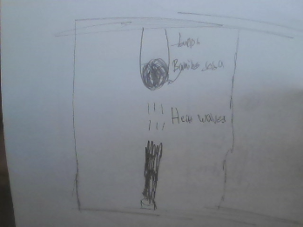
Design Idea #2
Date: 3/13/2026
Description:
An elevated cup hanging on the roof that holds baking soda at the bottom of the cup which is cut out and replaced with tape, so that when the tape is lit on fire it releases the baking soda onto the fire, hopefully suppressing it. Simple yet effective.
Materials: Tape, Plastic Cup, Baking Soda
Dimensions:
- Cylindrical cup: 3’ diameter (Bigger Circle), 2’ diameter (Smaller Circle), 4 inch height
- Baking Soda: Around 1 1/2 cup of baking soda is required to suppress a fire of the size described in the scenario.

Design Idea #3
Date:
Description: A cup filled with baking soda and surrounded with tin foil with baking soda in the inside. We use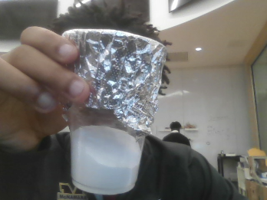 tin foil because it's not flammable and easy to burn through.
Drawing that includes distinguishing information such as scale, dimensions, and materials:

Design Idea Comparison and Selection (D1, D2)
When you’ve finished generating ideas, you must compare your design options according to all your design requirements. Incorporate the priority of those requirements when comparing design options. A decision matrix (perhaps a Pugh Matrix) is encouraged since it allows for systematic, weighted comparisons. If using weights in a decision matrix, be sure to explain and justify the weighting based on your design requirements. You may use the weighted design matrix template below, inserting your criteria and design options.

Criterion | Weight | Ceiling Pod | Heat Sensor | Sprinkler
Use | 0.20 | 2 | 3 | 2
Cost | 0.30 | 5 | 5 | 5
Safety Effectiveness | 0.30 | 5 | 4 | 4
Installation | 0.30 | 2 | 3 | 5
Durability | 0.40 | 4 | 5 | 4
score |  | 20 | 20 | 20

Design Blueprint (D4)
Describe all of your design's details such that someone unfamiliar with your project could build your prototype. Include sketches, dimensions, CAD (if taught in your class), manufacturing methods, material choices, supply lists, and costs.
Design Blueprint #1
Date: 3/13/2026
Sketch: The sketch shows a fire suppression sprinkler system mounted on the ceiling of the living room in a house. A water tank and small pump connected to a plastic tube that runs up the wall to a sprinkler nozzle placed on the ceiling above the area being protected. A temperature sensor near the ceiling detects heat from a fire and activates the pump so water sprays out of the sprinkler to stop the fire.
Manufacturing Methods:
Step 1: Build the base using cardboard or wood. Attach the water tank (plastic bottle) securely to the base.
Step 2: Connect the water pump to the plastic tubing and attach the tubing to the sprinkler nozzle so water can travel from the tank to the sprinkler.
Step 3: Install the temperature sensor and battery pack, connect them to the pump, and test the system to make sure water sprays when heat is detected.
Supply List and Costs:
Item | Cost each | # needed | Total
Small Water Pump | $8 | 1 | $8
Plastic Tubing | $3 | 1 | $3
Plastic Bottle (Water Tank) | $2 | 1 | $2
Temperature Sensor | $6 | 1 | $6
Battery Pack | $5 | 1 | $5
Sprinkler Nozzle | $4 | 1 | $4
Base Material (wood/cardboard) | $3 | 1 | $3
Tape / Glue / Fasteners | $2 | 1 | $2

Plan of Action (D3)
A Gantt chart is encouraged to lay out the primary steps expected on a visual timeline. Larger tasks from the Gantt chart should be broken down further into detailed sub-tasks, which may be housed in a different day-to-day document. Discrete tasks should include enough detail such that others could replicate the efforts, such as procedures, materials, tools, status, etc.

Step 1
Brainstorm fire‑suppression concepts(not the final)
Create sketches of potential final concepts
Step 2
Learn what materials you need for the concept
Prepare different designs
Start ordering materials
Step 3
Start making different designs
Get ideas from peers and teachers
Start the building process
Step 4
Be in the process of making the final design
Start testing the design when it’s ready

