MyDesign Portfolio
Element D Initial Template

How to use this template
Teachers: You may customize this document before providing it to students.
Students: The template below is one way to present your design ideas, but the specific assignment given by your instructor may require a different structure or dictate different details. If you make a copy of this template to edit for your own design ideas, be sure to delete the instructions.

Guidance before filling out the template on the next page:
Because you will iterate on your design multiple times, you will need to create multiple copies of these sections. Think of Element D as a diary that you will date and keep adding to throughout your work until your final iteration. It’s critical that iteration shines through in this Element.
You should begin with many design ideas that reflect the individual ideas of your group members and then the group ideas. Number these ideas and include a date, description, drawing, and details for each.
After you have created an initial set of ideas, document your decision making on which design to include, ideally with a design matrix. Create a plan of work, ideally using a Gantt chart that may be housed in this document or in a different day-to-day document. Generate a design blueprint with enough details that someone else not familiar with your project could also build your design.
You will then proceed forward to build and test this design, returning to Element D afterwards when you are ready to create more design ideas. Fill out each of these steps again.

Element D: Design Concept Generation, Analysis, and Selection

Design Idea Generation (D1)
This section focuses on the process of generating solutions. The initial rounds should include every idea you come up with but the subsequent rounds of ideation should lead to viable options. Each idea should include not only words, but also a picture. Use as many copies of this sub-template as needed.
Design Idea #1
Date: Jan-16-2026
Description: Using paper with sand in it on the roof. This is not too expensive but it is not really effective because when the paper gets burnt it will spread the fire instead of containing it because fire burns a lot.
Drawing that includes distinguishing information such as scale, dimensions, and materials:
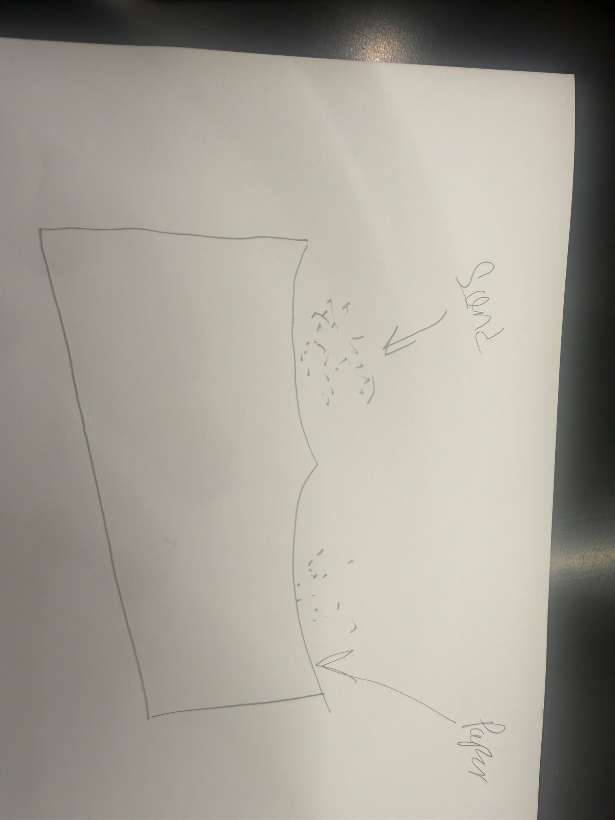
Design Idea #2
Date: feb 3 2026
Description: Sprinkler system with piping water and taping it to the roof. Water pump as well. This would be expensive due to consistent pumping of the water and risk of the tape getting loose and having to redo it numerous amounts of time, sprinklers are also a factor with the price as well as the pumping system. This method is very effective when it comes to stoping fires. It detects quickly and puts out the fire immediately.
Drawing that includes distinguishing information such as scale, dimensions, and materials:
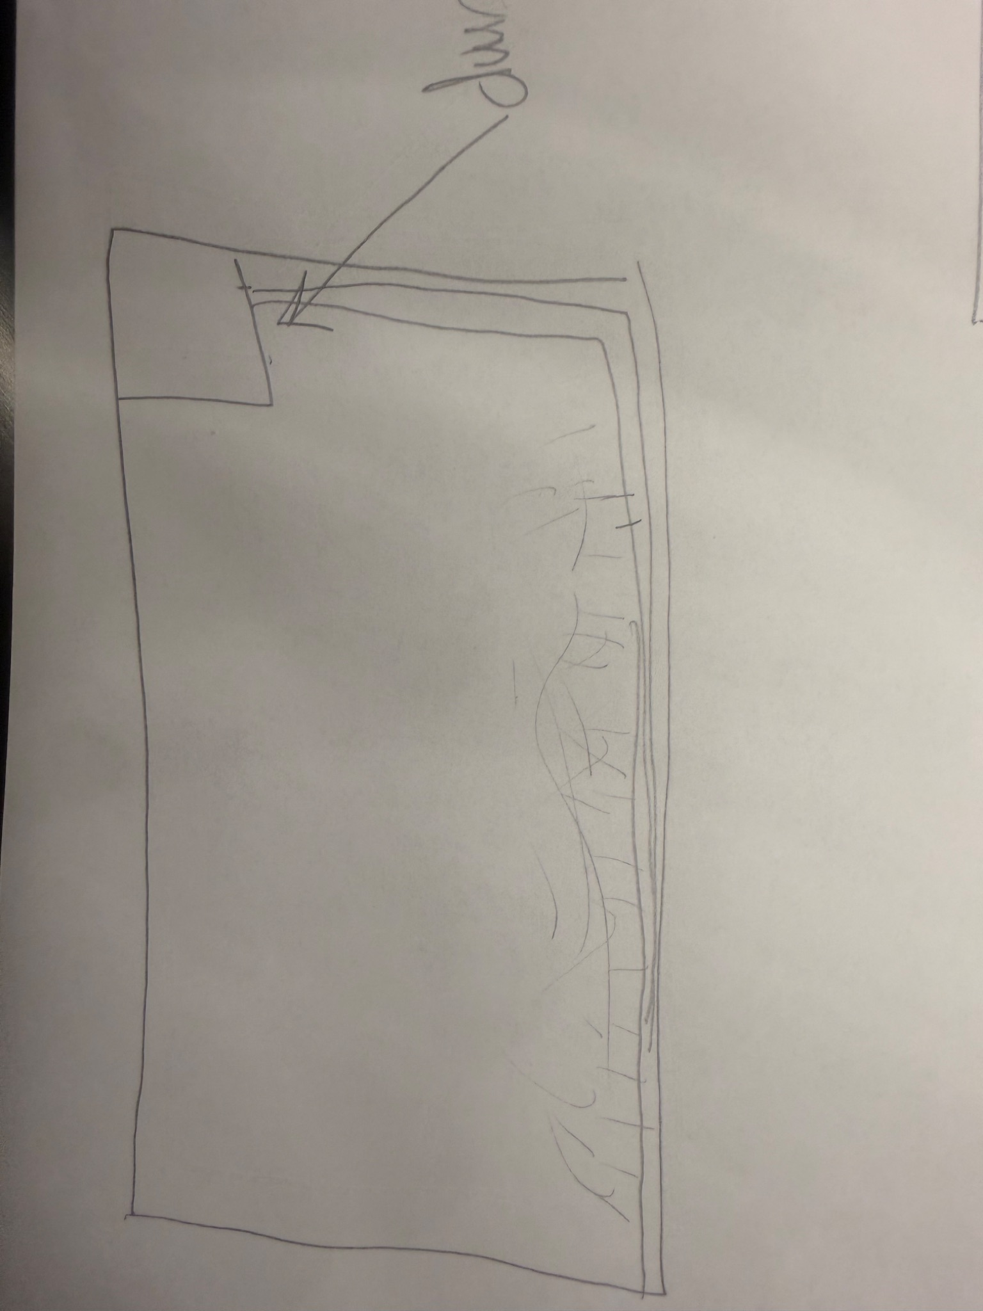
Design Idea #3
Date: March- 13- 2026
Description: Cups with a coffee filter taped to the bottom. There is sand in the cup and the cup has holes in it. When the coffee filter is burnt the sand will fall through. It is relatively cheap because it uses coffee filters, plastic cups, and sand which are not expensive. This is also not the best design. This is said because the coffee filter will only burn at high temperatures. The fire would have to burn pretty big and/or for a good amount of time for the system to actually start working. The coffee filter also wouldn't spread the fire once it burns because it doesn't burn too long.
Drawing that includes distinguishing information such as scale, dimensions, and materials:
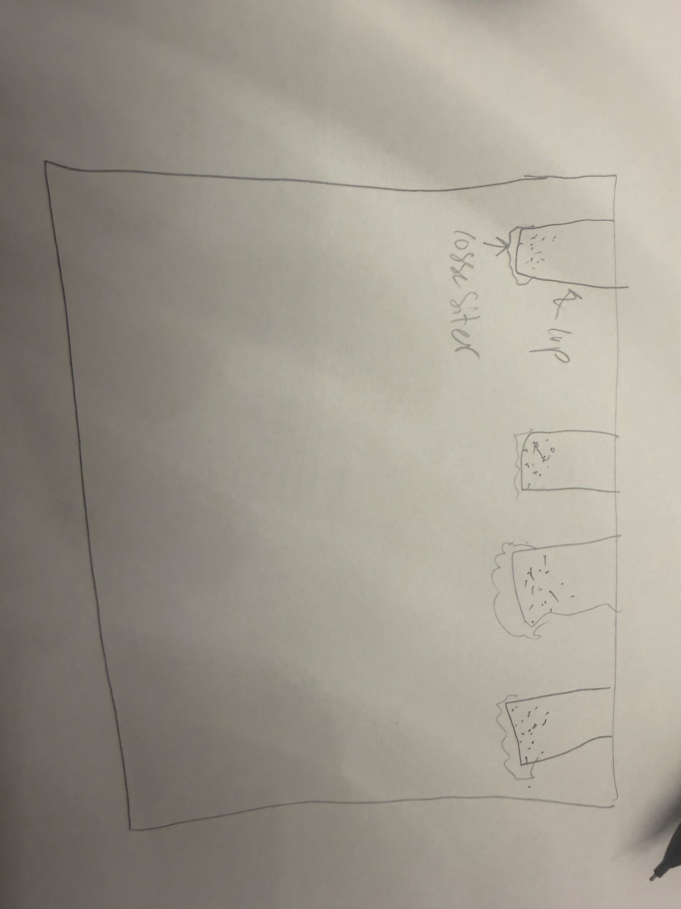

Design Idea Comparison and Selection (D1, D2)
When you’ve finished generating ideas, you must compare your design options according to all your design requirements. Incorporate the priority of those requirements when comparing design options. A decision matrix (perhaps a Pugh Matrix) is encouraged since it allows for systematic, weighted comparisons. If using weights in a decision matrix, be sure to explain and justify the weighting based on your design requirements. You may use the weighted design matrix template below, inserting your criteria and design options.
 | b1-5g | Option 1 | Option 2 | Option 3 | Option 4
Setup time |  | 4 | 2 | 3.5
effective |  | 1 | 5 | 3
cost |  | 5 | 2.5 | 4
Thinking time |  | 5 | 2 | 4
score |  | 15 | 11.5 | 15.5

Design Blueprint (D4)
Describe all of your design's details such that someone unfamiliar with your project could build your prototype. Include sketches, dimensions, CAD (if taught in your class), manufacturing methods, material choices, supply lists, and costs.
Design Blueprint #1
Date:March-13-2026
Sketch:
Manufacturing Methods:
Step 1: Put holes in your cup.
Step 2: Tape the coffee filter onto the bottom of the cup
Step 3: Place sand into the cup.
Step 4: Tape the top of the cup to the roof.
Supply List and Costs: 1 cup cost about 5 cents, 1 coffee filter cost about 1cent , 1 gram of sand is about 0.0003c. Meaning if i use about 10 of each of these it wouldn't make this project more then 1 doll
Item | Cost each | # needed | Total
Plastic cup | 5 cents | 10 | 50 cents
Coffee filter- white | 1 cent | 10 | 10 cents
Sand | 0.0003 c | 500 grams | 15 cents
Total Cost |  |  | 75 cents

Plan of Action (D3)
A Gantt chart is encouraged to lay out the primary steps expected on a visual timeline. Larger tasks from the Gantt chart should be broken down further into detailed sub-tasks, which may be housed in a different day-to-day document. Discrete tasks should include enough detail such that others could replicate the efforts, such as procedures, materials, tools, status, etc.
Ivan works on coding both the alert system and the detection system. He makes sure the code runs correctly and that both systems work together without problems. After testing everything, he puts the system into the apartment and checks again to make sure it works the way it’s supposed to. He also makes small fixes if anything goes wrong during testing.
At the same time, Oryan and Cashton follow the steps listed above to build the suppression system using cups, coffee filters, and sand. They work together to put the materials in the right order and make sure the system is stable. If something doesn’t work right, they figure out what went wrong and fix it so the system works better.
Meanwhile, Manny keeps working on the different elements of the project. He focuses on finishing his parts and making sure they are done correctly. If Manny needs help, everyone else stops what they are doing to help him. This depends on how close the due date is for each part of the project. If something is due soon, the team will help Manny right away so everything gets finished on time. Overall, the group works together and helps each other to make sure the whole project is completed successfully.

