MyDesign Portfolio
Element D Initial Template

Element D: Design Concept Generation, Analysis, and Selection
Design Idea #1
Date: 2-25-2026
Description: This design is a two piece set up. They are 40 inches in height and 77 inches in length and has a hinge top on top to come down over the top to cover up the hutch when they are needed to be in the dark and able for workers to lift it up so that when the workers need to provide the rabbits with food or anything else they would happen to need it will also have two levels so that the rabbits will have an enriched environment it will be made out of bamboo. This project/hutch is being built for the Piedmont wildlife center.
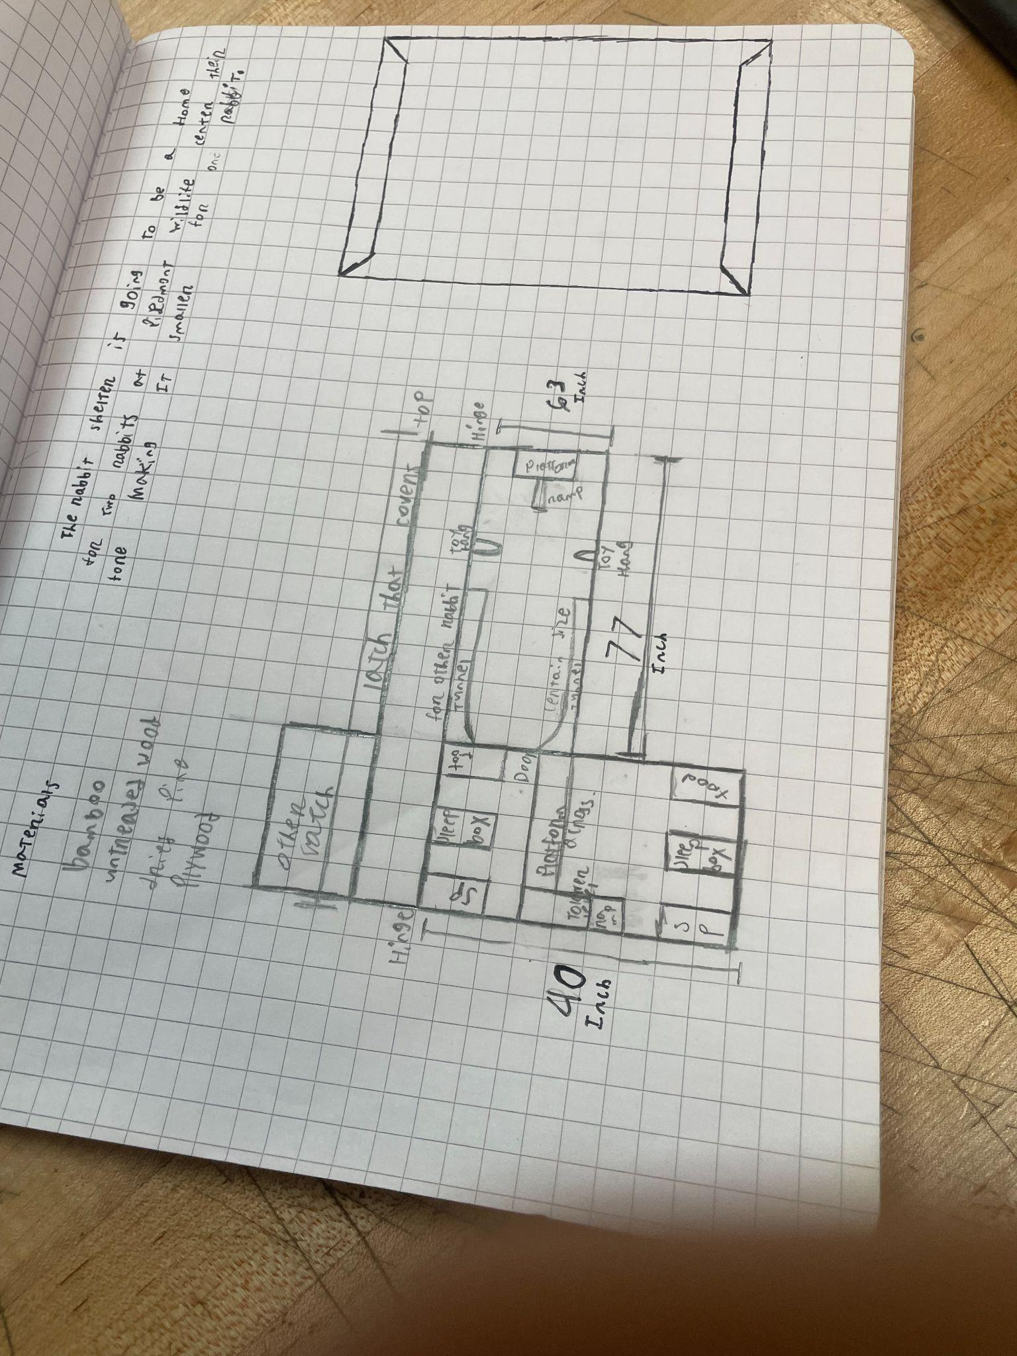
Design Idea #2
Date: 2-25-2026
Description: This design has two separate pieces. They are both 30 inches wide by 40 inches long by 40 inches tall. The parts will align together and match up to form an L shape. Both parts will have a small room under the platform. The platform is 20 inches above the floor piece and will be made of bamboo. The bamboo will be attached to the outer frame that's also made of bamboo. It will have a ramp so the rabbits can get up there. One of the rooms will have a smaller door so that the rabbits can move from space to space.
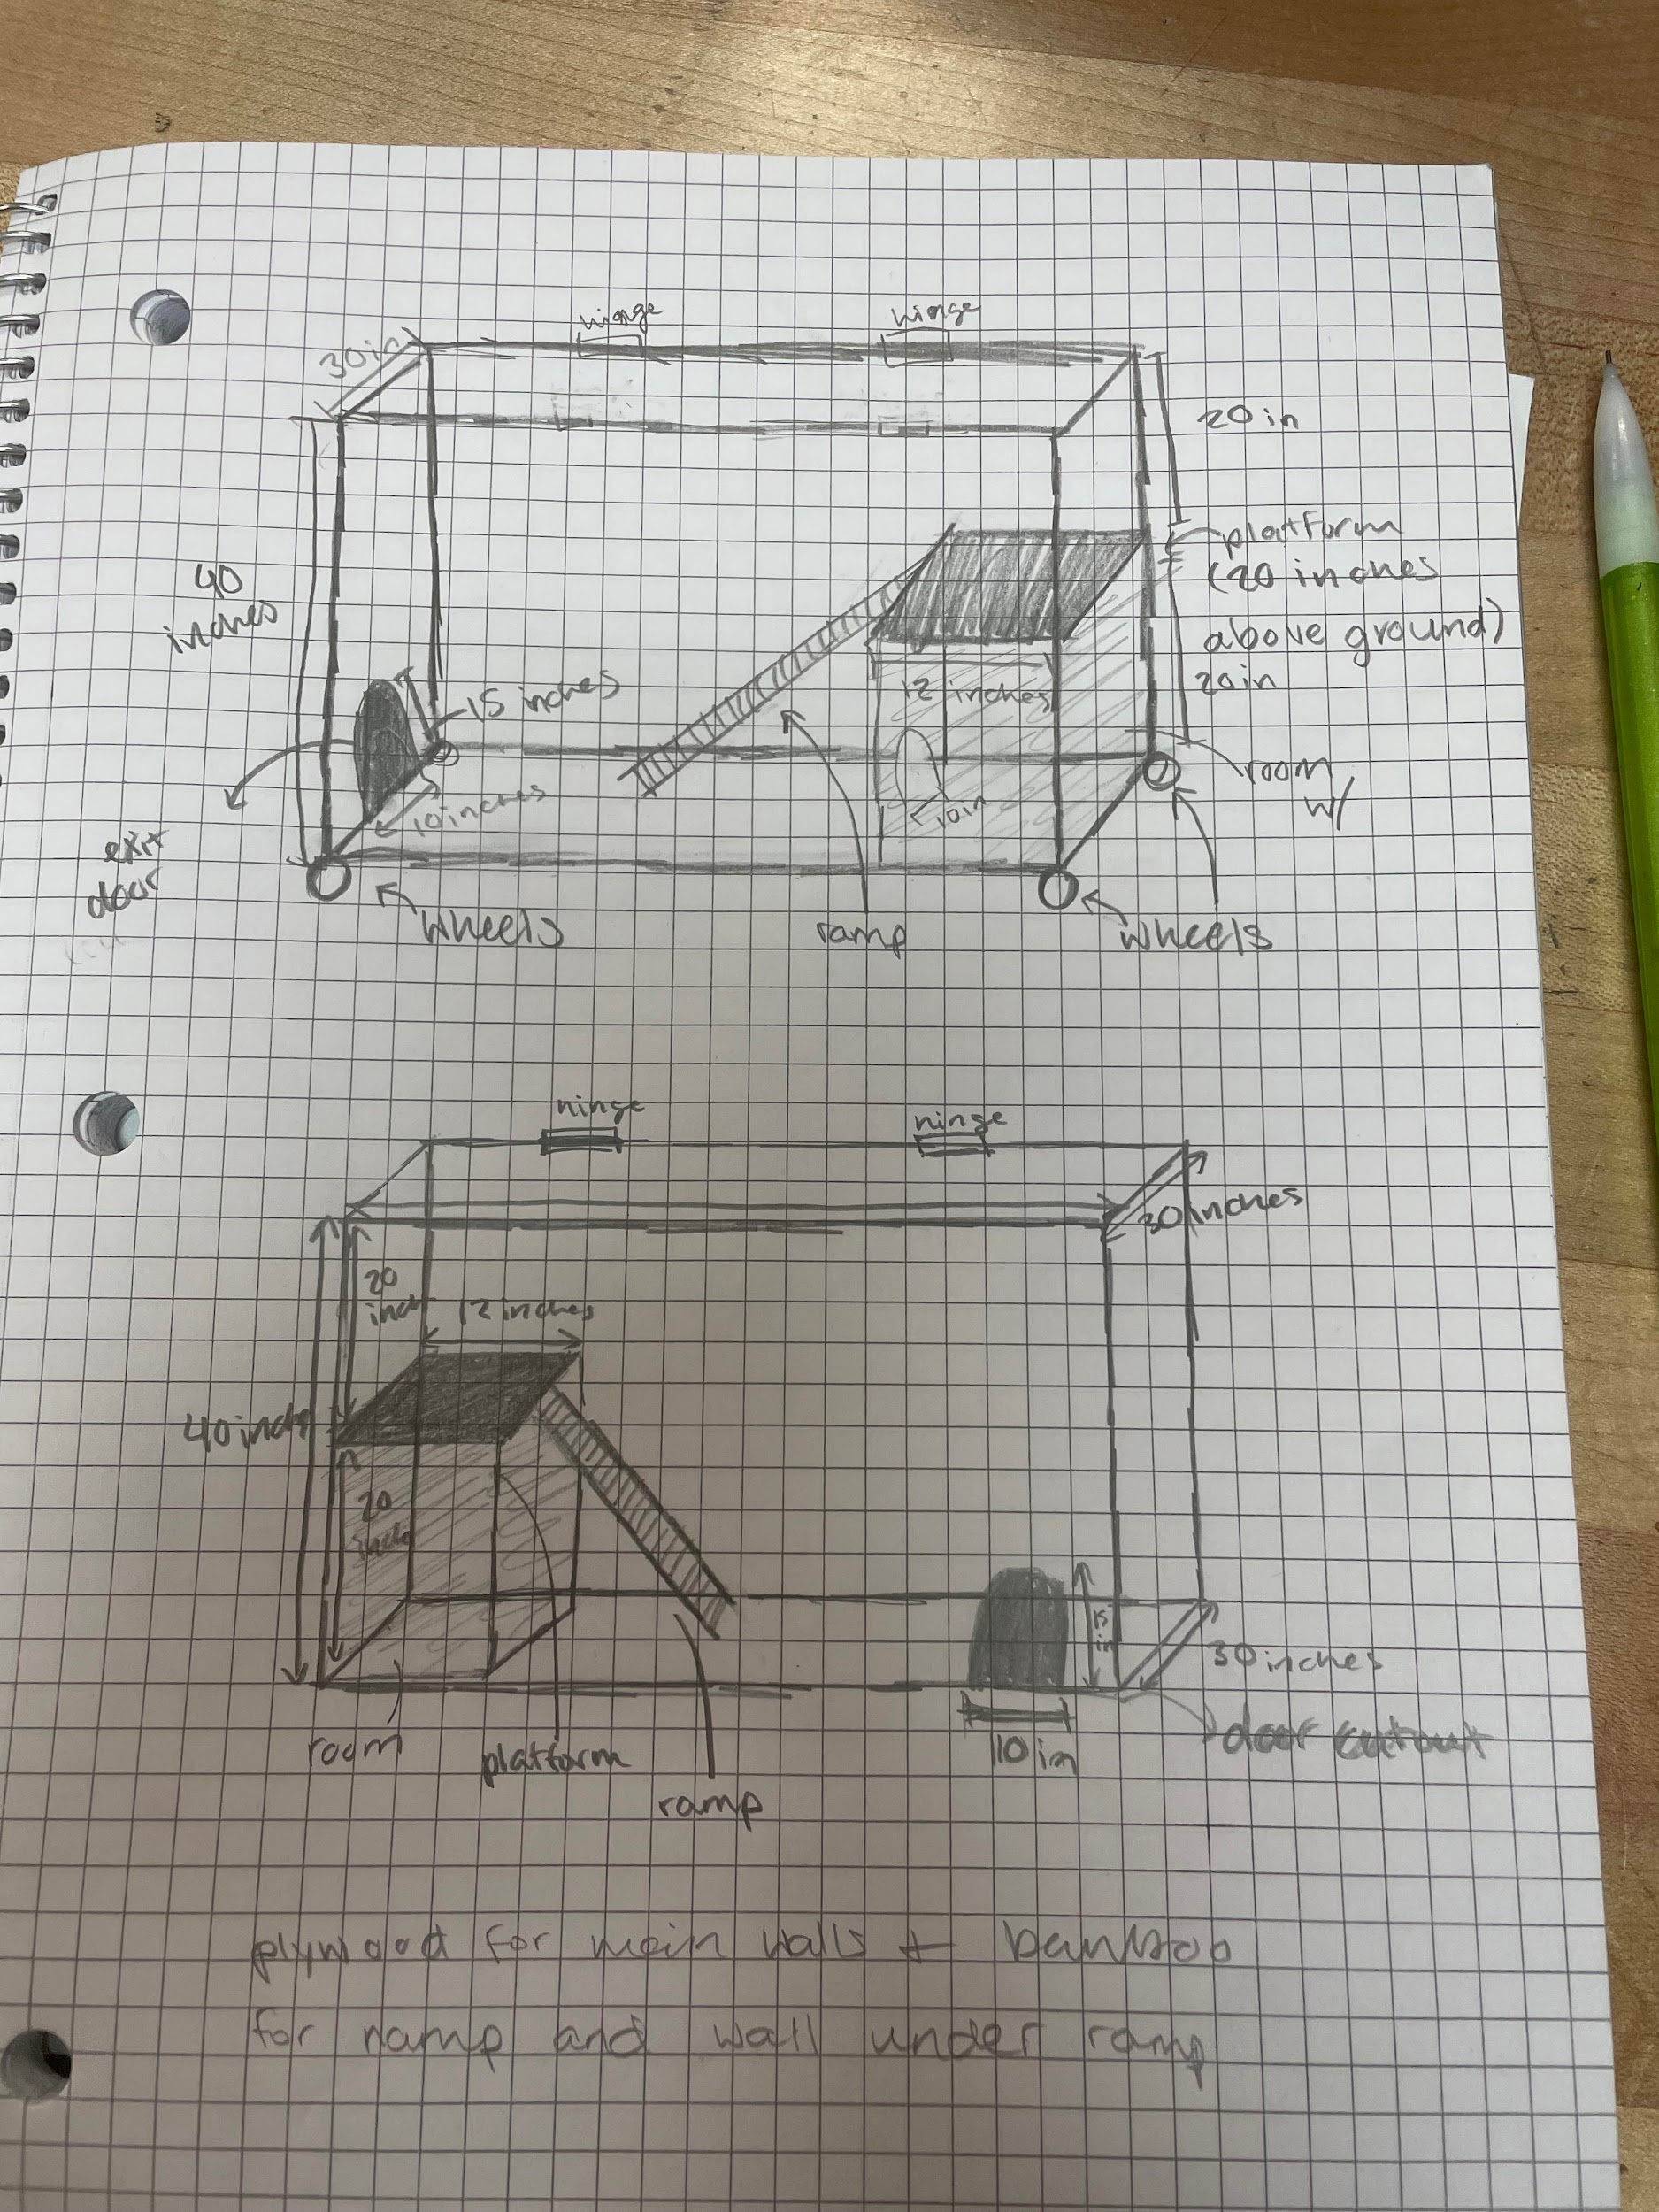
Design Idea #3
Date:02/25/26
Description:The design of the hunch is a 2 piece design with latches to connect them and wheels on the bottom along with hinges on the top to make it accessible from the top the hutch is made of bamboo on the inside there is a ramp leading to the 2nd floor and a smaller room under the ramp to allow the smaller rabbit to hide
Drawing that includes distinguishing information such as scale, dimensions, and materials:
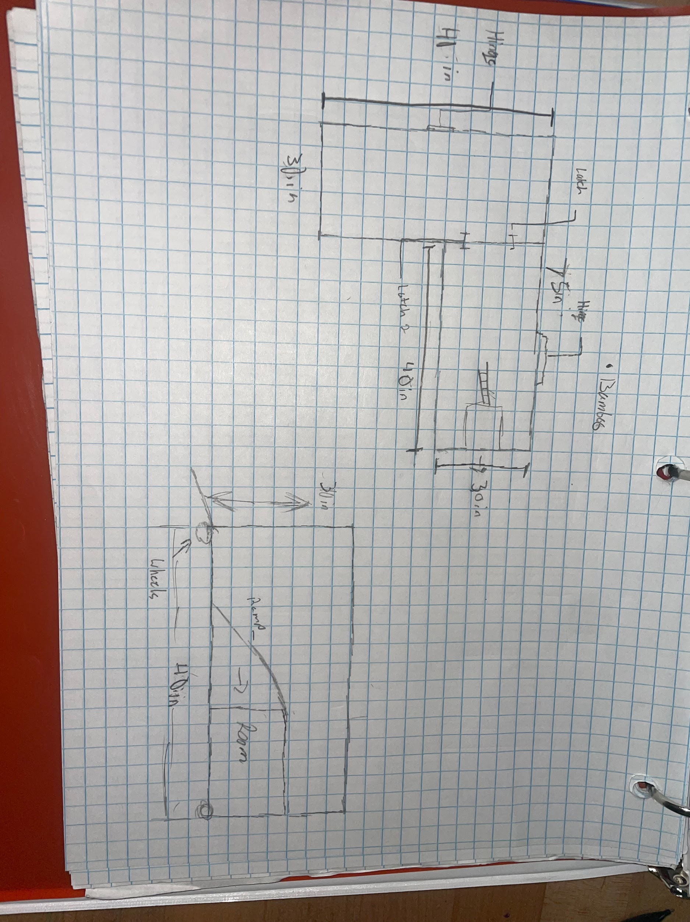
Design Idea #4
date: 3/2/2026
Description: This image is a hand drawn layout on a graph paper with measurements written in inches and feet. It appears to be a simple plan or design sketch of a small space. The drawing includes labeled sections and different wall lengths (like 40 in, 30 in and 3 ft). Heights are also marked, including 32inches. The bottom sketch shows a side view with a curved line, possibly representing a ramp and wheels under it.
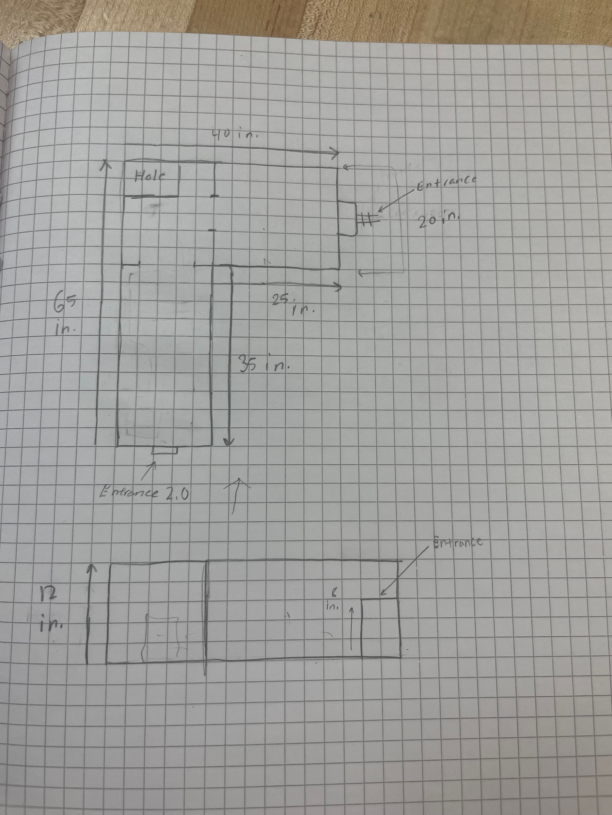

Design Idea Comparison and Selection (D1, D2)
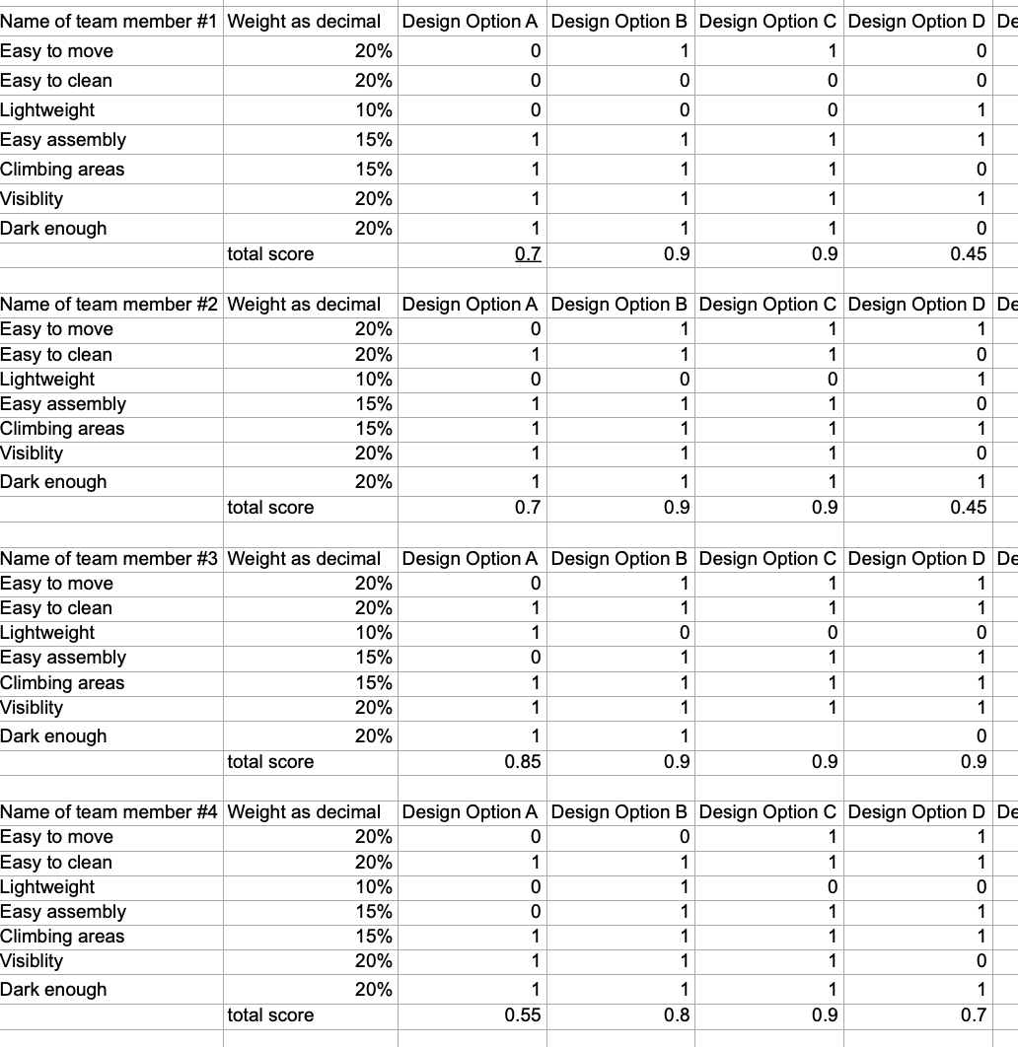

Design Blueprint (D4)
Describe all of your design's details such that someone unfamiliar with your project could build your prototype. Include sketches, dimensions, CAD (if taught in your class), manufacturing methods, material choices, supply lists, and costs.
Design Blueprint #1
Date: 3/9/2026
Sketch: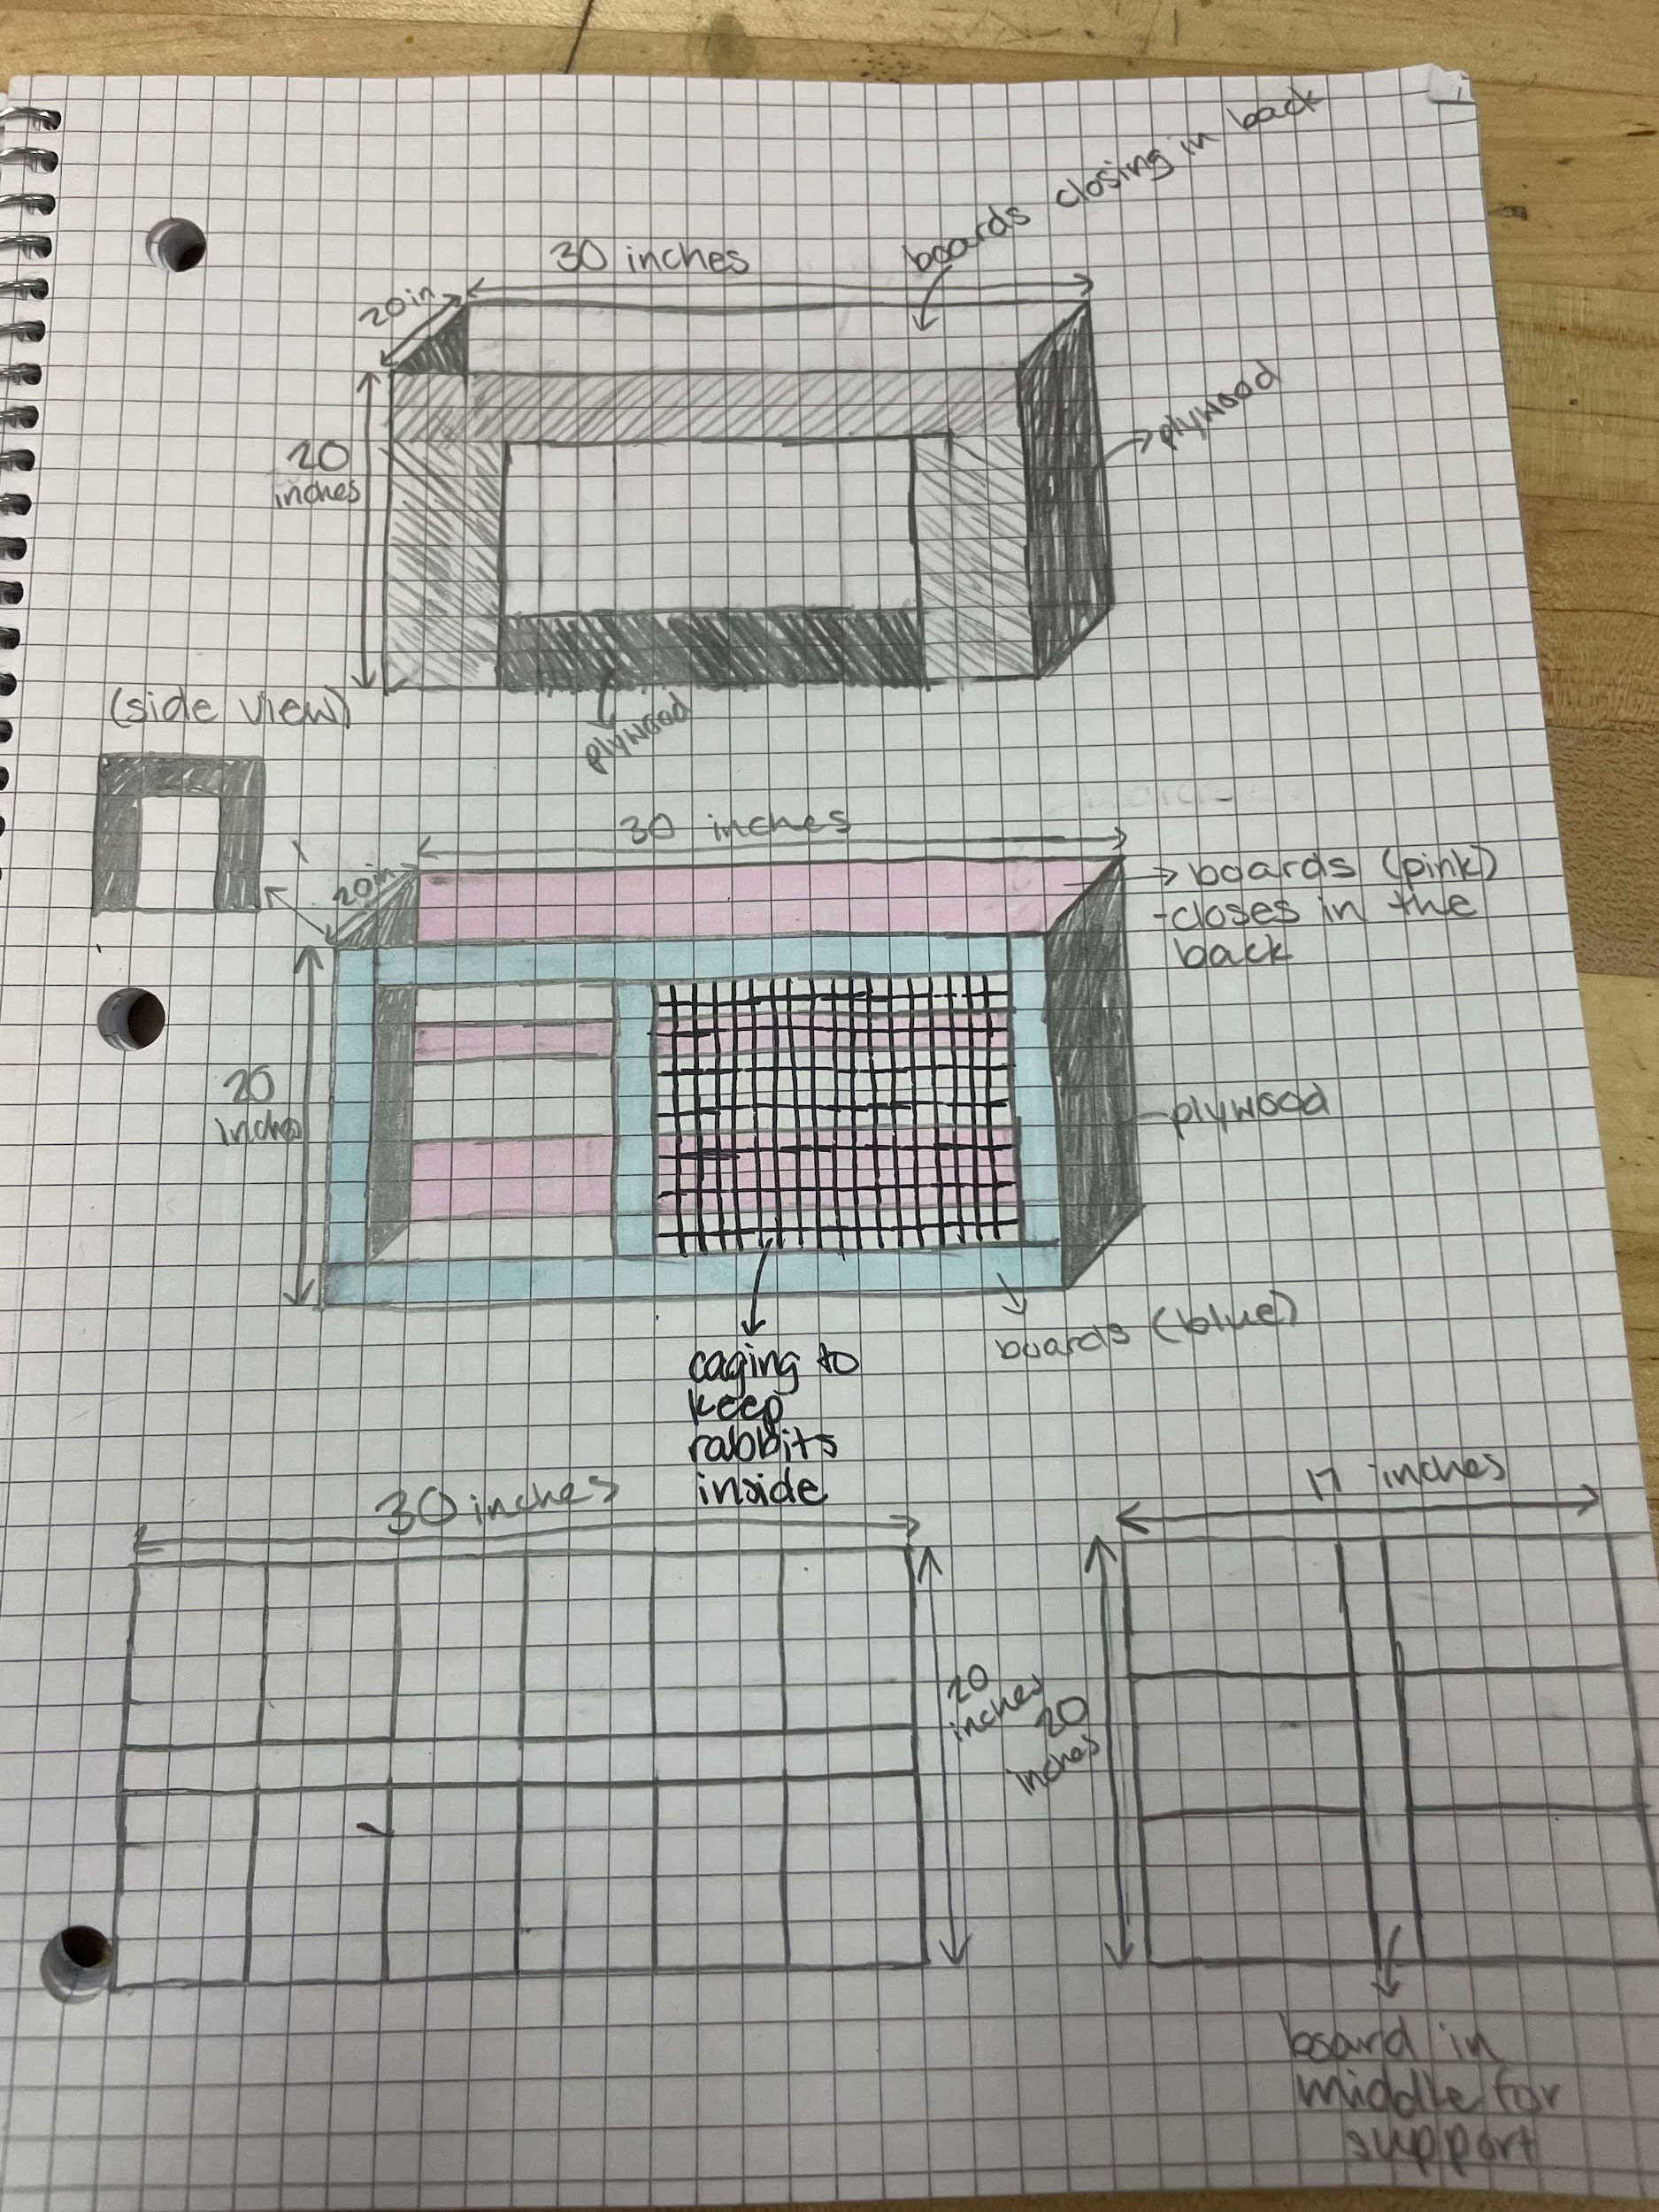
Manufacturing Methods:
Step 1: measure and cut wood to the right sizes to fit into place.
Step 2: attach and assemble the plywood, walls, etc.
Step 3: test out design; re adjust if needed.
Supply List and Costs:
Item | Cost each | # needed | Total
plywood | free | 6 sheets | free
bowls | $5 | 2 | $10
boards | free | 8 | free
Nuts, bolts, and washers | free | 1 pack | free
Handles for top | $5 | 2 | $10
Toys | $5 | 2 | $10
Total Cost |  |  | $30

