Element D: Design Concept Generation, Analysis, and Selection

Design Idea Generation (D1)
The way to fix this problem is to design the rabbit cage and tunnel with smooth, non toxic, rounded materials, easy to clean, and easy to access enclosure. Instead of using sharp metal wire or splintered wood the cage would be built with a lightweight PVC frame and clear acrylic panels so that owners can see the rabbit at all times. The tunnel would be made from smooth PVC with rounded edges to prevent injuries, and would have a clear section so that the rabbit cannot hide out of sight. The bottom of the cage would have a plastic tray that could be easily removed for cleaning and a non-slip rubber mat. It would have large front doors and a lift up top hide box lid that would be easy access to the rabbit. This design fixes the problem of injuries, cuts, and splinters and allows owners to watch their rabbits easily and shows good owner character traits by providing a safe and spacious place for the rabbit.

Date: 2/20/26
Description: My design has a hay feeder area so the rabbits can feed while also making it the easiest to clean up. It has two large water bottles that would be attached to the cage for the most space. In the middle of the cage is a tunnel made of a smooth rounded pvc pipe. On the left and right side of the opening is a hide box that has a lift up design. My design ensures that the rabbits have a safe place to live while also having the things that they like.
Drawing that includes distinguishing information such as scale, dimensions, and materials: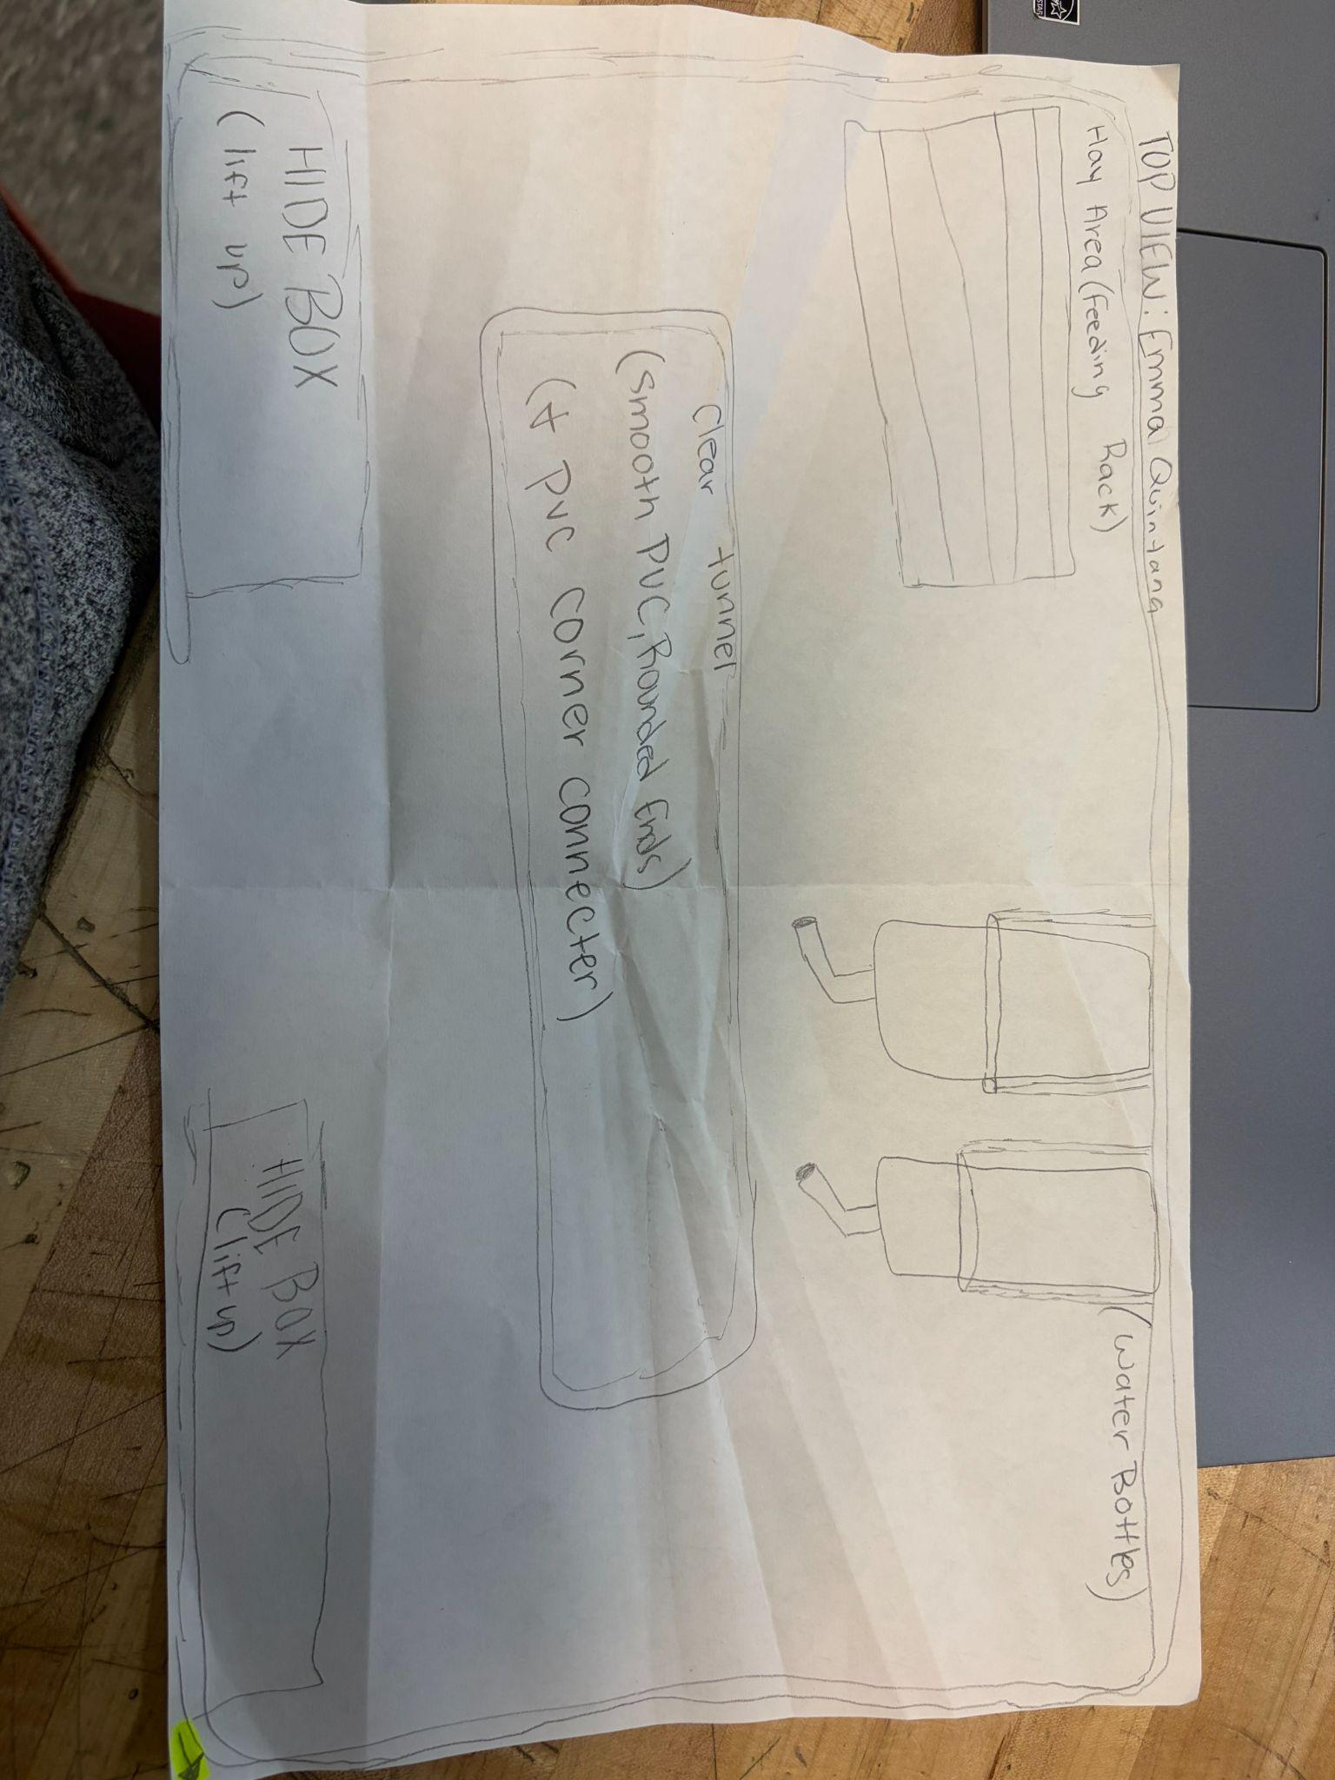
Design Idea #2
Date: 2/20/26
Description: A enclosure thats open at the top with walls that are hollowed for tunnels for the bunnies. The water bottles hang off the back wall so they have have more room in the closure instead of having a water bowl. Theres two openings on the right and left side of the enclosure so that the rabbits are able to go in the tunnels. Their food and hay go on the front wall in big bowls, and beside that will be their home/hiding place where they can sleep/rest.
Drawing that includes distinguishing information such as scale, dimensions, and materials: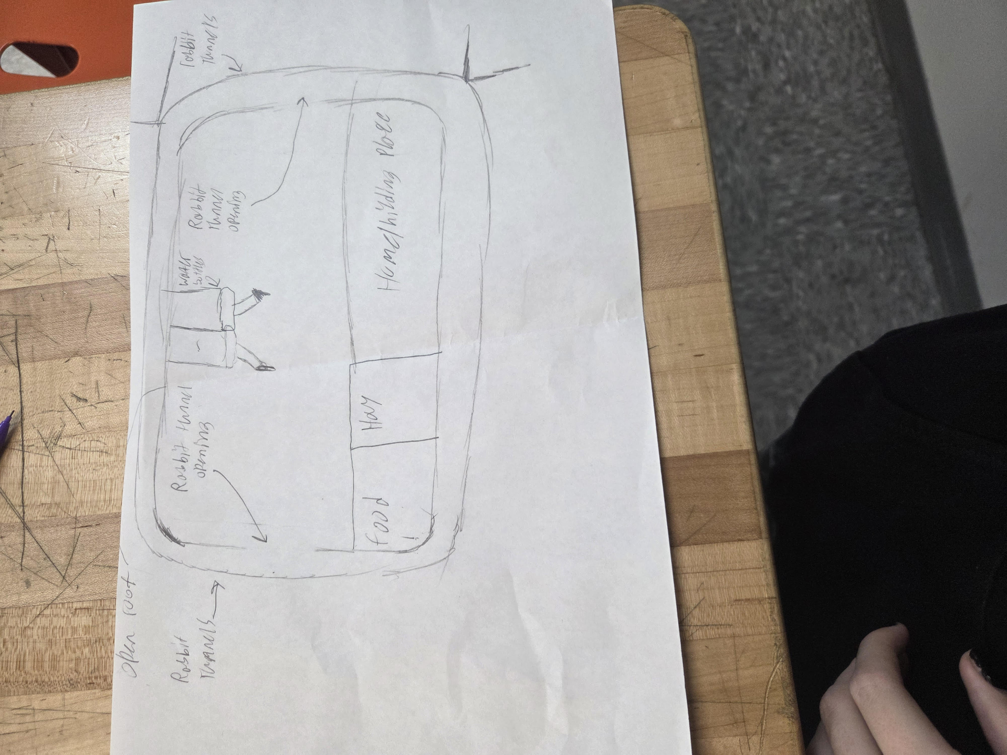

Design Idea #3
Date: 2/25/26
Description: This is a cage that is supposed to be simple but not very complex. It only consists of having a bedding with a rabbit water bottle that has an easy way of getting the water inside of the bottle and a good way of getting the food inside of the bowl. There is no door in the entrance so the Rabbit doesn’t get a sense of feeling trapped. There is also a way to easily access the Rabbit to check on it by opening the top of the cage and being able to grab the Rabbit out easily without hurting yourself. There are also going to be curvier edges so you don’t get hurt as easily as you normally would with pointy edges around the cage.
Drawing that includes distinguishing information such as scale, dimensions, and materials: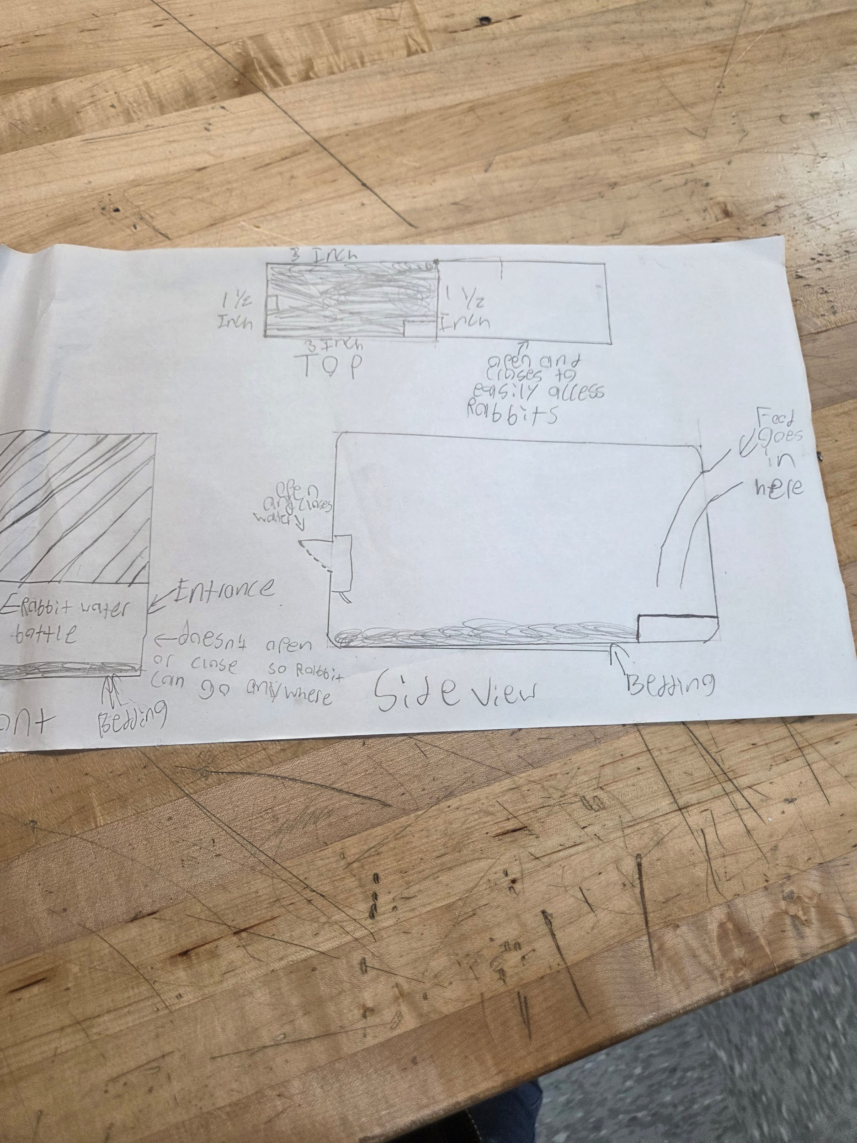

Design Idea Comparison and Selection (D1, D2)

 | weight | Option 1 | Option 2 | Option 3 | Option 4
Safety | 30% | Easy to carry around without getting hurt. | Easily be able to feed and water the rabbit safely | Make sure to be able to see the Rabbit whenever its inside the tunnel | Make sure that the Rabbit doesn’t get hurt getting in and out of the tunnel
Easy Access to Rabbits | 25% | A way to open the roofs | A big door to be able to grab the rabbit | Use food to attract the rabbit out of the tunnel | An easy way to open through the sides
Makes sure edges aren’t sharp | 15% | Making the edges curves | Adding a barrier on the edges | Using sandpaper to get rid of the wood and make it less sharp | Using a wood cutter to cut the wood and make it less sharp
Easy Access to refill the food and water | 20% | Things that open the water bottle and food bowl from the outside | An automatic way that detects if there is no food or water so it opens up and refills it. | A window to see how much food and water there currently is. | A meter that says how much food there is using weight
Easy way for rabbits to get in and out of the entrance | 10% | Keeping an open door for the rabbits | They have a way to detect if the rabbit is near the door or not | A window that easily opens to also see if the rabbit comes out or not | Using treats like bamboo to get them out.
score | 100%

Design Blueprint #1
Date: 3/18
Sketch: Rabbit Tunnel
Manufacturing Methods: Constructive
Step 1: Cardboard
Step 2: PVC Tunnels
Step 3: Bamboo
Supply List and Costs: Cardboard PVC Tunnels Bamboo
Item | Cost each | # needed | Total
PVC Tunnels | $3 | 1 | $3
Bamboo | $1 | 6 | $6
Total Cost | $5 | $20 | $45

