Sketches
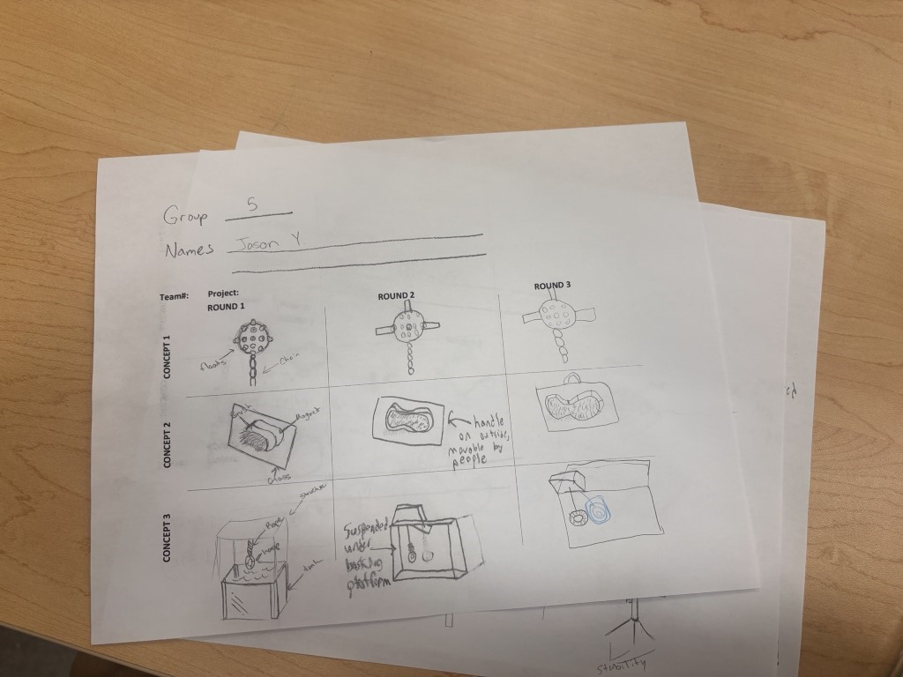

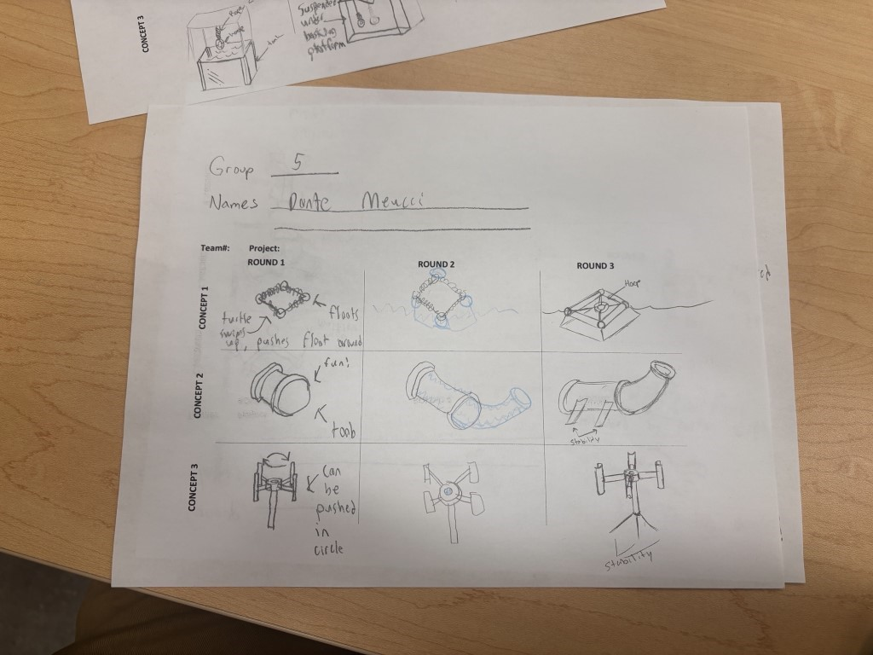
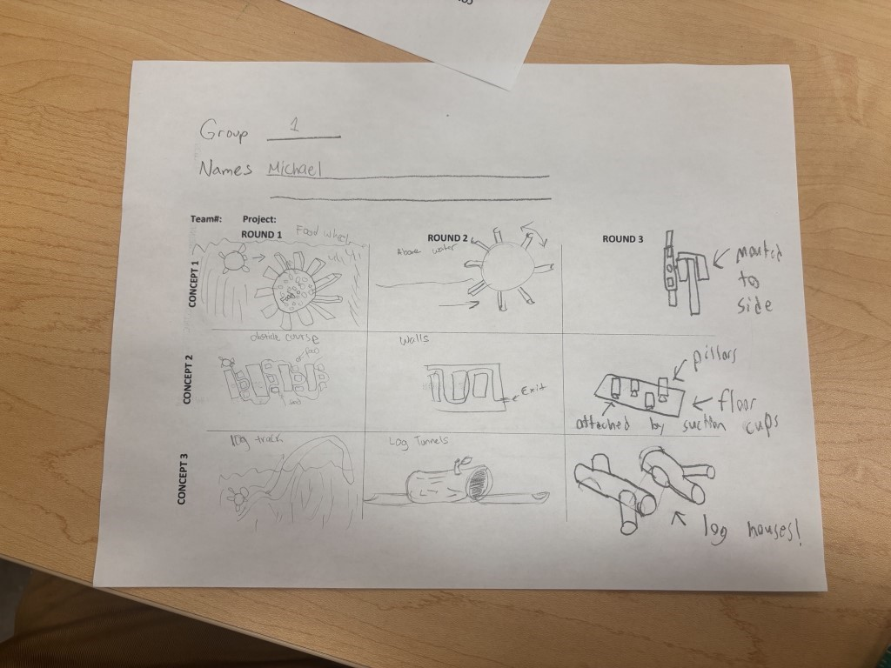

Two proposed Solutions:

Prototype 1 (Team has decided to go with this design after speaking with the Field Expert Attia. The comments from Attia are listed in Element E)
-Will focus on increasing the turtle's daily movement and metabolism
-Environment enrichment elements include the food wheel (feeding puzzle), hollowed logs for swimming, textured substrates and floating objects
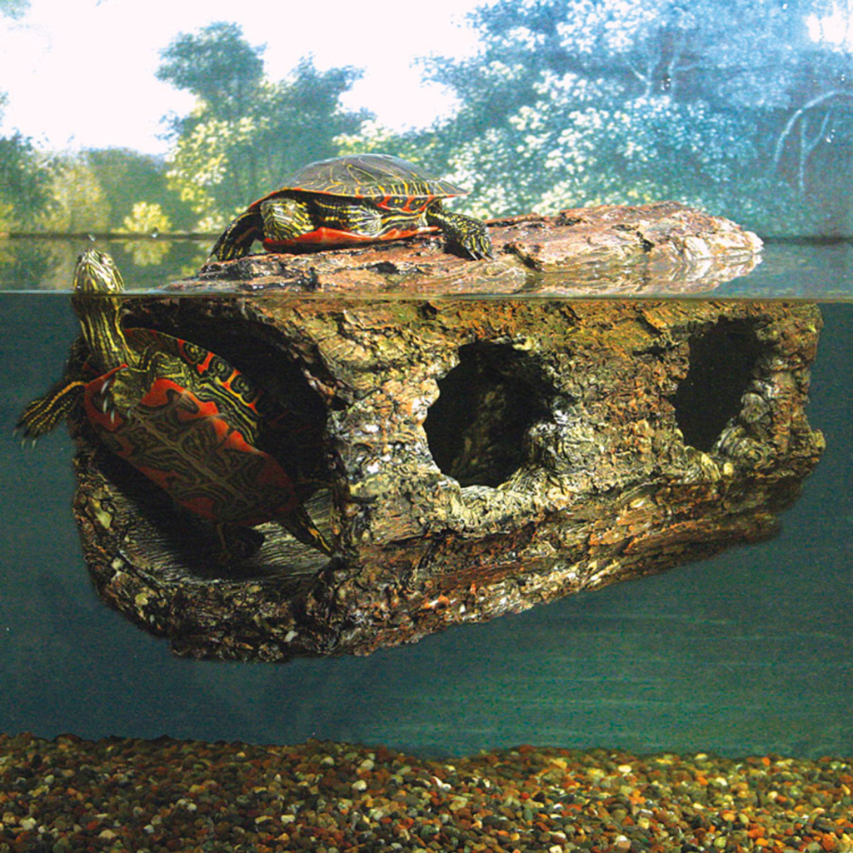

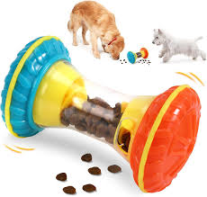

Prototype 2
-Will focus on basking and dry land areas
-Shallower water and more land space
-The water level in the tank will be lowered to accommodate the new terrain
-Log style basking platform that has swimming area underneath it
-Turtles can climb up either side of the log to get out of the water and bask
-Rocks for the turtles to climb on
