Our ideas in order:
- Two separate basking areas with Bella's being big for her and Zark's being small enough so that Bella cant comfortably fit in but Zark can.
- Create one big basking area that includes a wall that separates Bella from Zark. Bella's ramp pointing the towards the right side of the tank. Zark's ramp facing the front of the tank.
- One basking area with a wall down the middle. Making it like a one way for the turtles to go in and then go around the wall (like a U-turn) to come back out.
- Have one basking area with a ramp, with no wall on the back so that the turtles could crawl off and plop into the water. It would be low enough to the water level so that it's not as far as a drop.
- Have a platform that’s connected to the sides with suction cups and ramps on both ends. The ramps have floatation devices on the edges and hinges connecting to the platform. This way the ramp can give when the turtles climb on making it slightly easier.
Our thought process included making an area that both turtles can benefit from while also keeping in mind Bella's pushy nature. We wanted some way for Bella to continue basking without forcing Zark out the way or blocking him from getting to bask. That was our main reasoning for two separate basking areas. Seeing how turtles in the wild slide off back into the ocean after basking gave us the idea of no wall in the back allowing them to plop back into the water. We then talked to Mr. Jorge who gave us the idea of possible moving ramps. The ramps can move slightly under the weight of the turtle allowing them to climb easier. We are now looking at a platform instead of an boxy/enclosed area that is in place now the lamps can sit on top of the tank. Weren't you considering a floating platform as well?

Each iteration was made to either improve the turtle's comfort or resolve the problem of Bella taking over the whole platform.

Dimensions of Tank being: 48.5 in long, 12.5 inches wide, and 25 inches tall.
Current basking platform: 15.5 long, 13 wide, and 10 inches tall.
Bella being 10-11 inches long and 6 inches wide.
Zark being 6 inches long, and 4 inches wide.

The platform will most likely be about 18-20 inches long, 10-11 inches wide (giving slight space in between the platform and the glass for the suction cups to hold it in place) and maybe 2-3 inches tall. The ramps can be both about 4 inches long.
- Slight idea for suction cups. Instead of right in between platform could have them extend from the edges so that it isn't much of a struggle to get the platform in place)
Materials may include plexiglass, suction cups, hinges, and a rotation device.

In order to make this platform you would follow these steps:
- Laser cut out a platform using plexiglass with the following dimensions in inches: 20 x 11 x 2.
- Laser cut a small ramps for both sides of the platform each being 4 inches long.
- Attach the hinges to the ramps and the platform to allow the ramps to give slightly under the turtles weight when climbing.
- Create and attach a floating device to the ramps so that they float at water level.
- Attach the suction cups to the edges of the platform so that the platform can be attached to the sides of the tank using suction.
Our Double Basking Area Rough Sketch:
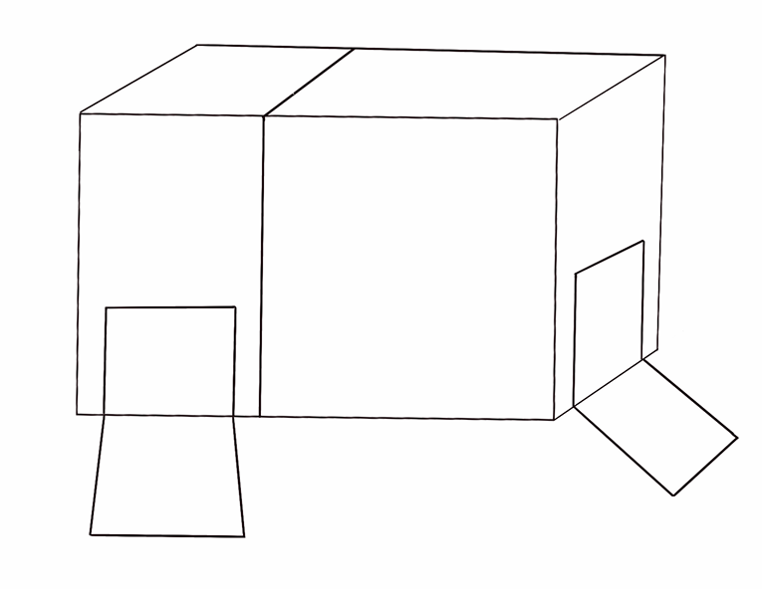
Our Floating Platform Rough Sketch (may be iterated but its idea we are leaning to more):
