MyDesign Portfolio
Element D
Element D: Design Concept Generation, Analysis, and Selection
Design Idea #1
In this design there is a base to keep the U shape upright and you could put pom-poms into each side. The total height of the design will be 8”, the diameter of the tubes will be 3”, and the base will be 6” x 6” x 3”.
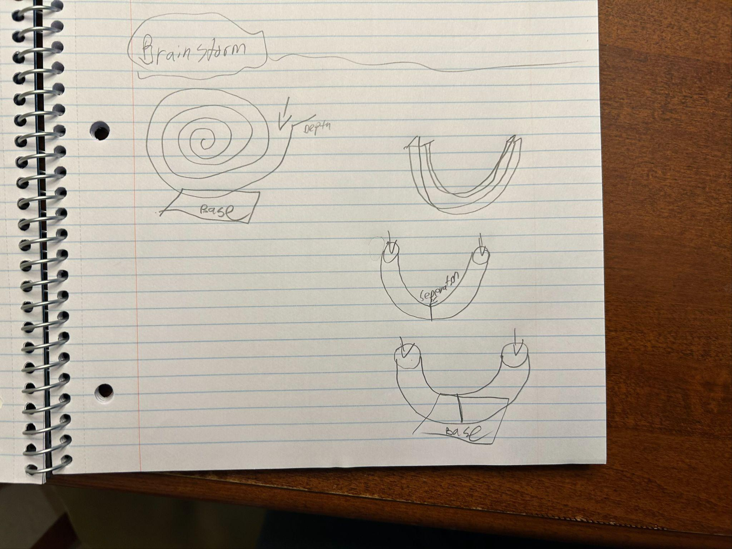

Design Idea #2
This design is very simple, just a box with two sides, and hash lines to show how high each side is so you can see the vote. The design will be 8” tall, 14” wide, and 9” deep. Each bin will be 4” wide and 13” deep.
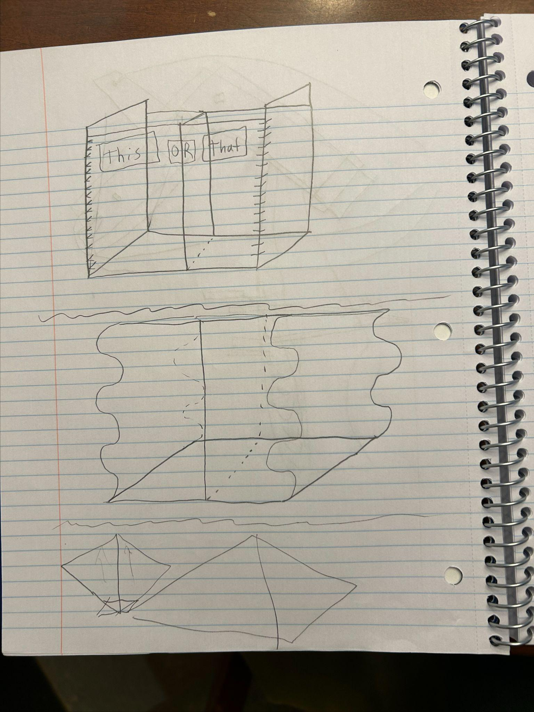
Design Idea #3
Designed March 3rd
This design is resettable similar to Connect 4 models that can be reset (by pulling a shelf out from under the bottomless jars). The jars would be some sort of clear pipe with no bottom and would be attached to the top of the stand (probably 3d printed). A slot goes right under this to hold the votes and can be pulled out to reset everything. Also could have/has sleeves for ‘this or that’ cards. The jars are to be approximately 7” in tall, and 7” wide. The base is to be 14” wide, 9” deep, and 8” tall.
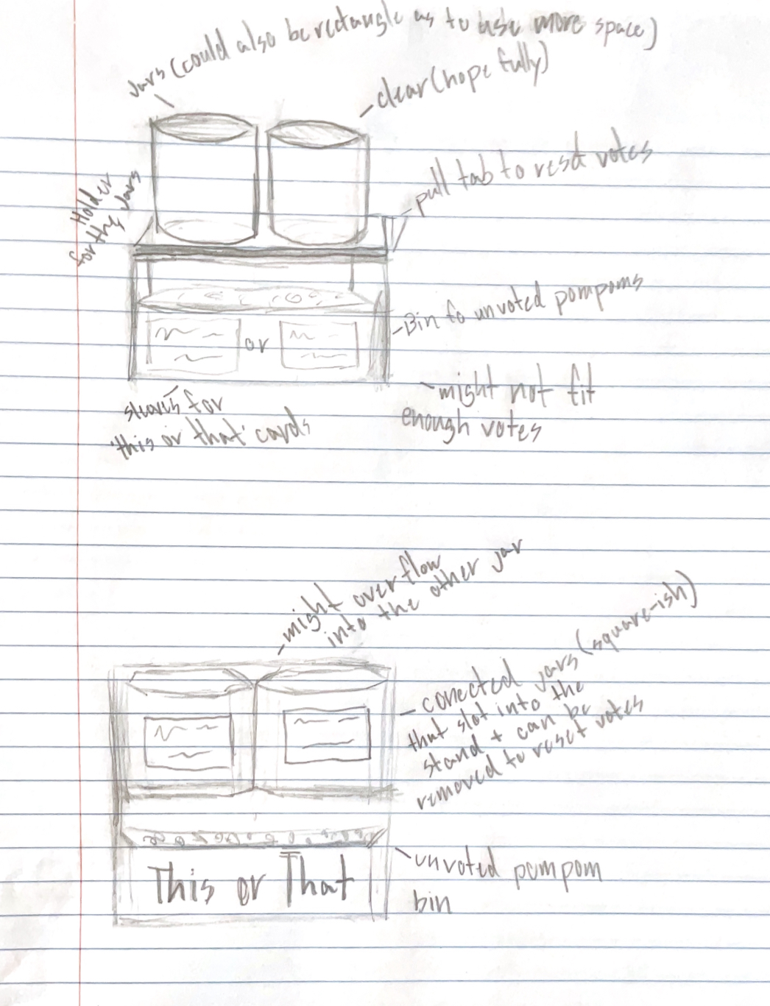
Design Idea #4
Designed March 3rd
This design has clear jars that slot in and out of the stand (which doesn’t have a top without the jars) so that the rotes can easily be replaced. The 3d printed frame is essentially just a bin with higher walls on the back and sides (or possibly a more beam-like structure). The jars are to be approximately 7” in tall, and 7” wide. The base is to be 14” wide, 9” deep, and 8” tall.

Design Idea #5
Date: Designed March 3rd. Design consists of two side compartments (clear plastic or acrylic) and top dispenser compartment (3d printed) And a knob (3d printed) with a pompom sized indent. The knob would be turned in whichever direction the students voted so that the pompom falls into that compartment. The knob would be secured in the front and the back, and the side and top compartments would be removable. The design is to be 6” wide, 9” tall, 7” deep.
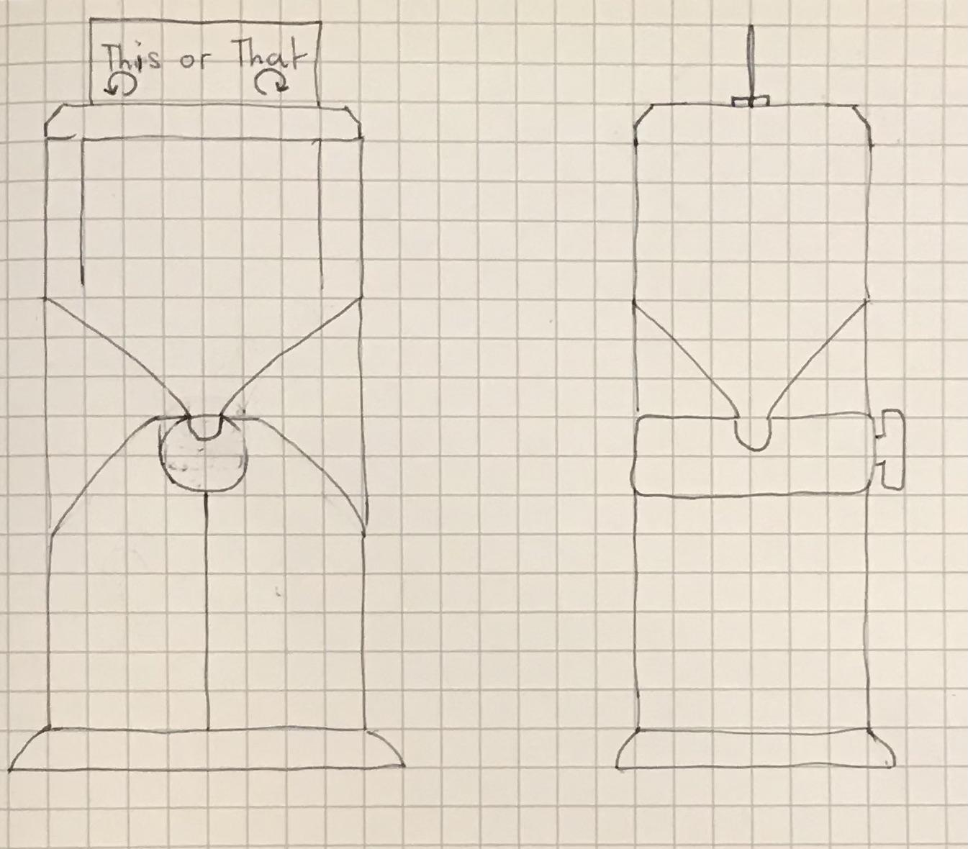

Design Idea #6
Date: Designed March 3rd. In this design, rather than having two separate containers for votes, votes are distinguished by color. The containers are set in a caddy-like frame and labeled accordingly. Students would take a pompom (red or blue) and place it in the combined votes container. The container frame would be 3d printed, and the pompom containers would be clear plastic or acrylic. The design is to be 14” wide, 9” tall, and 8” deep.

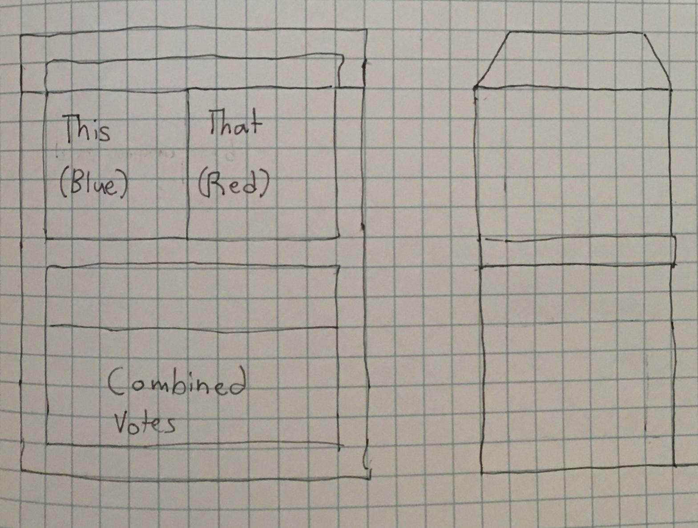

Design Idea #7
Date: Designed March 3rd. In this design there are three main compartments, all of them made from clear plastic or acrylic. Each compartment would be removable and would fit together. The design also consists of two knobs, one for each color, with a pompom sized indent. The knobs would be 3d printed and secured in front and back. The design is to be 14” wide, 9” tall, and 6” deep.
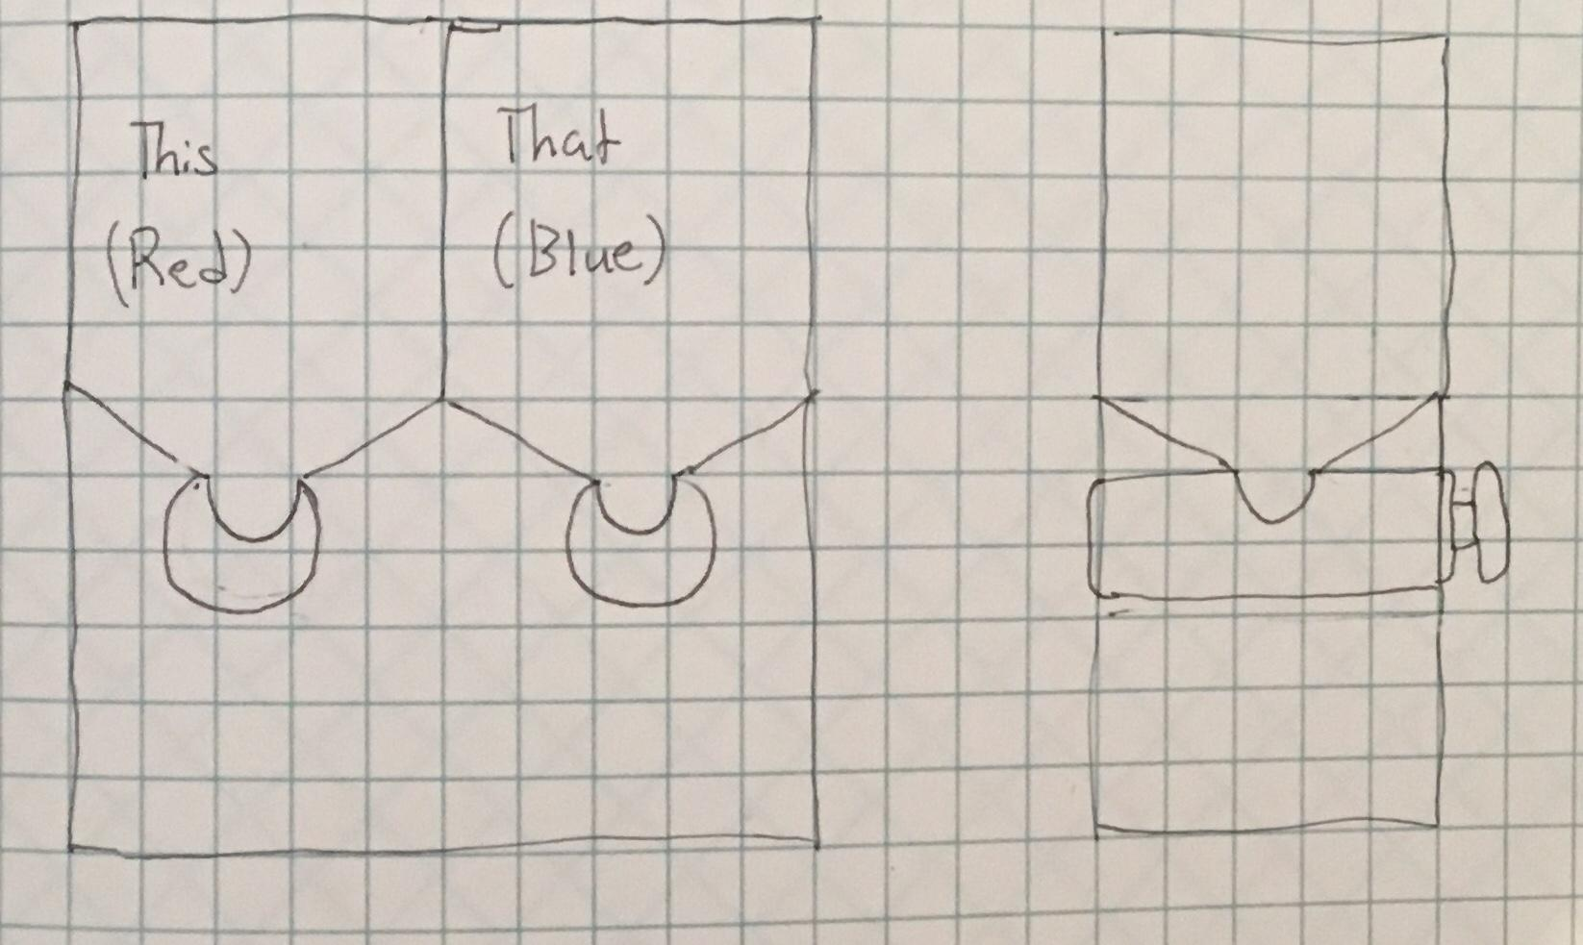

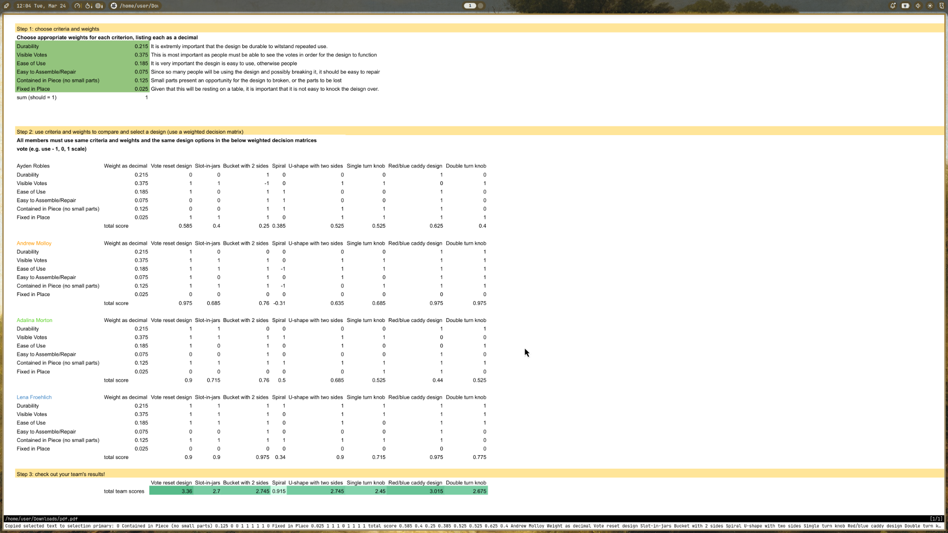
Decision Matrix - Decision_Matrix_Student_Template.xlsx

Design Blueprint (D4)
The design consists of a sliding bin that is set in a frame. On top of the frames are two jars with a removable tab underneath that slides out in order to reset the votes. The jars are clear tubes that are open on both ends and are attached to the top of the (3d printed) stand. A slot goes right under this to hold the votes and can be pulled out to reset everything. Also has sleeves for ‘this or that’ cards.

Design Blueprint #1
Date: March 24, 2026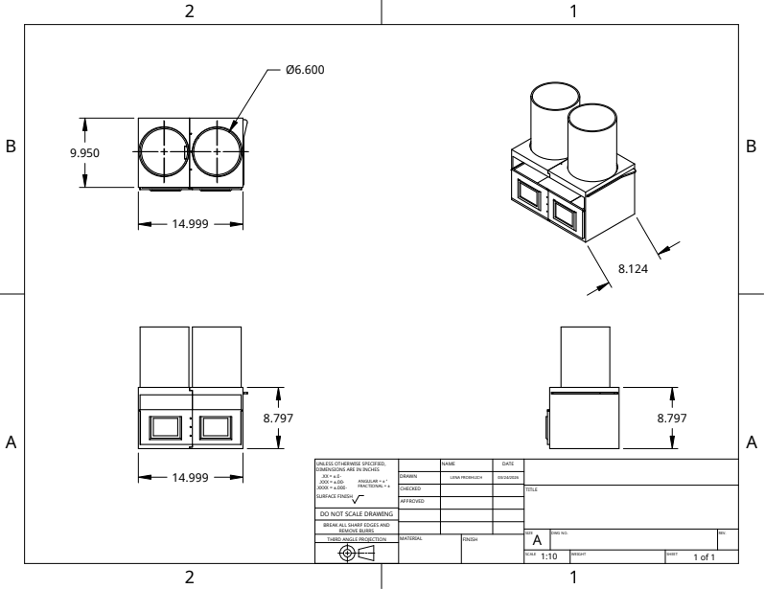

Manufacturing Methods:
Step 1: 3D-Print the CAD files of each of the components for the design.
Step 2: Process the 3D printed parts by removing the supports used during printing.
Step 3: Bolt the bins together as well as the frame pieces.
Step 4: Glue the acrylic tubes to the frame.

Material name | Description | Where  material was purchased | Cost  per  unit | #units | Total  cost per item
PLA 3D Printer Filament | Used to create bin, base, and tab | Amazon | 19.99 $ | 3 | 59.97 $
Hot Glue | Used to adhere acrylic tubes to the frame | Amazon | 10.99 $ | 1 | 10.99 $
M3 Nuts and Bolts Kit | Used to fasten the two pieces of the frame together as well as the two pieces of the bin. | Amazon | 9.99 $ | 1 | 9.99 $
Acrylic Tubes: | Used to hold votes (pom-poms) | Amazon | 37.09 $ | 1 | 37.09 $

Plan of Action (D3)
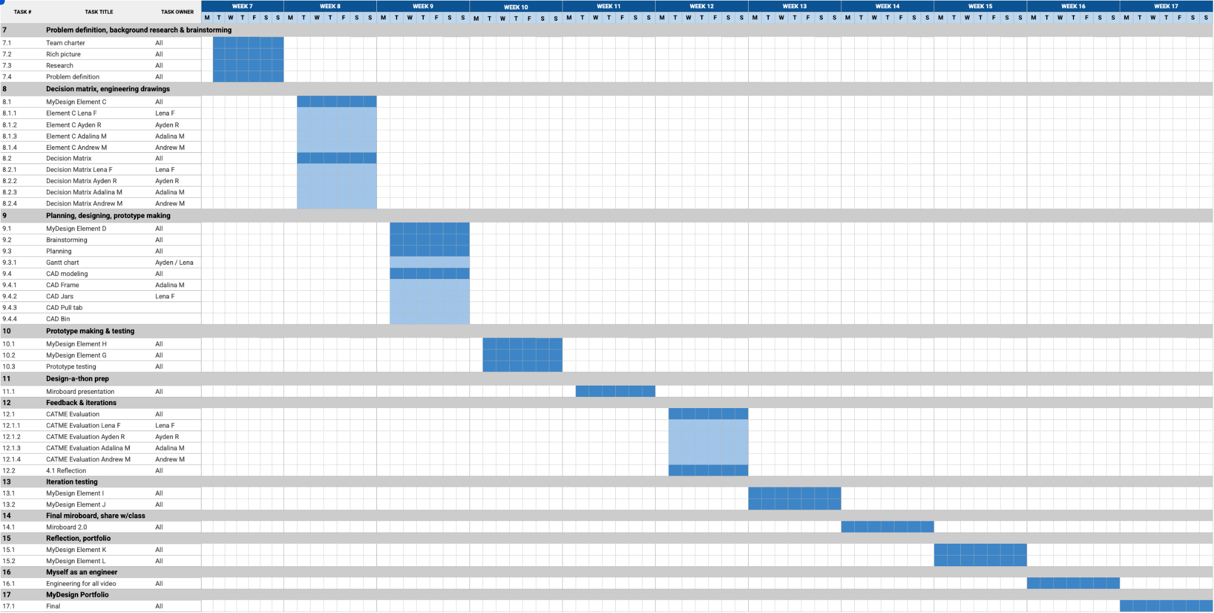
https://docs.google.com/spreadsheets/d/1xNOXuQa9A9YFCsUF_ZLZLE9VqqchOZ0N2OsCxRAecLU/edit?gid=1115838130#gid=1115838130

