Name: ___________Suvit Kumar, Hadley Siler, Lana Bassett, Preston Ramsey______________________ Date: __________3/27/2026_________ Class: ____Engineering_____________
MyDesign Portfolio
Element D Initial Template

Element D: Design Concept Generation, Analysis, and Selection

Design Idea #1
Date: 3/10/26
Description: A balance scale with cups on either side to hold pom poms that tips when pom poms are added to show which side has more pom poms based of of the weight of the cups.
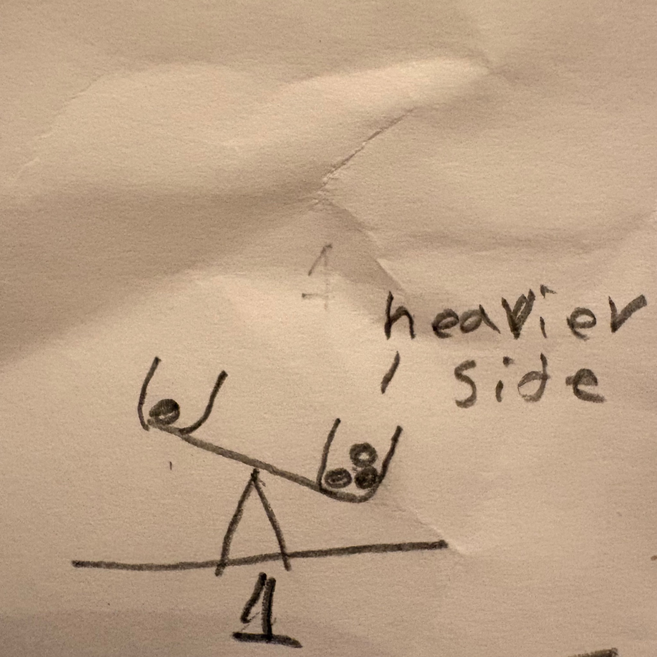

Design Idea #2
Date: 3/10/26
Description: Pom poms will slide into the jars witch are connected to a scale like contraption similar to #1 down a slide similar to something found in a gumball machine.
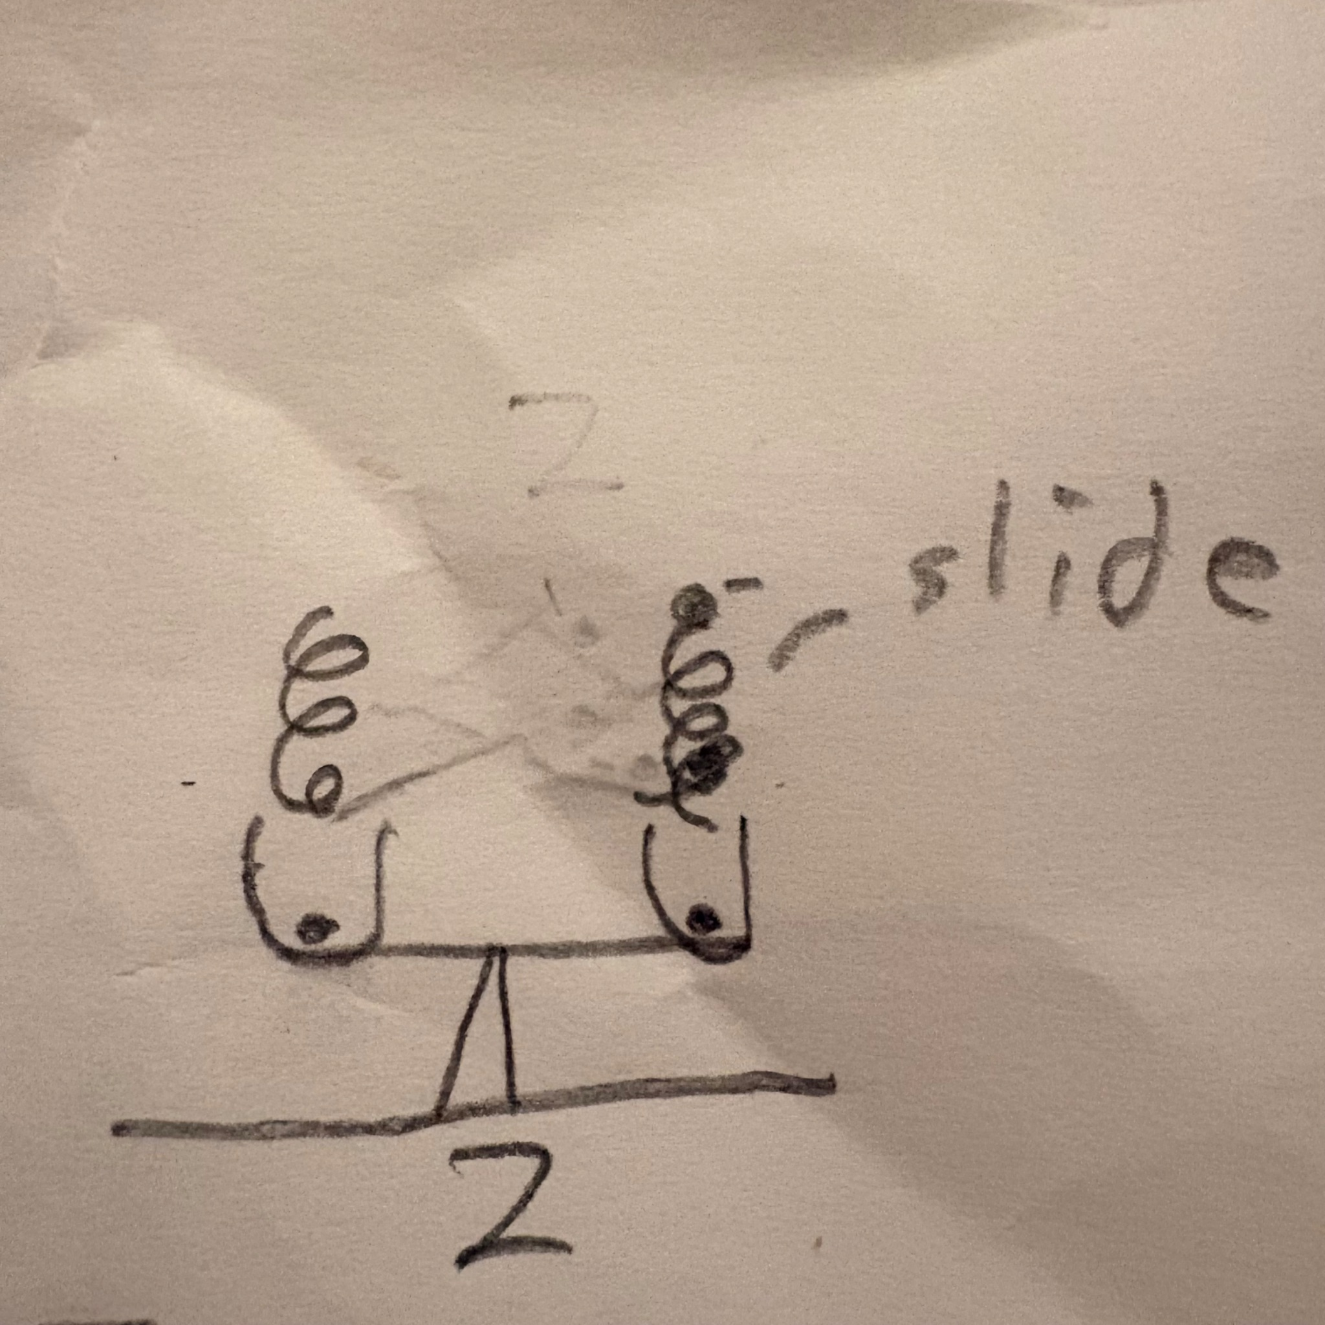

Design Idea #3
Date: 3/10/26
Description: The scale that is similar to #1 will have an perpendicular arrow attached to its center that will point at a sign connected to the back of the machine to show the winning choice of the scale.
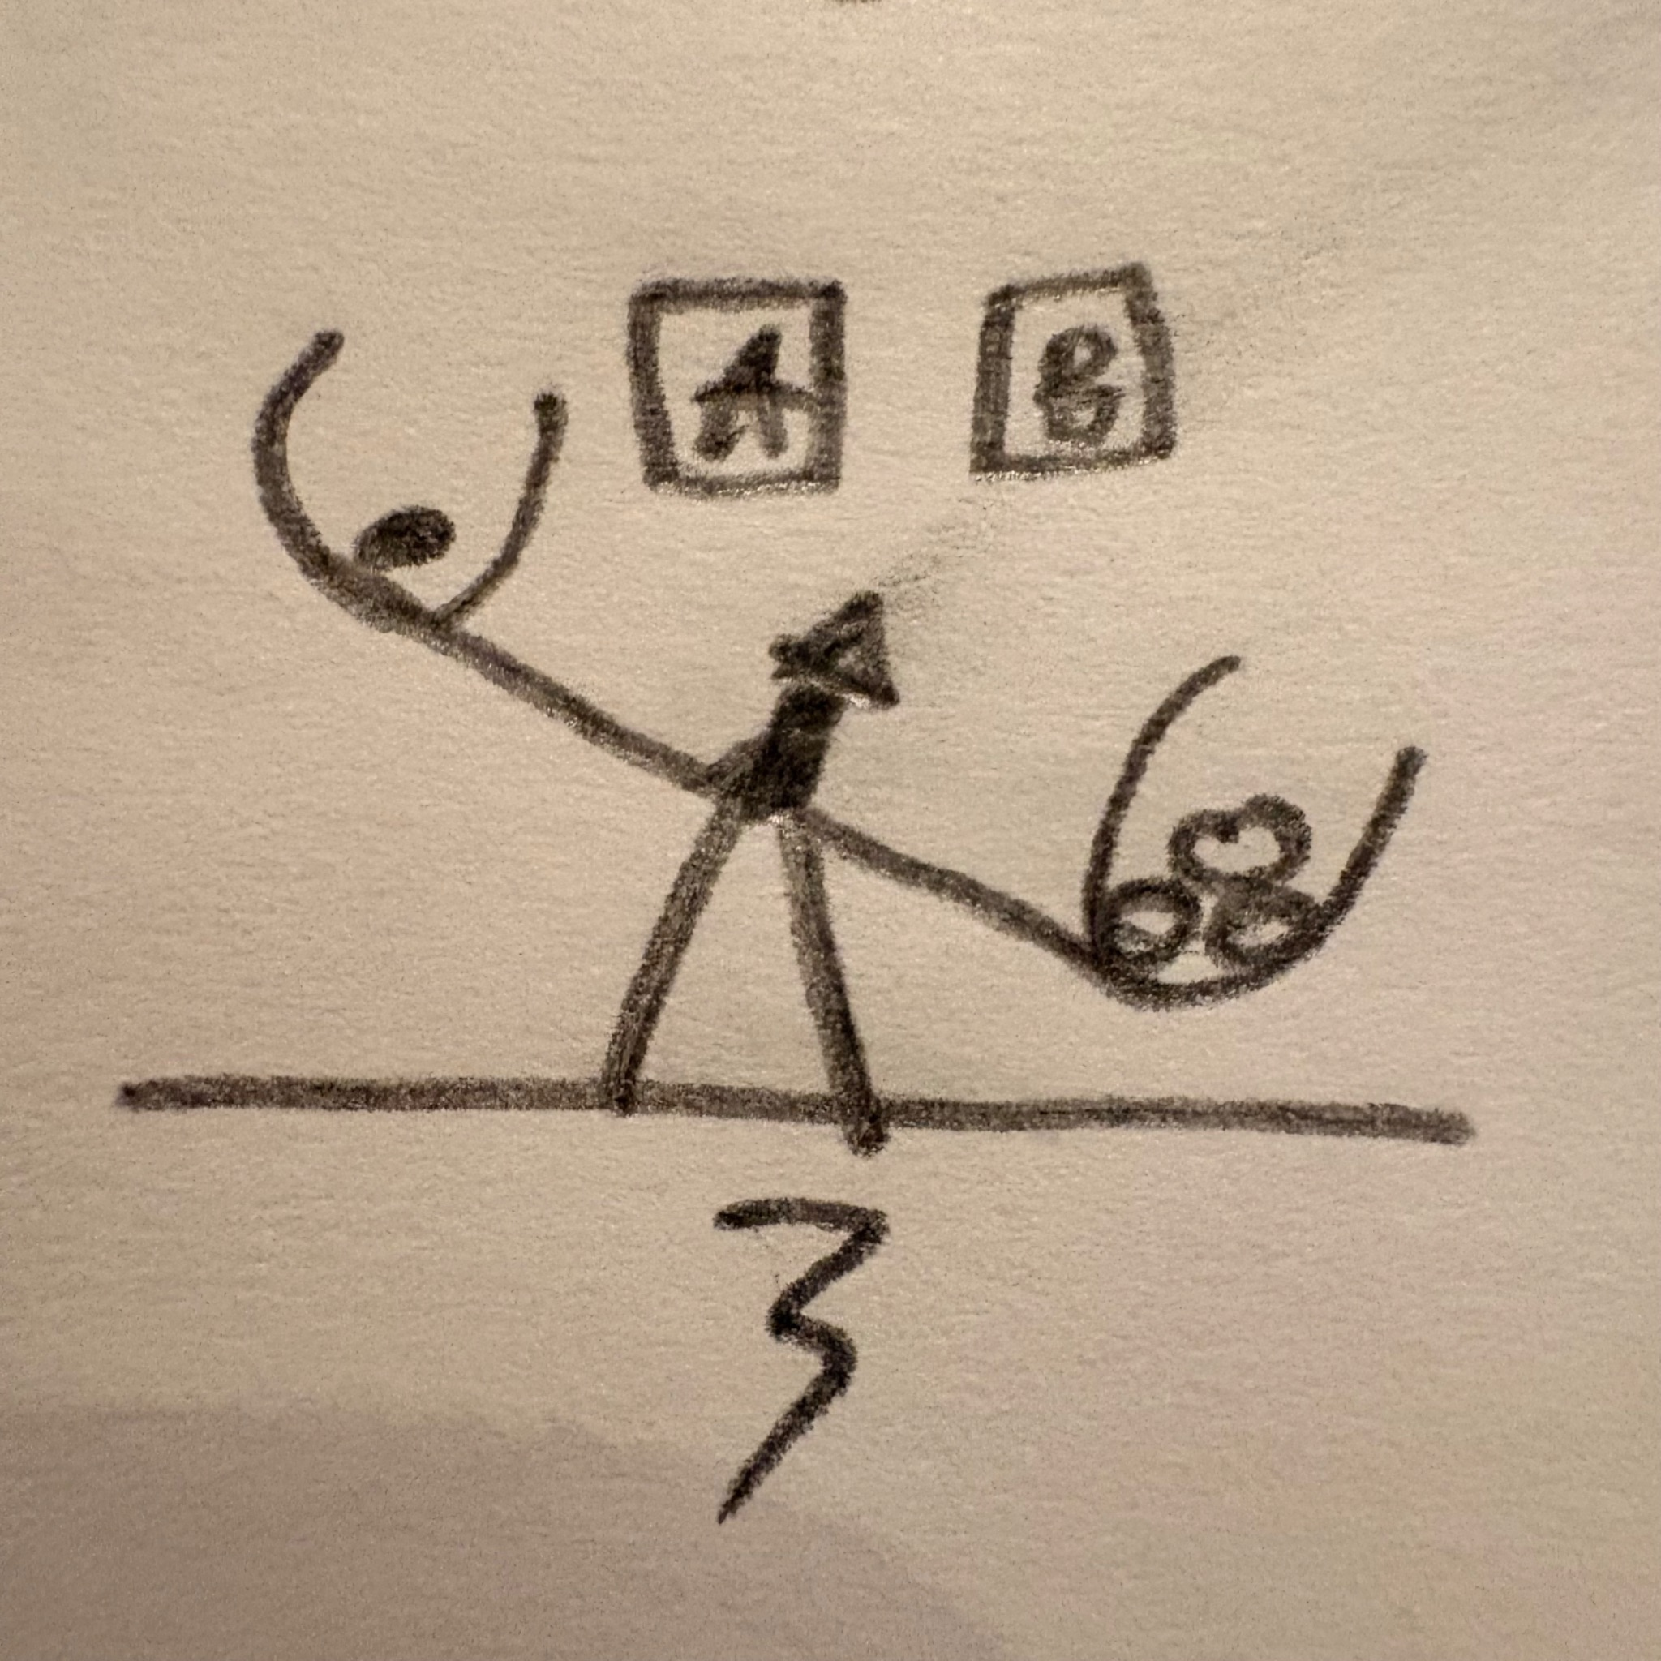
Design Idea #4
Date: 3/10/26
Description: An indicator card with the voting options would be placed on the back of the base of the scale. As the Pom Poms fill the jar they will move out of the way to show the winning card.
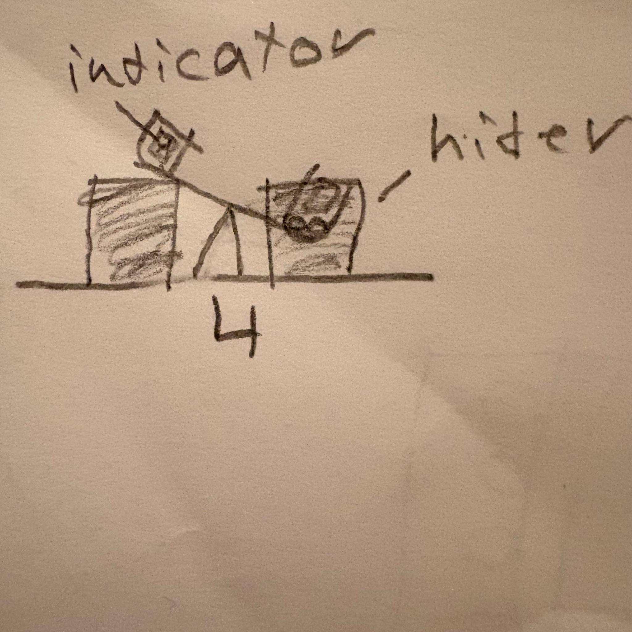

Design Idea #5
Date: 3/10/26
Description: As either side of the scale goes down, it lifts up the indicator to show how much each vote is winning or losing as if the scale is moving with the cards.

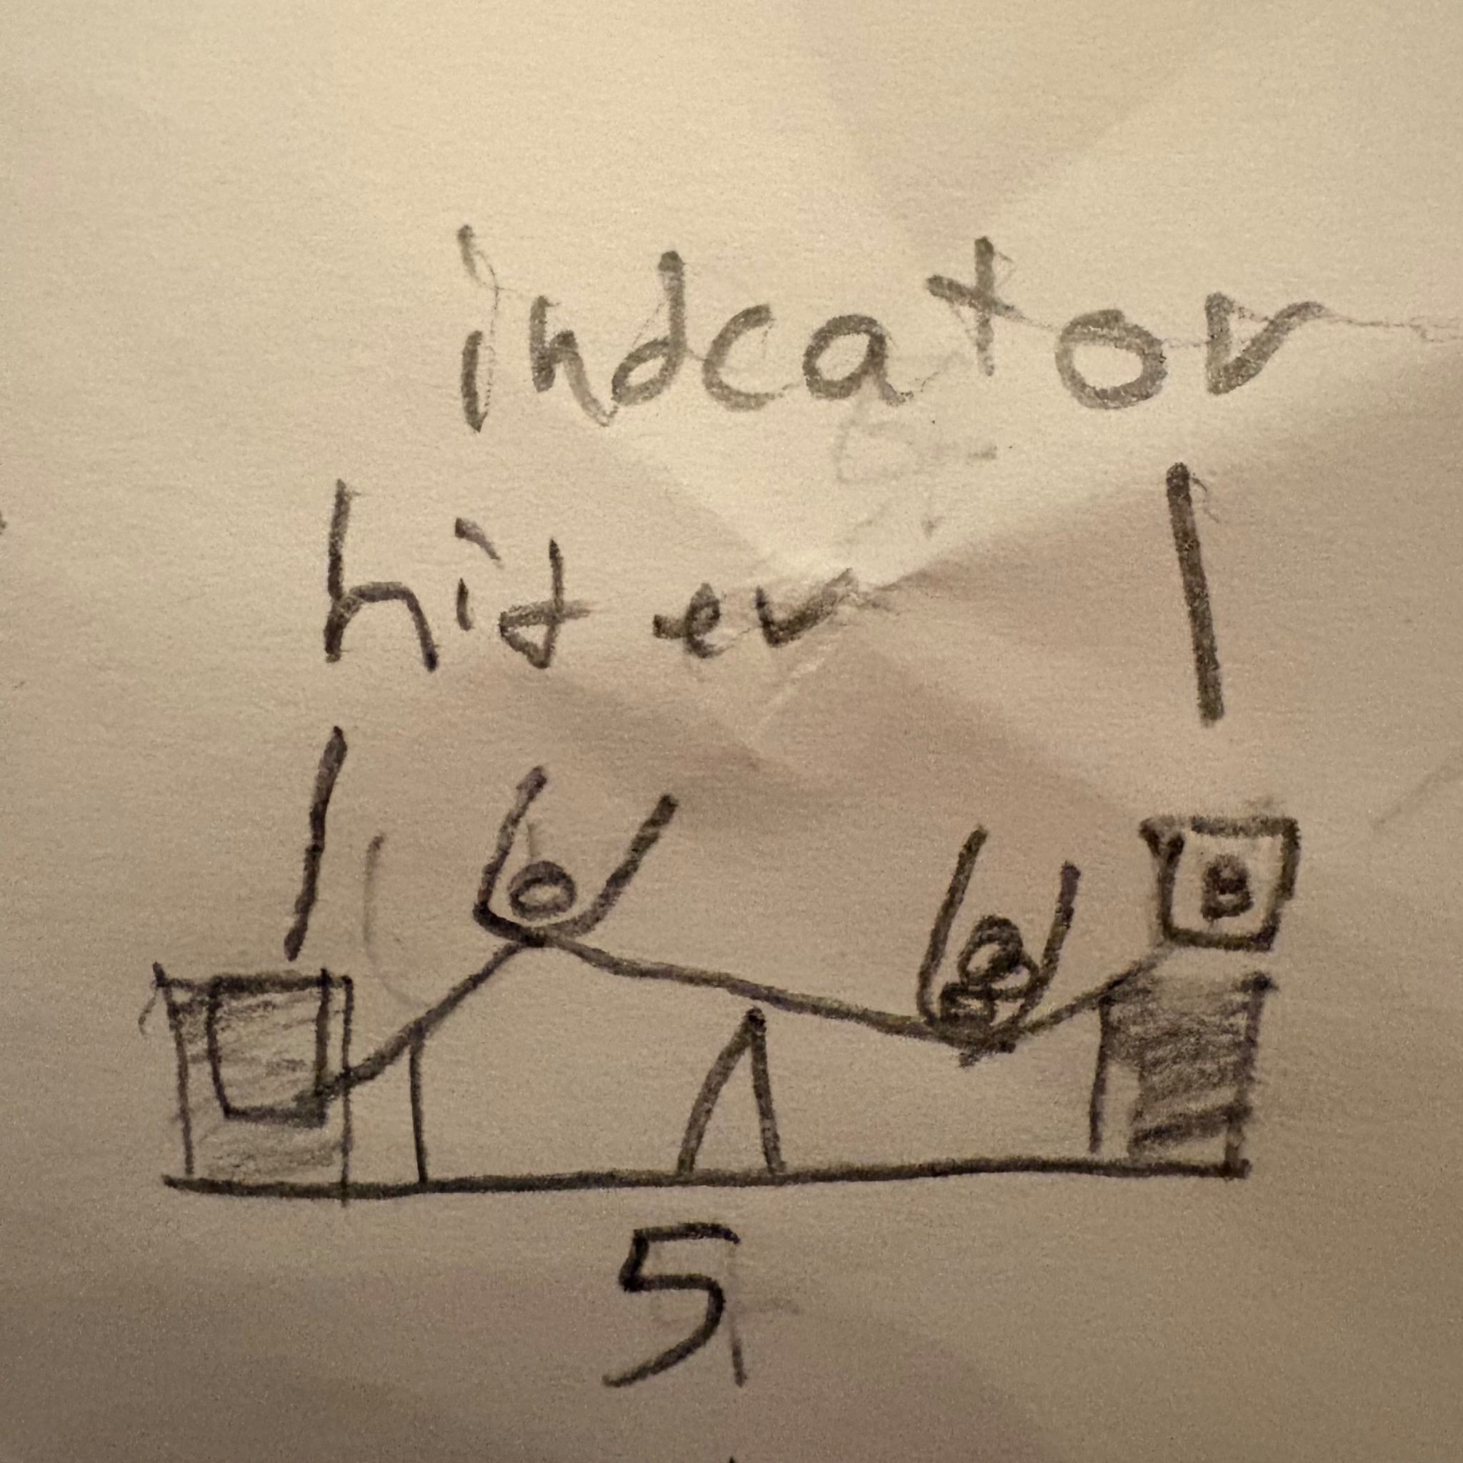
Design Idea #6
Date: 3/10/26
Description: Again using the weight idea we use a gear ratio to make an arrow point at the winning decision as more pom poms are added to each side .
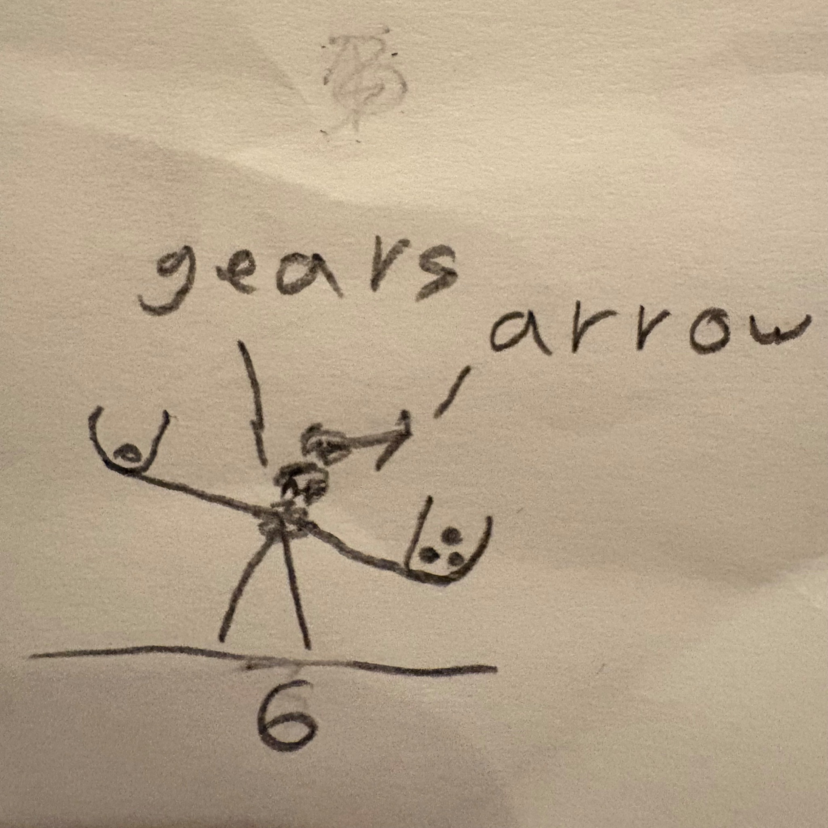

Design Idea #7
Date: 3/10/26
Description: Have a pom pom launcher. Two launchers each with a button where you put the pom pom into the corresponding launcher and press the button so the kids can interact and make it more of a game to see if you can shoot the pom pom into the cup with the decision card that they want to vote for.
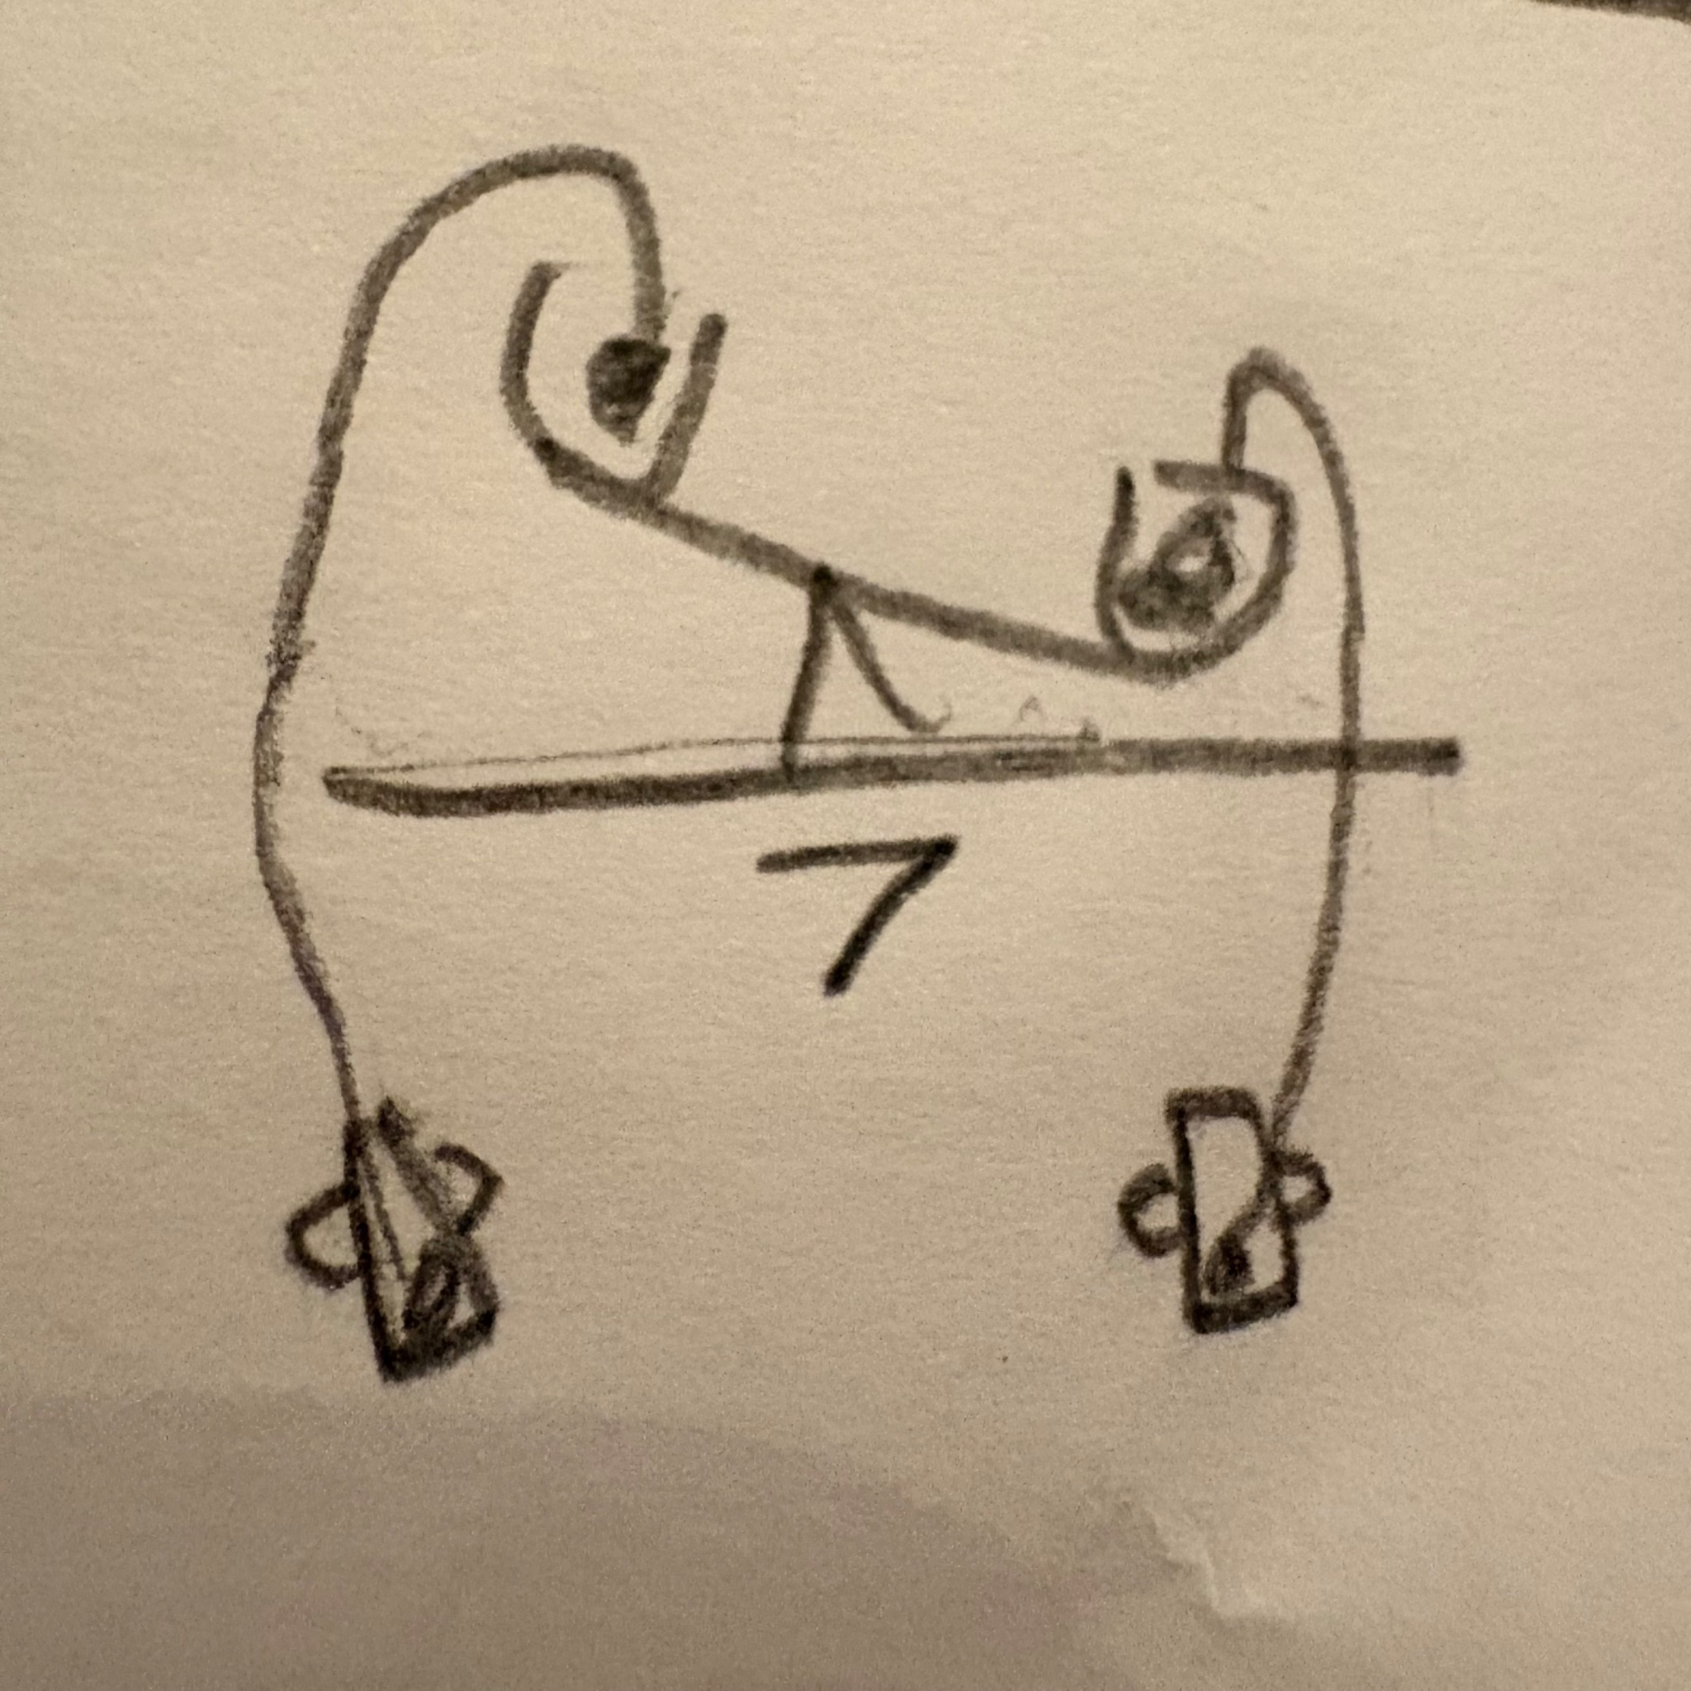

Design Idea #8

Date: 3/10/26
Description: A tree-like construct to hold up the signs. It’ll be a pillar attached to the base of the scale like in #1 and have two branches at a 120 degree angle. It’s basically a glorified Y shape that holds the decision cards .
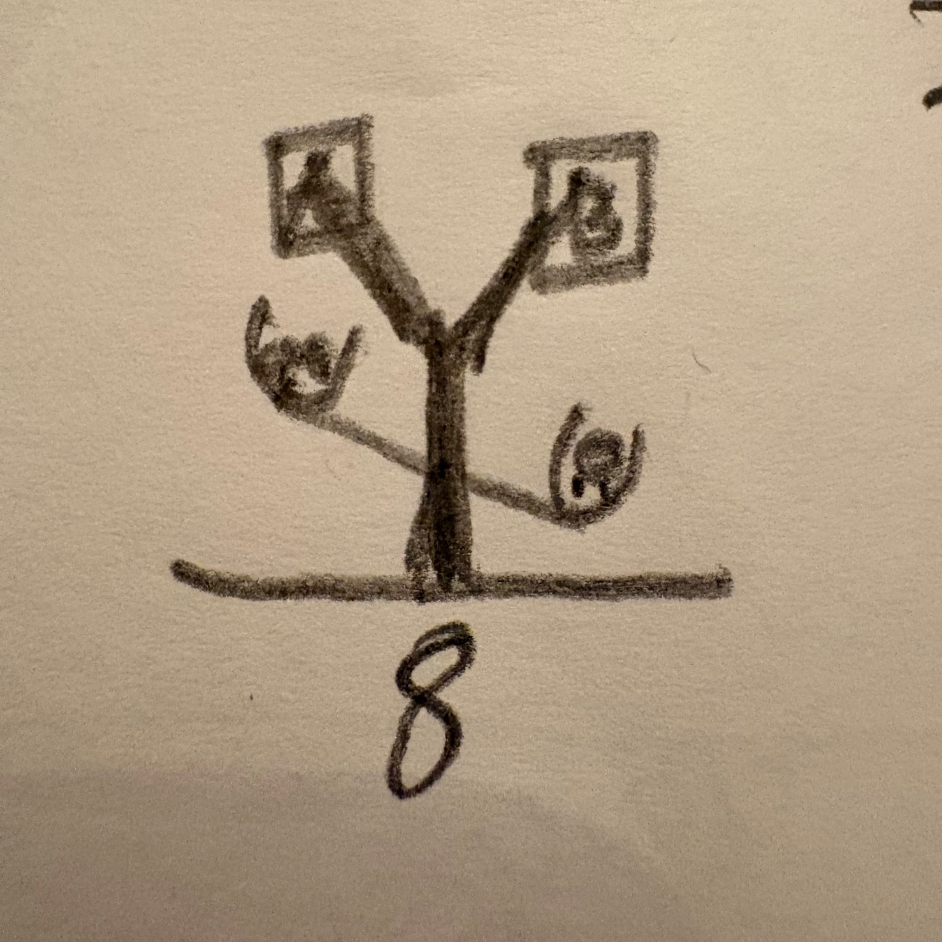

Design Idea Comparison and Selection (D1, D2)

https://docs.google.com/spreadsheets/d/1CRKORJ4kxV-cmJJCQgArWm2e-_Px-_Uz/edit?gid=1026446183#gid=1026446183

The decisions on how we weighed our decision matrix is based off of our original standards of what we wanted our project and prototype to be When we were making are team standards so we just believe that those were the best fit of how Important we decided that each one of our standards were

Design Blueprint (D4)

Design Blueprint #1
Date: 3/27/26
Sketch: 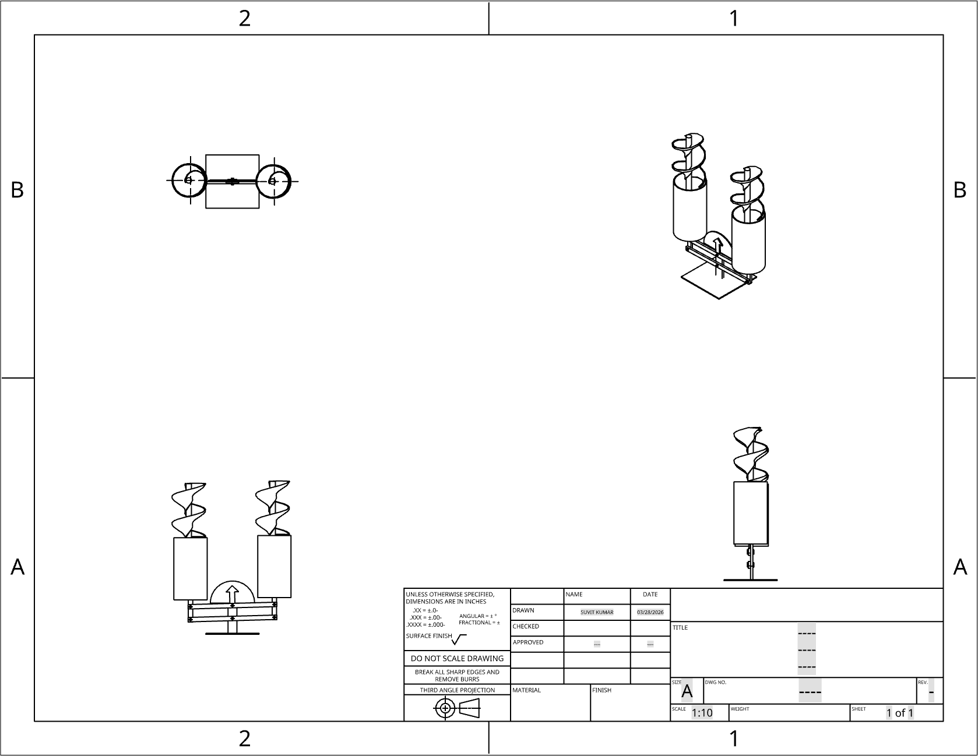

3D Assembly with dimensions and details (go to assembly)l: https://cad.onshape.com/documents/b54dae87b9f510f71a95c0a7/w/030c9343a50535f6bf611acb/e/e685f05062b6ead9bc7b4042

Manufacturing Methods:
Step 1: 3D Print the slide, vertical beams, horizontal beams, arrow, and base (or make it out of cardboard).
Step 2: Put the pin joints in the holes of the cross beams to hold it together.
Step 3: Attach the jars to the two end vertical beams by using the joints and securing them to the bottom of the jars .
Step 4: Attach the slide into the inside of the jar with glue.
Step 5: Create the indicator card.
Step 6: Attach the indicator card to the slots in the designs.

Supply List and Costs:
Item | Cost each | # needed | Total
plastic jars | 5$-10$ | 2 | 10$-20$
3d printer filament | 40$ | (1) | 40$
Mini pompoms | 4.35$ | 1 bag has 1200pcs | 4.35$
Velcro | 2.99$ | 1 | 2.99$

Total Cost |  |  | 67.34

Plan of Action (D3)

March 26th: CAD
March 27th: Finalizing Construction and Testing Plan.
March 28th-31st: Making and Testing Prototype
April 1st: Miroboard Presentation.
April 7th: Document Test Results
April 9th: Making sure the stakeholders are involved, and reiterating.
April 21st: Presentation of Final Iteration

4

