Element D: Design Concept Generation, Analysis, and Selection

Design Idea Generation (D1)
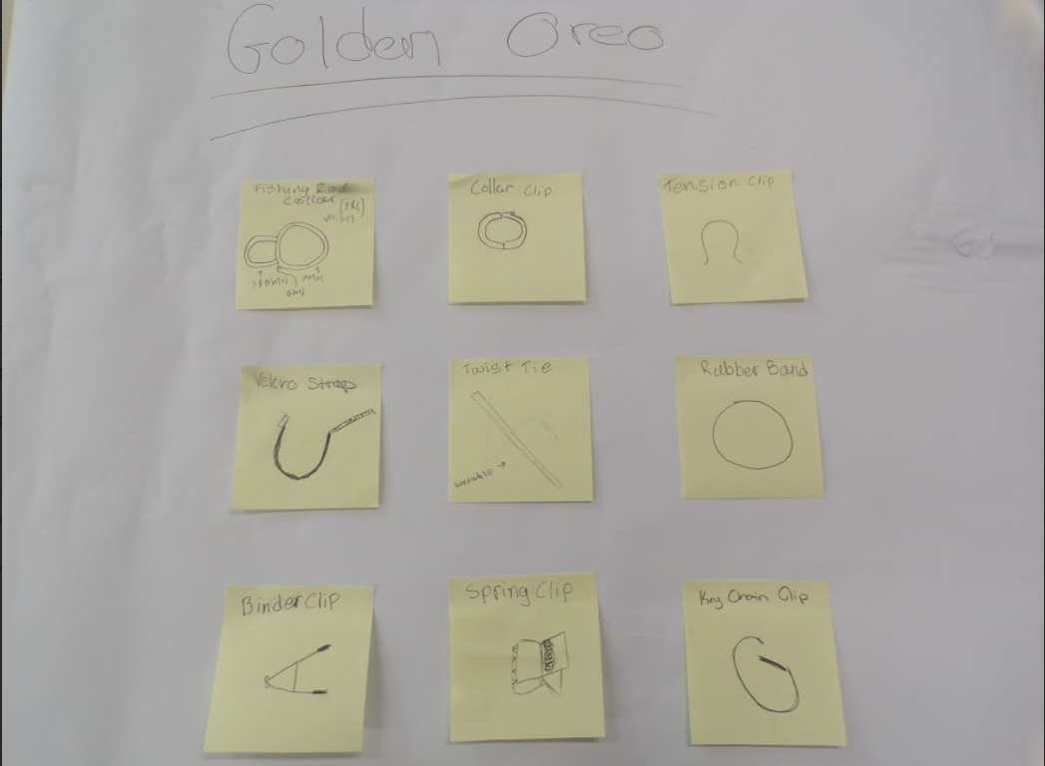

Design Idea #1 – Fishing Rod Collar

Date:3/18/26
Description: This clip will have two parts both made out of TPU or other 3D print filament: a clip that goes around the boom mic stick and a clip that connects to the other clip that will allow for the cable to go through it. The first clip will make it so that the entire thing doesn’t move on the boom mic stick. While the second part of the clip will ensure that the wire will be straight and constrained to only inside the loop.
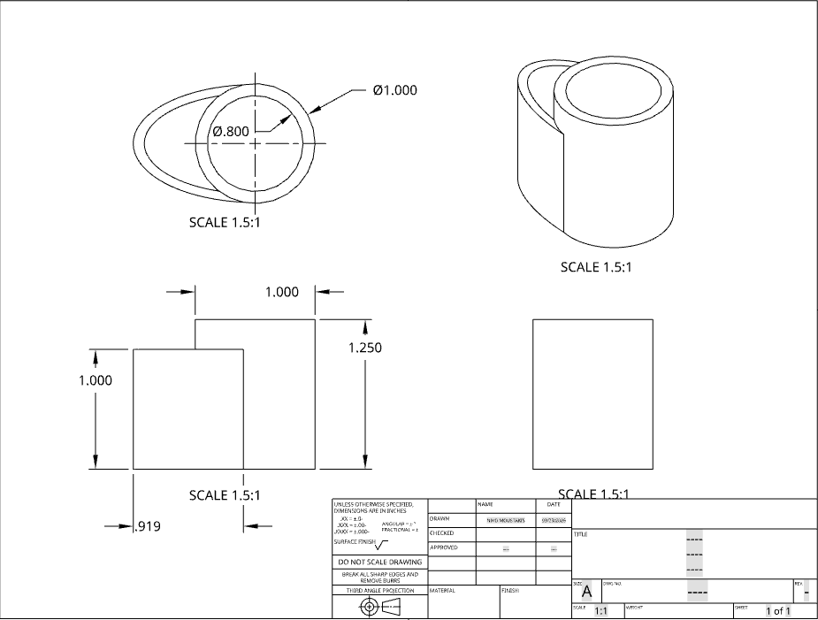
Design Idea #2 - Velcro Strap

Date: 3/18/26
Description: This clip will have one main part made out of TPU or other 3D print filament and a velcro strap. The main part will go around the boom mic stick. Once around the boom mic, the velcro strap will go into one of the side holes and around the entire clip. When around the clip, the cord will be set in place by the hooks of the strap connecting to the fluffy part of it.
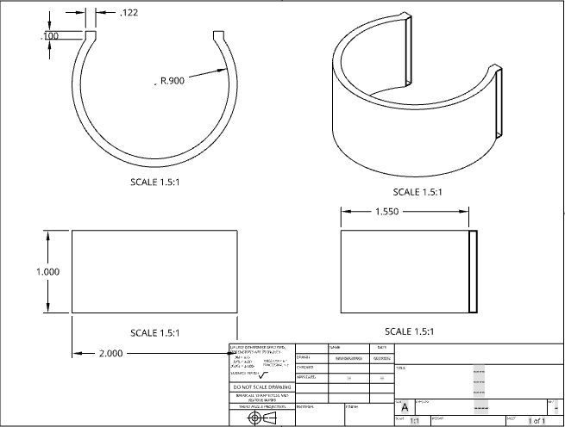
Design Idea #3 - Binder Clip
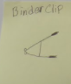
Date: 3/18/26
Description: This is a clip which will be operated with a main body, made of metal, and two arms, also made of metal. It is like a pair of pliers, in the sense that when you squeeze the arms of the clip, it opens, and when you let go of the arms or release the tension it closes.
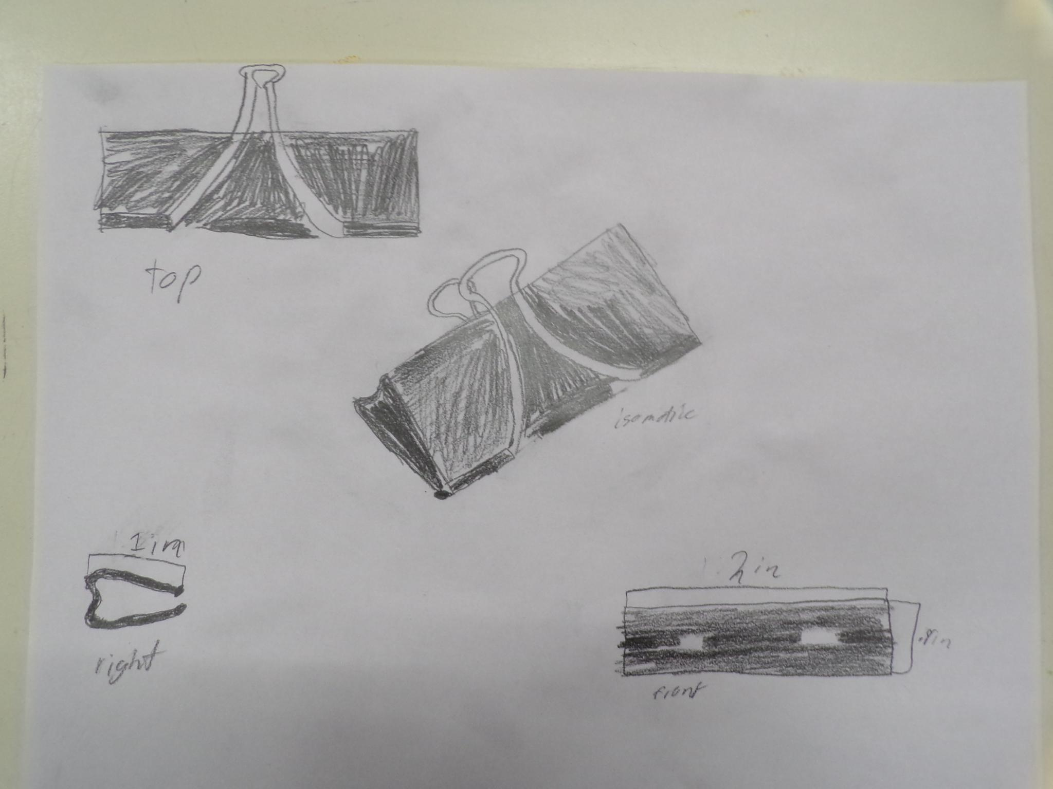
Design Idea #4 - Carabiner Clip
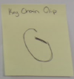
Date: 3/24/26
Description: This clip will work by having a main body with a lever like system to open and close the clip, which will let the cord and the boom mic stick to come out. First you will align the cord along the boom mic stick, and then you will push on the lever to open the clip, which will allow the entire clip to go around the boom mic, locking it in so it can’t move.
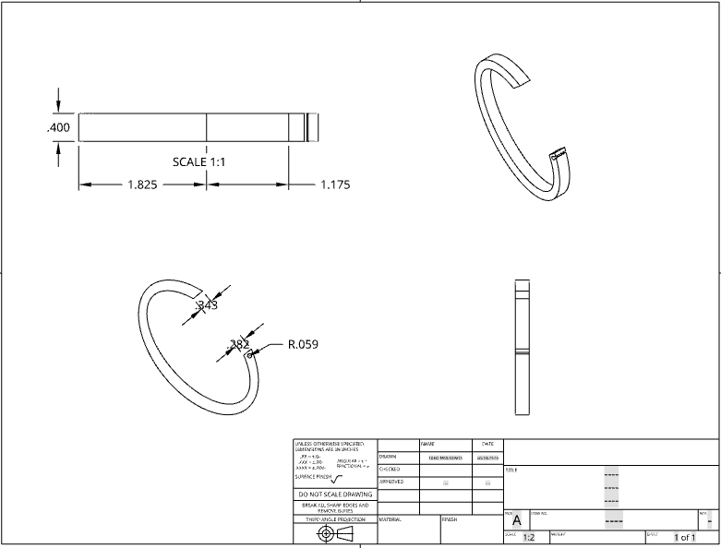

Design Idea #5 - Tension
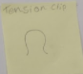
Date: 3/24/26
Description: This clip has one entire main body made out of TPU or other 3D print filament. First, you will align the boom mic stick with the cable, by doing so you will make it easier for the clip to attach to both of them. Then you will push the clip into the cable and stick to make it connect to both, making them unable to come out of it.
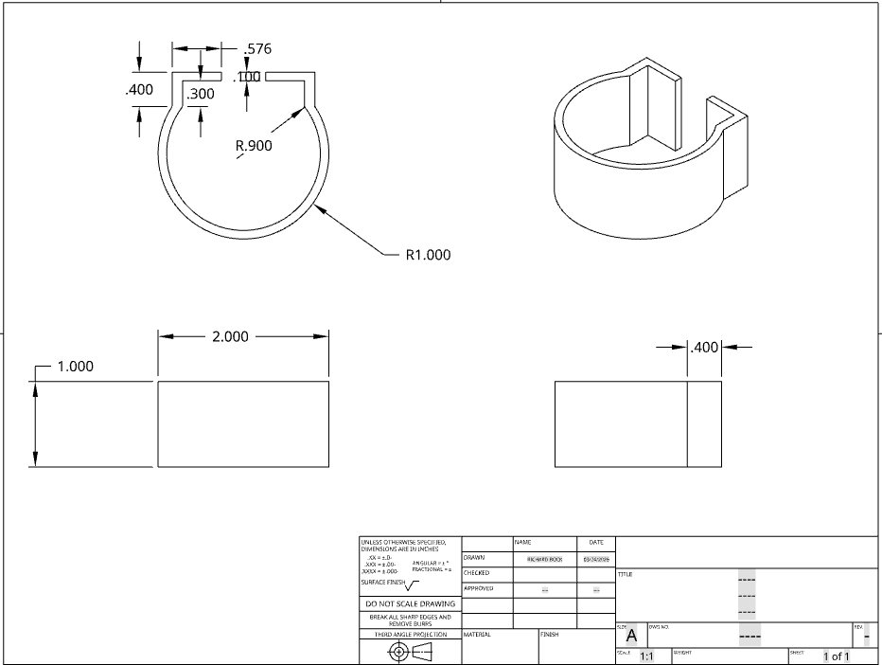

 | weight | Fishing Rod | Velcro | Binder | Key Chain | Tension
Durability | 3x | 2 | 5 | 1 | 4 | 3
Weight | 2x | 2 | 4 | 3 | 1 | 5
Price | 1x | 4 | 3 | 1 | 2 | 5
Gripability | 2x | 5 | 3 | 1 | 4 | 2
Diameter | 1x | 2 | 4 | 5 | 1 | 3
score |  | 26 | 36 | 17 | 25 | 26
Score (5 Best, 1 Worst)
Durability: how well the clip holds up
Weight: how much the clip weighs
Price: how much the clip costs to make
Gripability: how well the clip attaches to the cable/boom mic
Diameter: how easy it will be to change the diameter of clip according to the boom mic stick
We have chosen to go with the velcro clip design as it scored the best on our matrix.

Design Blueprint (D4)
Design Blueprint #1
Date:3/26/26
Sketch: Velcro Boom Mic Clip

Manufacturing Methods: Onshape & 3D Printer
Step 1: Follow the sketch to make the design on onshape
Step 2: Export the design as STL file
Step 3: Slice design in Bamboo (0.2 mm Speed, 15% Infill, Generic TPU), export as G Code and send it to the 3D printer
Step 4: Print the mic clip
Step 5: Sauder/glue velcro strap (3/4 in. x 35 ft.) properly onto the inside of the clip (view picture below on how it is attached [will glue/sauder at star point])
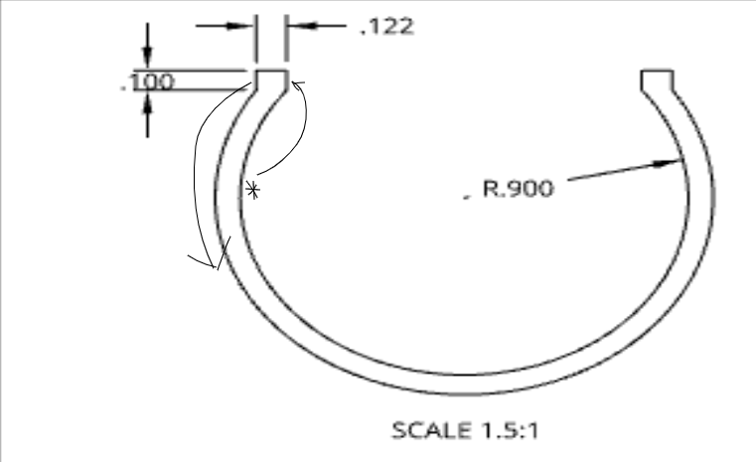
Supply List and Costs:
Item | Cost each | # needed | Total
TPU filament | $25 | 3 G | $0.08
Velcro strap | $7.99 | 6 inches | $0.11
Total Cost |  |  | $0.19

Plan of Action (D3)
- Sketch Designs (1-2 Classes)
- Make Design In Onshape & Export as STL (1-2 Classes)
- Slice Clip in Bamboo & Print The First Mic Flag (1 Class)
  - 0.2 mm Speed, 15% Infill, Generic TPU
- Test The Mic Flag (2-3 Classes)
  - Testing Requirements From Element C
    - Doesn’t damage mic
    - Weight
    - Price
    - Gripability
    - Diameter
    - Color
    - Speed
- Record Strengths/Weaknesses (1 Class)
- Make Innovations In Prototypes & Onshape (2-3 Classes)
- Print New Mic Clip With New Innovations (1 Class)
- Repeat Steps 2-5 Until Mic Clip Meets Our Design Requirements (6-8 Classes To Repeat Steps 2-5)
- Produce Multiple Mic Clips With different Shapes and Designs Based On Final Design After Going Through Steps 1-6 Until We Our Satisfied With Final Product (1 Class For Each New Mic Clip To Be Manufactured)
- After you are satisfied with the first design (Velcro Strap), repeat steps 1 to 9 with the second design (Fishing Rod Clip) until satisfied with that design as well.

