MyDesign Portfolio
Element D Initial Template AT - 15 points

Design Idea #1 | Magnetic V8
Date: | 10-16-2025, 9:09:35 AM
Description: | A v8 engine that powered by magnets
Drawing that includes distinguishing information such as scale, dimensions, and materials: | A carbon fiber cam shaft with 4 strong magnets that spin and pull the piston head what is one polarity. An eclectic starter could be used to make the inetitlal spinning ong the cam/crack shaft.

Design Idea #2 | A magnetically powered car that uses magnets in the ground
Date: | 10/16/25
Description: | A magnetic-powered car that runs with magnets underground and is propelled forward
Drawing that includes distinguishing information such as scale, dimensions, and materials: | 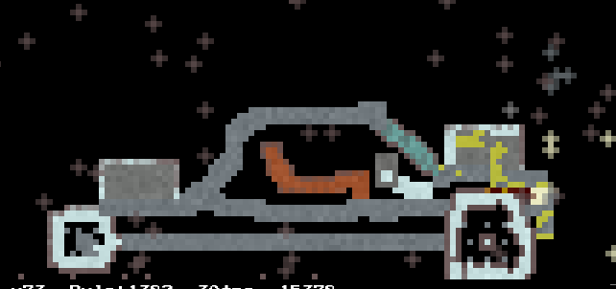  Plastic wheels with metal inside. 18 blocks long and 5 blocks tall, magnets on front and back with wires to connect

Design Idea #3 | Magnetic Powered Engine
Date: | 10/16/2025
Description: | An engine that uses magnets, using force and a rotating pole that rotates back and forth to avoid the magnetic force from being equalized out.
Drawing that includes distinguishing information such as scale, dimensions, and materials: | 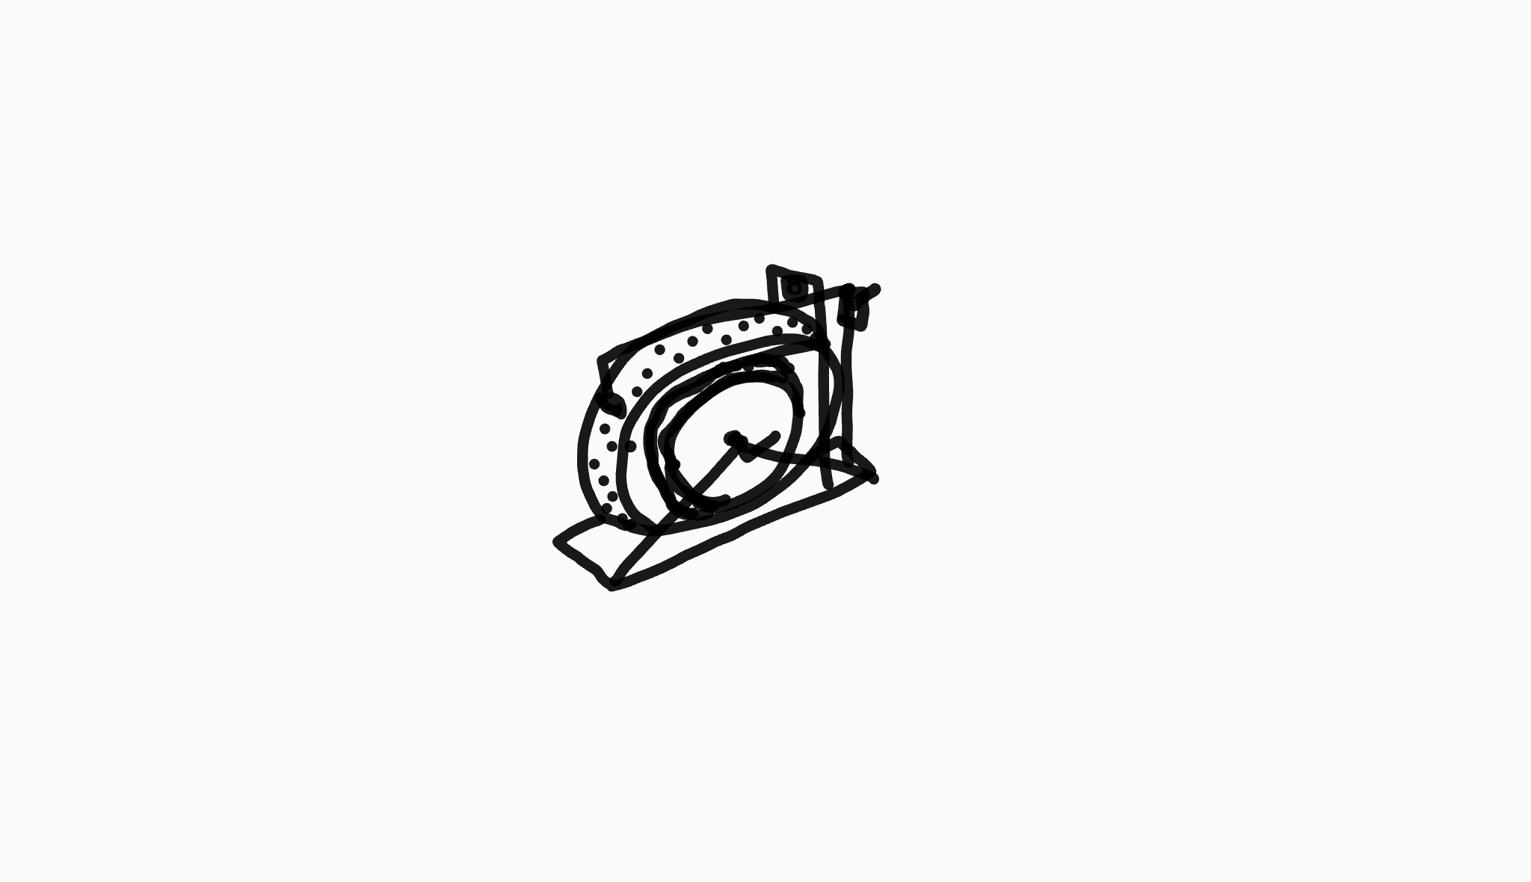

Design Idea #4 | Electromagnetic powered cars
Date: | 10/16/25
Description: | Uses flipping of 2 parts of a magnet, a repelling magnet and a pulling magnet, an electric rotor flips the small magnets pulling the piston, if this is done at the right time it should generate force.
Drawing that includes distinguishing information such as scale, dimensions, and materials: | Pulling magnet  Repelling magnet  Spinning rod  Piston  Dimensions per system part: ~6in tall, 2in, wide 10 in long  Ferrous stuff, magnets, non magnetic stuff  lubricant

Design Idea #5 (if needed)
Date:
Description:
Drawing that includes distinguishing information such as scale, dimensions, and materials:

Design Idea Comparison and Selection (D1, D2)

(List your requirements for Element A below) | Weight (multiplied by each design score) | Design 1 | Design 2 | Design 3 | Design 4
Requirement A |  | Non magnetic material | If it can stand still and not fall apart, and also if it can run 3
Requirement B |  |  | If the item can run by itself without any carbon fuel 6
Requirement C |  |  | If it can symbolize the experience of how the magnetically powered car can beat the other cars 2
Requirement D |  |  | If the magnet can withstand the pressure on top 1
Requirement E
Total score |  |  | 11

Our team chooses design _magnetic powerd cars_________________________ to solve the community problem because it is very simple to make this car _____________________________________________________________________________________

Design Blueprint (D4)

Design Blueprint #1 
Date:
Sketch or CAD Drawing (orthographic):
Manufacturing Methods (cut, saw, paste, screw, tie, glue):
Step 1: Buy magnets and other supplies like plastic, wheels, and some wood
Step 2: Manufacture a way to you can add the magnetic engine to the car
Step 3: Make sure you can pull back so the car can go
Supply List and Costs:
Item | Cost each | # needed | Total
Wood | 12 | 2-3 | 36 dollars
Plastic | free | 3-4 | 0
Magnets | Free | 2 | 0
Total Cost

Plan of Action (D3)
- A Gantt chart is encouraged to outline the primary steps expected on a visual timeline. Here is one you can use.
- Larger tasks from the Gantt chart should be broken down further into detailed sub-tasks, which may be housed in a different day-to-day document.
- The Gantt chart will be a future assignment so if you start now you will be ahead.
- Discrete tasks should include enough detail such that others could replicate the efforts, such as procedures, materials, tools, status, etc.

- Make screenshots of the document instead of using the link.

Wait until you create and test your first prototype to fill out the next section.
Iterations for the Solution (How did you change your prototype after building and testing it?):
Date of Iteration:
Description of Iteration:
Images if applicable:

Date of Iteration:
Description of Iteration:
Images if applicable:

Date of Iteration:
Description of Iteration:
Images if applicable:

Rubric
Element D: Design Concept Generation, Analysis and Selection
 | 5 | 4 | 3 | 2 | 1 | 0
1. Process for Generating & Comparing Possible Solutions. The Process for Generating Possible Solutions _____________. | was comprehensive, iterative, and consistently defensible (viable design highly likely) | was thorough, iterative, and generally defensible (viable design likely) | was adequate, generally iterative and defensible (viable design is possible) | was partial or overly general and only somewhat iterative and/or defensible (raising issues with the design viability) | was incomplete or minimally iterative and/or defensible (raising issues with the design viability) | was not evident that there was an attempt
2.Design Solution Choice. The Design Solution chosen ____________. | was well-justified and demonstrated attention to all design requirements | was justified and demonstrated attention to most if not all design requirements | was explained with reference to at least some design requirements | was not sufficiently explained with reference to design requirements | lacked support related to design requirements | was not attempted or evidence not provided
3. Plan of Action. The plan of action _____________. | has considerable merit and would easily support repetition and testing for effectiveness by others | would support repetition and testing for effectiveness by others | might not clearly or fully support repetition and testing for effectiveness by others | has insufficient detail to allow for testing for replication of results | is lacking to the point that the design solution cannot be tested | cannot be executed or does not exist

