do Portfolio
Element D Initial Template AT - 15 points

Element D: Design Concept Generation, Analysis, and Selection

Design Idea Generation (D1)

Design Idea #1 | Paper spreadsheet
Date: | Apr 18, 2026
Description: | A simple spread sheet where students write their name and time in and time out. Many schools, including Churchill, have adopted this method.
Drawing that includes distinguishing information such as scale, dimensions, and materials: | 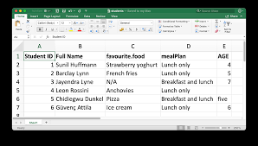

Design Idea #2 | Motion sensor tracker
Date: | Apr 20, 2026
Description: | Using an Arduino Kit, we would use motion sensors to detect motion inside bathrooms. There are many flaws, however. It would be tricky to track which students are out and how long they are out for.
Drawing that includes distinguishing information such as scale, dimensions, and materials: | 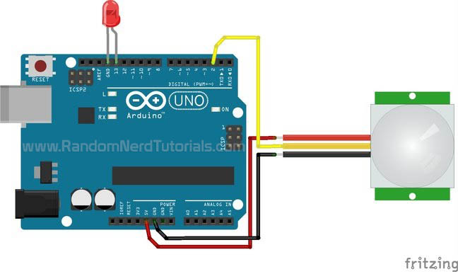

Design Idea #1 | MATLAB Computer Program
Date: | Apr 21, 2026
Description: | With the assistance of MATLAB’s AI Playground, we created a program that tracks a given amount of students out in the bathroom. Students input their name and student ID. Once they do this, they are timed for how long they are out in the bathroom for. Once they return to the classroom, they can check back in and the timer will stop. If the student is out for longer than 5 minutes, security will be notified.
Drawing that includes distinguishing information such as scale, dimensions, and materials: | Student inputs their name and student ID. Begin tracking time  Is the student out for longer than 5 minutes?  Notify Security.

Design Idea Comparison and Selection (D1, D2)
(List your requirements for Element C below.) | Weight (multiplied by each design score) | Design 1 | Design 2 | Design 3 | Design 4 | Design 5
Must record all data | 5 | 5
Must allow students to create or update pass within 30 seconds | 5 | 5
Must Display data for teachers and staff to see | 3 | 3
Must allow teachers or staff to export data as a csv file | 3 | 3
Total score | 16 | 16

Our team chooses design idea 1 to solve the bathroom pass problem because it is easy to implement and tracks students effectively.

Design Blueprint (D4)
Design Blueprint #1
Date: 5/19/2026
Sketch or CAD Drawing (orthographic/multiview):
Manufacturing Methods (cut, saw, paste, screw, tie, glue):
Step 1: Install program into computer
Supply List and Costs (only if school does not have existing technology infrastructure):
Student inputs their name and student ID. Begin tracking time
Is the student out for longer than 5 minutes?
Notify Security.
Item | Cost each | # needed | Total
Chromebook | $150 | 100 | $15,000
Total Cost |  |  | $15,000

