MyDesign Portfolio

Element D: Design Concept Generation, Analysis, and Selection

Design Idea Generation (D1)
Design Idea #1
Date: 3/19/2025
Description: A chain of different parts that are held together by pegs/rods.
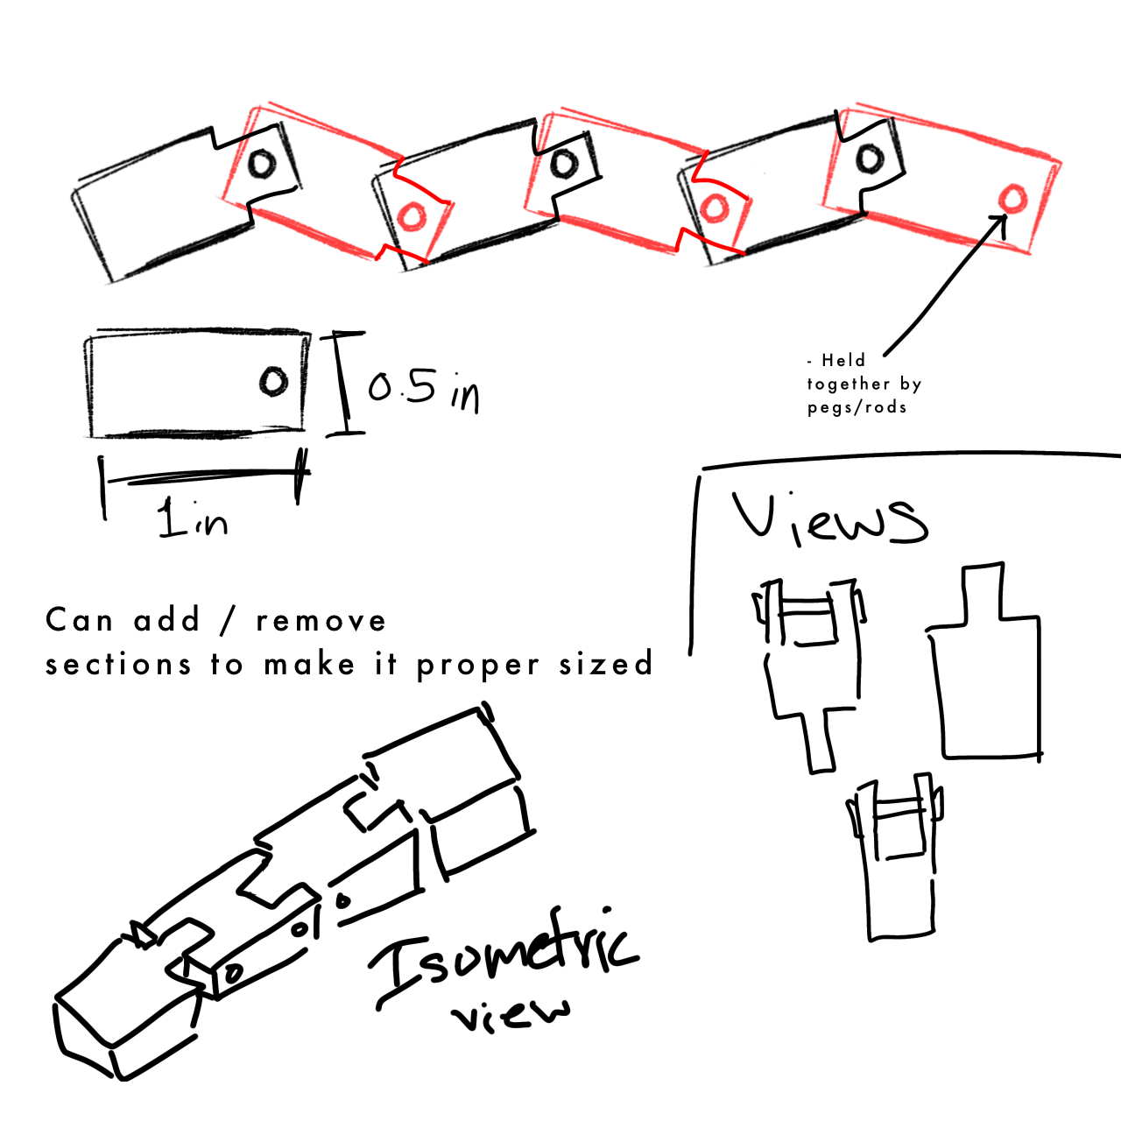

Design Idea #2
Date: 3/25/25
Description: Two cones with patterns that interlock with each other.
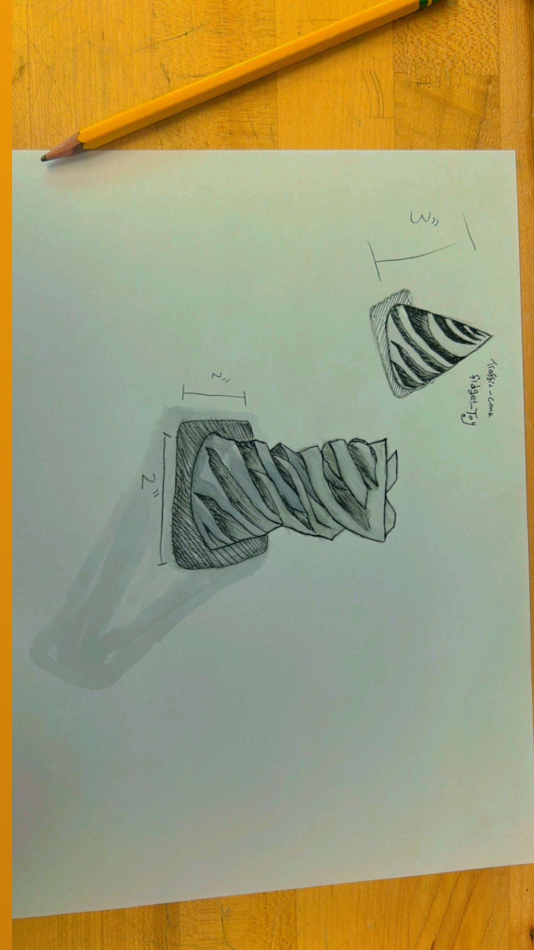

Design Idea #3
Date: 3/25/25
Description: Small cubes that are connected to each other to move around.
Drawing:
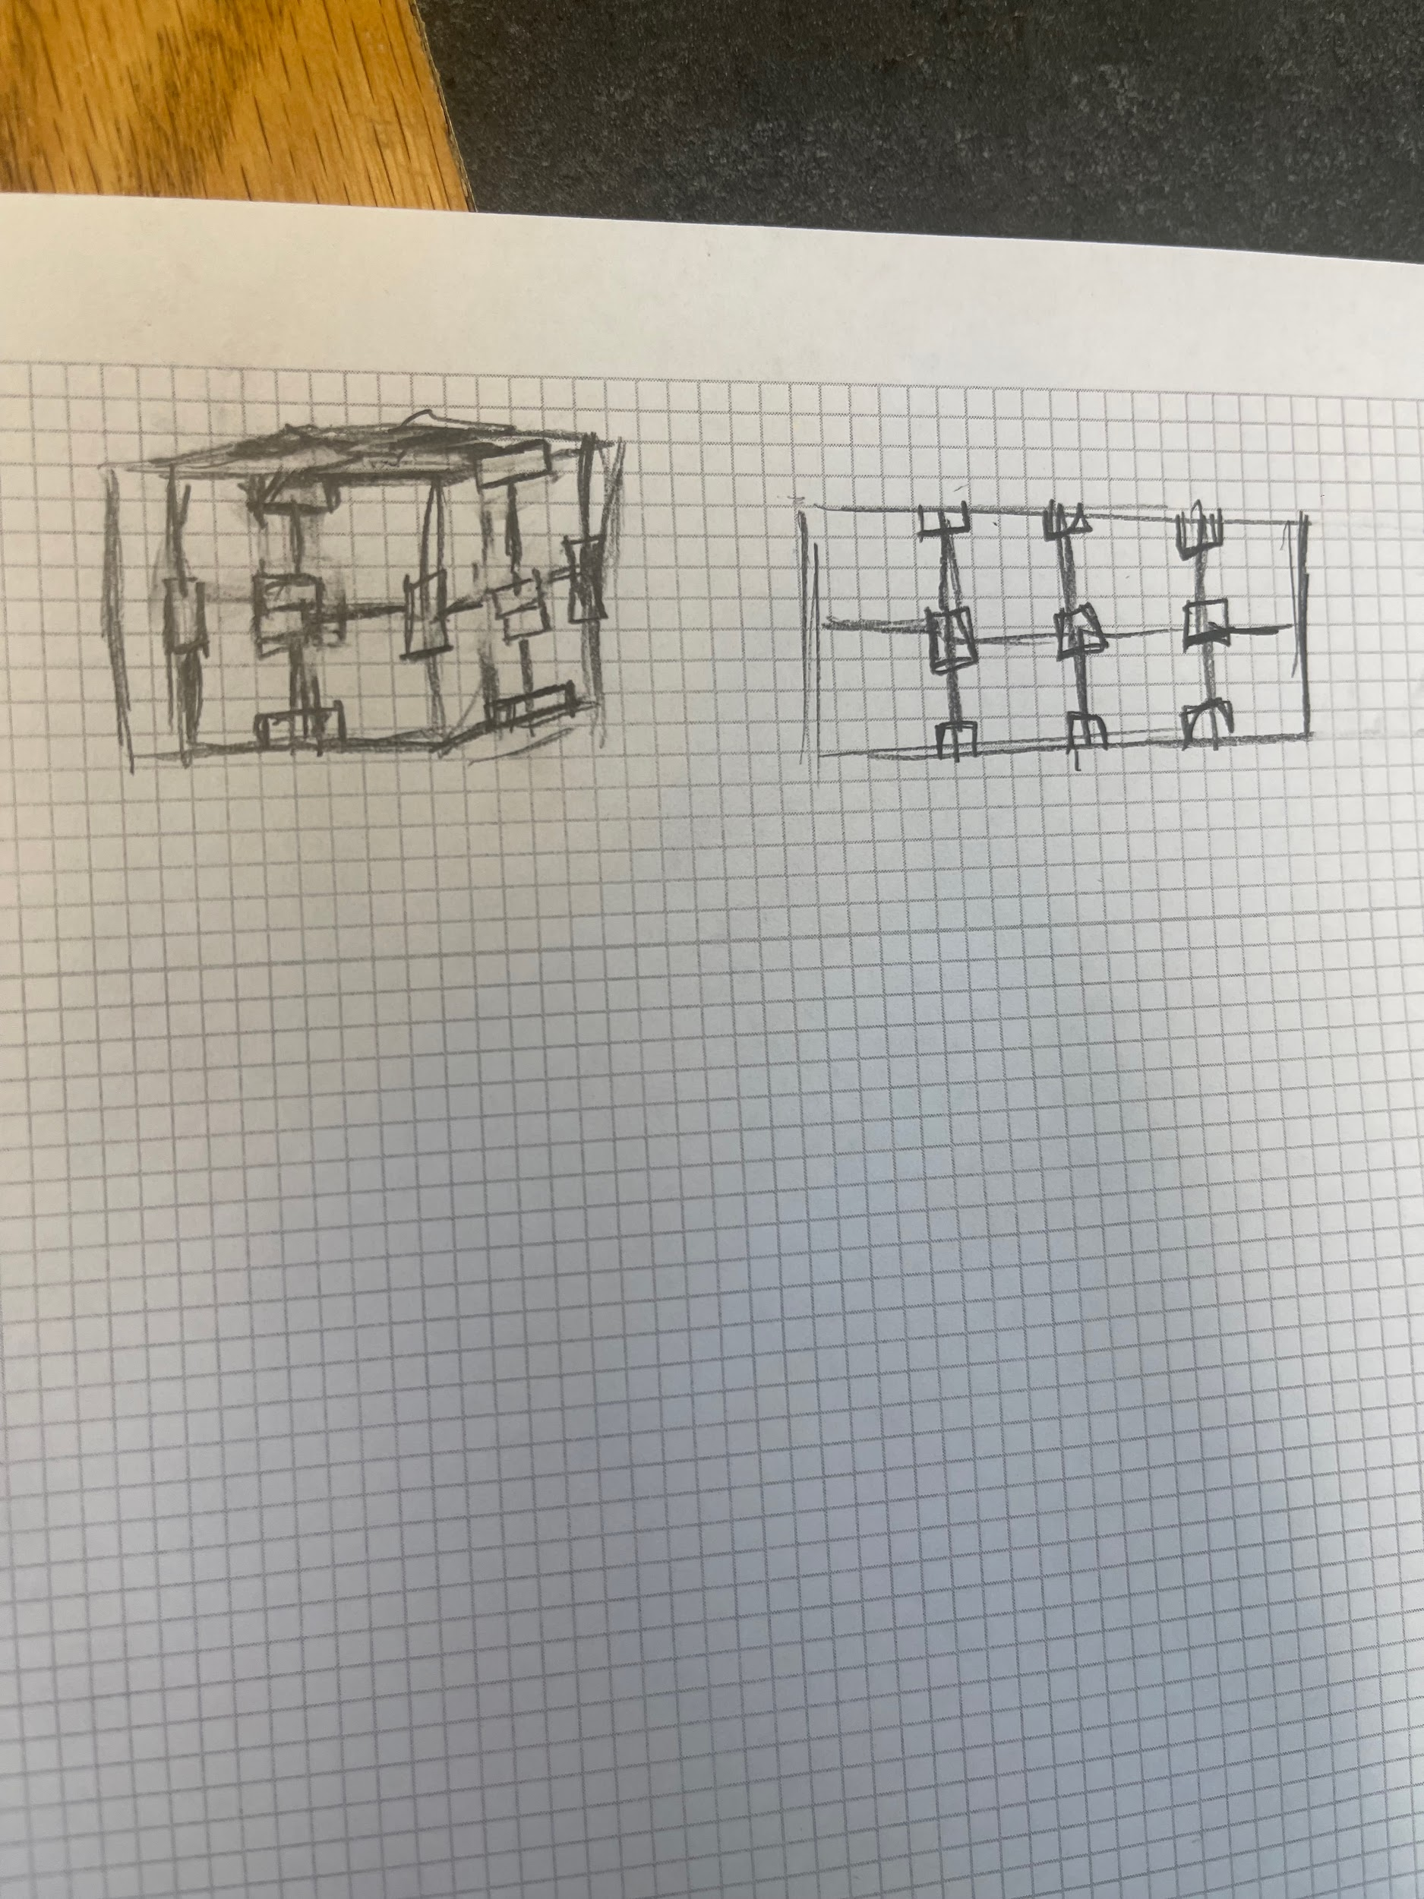

Design Idea #4
Date: 3/27/25
Description: Chain of hollow cylinder beads that are able to move and spin around. Each bead is a unit that consists of a rod that the bead spins on and flared ends to prevent beads from moving up and down the chain.
Drawing:

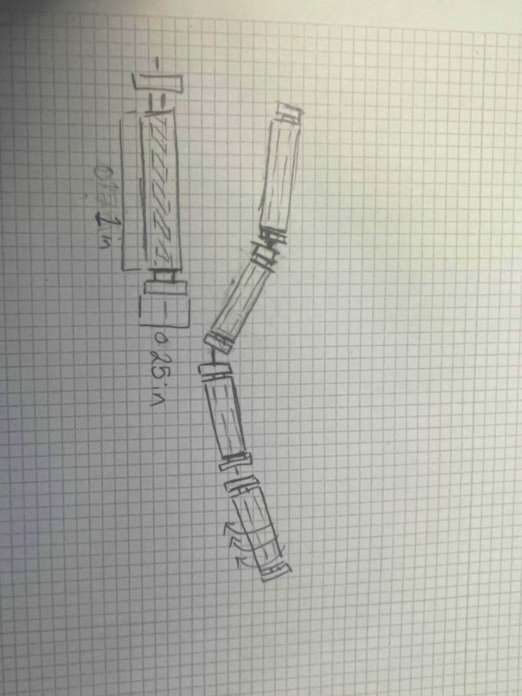

Design Idea #5
Date: 4/2/25
Description: Small cubes that are connected to each other with rubber bands to move around and pose.
Drawing:
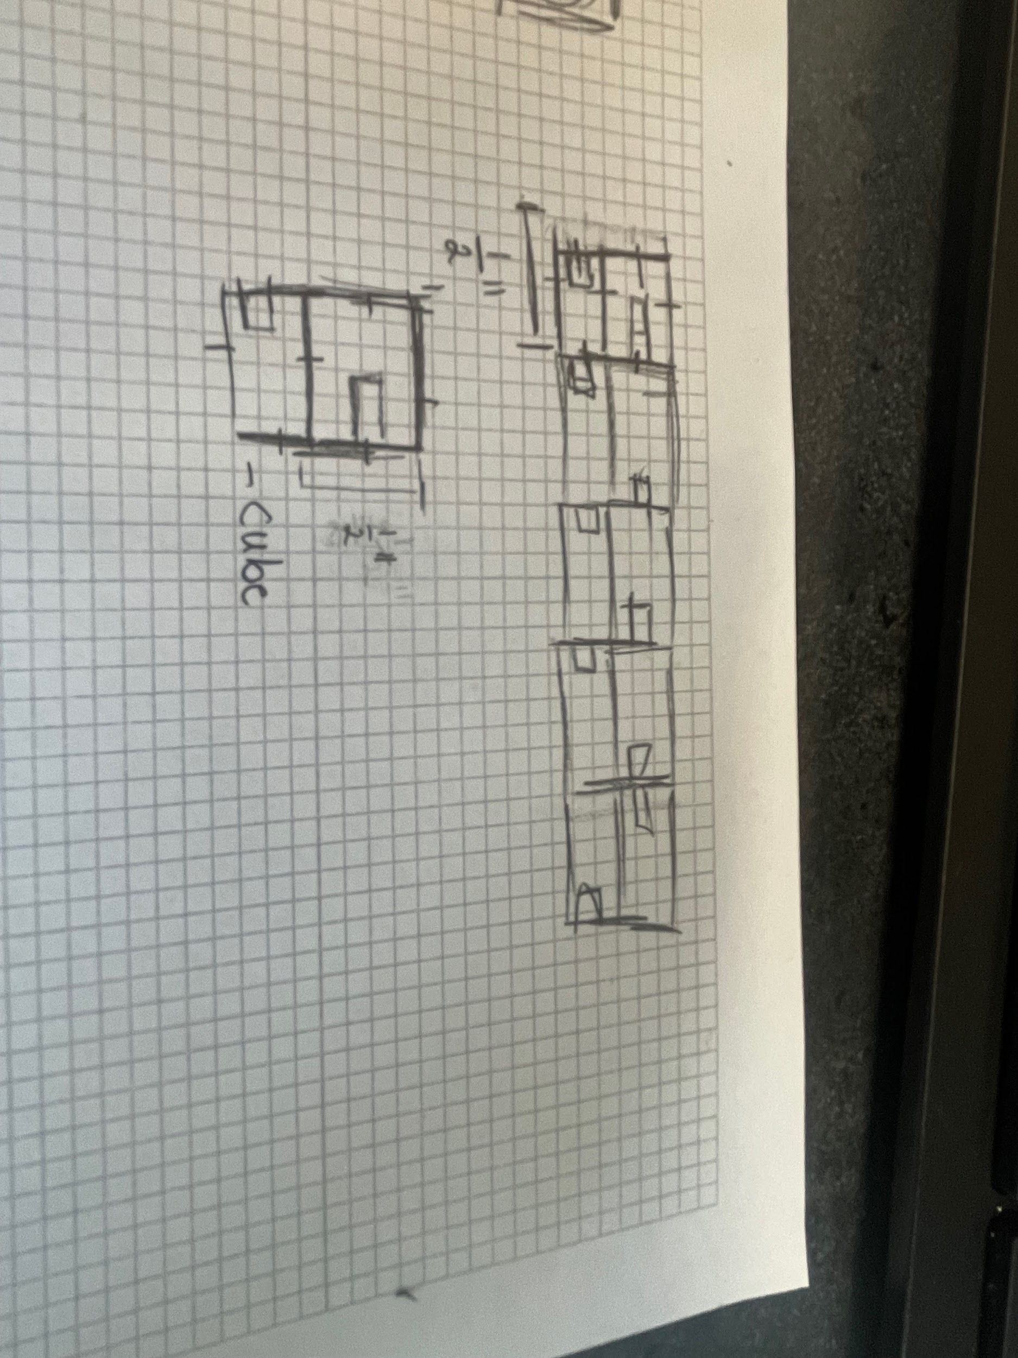

Design Idea Comparison and Selection (D1, D2)
Link to Decision Matrix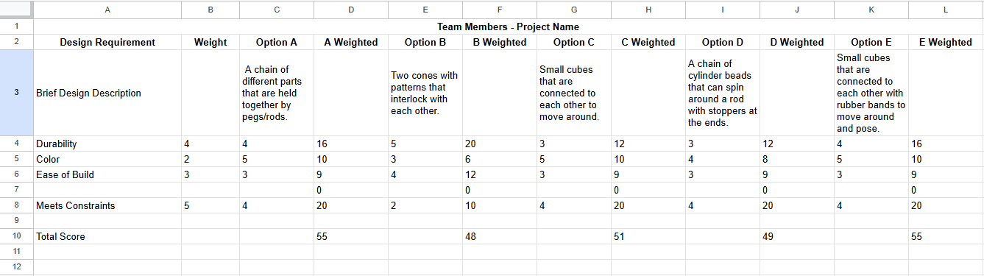

Design Blueprint (D4)
Design Blueprint #1
Date: 3/25/25
Sketch:

Manufacturing Methods: 3D-printing
Step 1: Design the parts in Inventor CAD
Step 2: Slice the parts on a 3D-printing software
Step 3: Print
Supply List and Costs:
Item | Cost each | # needed | Total
ABS Plastic | N/A | Unknown | N/A
Total Cost |  |  | $0.00

Plan of Action (D3)
 | Week 1 (3/31) | Week 2 (4/7) | Week 3 (4/21) | Week 4 (4/28) | Week 5 (5/5) | Week 6 (5/12)
Create CAD file | X | X | X
Print design 1 |  |  | X
Share design 1 |  |  |  | X
Revise CAD file |  |  |  | X | X
Print design 2 |  |  |  |  | X
Present design 2 |  |  |  |  |  | X
The chart can be edited anytime as needed

