Section D: Design Concept Generation, Analysis, and Selection

Our team set out to create a solution for swiveling desks. In our school, many classrooms use these desks, which often swing and swivel unexpectedly, becoming a distraction or even a source of harm. We planned to create a locking mechanism, something that will stop the desk from swiveling, but it can be undone if one of our stakeholders desires. However, we weren’t sure how we were going to design this lock. The first thing we did was obtain one of these swivel chairs and examine it. The desk was designed to swivel, so there was nothing on the outside that let us alter the function of the chair. After determining that there wasn’t much we could add on the outside to fix it, we decided to take the chair apart and investigate its inner workings. We took the chair and desk parts off of the base. From here, we discussed many different solutions, like jamming something small in the mechanism to stop it from moving. However, we concluded that anything we could do inside the desk would not be able to unlock easily, and therefore would not meet our design requirements. Thus, we came back to looking for a solution outside of the desk. We put the desk back together and tested it out, moving it around to find out exactly how it worked.
That’s when we came up with the idea for a rubber tube, or something similar, that would be on the part of the chair holding the desk. It would be tight, holding the two chair pieces together, and with the use of friction, stop them from moving. We ultimately decided to use this idea rather than something to jam the mechanism because it met more of our design requirements. A decision matrix helped us come to this agreement. We set up the design matrix with our two ideas, the rubber tube and jamming design, and our design requirements: the ability to lock, unlock, fit under a desk, be unnoticeable, be affordable, and be easy to use. We scored each design on a scale from 1-5 on how well we thought it would serve each need. From there, we found that the rubber tube design was much more effective, so we decided to use it.

DECISION MATRIX | Rubber Tube | Stick to Jam Inner Mechanism
Can Lock | 4 | 4
Can Unlock | 5 | 2
Small/fits under desk | 5 | 4
Unnoticeable | 4 | 5
Affordable | 3 | 4
Easy to Use | 5 | 2

In order to build our design, we will need to research and buy different types of rubber bands to figure out the size and thickness ideal for our project. We will test these rubber bands by placing them over the desk and observing how they would work if they were our prototype. Once we have settled on the size and thickness of the rubber bands, we will weave them together to create a tight and strong lock that can easily stop the desk from moving. We will test this design, then make any changes if it does not work, or improvements if it could be better.
Our initial solution was a rubber tube made out of rubber bands. We concluded after determining that our other solutions would not work, at least not as well as this one would. It will be built by taping together two heavy-duty rubber bands with a piece of thin and strong tape, essentially creating a wider rubber band. We will take the desk part off of their chair using our tools, stretch the band over the part that was holding the desk up, and push it into place. We will get the bands from Amazon, in a pack of 25 for any iterations of the prototype we might create. It will cost $8.85. Each rubber band is 0.75 inches in width, so the final product will have a width of 1.5 inches. We will get the tape, preferably duct tape, from DCI in our engineering classroom. With this prototype, we will stop these desks in DCI from moving unexpectedly.
Supplies List:
Duct Tape - Free, from the classroom
Rubber bands - Amazon, $8.85
Pictured below is the chair part responsible for moving the desk. On the right is a CAD sketch of this same part, both with and without our design.
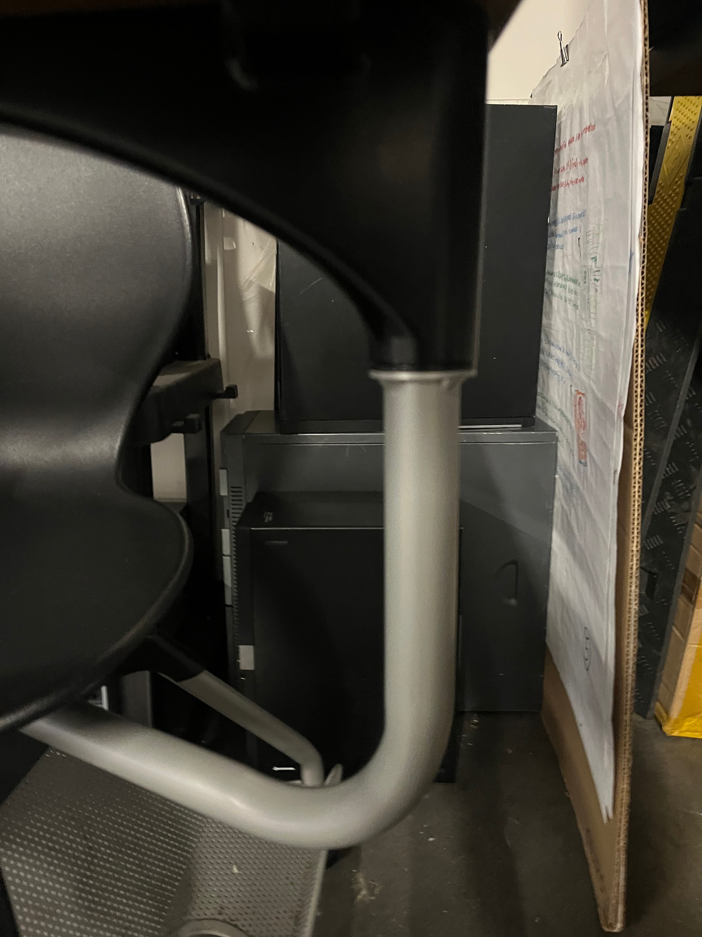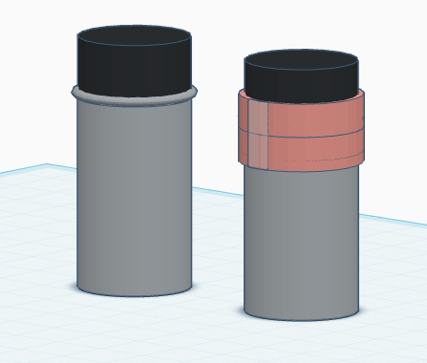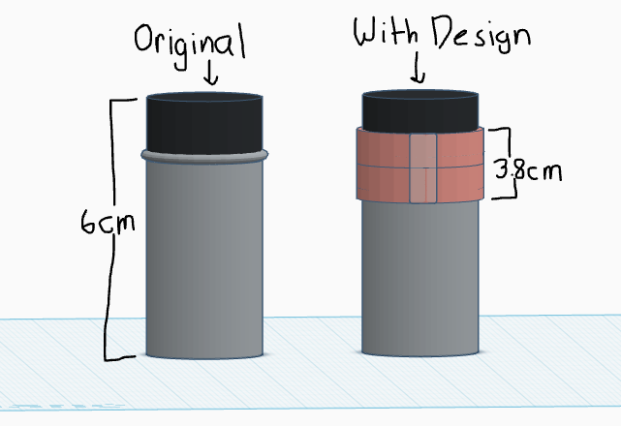
Above is a CAD design of the desk part and what it will look like with our final solution. By itself, the final solution is a simple rubber tube pictured below.
Ultimately, we moved away from the rubber tube design. During our testing phase, we discovered that it did not work as well as we thought it would. The rubber bands were delivered, and we tried them out on the desk, but they were not strong enough to affect the desk’s movement. During this time, we were also considering other possible solutions thanks to feedback from our experts. They had suggested trying out different solutions at the same time, encouraging us to attempt the pin-lock design as well. Although we had decided against the idea earlier, our rubber band design failed so spectacularly that we had to try another method before testing different rubber bands.
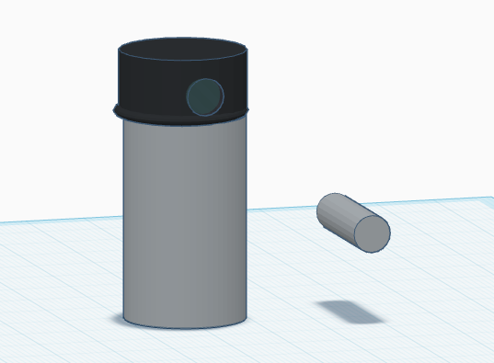
For our new design, we decided to keep working on the same mechanism we were working on before. It was the same pole that held up the desk itself, the one we were planning to place the rubber tube on. However, for this design, we were drilling a hole instead. We drilled two holes through the entire pole and all its layers inside. We drilled these holes in two positions, one for right-handed students and one for left-handed students. We were given a release pin from Mr. Donovan, and used it in the hole to essentially jam the swivel mechanism and stop the desk from moving. We added pieces of tape to signify where the holes were so that the stakeholders could line them up. We were satisfied with this design and decided to move forward with it.
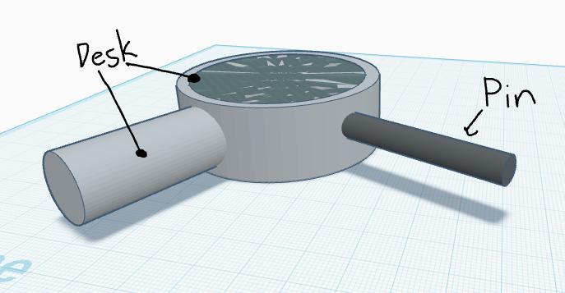
However, after feedback from our stakeholders, we discovered that stopping only this swivel mechanism would not be enough. Although we had concluded earlier that we would only stop one of the desk’s movements, once again we were persuaded to change our minds. There was another mechanism moving the desk that was placed under the chair. We decided to solve this problem the same way we did the other swivel mechanism. We drilled another hole below the chair, found a thicker metal rod (so that it would be easy to use despite the solution being under the user), and stuck it in as well. It worked very well and became our final iteration of the solution.
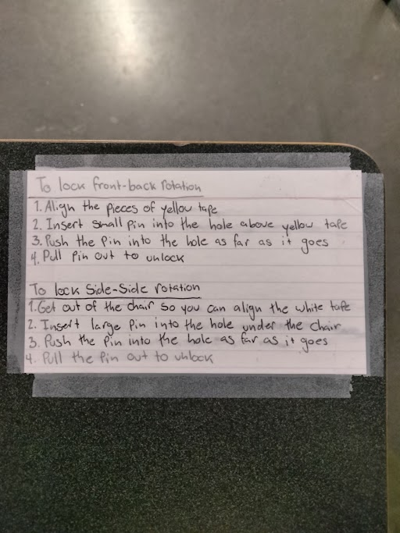
With both the swivel mechanisms on the desk locked, we only had one last problem: people might not know how to use it. With suggestions from our stakeholder/expert, Mr. Binsner, we created an instruction sheet and taped it to the desk so that everyone would know how to use our design.

Initial Sketch:
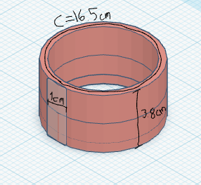

Final Sketch:
