MyDesign Portfolio
Element B

Element B: Documentation and Analysis of Prior Design Attempts

Prior Design Attempt #1 - Rubik’s Snake
Source: National Autism Resources, Mathnasium
Image
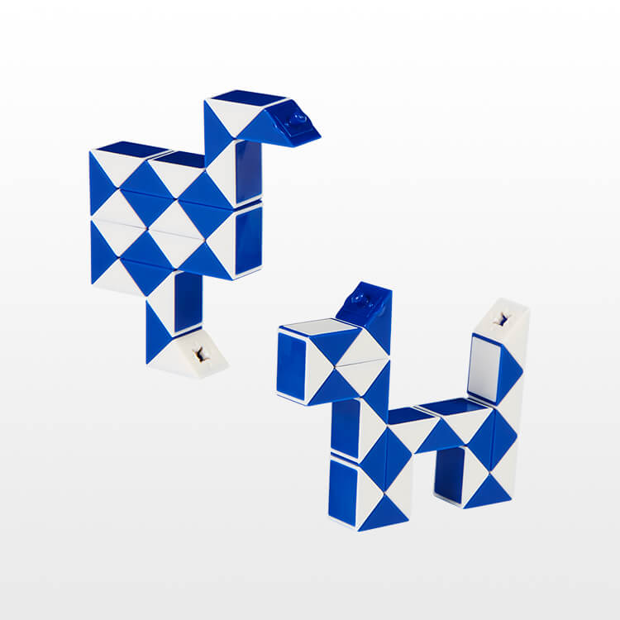
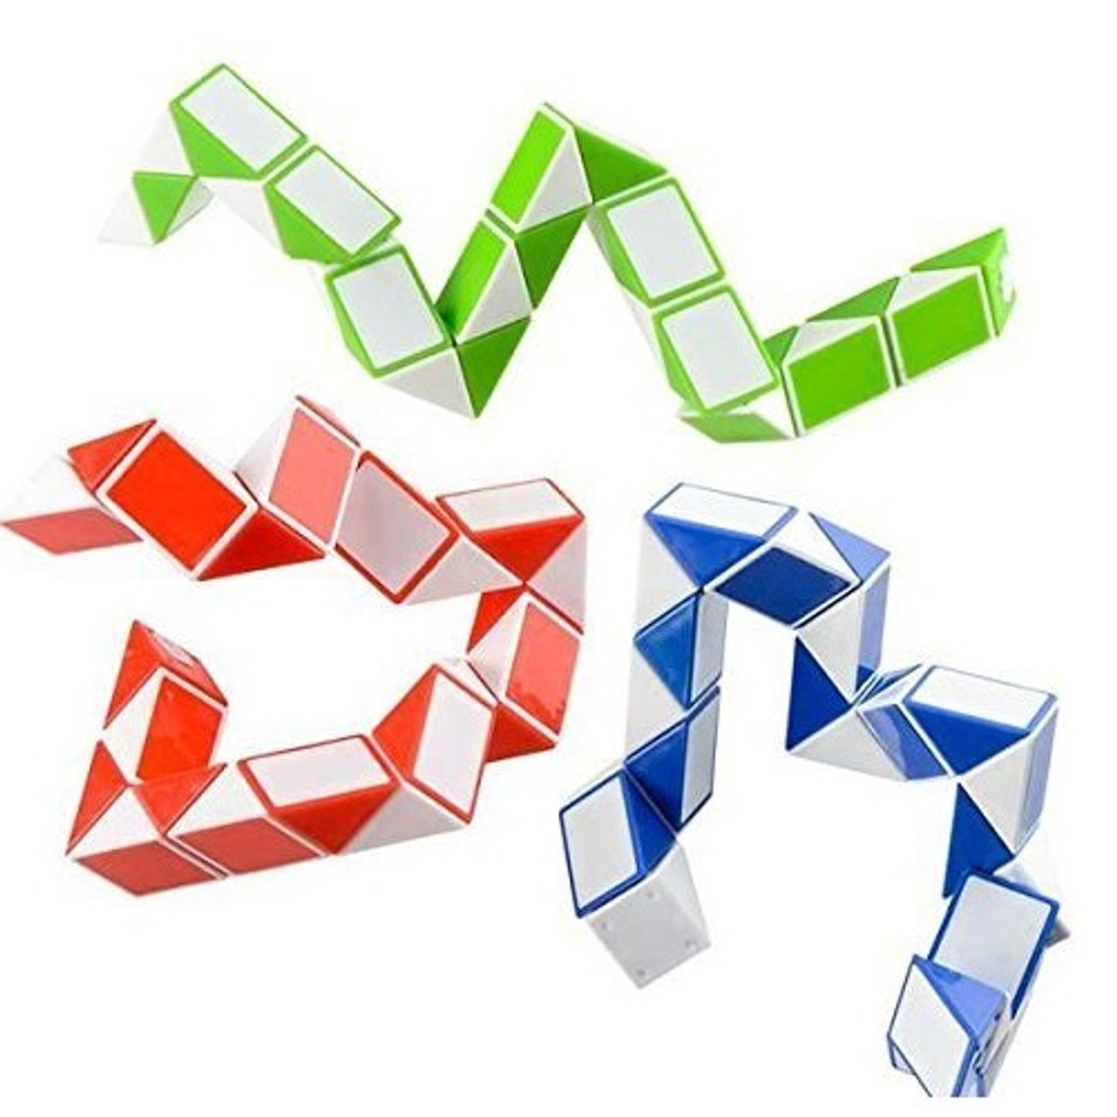
Image credit from left to right: National Autism Resources & The Official Rubik’s Cube
Details
The Rubik’s Snake is a set of 24 right isosceles triangles that are connected by spring bolts so they can rotate 360 degrees. The snake can form different shapes through bending and rotating each prism.
Analysis
The original Rubik’s Snake is quite large, which makes it distracting. This design cannot fit in one hand, and noises that it makes while in use can be loud as well. It cannot be used during instructional time or independent work time. Though, according to the National Autism Resources, “This… keep[s] fingers busy so students can concentrate [and] it's made of sturdy plastic that's easy to clean,” (NSA, 2025). This is mostly because they use a smaller, 3.9 x 2.6 x 1 inch design.

Prior Design Attempt #2 - Wacky Track
Source “Wacky Track - Official Wacky Track Fidget Toys.” Wacky Track, 2 July 2019, Wacky Track - Official Wacky Track Fidget Toys/.
Image
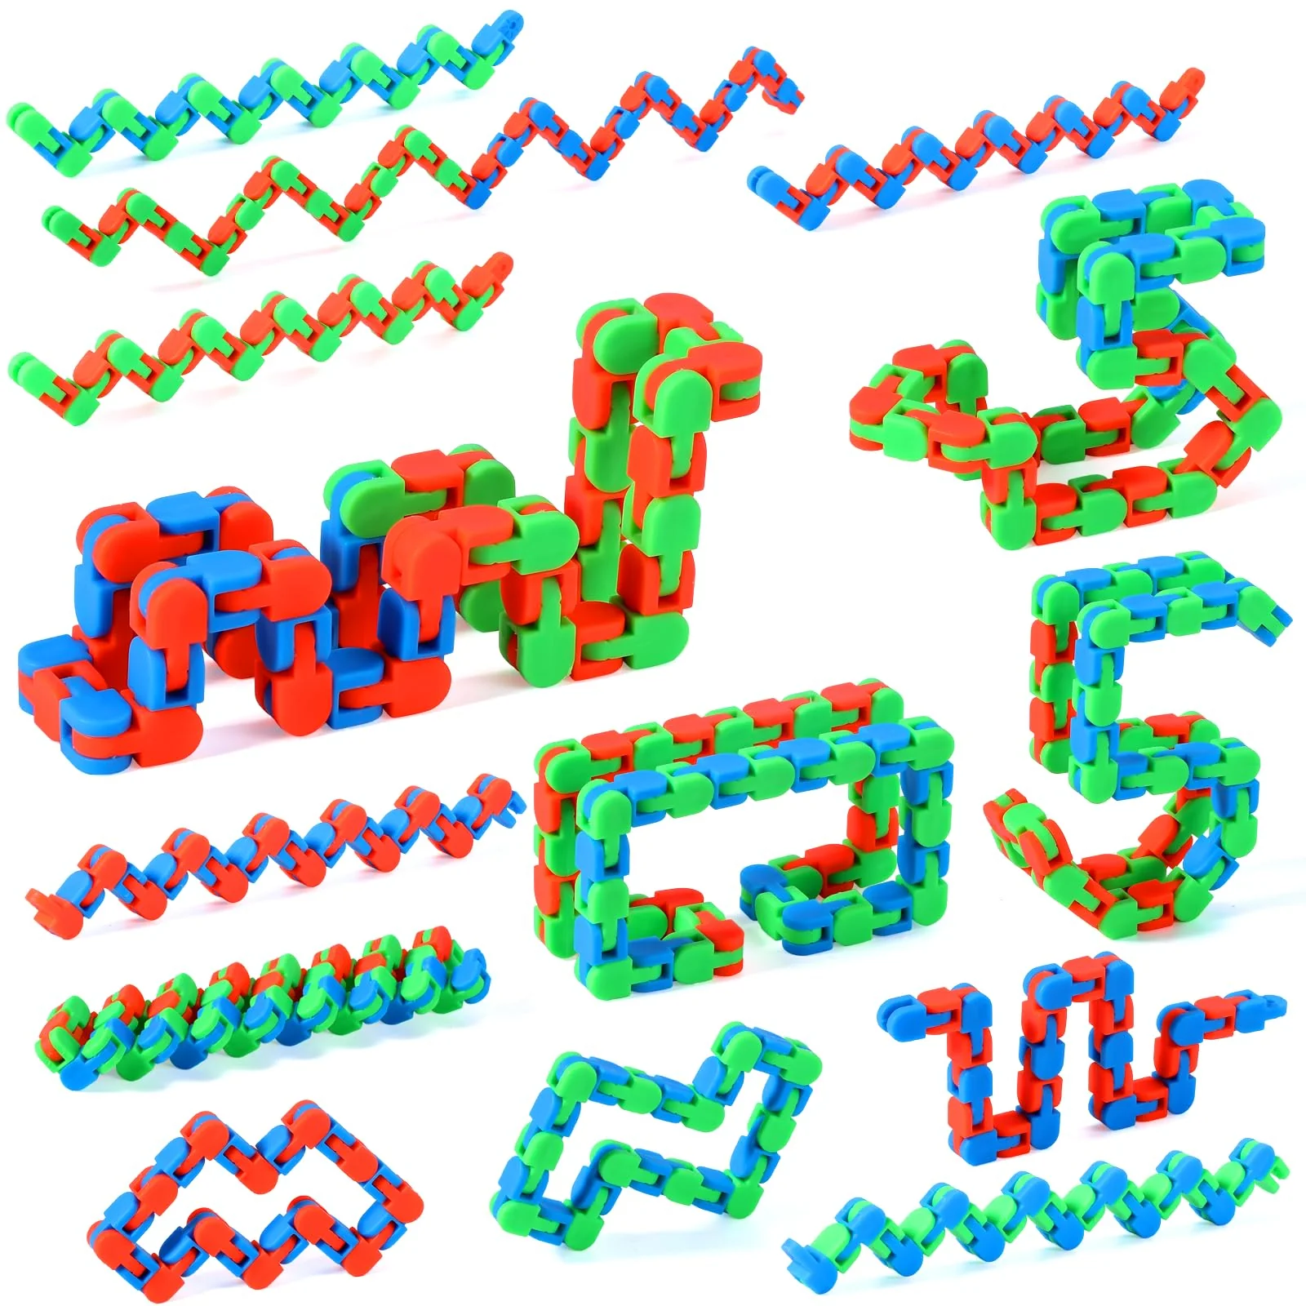

Details
The Wacky Track is made out of an articulated plastic chain that can be formed into countless shapes, such as numbers, symbols, letters and even necklaces by using the connected links to manipulate it into any creative shape in mind.
Analysis
These designs are easily breakable as the joints are only snap locked together and not secured. The pieces that the toy is are easily lost since they are small. They can be made in a variety of sizes so they can be made easy to handle, and a small distraction. They can be made into interesting patterns and colors to make it interesting for the students using them without being too distracting to other students. This also is supported by the statement on their website that says, “... great for kids and adults suffering from short attention span…” (Wacky Tracks, 2019). They are nice to use due to the fact that they are easily bendable, but that is the main flaw.

Prior Design Attempt #3 - Tangle Fidget Toy
Source
Tangle Creations. “Tangle® Jr. Classic.” Tangle Creations, 2025, Tangle Creations.
Accessed 7 Mar. 2025.
Image
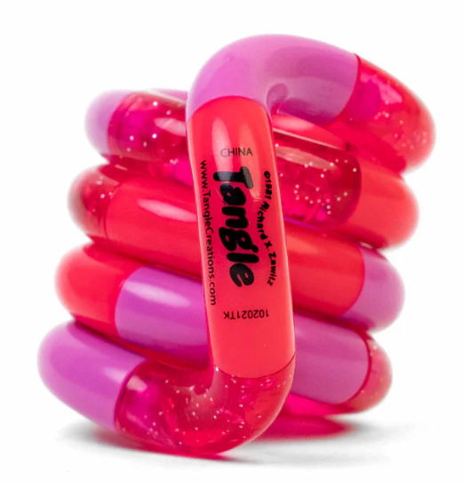
Image credit: Tangle Creations
Details
Tangle fidgets feature many macaroni-shaped segments that are connected together in a loop. The chain of these segments can be twisted into any shape or form. Each of the segments can also be separated to combine with other Tangle fidgets.
Analysis
The parts are designed to come apart, which would cause them to get lost easier in the classroom. They are also made of rubber, which cannot be made with the tools at our disposal. The fact that when unrolled, it will be about 7 inches means that it can pose as a distraction. It “calms anxiety & relaxes the mind”, (Tangle, 2025), due to being small when coiled, at about 1.5" x 2" x 1.5", but the uncoiling ability is a major downside.

Prior Design Attempt #4 - 3D Printed Flexi Snake
Source: Instructables Article by Penolopy Bulnick
Instructables. “3D Printed Flexi Snake.” Instructables, 17 July 2023, Instructables. Accessed 7 Mar. 2025.
Image
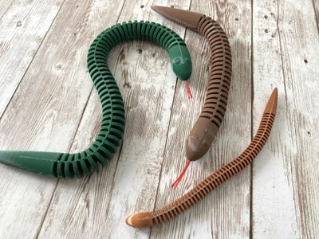
Details
A 3D-printed flexible snake that closely resembles a real one. Inside the snake is some tulle for flexibility and strength. There are multiple different sizes and colors of each featured in the article.
Analysis
This is a literal fidget snake, but what we are looking to create doesn’t look anything like this. The fidgets do bend very well but they don’t provide any other forms of fidgeting. The swinging function can be a safety hazard to students as they can be used to hit students in the face, but it only applies to the larger designs. The author noted, “... [breakage] and an additional test completely failed,” (Bulnik, 2023). The breakage was around the joints since they are designed to be one long unit with cuts instead of individual moving joints to mimic the wooden design. Rough handling, which is expected around kids, can break it easily, even with the right materials.

Prior Design Attempt #5 - Monkey Doodle
Source Monkey Doodle
Image
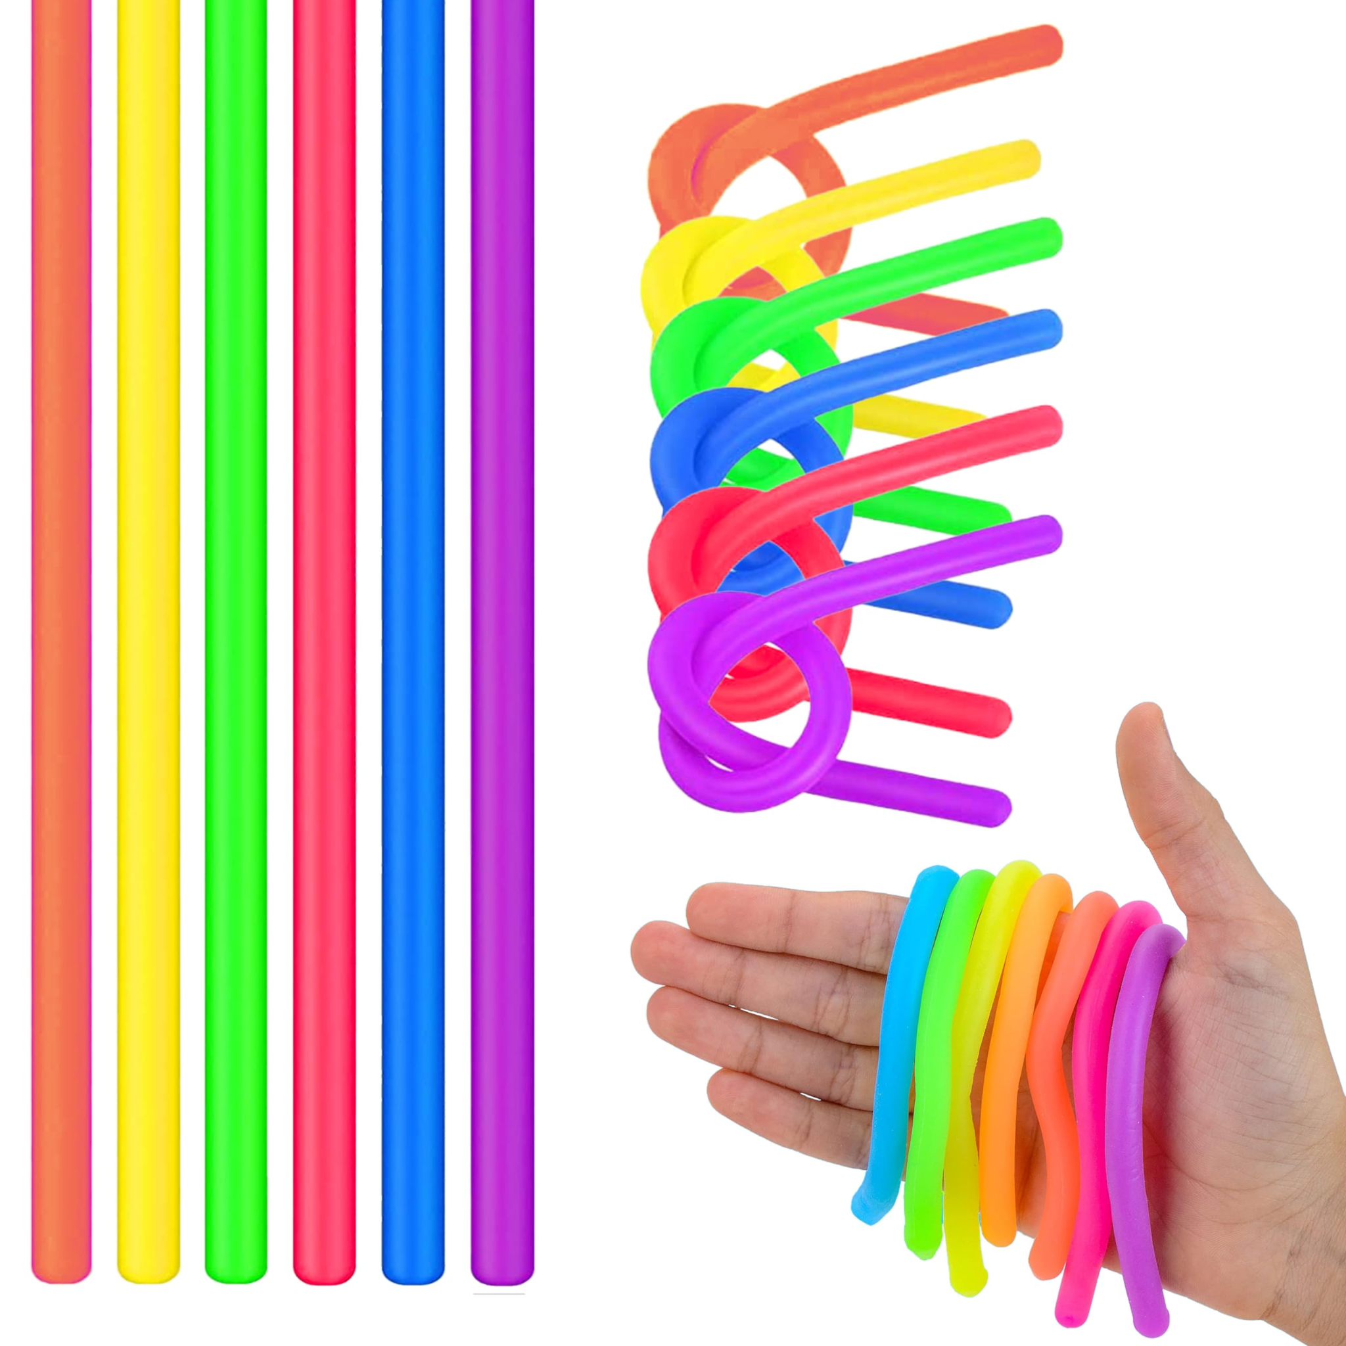
Details
A stretchable, noodle-shaped fidget toy that always returns to its original shape when released. Made of rubber and designed for sensory and tactile stimulation.
Analysis
They work quite well as a small fidget that is not too distracting. They are colorful but not striking to other students. They also are easily manipulated with one hand so you are able to focus more accurately. We do not have the tools necessary to create them accurately as they are made of rubber, meaning they cannot be fabricated in this class.

Sources:
“Magic Snake Fidget” Nationalautismresources.com, 2025, nationalautismresources.com/magic-snake-fidget. Accessed 7 Mar. 2025 & Ali, Omar. “Rubik’s Snake
- Our New Favorite Puzzle.”, Mathnasium, 3 May 2023, www.mathnasium.com/math-centers/hinsdale/news/rubiks-snake-our-new-favorite-puzzle. Accessed 11 Mar. 2025.
“Wacky Track - Official Wacky Track Fidget Toys.” Wacky Track, 2 July 2019, Wacky Track - Official Wacky Track Fidget Toys/.
Tangle Creations. “Tangle® Jr. Classic.” Tangle Creations, 2025, Tangle Creations. Accessed 7 Mar. 2025.

Instructables. “3D Printed Flexi Snake.” Instructables, 17 July 2023, Instructables. Accessed 7 Mar. 2025. https://monkey-noodles.com/

