ELEMENT B

This project aims to develop an Arduino-based soil moisture monitoring system using a moisture sensor LM393 to measure and track soil moisture levels in real-time. The system will provide instant feedback on soil conditions, and potentially trigger an alert when moisture levels drop below a predefined threshold. By implementing this system, farmers and gardeners can optimize water usage, improve plant health, and reduce labor efforts in maintaining soil conditions.
The first attempt to solve this problem is a commercial soil moisture meter, one example being the one created by XLUX. A positive aspect of this solution is it has been tested by lots of people already, so it is pretty much guaranteed to give an accurate reading. However, something negative about these types of products is it isn’t super obvious what the reading is from far away, like our prototype is with a bright LED light indicator. This is also an example of not meeting our stakeholders’ standards, as it is important to them that it is easy to simply walk by and know immediately if the moisture level is high or low.
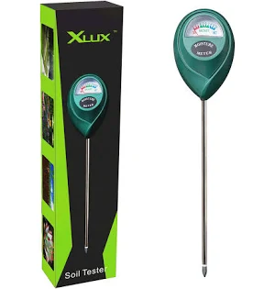
A second attempt is the “finger test” method, where you simply test if the soil is wet or dry by digging your own finger into the dirt. The positive of this method is it has very little cost, as it doesn’t require any equipment to perform. Although it would not be the best option because it isn’t very efficient, especially compared to being presented with a bright LED light, and it would also most likely be inconsistent. Additionally, this means it would still not meet our stakeholders’ requirements of it being obvious from far away what the soil reading is.
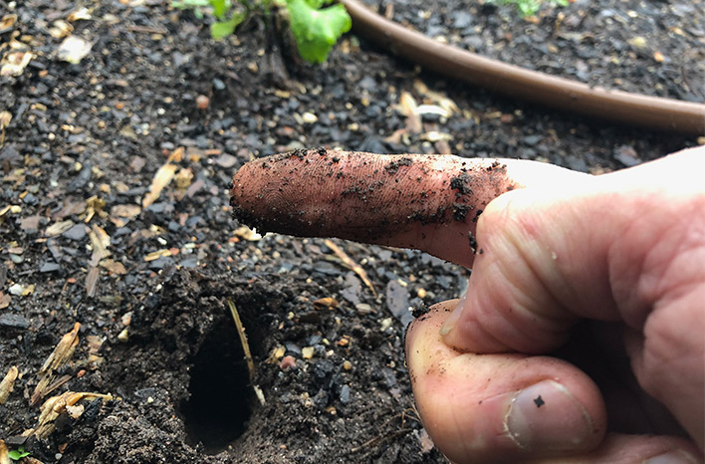
The final attempt we found to conquer this problem is the “gravimetric method”, which is completed by taking a soil sample, weighing it, then drying it in an oven to remove the moisture. After drying, the sample is weighed again, and the moisture level is able to be calculated using a specific formula. A positive aspect of this method is the accuracy it provides, and you can get an exact number if you use the correct input. A negative aspect of this method is the amount of manual labor it requires, and it is very time-consuming, which contradicts an important need from our stakeholders.
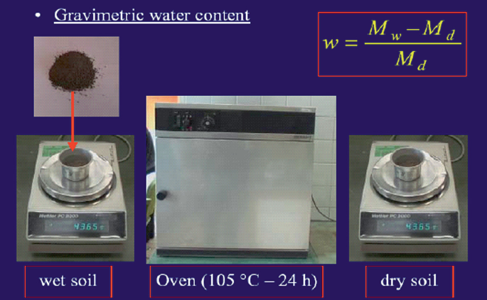
Our stakeholder is currently solving this problem using the “finger test” method described prior, which is often inconsistent and inefficient, as it takes some time to do. However, this method can be positive because it requires no equipment to complete
Master, L. (n.d.). Watering your lawn: expert advice for a lush & healthy lawn. https://www.lawnmaster.co.uk/advice-centre/watering-your-lawn
JoVE. (2024, August 7). Determination of moisture content in soil - JOVE. https://www.jove.com/v/10011/determination-of-moisture-content-in-soil#:~:text=Calculate%20the%20moisture%20content%20of,weight%20of%20the%20dry%20soil.
https://www.wikihow.com/Measure-Soil-Moisture#:~:text=Purchase%20a%20basic%20soil%20moisture,soil%20and%20determining%20soil%20temperature.

