MyDesign Portfolio
Element B Initial Template - AT - 6 points

Element B: Documentation and Analysis of Current and Prior Design Attempts

Current or Prior Design Attempt #1 - Geoguesser is a famous online game that allows players to guess their country based on their surroundings.

Eurogamer article: "An amateur attempt to improve my GeoGuessr score in the space of a week" (https://www.eurogamer.net/an-amateur-attempt-to-improve-my-geoguessr-score-in-the-space-of-a-week)

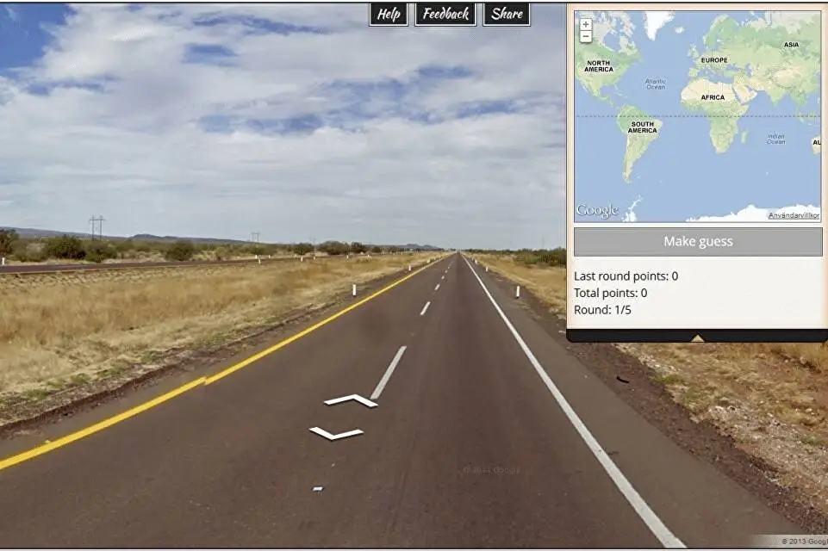

The game allows players to access Google maps and to look at the area to guess where you are located. One of the failures of this game is that it requires previous knowledge rather than allowing the player to learn about geography. It is more of a high-level game where the players are already well-versed in geography.

Prior Design Attempt #2 - <insert name of prior design attempt #2>

Seterra game
Seterra is a map game that helps users learn about countries, capitals, states, and more through easy-to-play games. It’s used in classrooms and by individuals preparing for geography competitions. It's a good repetition tool for memorizing locations and has multiple language options. It requires a phone to download the app, which may be harder for students to access.
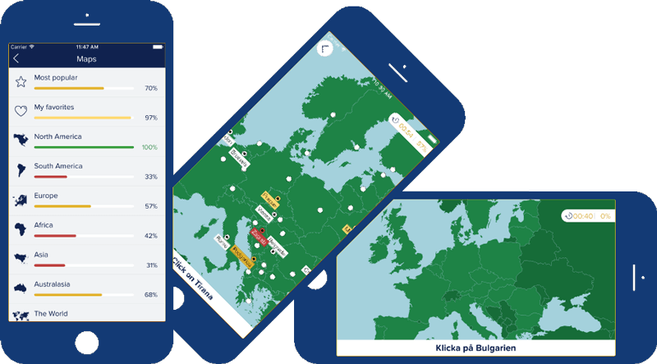

Sporcle geography games
The Sporcle geography games allow players to name all the world's countries, identify U.S. states on a map, or match capitals to their countries. You can learn through memorization and repetition. It has few pictures and is mostly text-based, making it harder for a younger audience to understand.

Element B: Documentation and Analysis of Prior Design Attempts
B1. Documentation of plausible prior attempts to solve the problem and/or related problems is drawn from __________. |  | score = 5 | score = 4 | score = 3 | score = 2 | score = 1 | score = 0
 |  | a wide array of clearly identified and consistently-credible sources | a variety of clearly identified and consistently-credible sources | several—but not necessarily varied—clearly identified and generally-credible sources | a limited number of sources, some of which may not be clearly identified and/or credible | only one or two sources that may not be clearly identified and/or credible | missing or minimal (a single source that is not clearly identified and/or credible)
B2. The analysis of past and current attempts to solve the problem — including both strengths and shortcomings — __________. |  | score = 5 | score = 4 | score = 3 | score = 2 | score = 1 | score = 0
 |  | is consistently clear, detailed, and supported by relevant data | is clear, generally detailed, and supported by relevant data | is generally clear and contains some detail and relevant supporting data | is overly general and contains little detail and/or relevant supporting data | is vague and is missing any relevant details and/or relevant supporting data | cannot be inferred from information intended as analysis of past and/or current attempts to solve the problem

