MyDesign Portfolio
Element B

Element B: Documentation and Analysis of Prior Design Attempts

Prior Design Attempt #1 - Sketch
Source
For our sketch, we got details and information from “University OF Maryland A, James Clark School of Engineering” and the primary Stakeholder, Dr. Anderson.
For our sketch, we made the following design: A glass wall needs to for 1 long wall, All other walls, floor (18x18), Two rooms (12x12 and 6x12), Must be one doorway (6.5x2.5) leading out of the front room to outside, One doorway (6.5x 2.5) connecting the rooms (interior), Must be one window on two exterior walls for the larger room (two windows) Windows should be at least 3" wide and 2" high), 2 Beds ( 6 X 3 x 2), 2 chairs (2.5 x 2.5 x 2) and 2 Desks ( 4 x 2 x 3).
Image
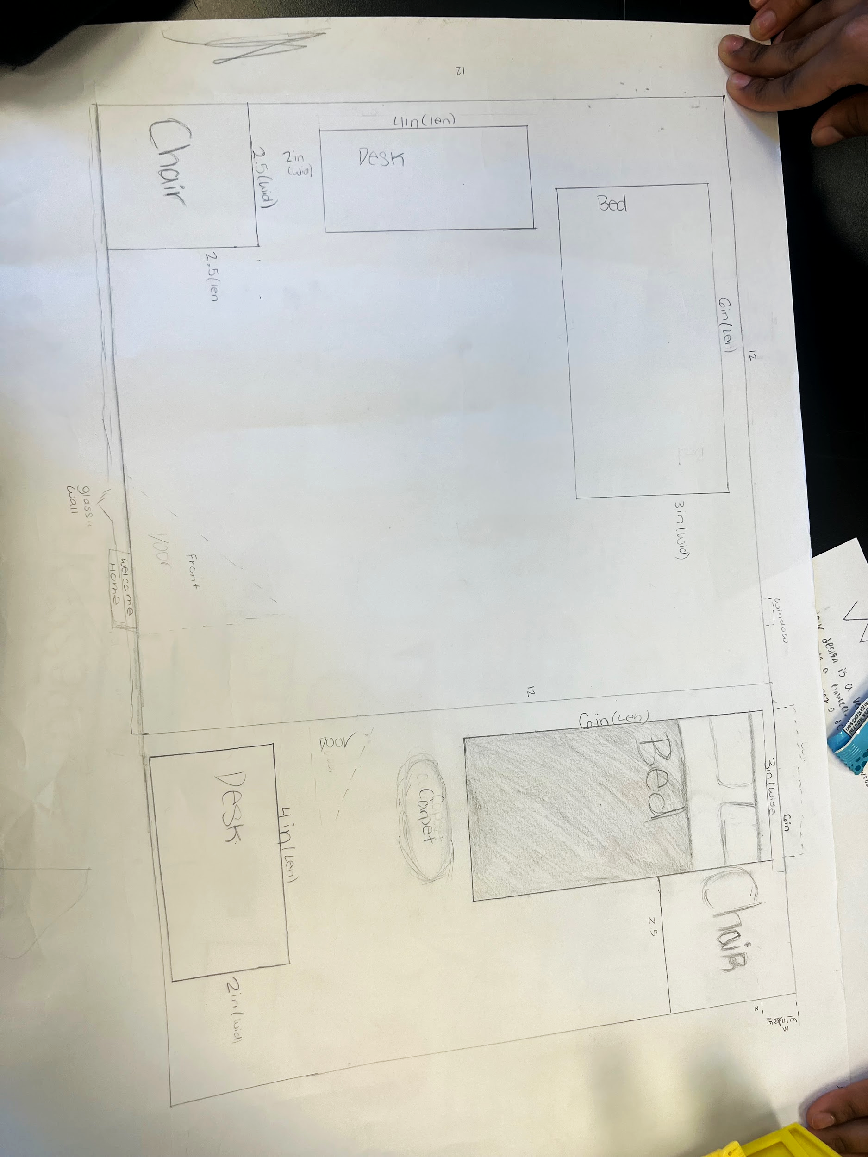
Details
When sketching the design, our main objective is to make sure it is functional and to get an idea of where everything will be. We made sure to add the measurements and the names of the tables, chairs, and stuff
Analysis
What we could have done better was understand more because we were somewhat confused at the measurements because of how they said it.

Prior Design Attempt #2 - Online sketch
Source
When creating the online sketch, we used the website Planner 5d. It's a tool for creating buildings online to get a feel for what they will look like. We added everything to get a feel for what the final building will look like.
Image
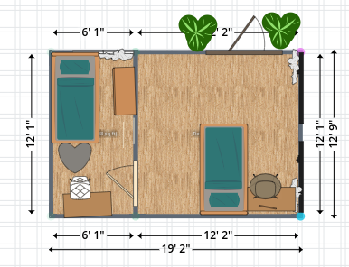
Details
It's showing everything we added to our final building with the beds, chairs, tables, door, and decoration.
Analysis
Some unsettled parts were learning how to use it because when making prototypes, time is very important, so learning how to use it took a lot of time. But after learning how to use it, we ensured everything was in place.

Prior Design Attempt #3 - Prototype
Source
When making the prototype, you want to ensure everything is working so when you work on the final solution everything will work. We made the walls and furniture out of cardboard and made the windows and door by cutting up the cardboard.
Image
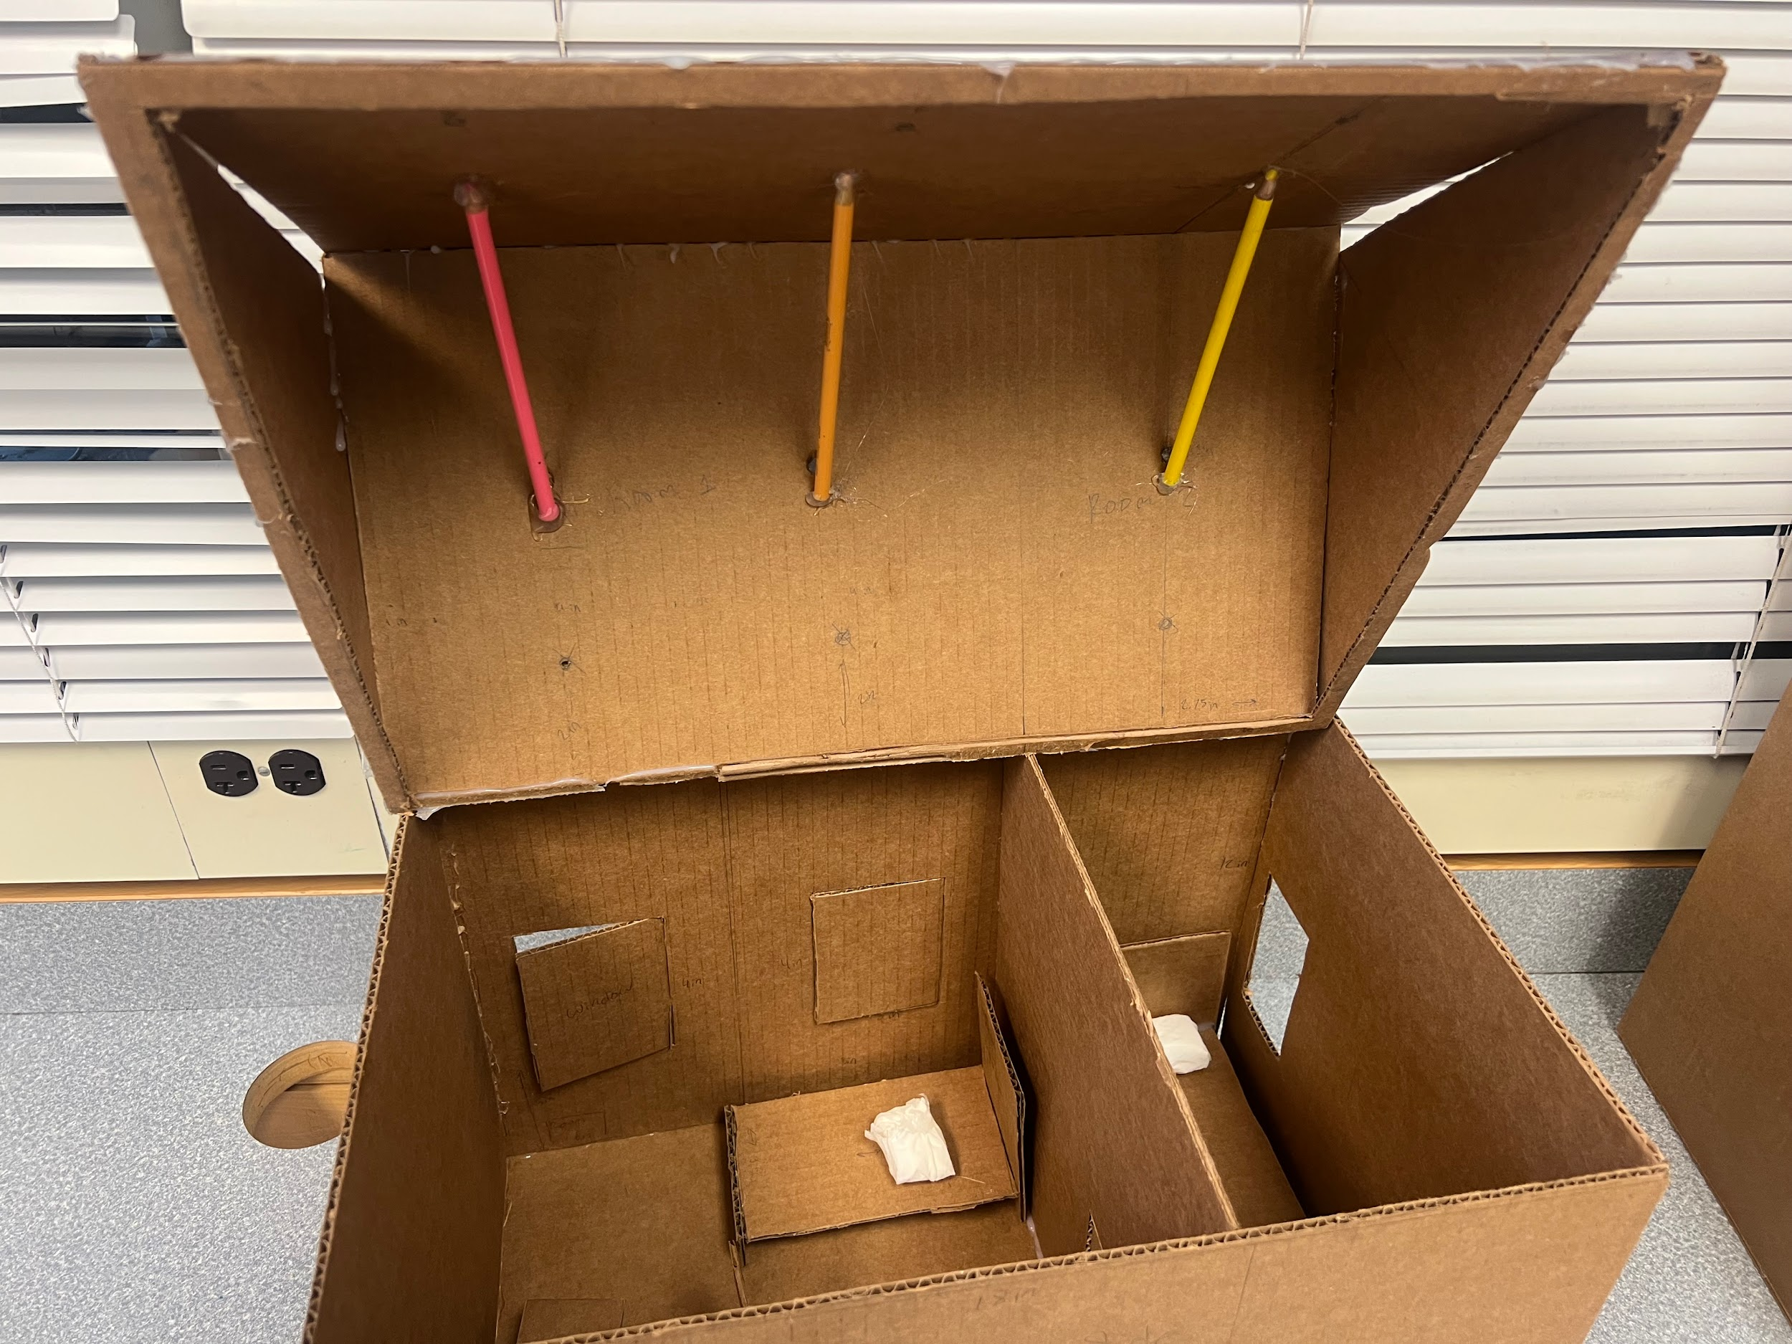
Details
This is our system design and the pencils will hold our water balloons to so when the fire happens, it will pop the balloon and the water will stop it
Analysis
Some unsuccessful attempts were our limited resources, so we couldnt waste our ideas on things. Also the measurements, making sure the measurements were right was an important role to.

Prior Design Attempt #4 - Final design

Source
For our final design, we made sure to add everything like the glass wall, windows, furatire, and etc. We also made our own fire alarm system with the website https://www.arduino.cc/. We used curtis and wires so when the fire goes off we will be alarmed.
Image
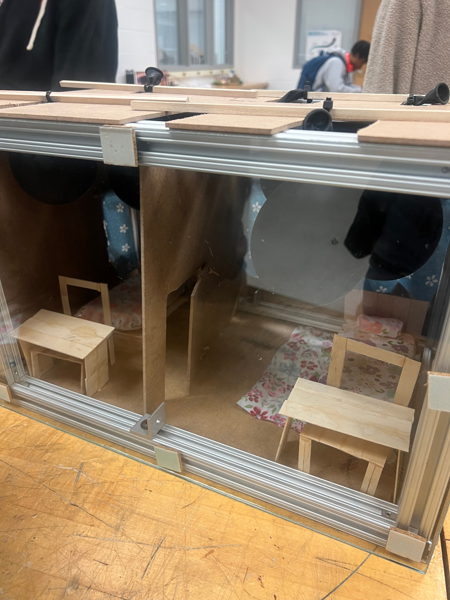
Details
This was our final design, and houses that use water balloons to stop the fire. We used wood for the furniture and the glass and a fire detection alarm
Analysis
Some things we could have done better were making the balloons cheaper because the fire wasn't able to pop the balloon.
Rubric
Element B: Documentation and Analysis of Prior Design Attempts
B1. Documentation of plausible prior attempts to solve the problem and/or related problems is drawn from __________. |  | score = 5 | score = 4 | score = 3 | score = 2 | score = 1 | score = 0
 |  | a wide array of clearly-identified and consistently-credible sources | a variety of clearly-identified and consistently-credible sources | several—but not necessarily varied—clearly-identified and generally-credible sources | a limited number of sources, some of which may not be clearly identified and/or credible | only one or two sources that may not be clearly identified and/or credible | missing or minimal (a single source that is not clearly identified and/or credible)
B2. The analysis of past and current attempts to solve the problem — including both strengths and shortcomings — __________. |  | score = 5 | score = 4 | score = 3 | score = 2 | score = 1 | score = 0
 |  | is consistently clear, detailed, and supported by relevant data | is clear, generally detailed, and supported by relevant data | is generally clear and contains some detail and relevant supporting data | is overly general and contains little detail and/or relevant supporting data | is vague and is missing any relevant details and/or relevant supporting data | cannot be inferred from information intended as analysis of past and/or current attempts to solve the problem

