Prior Design Attempt #1 - <Shade Cloth #1>
Source
Amazon.com: Poyee. (n.d.-a). https://www.amazon.com/stores/POYEE/POYEE/page/B53EB996-4BD5-4AED-9FA4-C10332DF23A0
Image
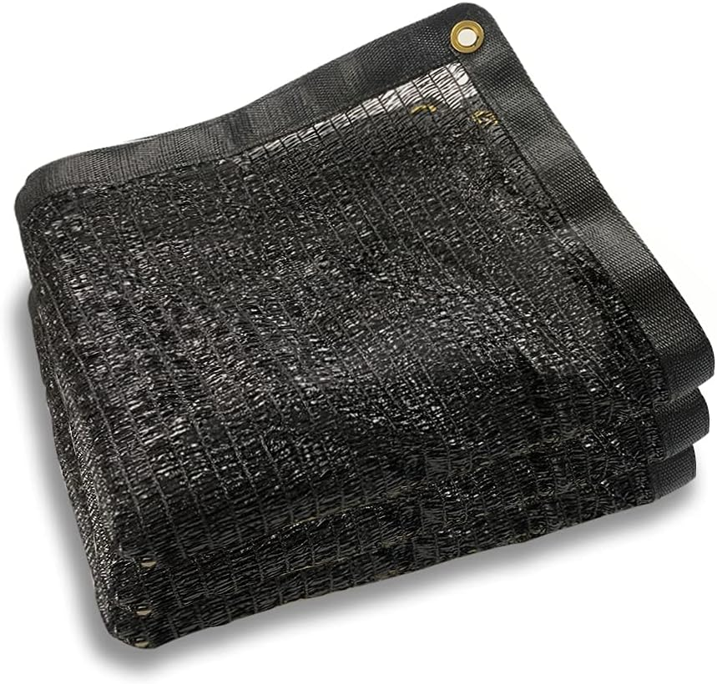
Details
This would cover the plant to make less sunlight come through it.
Analysis
Customers left reviews about the product of how it blocked the sun some but not completely. What the customers said”Customers like the shade sail for its performance, sun protection, and value for money. They mention it works well, provides good sun protection without blocking all the sun, and is a perfect shade barrier. Some appreciate the ease of installation, temperature control, and weight. However, some customers disagree on the build quality and size.” What was unsuccessful that the customers said was it was a cheap material and did not last long in the sun.

Prior Design Attempt #2 - <Shade-A-rella #2>
Source
A-rella, protect those delicate plants from the harsh sun!. Shade. (n.d.). https://www.shade-a-rella.com/

Image
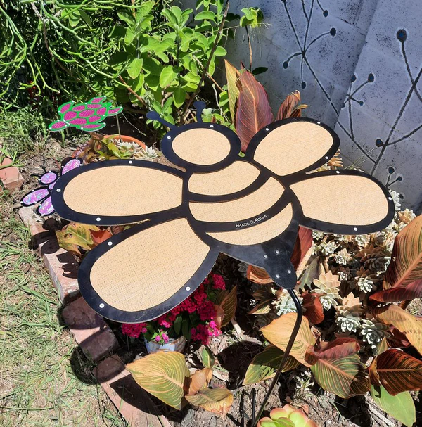
Details
This design protected the plants under the “shade-a-rella” from sunlight when the sun was above it.

Analysis
The customers left reviews about the product.Customer review “Super cute, but even after tightening, the bee shape won’t stay in place.”This customer was saying it was loose and did not work. The cover also only covered a small area.This did not work based on the design requirements because it was supposed to cover them completely and did not.

Prior Design Attempt #3 - <Plant Shade Tent#3>
Source
Amazon.com : 2PCS plant shade tent, 22x22x22 Inch garden shade tent UV resistant plant sunshade cover Sun Blocker Plant Cover Tent Green Plant Sun Protection Tent protect outdoor plants from animals : Patio, Lawn & Garden. (n.d.). https://www.amazon.com/22x22x22-Resisitant-Sunshade-Blocker-Protection/dp/B0CXS69VW9
Image

Details
This design protects the plants from the sun when they are in the tent but they still can get sun by opening the tent's zipper.
Analysis
The customers said that the rods that held the tents up broke and the tent did not study and fell down from wind.This failed because the tent did not protect the plants.

Prior Design Attempt #4 - <Garden shade #4>
Source
Maxi Garden Shade Fabric X-Large: Gardener’s supply. www.gardeners.com. (n.d.). https://www.gardeners.com/buy/maxi-garden-shade-fabric/8610372.html?channable=4118756964003836313033373243&srsltid=AfmBOop19BFIIYjbDIHMzMFQ5xHnIG3pDK6KX0uHzCBP9cxrojxnkjCkKZc
Image
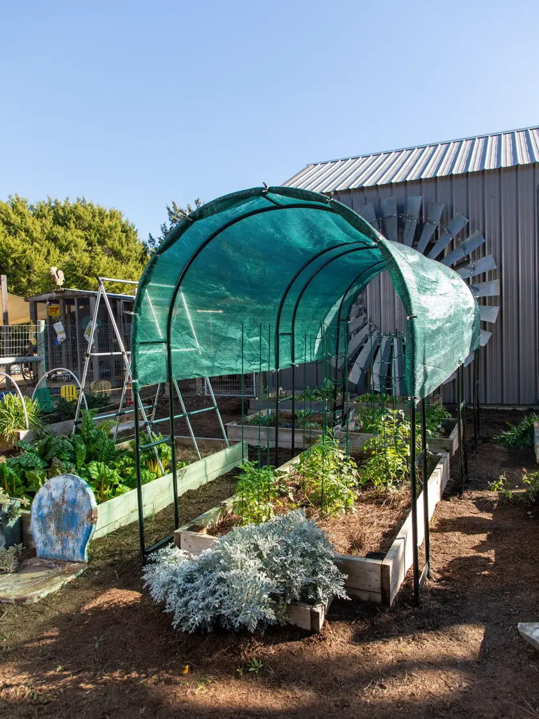
Details
This design attempt can cover a large area of plants and is tall.
Analysis
One customer said that the tarp on top was like a fitted sheet and was hard to put up. You need two people to put it up.This is bad based on our design requirements because it needs to be easy to use for everyone.

Prior Design Attempt #5 - <Shade nets #5>
Source
Shade nets: Gardener’s supply. www.gardeners.com. (n.d.-b). https://www.gardeners.com/buy/shade-nets/8609738.html?channable=41187569640033382d353536eb&variationId=4569&srsltid=AfmBOoo-Ug1-XKNklxKhgPEaKw-juNE3cBsj4A97Ldx8DzIkCVGEXpJG_So
Image
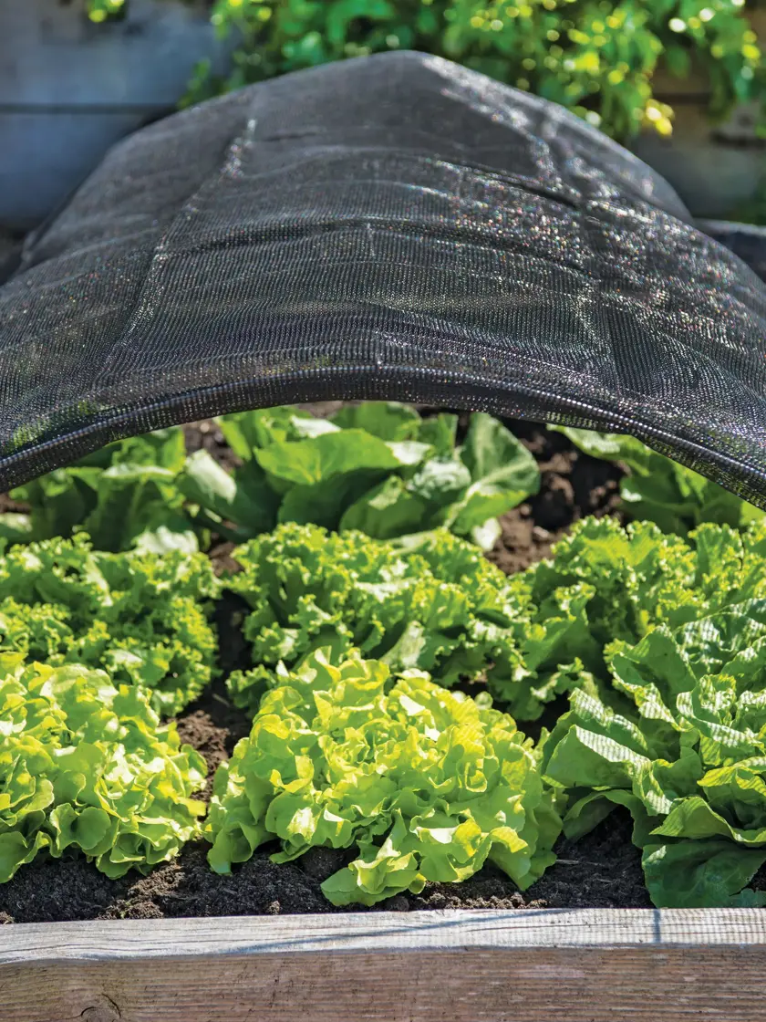
Details
This design covers a good amount of plants and lets some light in but keeps most out.
Analysis
One of the customers said that the product did not stay up they wished that it came with adjustable stakes.This is bad based on the design requirements because the product did not stay in place.

