Section B: Documentation and Analysis of Prior Design Attempts

The problem we are trying to solve is the disruptive and distracting nature of the black swivel desks in DCI classrooms. Students need a way to prevent the desks from swiveling because the swiveling nature of the desks causes them to be distracting and dysfunctional. These desks can be a huge problem or distraction for students since the inability to lock them into place can knock materials off the desk, be a distraction, or even cause injuries for those unaware of the moving desks. Thus, we decided to make a desk lock that can keep them in place, but that can also be opened if a student wants to be able to swivel their desk.

There are many solutions that have been implemented in order to prevent the inconvenience and hazard of these swivel desks. First, one can buy a gas cylinder with a rotation brake, in order to prevent the swivel. While these are more commonly used to prevent the swivel on desk chairs, not desks, they are still used on swivel desks. This solution is good due to its effectiveness since it is widely regarded as a good solution. However, they are very expensive. The one from MTSIM, which is generally regarded as a quality product, is $139. This is a large price tag for a solution to a single desk, meaning it is not effective at schools due to the general lack of funding at public and charter schools.
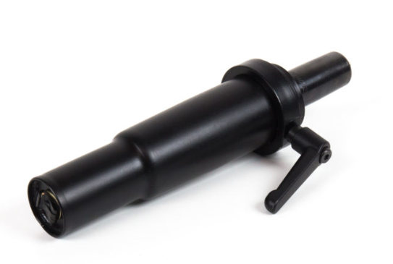
Gas cylinder with a rotation brake
Next, the manufacturers added water bottle holders on the desks in order to allow students to have a place to put their water bottles without knocking them off the desks. This is functional because it prevents people from dropping their water bottles by accidentally rotating their desks. However, these are too small to fit most standard-sized water bottles, making them ineffective. They also don’t provide a solution to other things being knocked off the desk, such as papers, pencils, etc. Additionally, when students have water bottles small enough to fit in the holders, they often leave them there because they are tucked away and easy to forget.
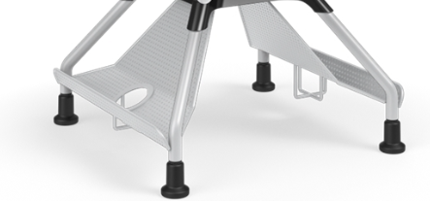
Bottle holders on the chairs
Lastly, cable ties have been used to stop swivel mechanisms, both on desks and chairs. This solution involves wrapping heavy-duty cable ties on the swivel structure and tightening it, in order to stop the rotation. This method is good because it is cheap and doesn’t require tools. However, they are a complicated solution and can be difficult to assemble. Also, cable ties need to be cut to be undone, meaning this solution is permanent and can't be locked and unlocked. Instead, it is stuck in a fixed position fairly permanently, which is not ideal since sometimes the swivel can be useful.
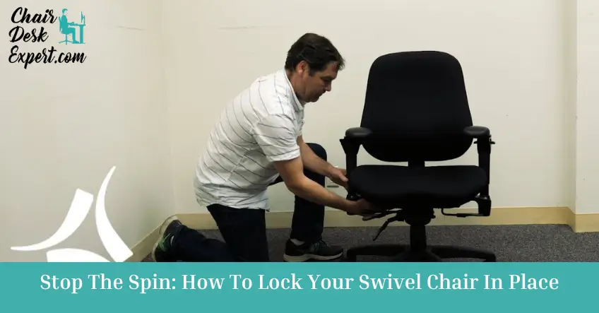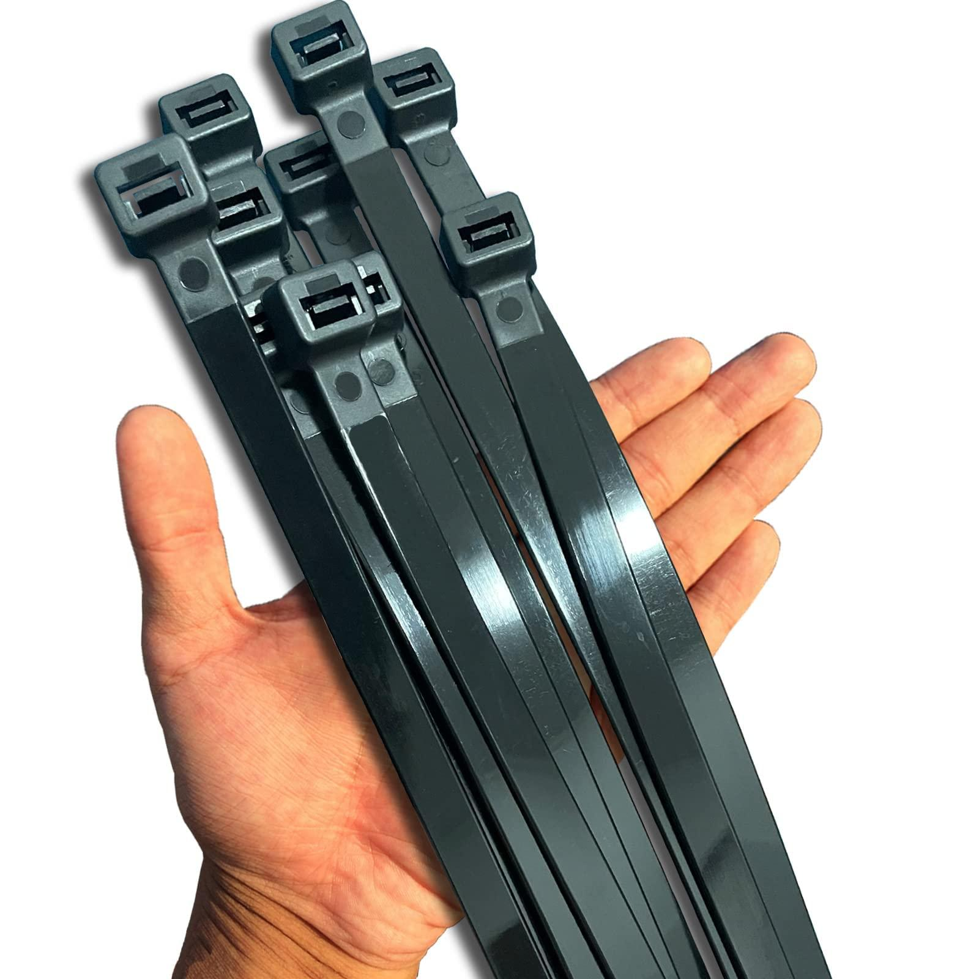
Person installing the solution with cable ties and the cable ties themselves
Currently, our stakeholders’ solutions are to either hold the desk or keep materials in backpacks. Neither of these is helpful and both inconvenience the stakeholders. Students can hold their desks with one hand, while working with the other, to ensure that the desks do not move unexpectedly. They can also leave materials in backpacks or put them on the floor to prevent them from being knocked over. However, none of these methods are ideal. While they are effective, they do not meet our design requirements because they are irritating solutions to use. Holding the desk is a functional solution, but it is not very practical. Students implementing this solution lose the ability to work with two hands, making it difficult to type, write, and more. This is one of the ways these desks affect students’ learning, by restricting their ability to work. Leaving materials in backpacks or on the floor limits students’ access to materials. It adds time and annoyance to using resources and prevents our stakeholders from having materials easily available to them. Our design requirements include making a functional and easy-to-use lock that allows students to choose whether their desks move or not. Our previous solutions for all of our stakeholders do not meet these requirements. Our project will create a better alternative, and make class time more efficient with its simple fix.
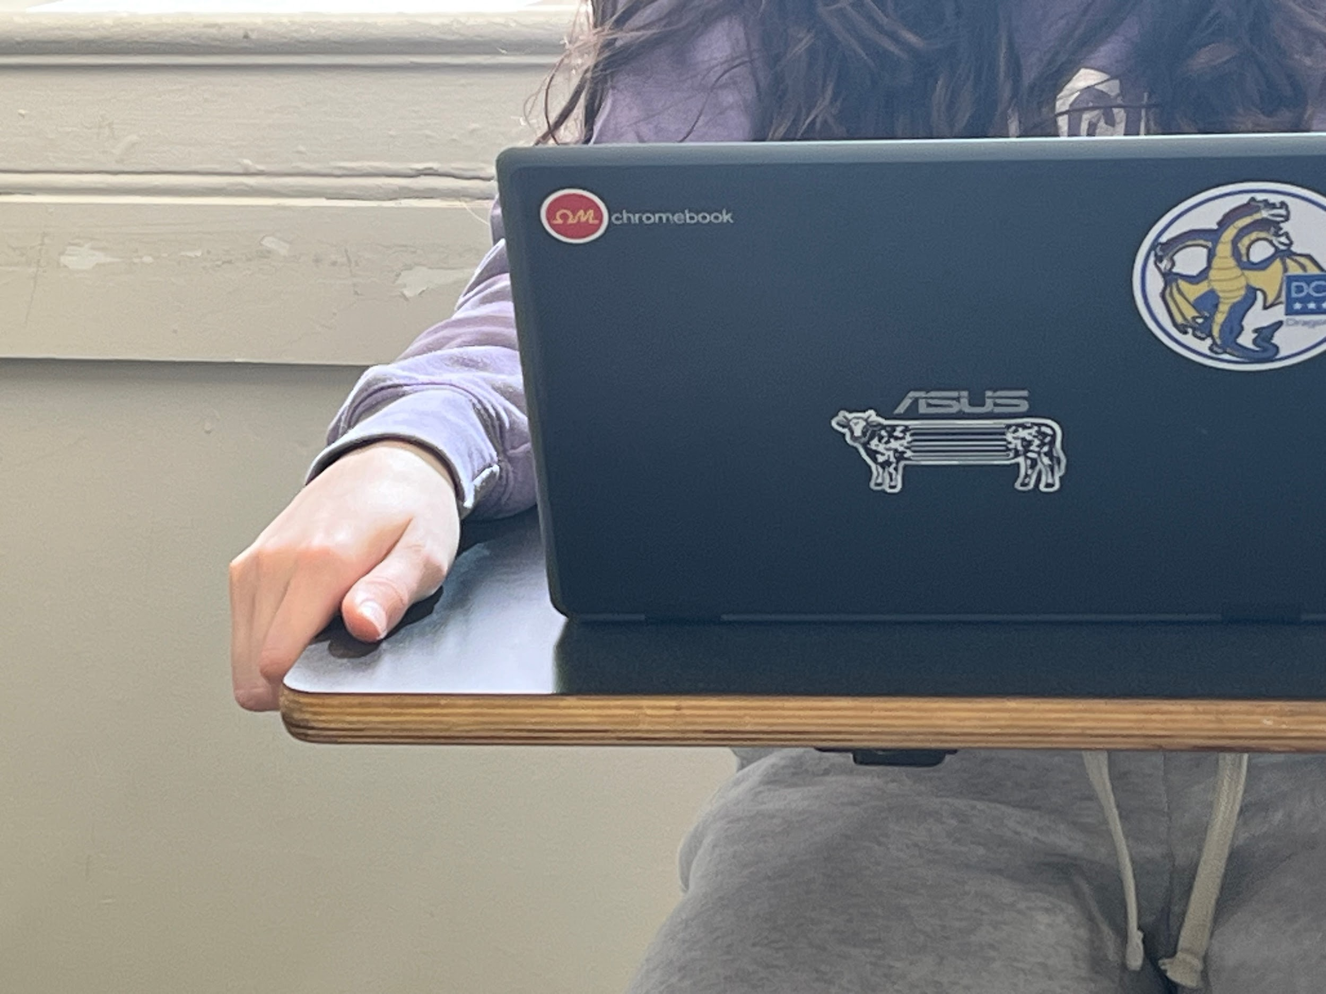
Student holding their desk
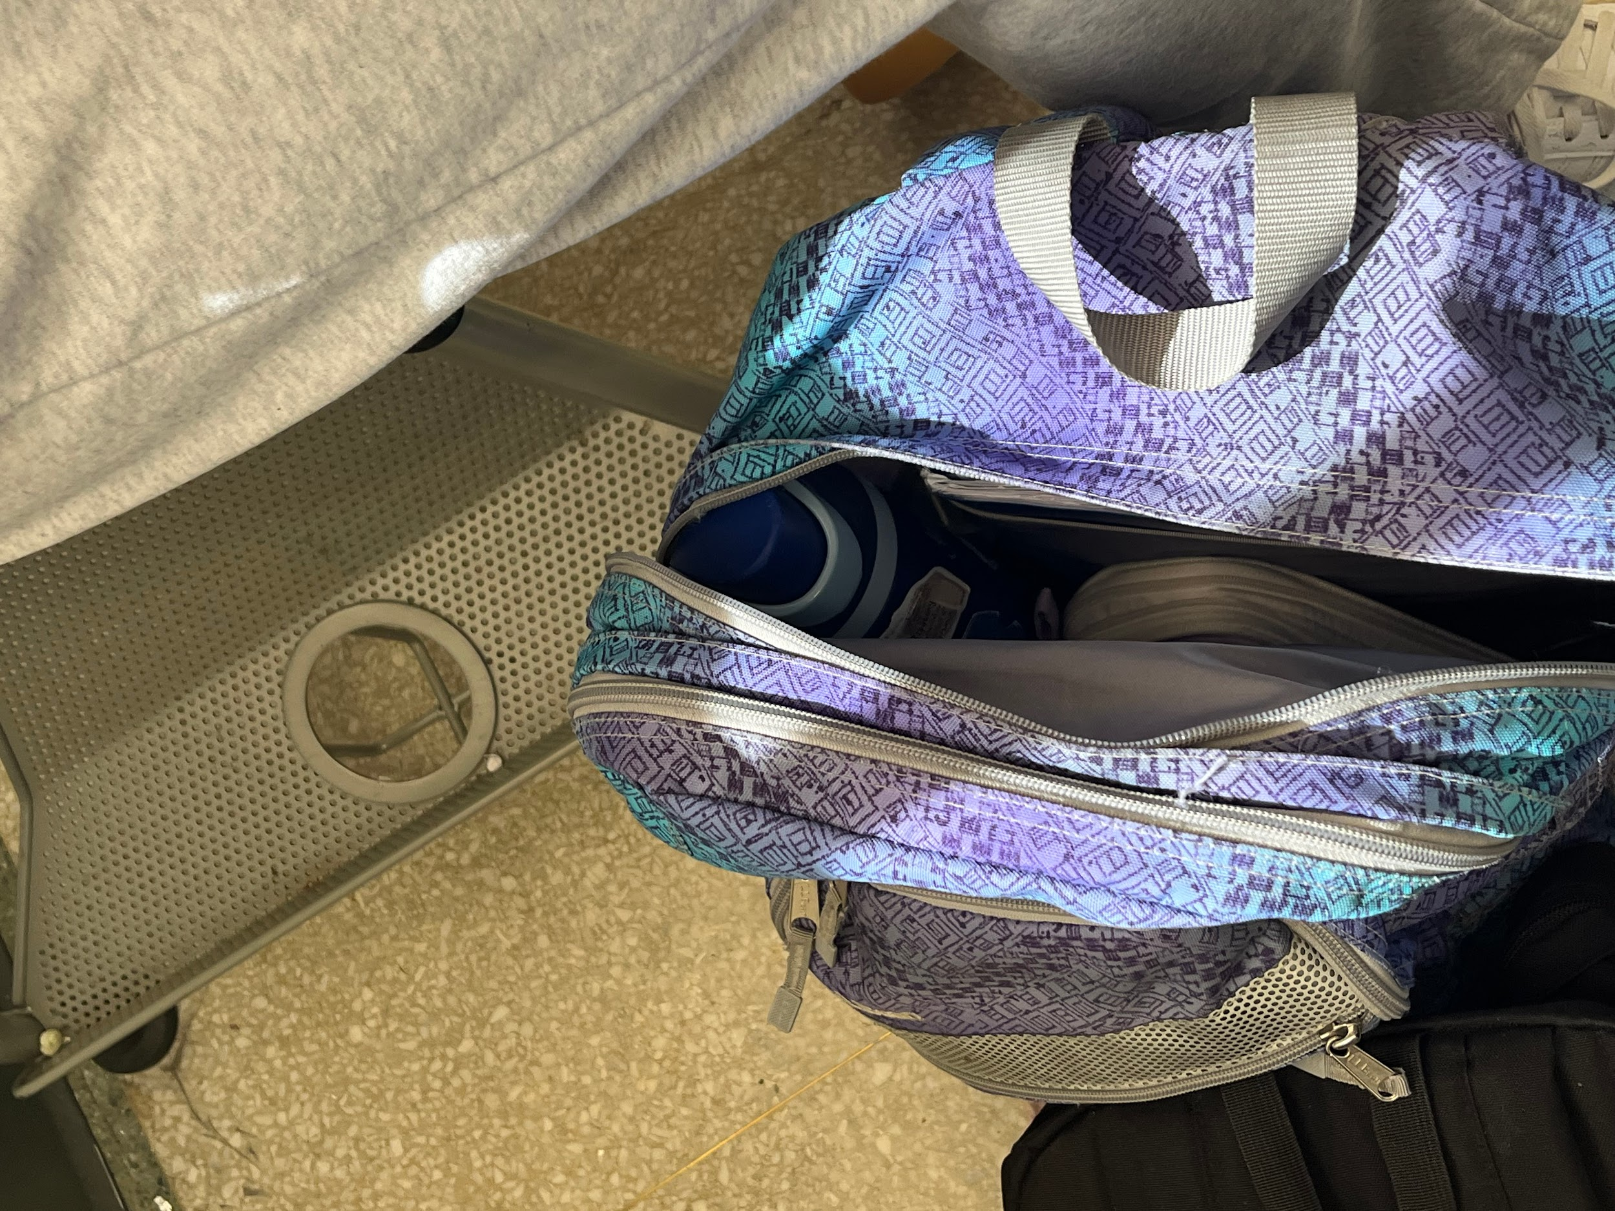
Materials kept in a backpack

Bibliography:
Elizbath, Hannah. “Chair Mastery: How to Lock the Swivel Chair? Unlock the Secret!” Chair Desk Expert, 24 Oct. 2024, chairdeskexpert.com/guide/chair-guide/desk-chairs/how-to-lock-the-swivel-chair/.
“Gas Cylinder with Rotation Brake – MTSIM USA.” MTSIM USA, 19 Feb. 2024, www.mtsim.com/product/gas-cylinder-with-rotation-brake/.
“Learn2 Seating.” KI, 2025, www.ki.com/products/name/learn2-seating/spec/.

