MyDesign Portfolio
Element B Initial Template

Element B: Documentation and Analysis of Prior Design Attempts

Prior Design Attempt #1 - <Analysis of microplastic collection methods>
https://link.springer.com/article/10.1007/s11356-020-07783-8
State the source of the information about this prior design attempt, which should be taken from any of the following credible source categories: peer-reviewed journals (check out your public library for free digital access to journals; here are some free online journals and research databases), professional organizations, government agencies, local and national newspapers, patents (here is a patent search site for the United States Patent and Trademark Office), and reputable vendors and manufacturers. Make sure to incorporate in-text citations in the details section below (i.e. don't just give a list at the end of the element or footnote).
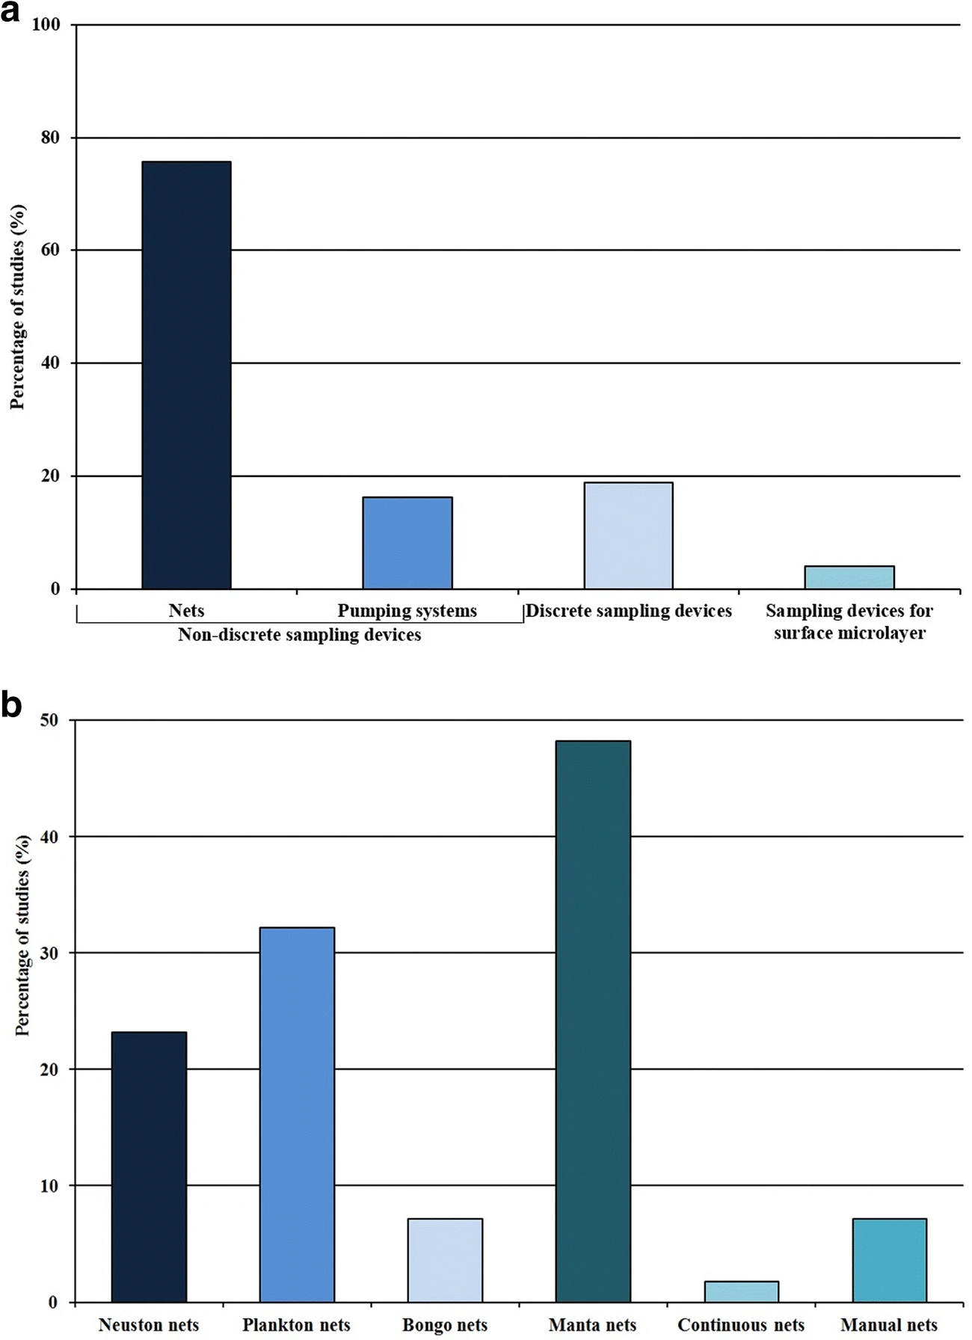
https://link.springer.com/article/10.1007/s11356-020-07783-8/figures/3
Details
The source talked about the different types of sampling devices used for microplastics. The main ones were different types of nets. The additional ones are pumping systems and surface level sampling devices.
Analysis
This source showed that the most used option was the nets, and for that reason a net is probably the best possible option to use. The source talked about plankton nets, and how there would be two different sizes of mesh, to filter the microplastics into the correct size.

Prior Design Attempt #2 - <insert name of prior design attempt #2>
https://oceanservice.noaa.gov/facts/microplastics.html
State the source of the information about this prior design attempt, which should be taken from any of the following credible source categories: peer-reviewed journals (check out your public library for free digital access to journals; here are some free online journals and research databases), professional organizations, government agencies, local and national newspapers, patents (here is a patent search site for the United States Patent and Trademark Office), and reputable vendors and manufacturers. Make sure to incorporate in-text citations in the details section below (i.e. don't just give a list at the end of the element or footnote).
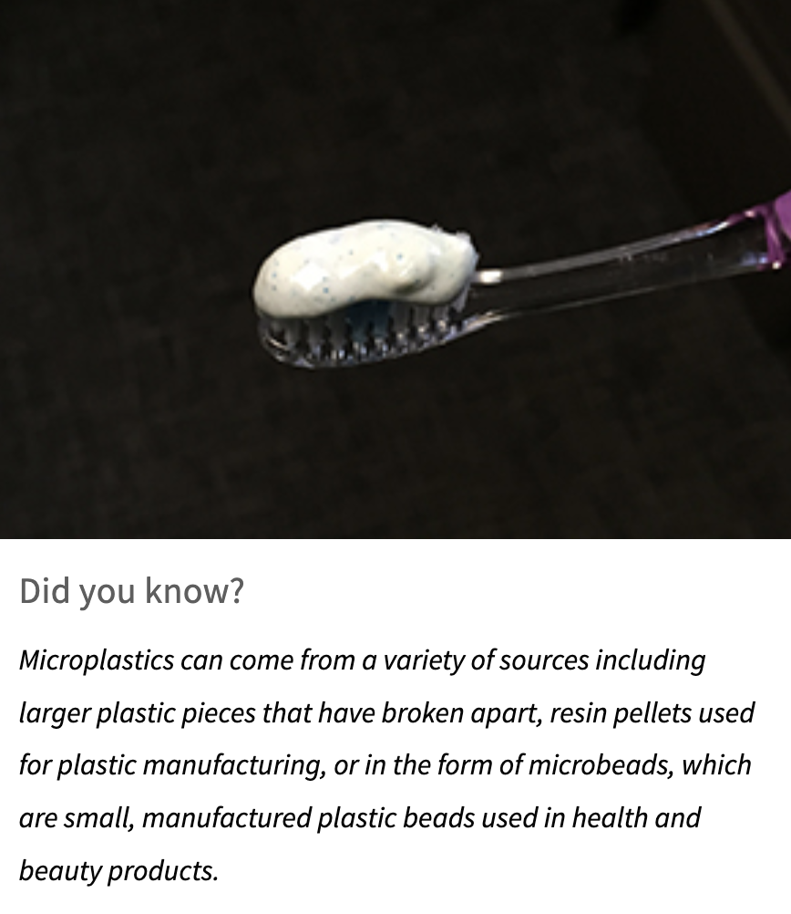
Include at least one image of this prior design attempt. Make sure to cite all images.
Microplastics are everywhere. They are pieces of plastic 5mm or less. “Standardized field methods for collecting sediment, sand, and surface-water microplastic samples have been developed and continue to undergo testing.”
Include main details about this prior design attempt
The collection method must be able to filter out things that are bigger or smaller than microplastics without filtering out pieces of microplastic
Provide evidence and explain what parts of this prior design attempt were unsuccessful at solving the defined problem and why based on design requirements.

Prior Design Attempt #3 - <Carl Hayden High School ROV kit>
https://community.robotshop.com/blog/show/build-your-own-underwater-rov-for-250
State the source of the information about this prior design attempt, which should be taken from any of the following credible source categories: peer-reviewed journals (check out your public library for free digital access to journals; here are some free online journals and research databases), professional organizations, government agencies, local and national newspapers, patents (here is a patent search site for the United States Patent and Trademark Office), and reputable vendors and manufacturers. Make sure to incorporate in-text citations in the details section below (i.e. don't just give a list at the end of the element or footnote).
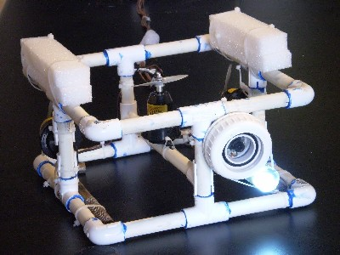
Details
The ROV is rectangular, with four supports in the middle of each side connecting the top and the bottom. It has two propellers that are placed horizontally, and one that is placed vertically. It also has a camera on the front of it, with a light taped on. Lastly it has flotation devices on the top.
Analysis
The design overall is successful, as it is “being promoted by the Honeywell Hometown Solutions National Underwater Robotics Challenge (NURC) for use in their upcoming 2008 Underwater Challenge.” The frame of the build makes the ROV itself stable and solid, and gives plenty of space for the different internal systems. The camera and light allow the operator to see what the ROV sees, and the vertical propeller and flotation devices allow the ROV to float on the surface and submerge.

Prior Design Attempt #4 - <insert name of prior design attempt #4>
Source
State the source of the information about this prior design attempt, which should be taken from any of the following credible source categories: peer-reviewed journals (check out your public library for free digital access to journals; here are some free online journals and research databases), professional organizations, government agencies, local and national newspapers, patents (here is a patent search site for the United States Patent and Trademark Office), and reputable vendors and manufacturers. Make sure to incorporate in-text citations in the details section below (i.e. don't just give a list at the end of the element or footnote).
Image
Include at least one image of this prior design attempt. Make sure to cite all images.
Details
Include main details about this prior design attempt
Analysis
Provide evidence and explain what parts of this prior design attempt were unsuccessful at solving the defined problem and why based on design requirements.

Prior Design Attempt #5 - <insert name of prior design attempt #5>
Source
State the source of the information about this prior design attempt, which should be taken from any of the following credible source categories: peer-reviewed journals (check out your public library for free digital access to journals; here are some free online journals and research databases), professional organizations, government agencies, local and national newspapers, patents (here is a patent search site for the United States Patent and Trademark Office), and reputable vendors and manufacturers. Make sure to incorporate in-text citations in the details section below (i.e. don't just give a list at the end of the element or footnote).
Image
Include at least one image of this prior design attempt. Make sure to cite all images.
Details
Include main details about this prior design attempt
Analysis
Provide evidence and explain what parts of this prior design attempt were unsuccessful at solving the defined problem and why based on design requirements.

