MyDesign Portfolio
Element B Initial Template

How to use this template
Teachers: You may customize this document before providing it to students.
Students: The template below is one way to structure your research findings around past and current attempts to solve the problem, but the specific assignment given by your instructor may require a different structure or dictate different details. If you make a copy of this template to edit for your own research into prior design attempts, be sure to delete the instructions.

Element B: Documentation and Analysis of Prior Design Attempts

Prior Design Attempt #1 - <Urea#1>
Source :
https://www.almanac.com/7-better-alternatives-salt-de-icing-driveways talks how urea is safe for the environment and which ways that it is used.
In https://meltsnow.com/products-old/urea-and-kcl/ it talks about what it is made out of and how it can benefit the environment,
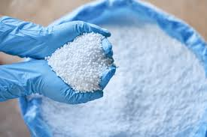
Image :

Details:
It’s environmentally safe and doesn’t cause damage to concrete. It’s often used on airport runways. It can melt ice down to temperatures of 15℉. Urea provides as much traction from not melting as it does provide melting of snow and ice.
Analysis:
Using Urea on concrete is good for the environment and dogs, but using it can cause vomiting. Urea as an ice melter it’s ok but not great but it does help dissolve the ice and snow preventing cracking to the surface. It can damage soil mineral balance; and, it can stunt or kill plants adjacent to de-iced areas.

Prior Design Attempt #2 - <fiber reinforcement #2>
Source:
Damaged Concrete? Now What? goes into what could cause concrete to be damaged during cold weather and some tips in preventing it. One of these tips suggested using fibers as additives on the concrete surface. In Effect of Fibers on Concrete Properties it goes into depth as to why fibers in concrete can help it avoid further damage and I used What Is Fiber-Reinforced Concrete? To look at the pros and cons.

Image:
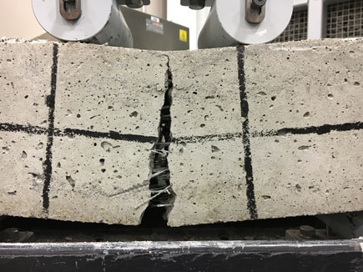
(Using fibers on the concrete) (Adding fibers to concrete pavement may help it last longer).
Details:
Using fiber reinforcement helps to prevent them from developing cracks in freezing temperatures (Winter Damaged Concrete? Now What?). Using Fibers on Concrete also reduces Reduced Cracking & Crack Width Reduction, Increased Ductility & Toughness, Potential for Concrete Thickness Reduction, and Improved Explosive Spalling Resistance (Effect of Fibers on Concrete Properties).
Analysis:
While using fiber on concrete has it upsides, some things that hold it back is the high cost of using fiber compared to non reinforced concrete, The weight of the fiber makes the concrete heavier, and the fact that it must be mixed carefully as fibers can form in a way that causes the dispersion to be inconsistent (What Is Fiber-Reinforced Concrete?).

Prior Design Attempt #3 - <Calcium Magnesium Acetate#3>
Source: What Is CMA Ice Melt, and How Does It Work? | Ninja De-Icer
Details:
Calcium Magnesium Acetate (CMA) is an environmental ice melt that is used to manage snow and ice on roads, pavements, and other surfaces containing dolomitic lime and acetic acid. CMA works by interfering with the ability of snow and ice particles to adhere to each other and to surfaces it prevents a compact snow pack from forming keeping the snow light and dry this improves traction and makes it easier to remove
Image :
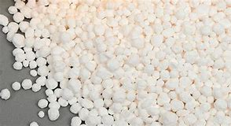
This is what the CMA looks like.

Analysis:
CMA ice melt is an environmentally friendly product that prevents ice and snow from sticking together and to surfaces. Even though it is more costly and less effective at very low temperatures.

Prior Design Attempt #4 - <Magnesium Chloride#4>
Source :
The Case Against Magnesium Chloride goes into detail as to why using Magnesium Chloride on concrete does more harm than good and includes links to studies that back up their claim. CALCIUM CHLORIDE VS. MAGNESIUM CHLORIDE compares the two different chlorides and how magnesium chloride is the weaker of the two despite claims of it being just as good or even better than calcium chloride.

Image:
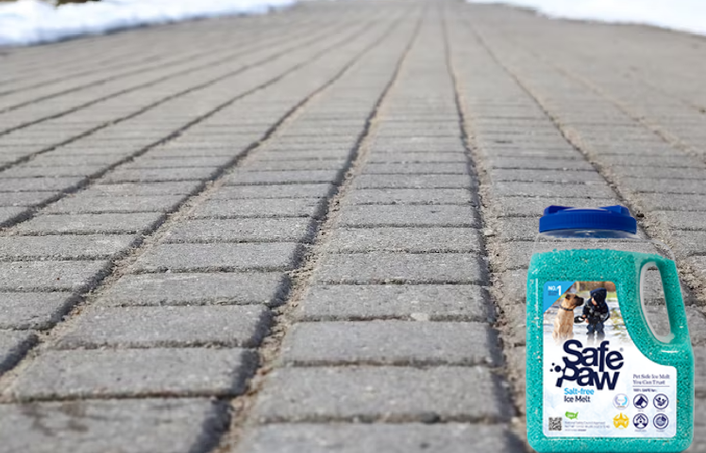
(Is Magnesium Chloride Safe For Concrete?)

Details:
Using Magnesium Chloride is dangerous because it can cause scaling which is when flaking or peeling of hardened occurs due to freezing and thawing, causing surface deterioration over time. (The Case Against Magnesium Chloride). The severe deterioration of Magnesium Chloride causes crumbling and discoloration of the concrete (CALCIUM CHLORIDE VS. MAGNESIUM CHLORIDE). It was also determined that the chemical reaction with magnesium chloride and the concrete paste causes the concrete to lose its compressive strength and increases its permeability which can cause water and other liquids to penetrate the concrete more quickly (The Deleterious Chemical Effects of Concentrated Deicing Solutions on Portland Cement Concrete, TR-480, 2008 - Iowa Publications Online).
Analysis:
Magnesium Chloride is not recommended to be used on concrete because of how it causes slow deterioration to the concrete which includes crumbling, fracturing, and brown discoloration to the concrete (CALCIUM CHLORIDE VS. MAGNESIUM CHLORIDE).

Prior Design Attempt #5 - <Heated walkway(heated mats) #5>
Source: https://www.osti.gov/etdeweb/biblio/895225
Image: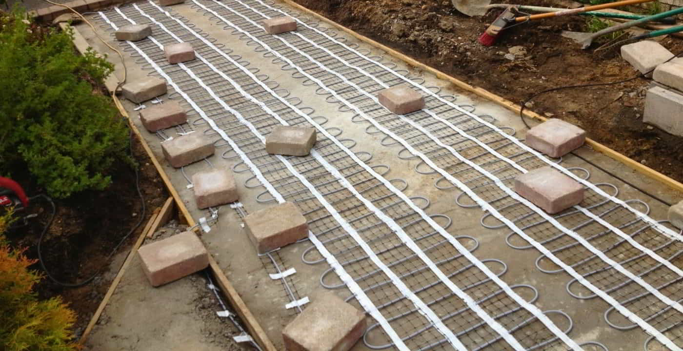
Include at least one image of this prior design attempt. Make sure to cite all images.
Details:
This prior solution is the heated walkway. The cost of this would be $12 to $15 per square foot. Using data from a driveway as an example an average driveway is about 600-800 square feet which cost around 7,200 to 20,000. “This option is a great one but not very cost effective during off seasons when there is no snow. The main problems anticipated with this system was to make sure all joints were sealed and that the pipes were protected against corrsin. Construction cost would increase for the pavement due the unusual characteristics of the system and for drilling and placing the vertical pipes. “(https://www.osti.gov/etdeweb/biblio/895225).
Analysis:
This would be a great decision for a homeowner with less coverage. For a school to be a commercial building these can be heavy expenses just to only be used during one season. There could also be further yearly maintenance due the corrosiveness of the pipes. There could also be Thermal Expansion problems when pipes are exposed to heat, the material of the pipe can expand. Different materials expand at different rates, which can cause the pipes to distort, deform, or even rupture under stress.

