MyDesign Portfolio
Element B Initial Template

Element B: Documentation and Analysis of Prior Design Attempts

Prior Design Attempt #1 - Sun blocking shade device
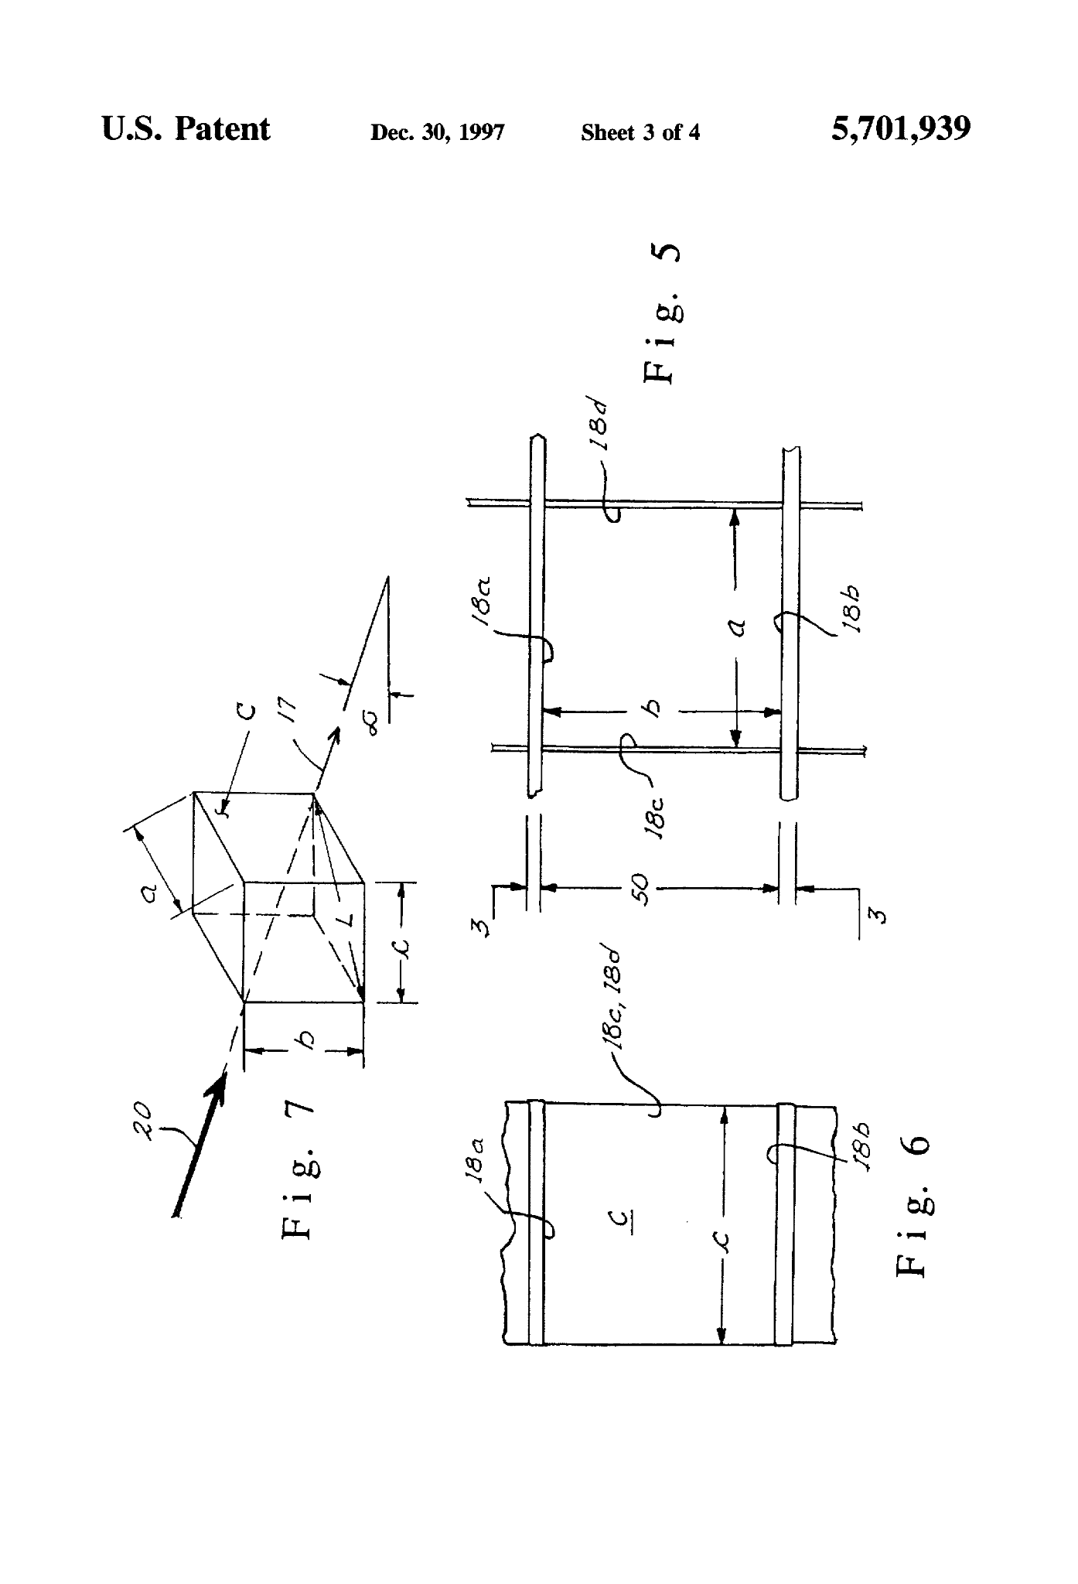
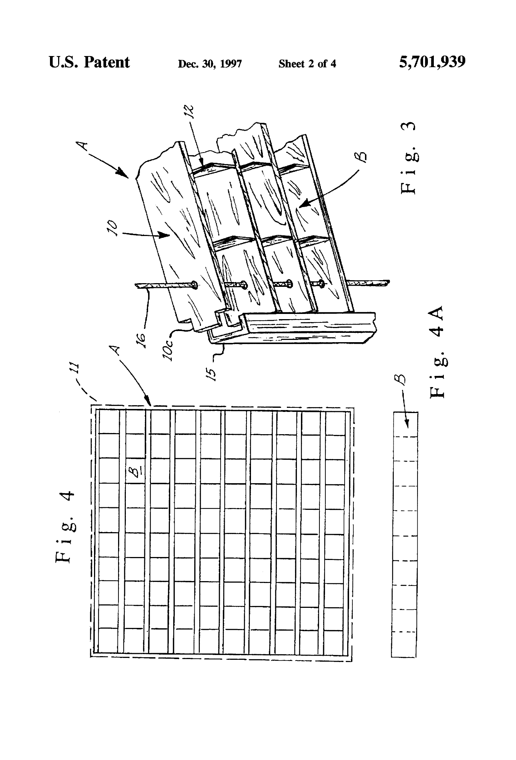
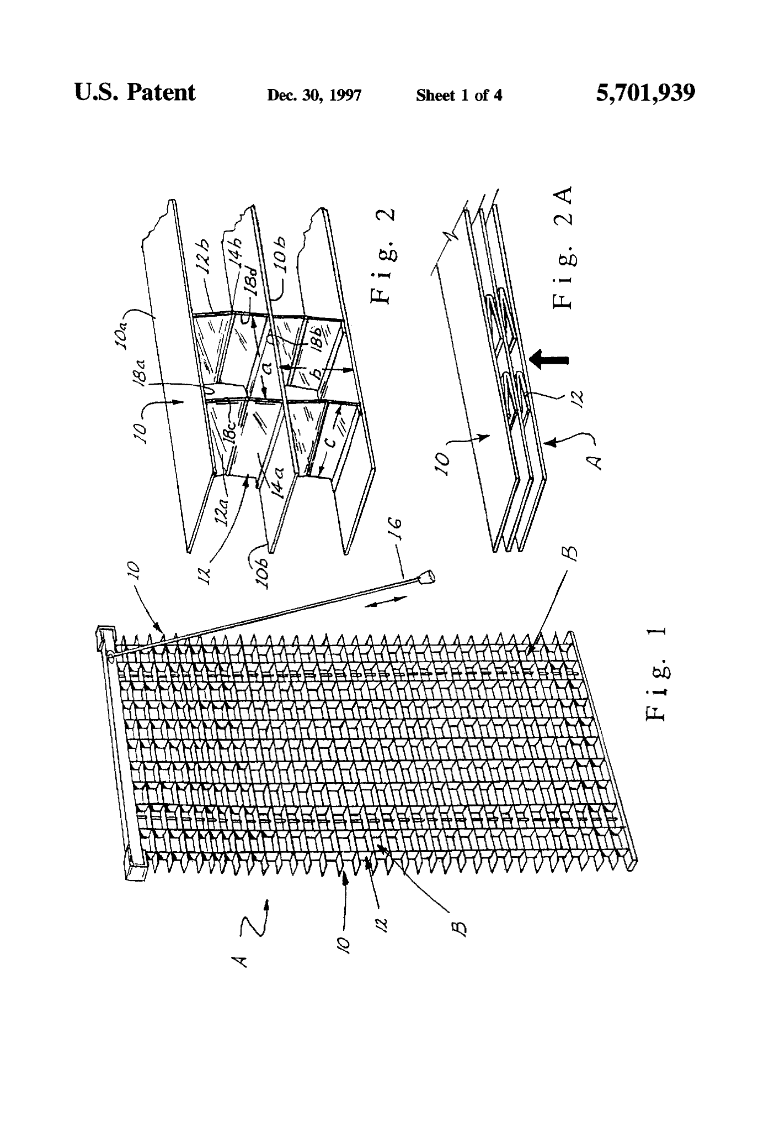
Source https://patents.google.com/patent/US5701939A/en

ImageWO2002019800A2

WO2002019800A2

WO2002019800A2
Details- A covering device is disclosed for substantially blocking solar rays and heat coming inwardly through an architectural opening while allowing substantial visibility outwardly through the covering and opening. This design uses a tilting mechanism which controls the amount of light and visibility through the blind.

Prior Design Attempt #2 - forecasting sunlight

Source https://patents.google.com/patent/US10133245B2/en?q=(sunlight+device+fro+plnat)&oq=sunlight+device+fro+plnat+

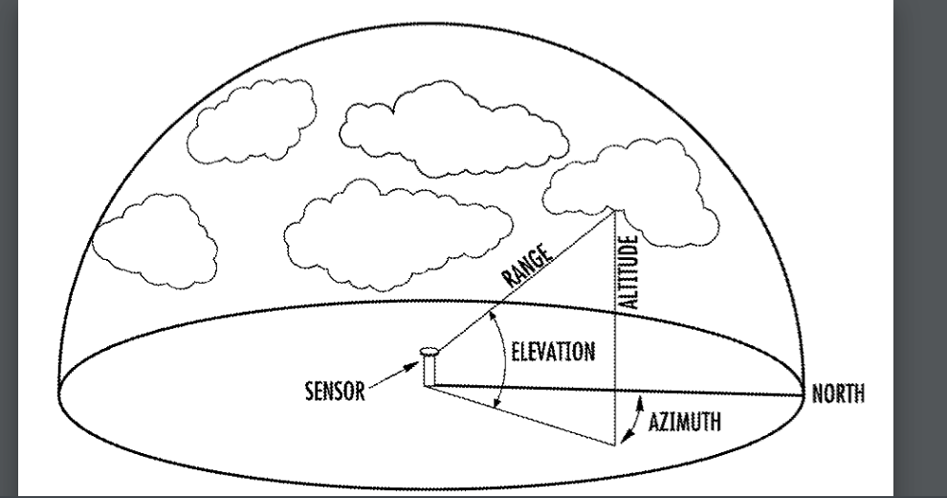

Details about patent: This method comprises determining characteristics of one or more clouds from sensors surrounding the photovoltaic power plant. The cloud characteristics are used to create a 3D map of the clouds. The 3D map in combination with information on the angle of the sun is used to create a 3D projection on the surface of the earth, resulting in a 2D surface irradiance map. The 2D surface irradiance map may be taken in successive projections or used in combination with wind speed data to forecast fluctuation in irradiance at the photovoltaic power plant.

Prior Design Attempt #3 - US10455775B2

https://patents.google.com/patent/US10455775B2/en

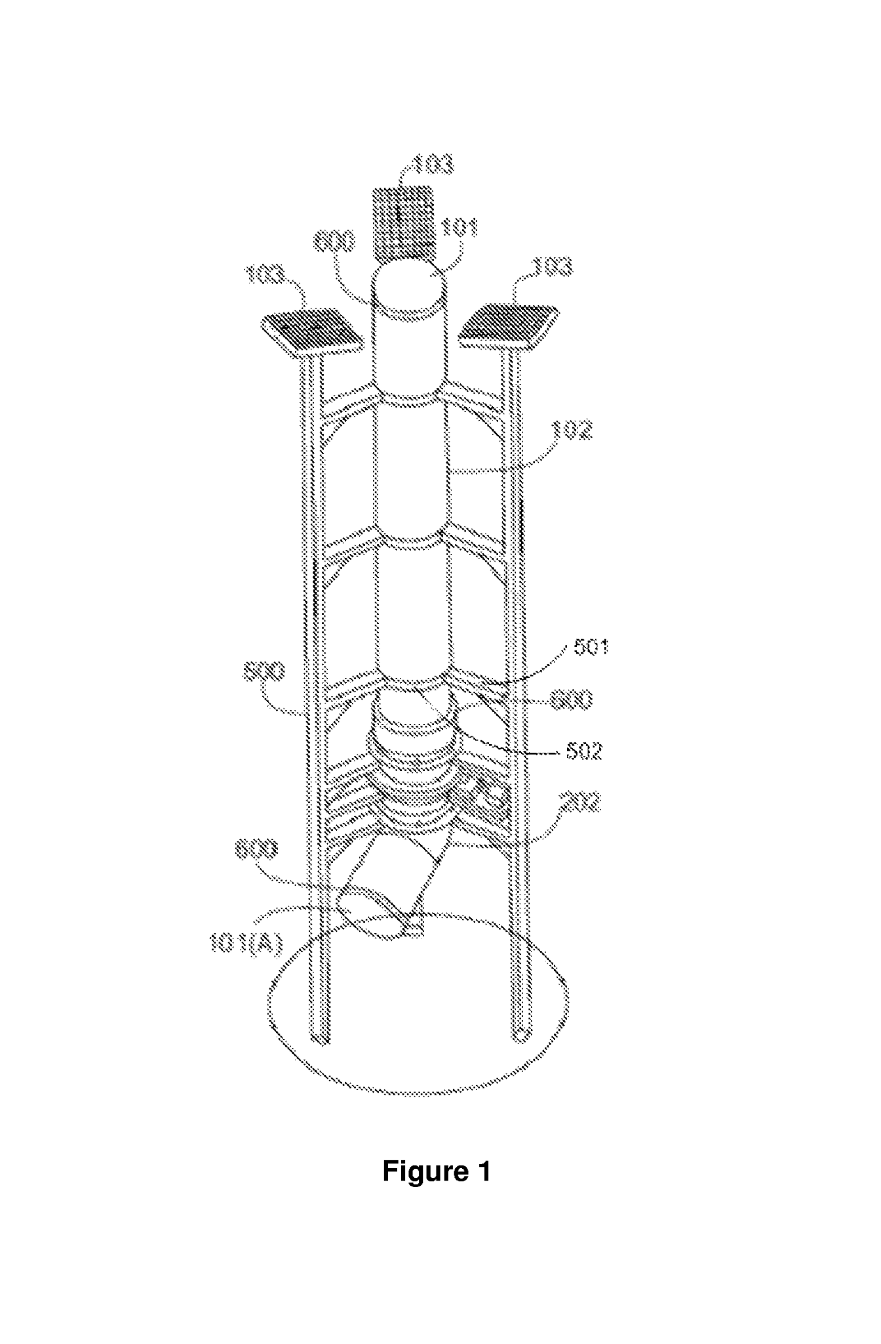

Details about patent: The present disclosure relates to a system for growing crops/plants under canopy of trees or shades. Embodiments of the disclosure provide a sun light Capturing Unit, sun light tubes to channel the captured sunlight and a rotating bent part in the sun tube that can be rotated to direct captured sunlight to the desired direction. An embodiment also provides a mechanism to rotate the bent part.

Prior Design Attempt #4 - Plant cover
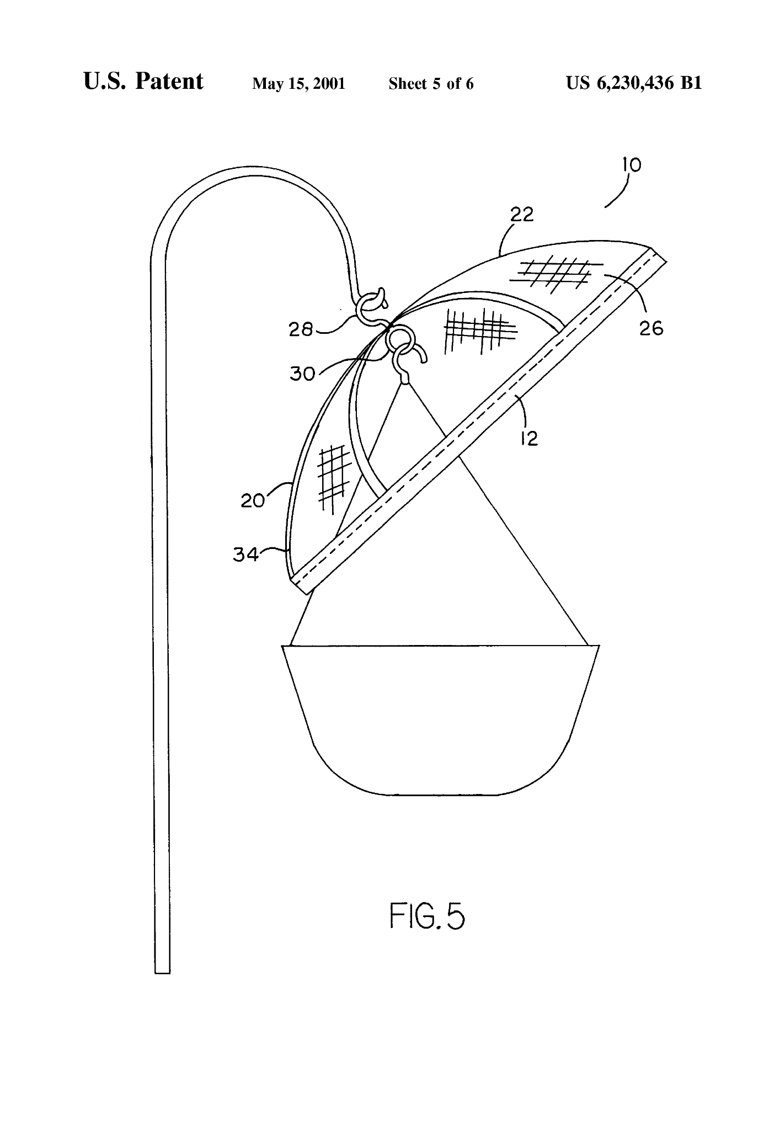
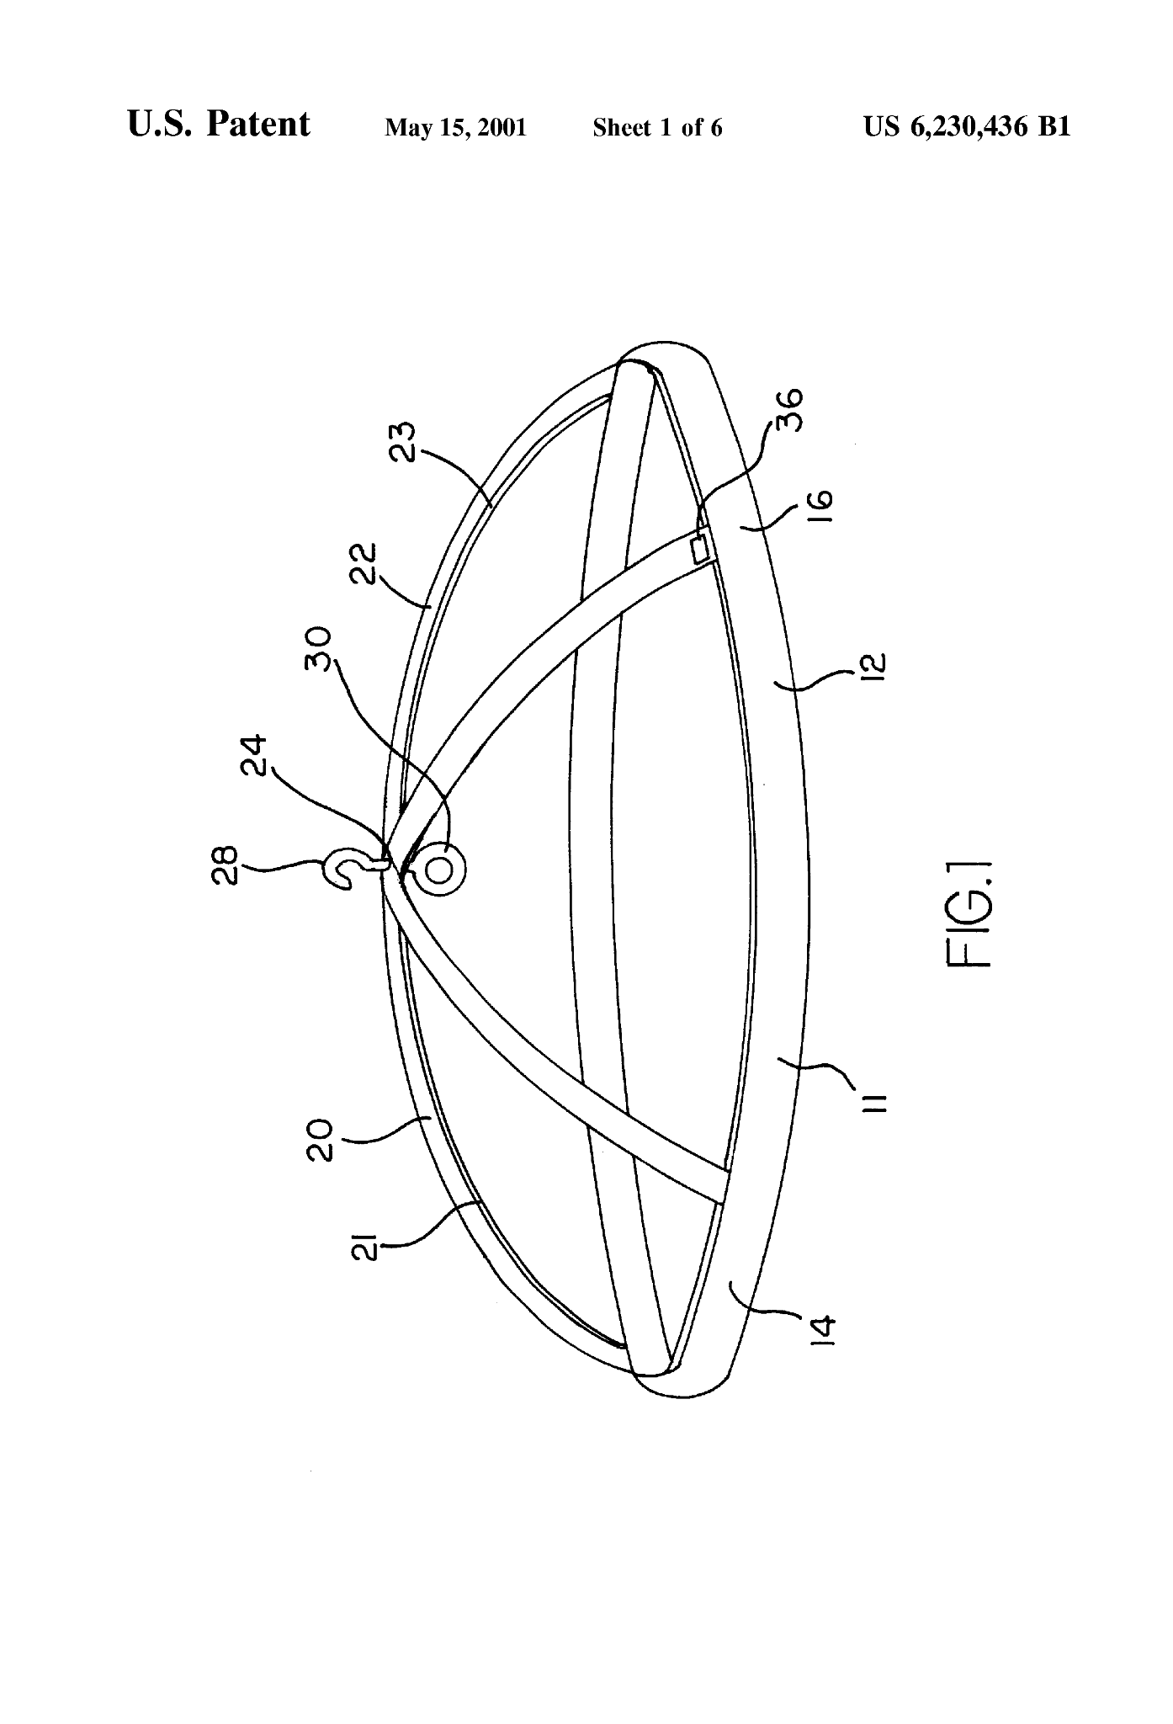
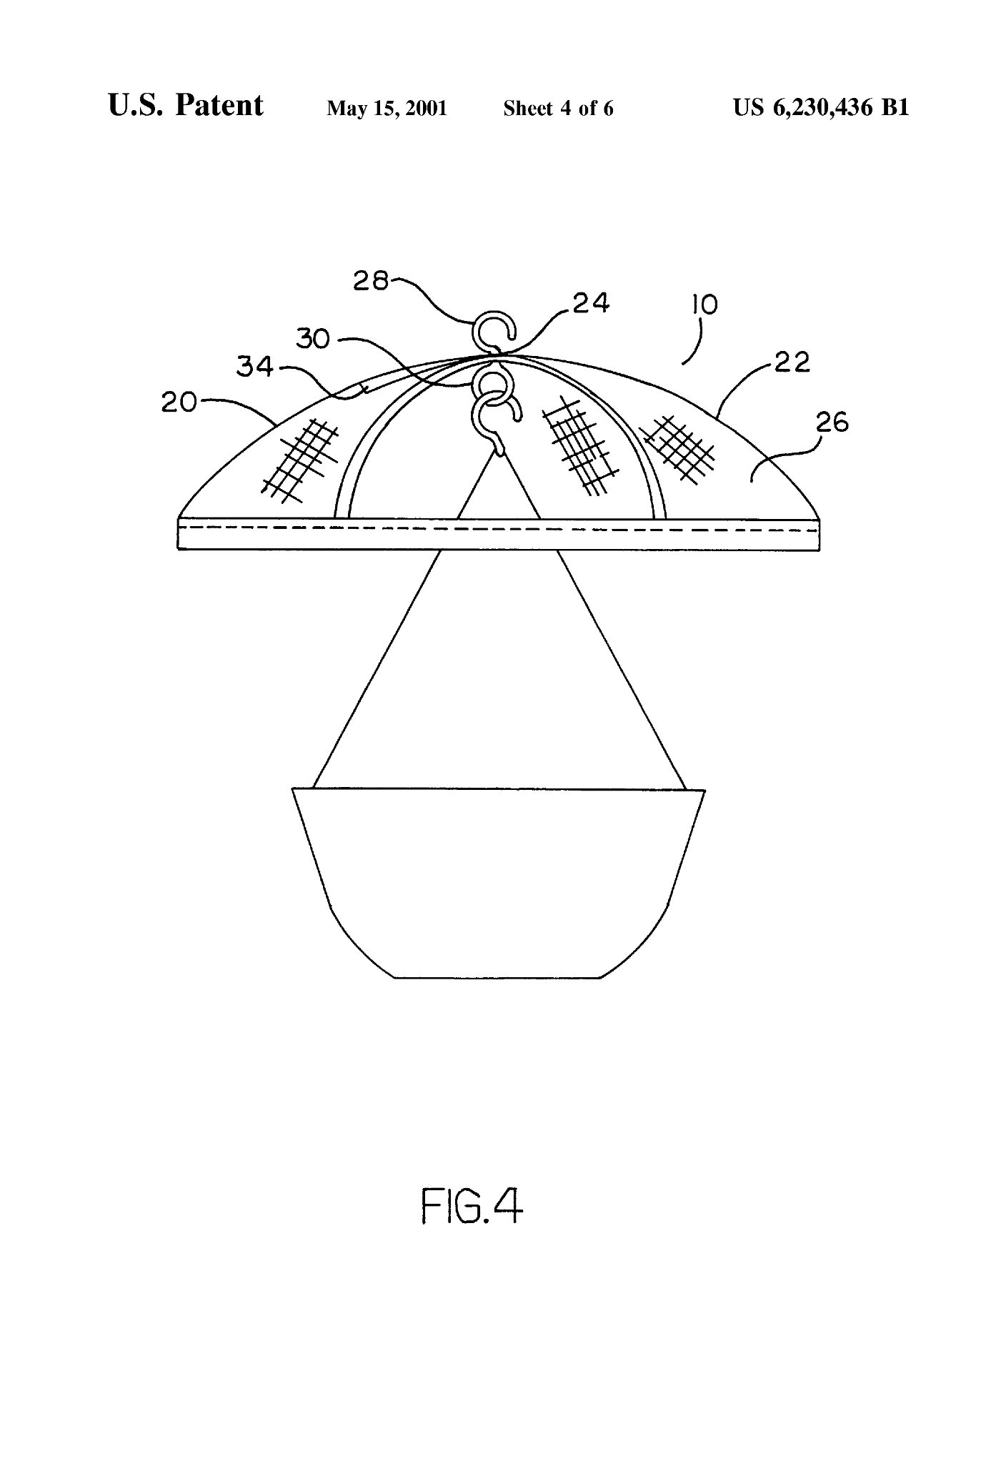
Source- https://patents.google.com/patent/US6230436B1/en

Image

Details about patent: This device is a plant cover used to protect a plant from intense sunlight. The plant cover has a rigid frame with a shade and is typically used for hanging planters. The plant cover can be further adjusted to select the type of light exposure.

Prior Design Attempt #5 - Adjustable plant shade/protection apparatus
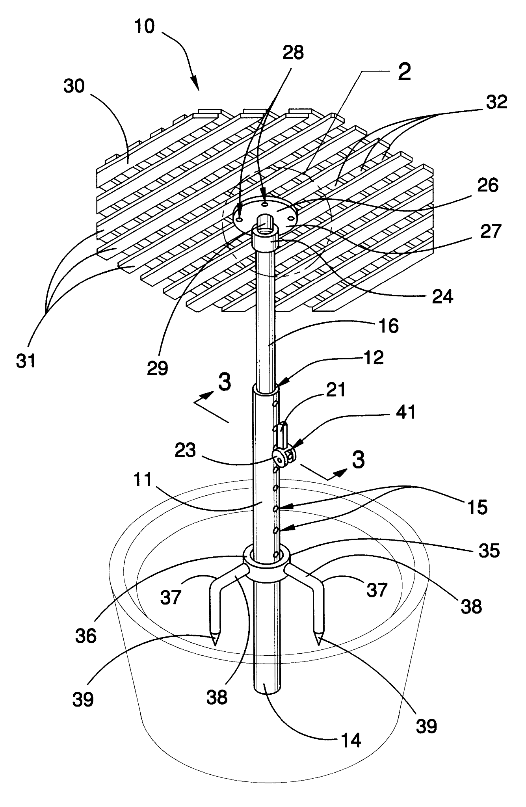

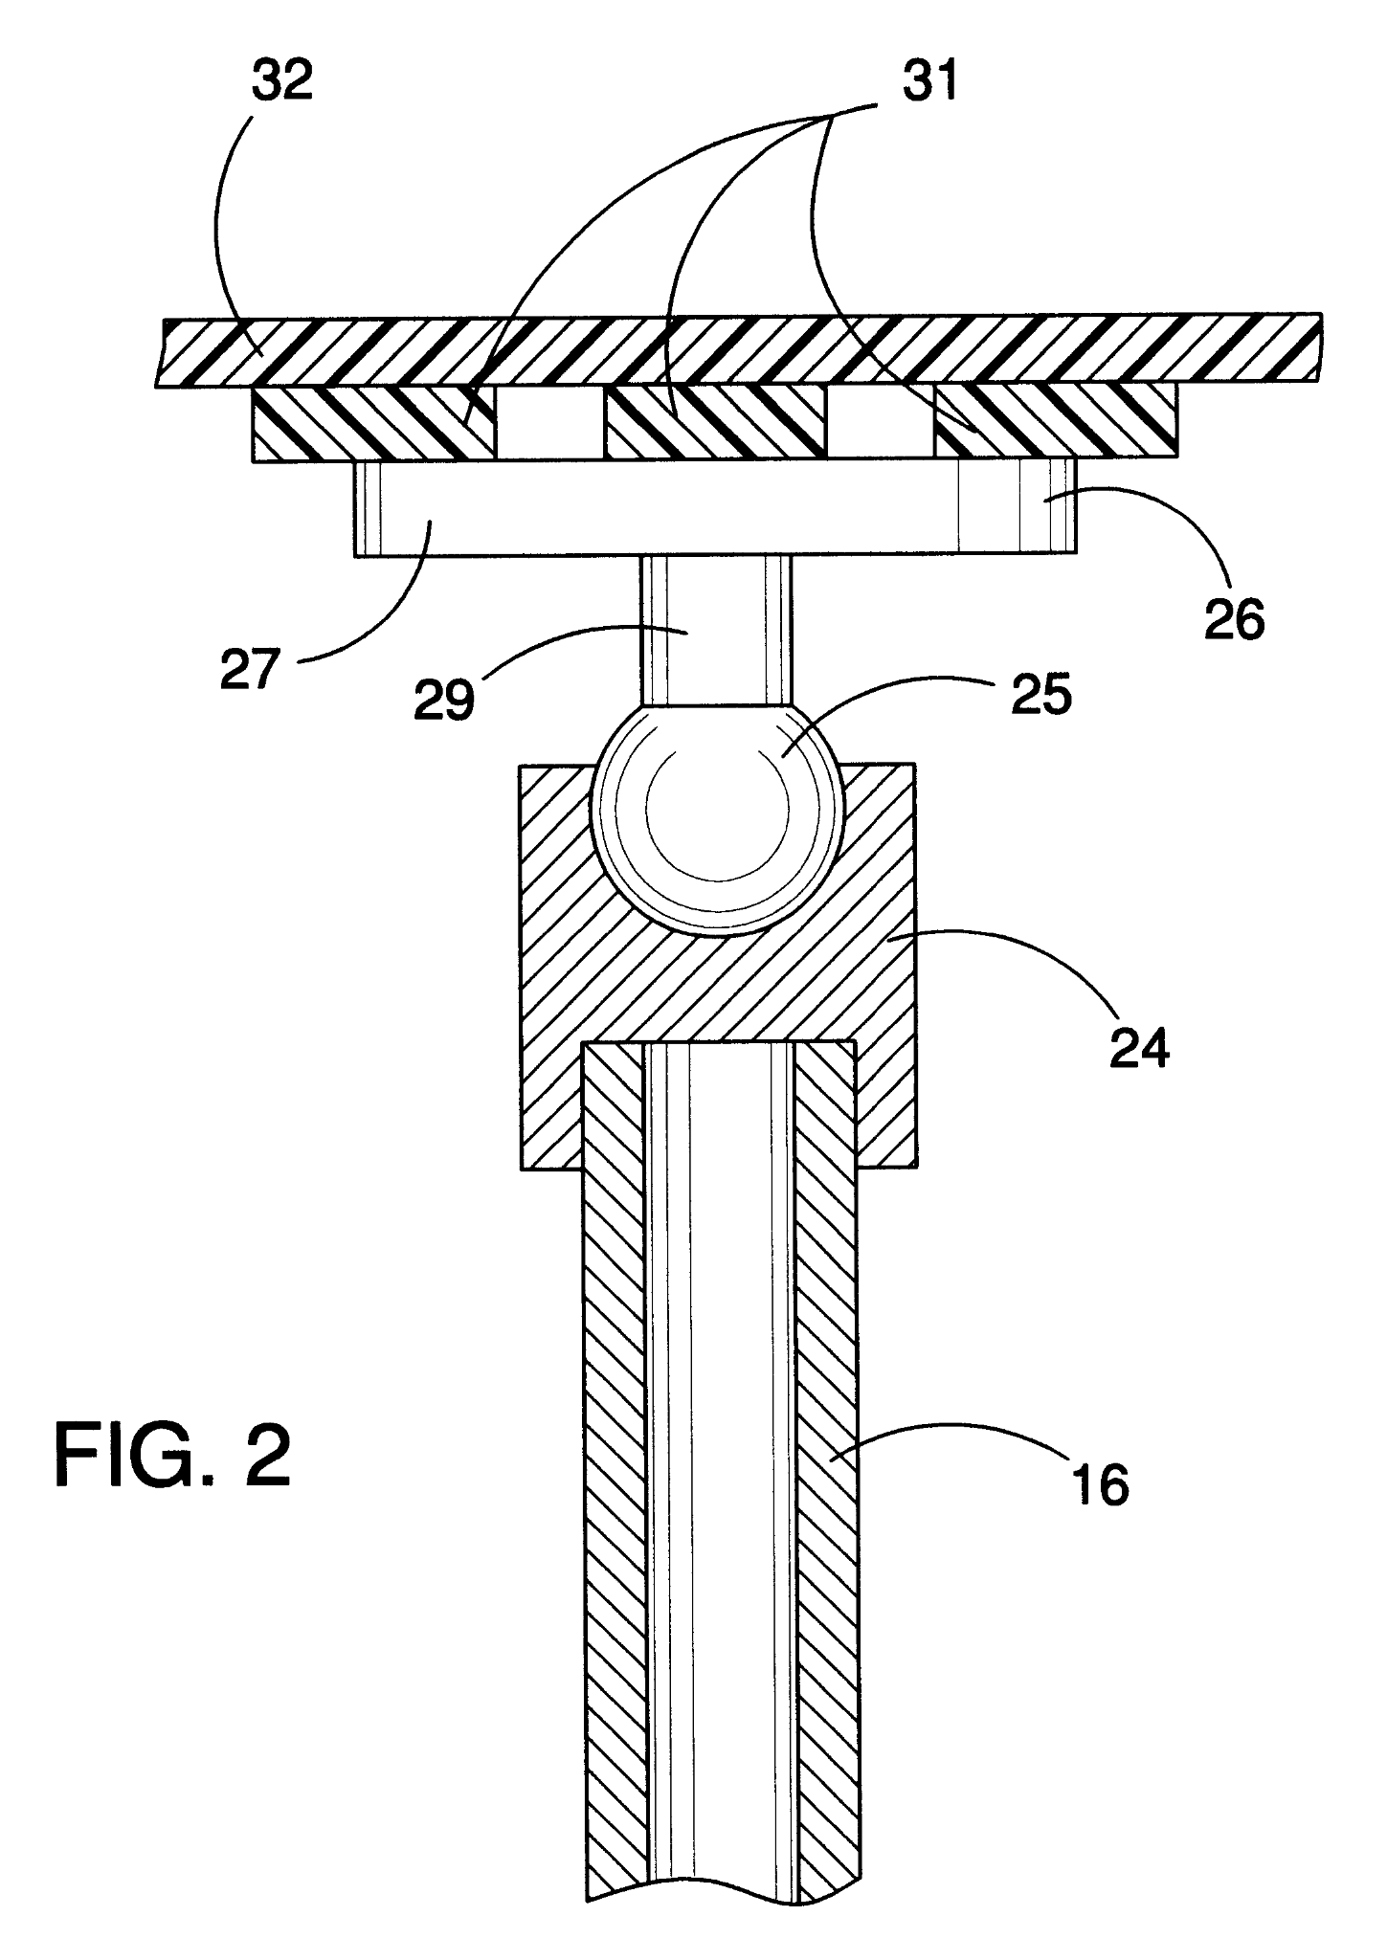
Source https://patents.google.com/patent/US6609332B1/en

Image

Details about patent: An adjustable plant shade/protection apparatus for shielding a plant from certain weather conditions like sunlight and strong storms. The adjustable plant shade/protection device includes a shade support assembly including a base tubular member having an open second end and a bore extended there in through the open second end and also having a plurality of diametrically-opposed holes being spaced aligned along and disposed through a sidewall of the base tubular member, and also including an extension tubular member being adjustably extended in and from the base tubular member and also having a plurality of diametrically-opposed holes being spaced aligned along and disposed through a side wall of the extension tubular member; and also includes a shade assembly being mounted upon the shade support assembly and being adapted to be disposed over a designated plant.
Analysis- All of these designs include interesting components that give us some more inspiration for our design. Some of these components are the second one having the characteristics of clouds, the first one having a tilting mechanism, and the fourth one incorporating a hanging planter for houses. All of these designs work well for different things so they are all successful, and they can help us think outside the box for our design.

