MyDesign Portfolio
Element B Initial Template

How to use this template
Students: The template below is one way to structure your research findings around past and current attempts to solve the problem, but the specific assignment given by your instructor may require a different structure or dictate different details. If you make a copy of this template to edit for your research into prior design attempts, be sure to delete the instructions.

Element B: Documentation and Analysis of Prior Design Attempts

Prior Design Attempt #1 - GUITAR BIN
Source: https://www.walmart.com/ip/Electric-Guitar-Collapsible-Storage-Bins-Fabric-Shelf-Baskets-with-Handles-16-9-x11-4-x10-Closet-Organizer/9889270901?wmlspartner=wlpa&selectedSellerId=101639587&gQT=1
State the source of the information about this prior design attempt, which should be taken from any of the following credible source categories: peer-reviewed journals (check out your public library for free digital access to journals; here are some free online journals and research databases), professional organizations, government agencies, local and national newspapers, patents (here is a patent search site for the United States Patent and Trademark Office), and reputable vendors and manufacturers. Make sure to incorporate in-text citations in the details section below (i.e. don't just give a list at the end of the element or footnote).
Image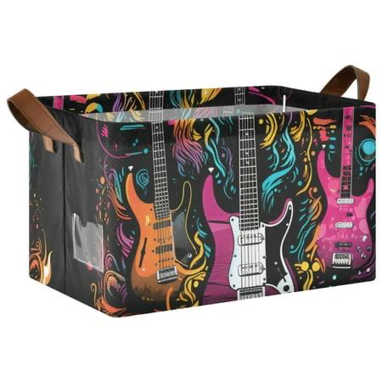
Include at least one image of this prior design attempt. Make sure to cite all images.
Details:
The positives for a guitar bin is that they are very easily accessible, easy to set up and cheap. The negatives are that they might not look pleasant or work very well.

Include main details about this prior design attempt
Analysis:

Although this design is being sold, it isn’t perfect for everyone. A guitar bin can damage the guitars inside of it and be a messy solution to an already messy problem.

Provide evidence and explain what parts of this prior design attempt were unsuccessful at solving the defined problem and why based on design requirements.

Prior Design Attempt #2 - Guitar Rack
Source: https://www.stringswing.com/rack-for-5-acoustic-or-electric-guitars/?gQT=1
State the source of the information about this prior design attempt, which should be taken from any of the following credible source categories: peer-reviewed journals (check out your public library for free digital access to journals; here are some free online journals and research databases), professional organizations, government agencies, local and national newspapers, patents (here is a patent search site for the United States Patent and Trademark Office), and reputable vendors and manufacturers. Make sure to incorporate in-text citations in the details section below (i.e. don't just give a list at the end of the element or footnote).
Image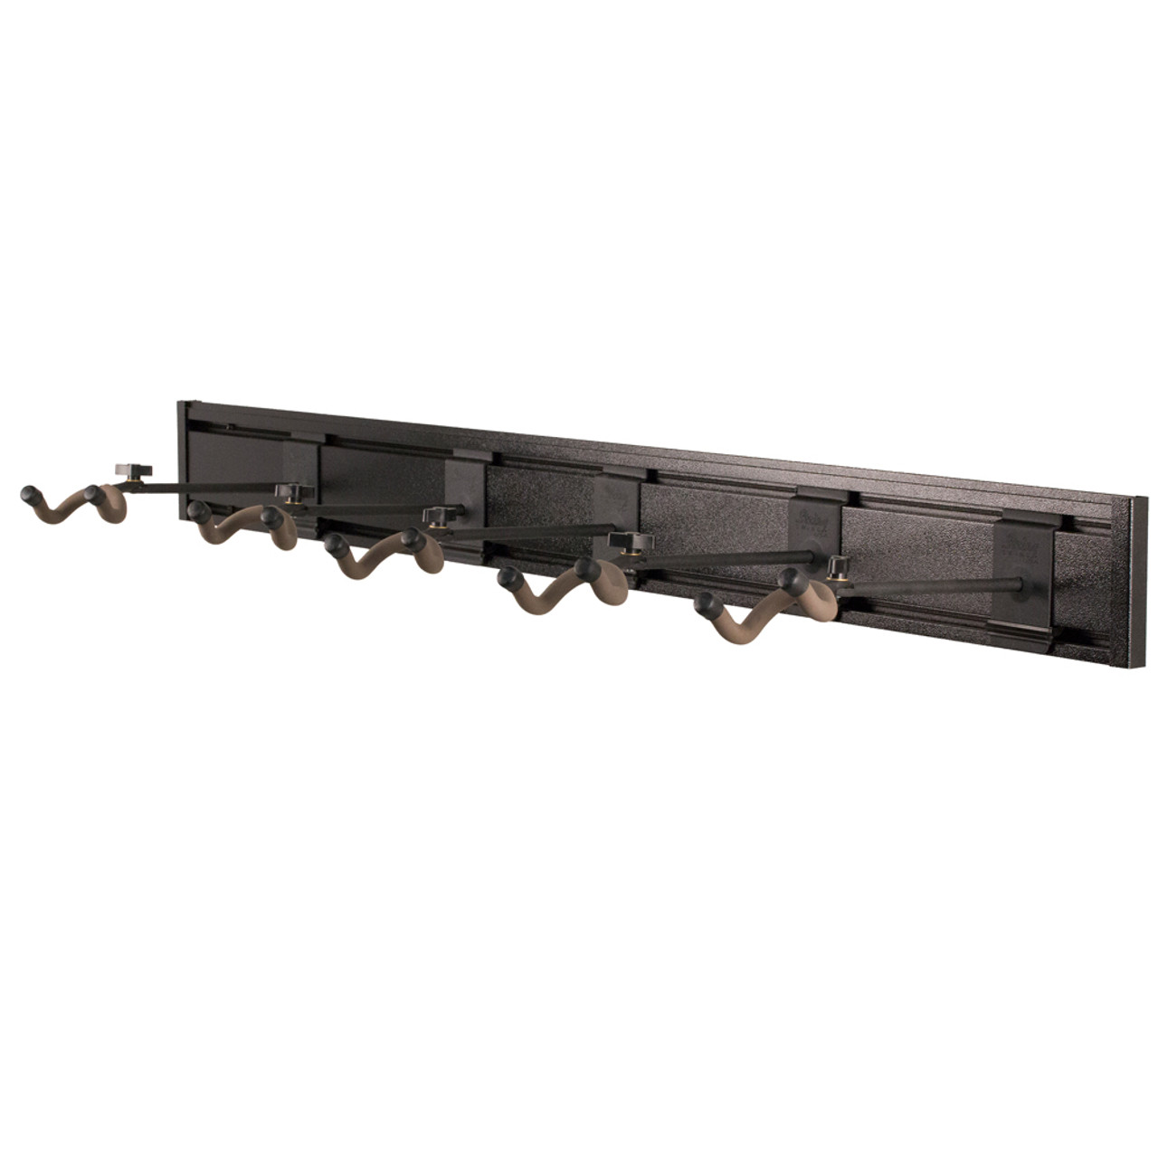
Include at least one image of this prior design attempt. Make sure to cite all images.
Details:
The guitar rack would not solve our stakeholders needs because it is too expensive and not easily accessible. Nevertheless, it is really good at holding many guitars at once in an orderly manner.

Include main details about this prior design attempt
Analysis:
This guitar rack wouldn’t be the right solution for the Bridge To Wellness room because of its high cost. At $140 on sale to hold up 5 guitars, it is significantly higher than the $10 per guitar storage we were given.
Provide evidence and explain what parts of this prior design attempt were unsuccessful at solving the defined problem and why based on design requirements.

Prior Design Attempt #3 -
Source
State the source of the information about this prior design attempt, which should be taken from any of the following credible source categories: peer-reviewed journals (check out your public library for free digital access to journals; here are some free online journals and research databases), professional organizations, government agencies, local and national newspapers, patents (here is a patent search site for the United States Patent and Trademark Office), and reputable vendors and manufacturers. Make sure to incorporate in-text citations in the details section below (i.e. don't just give a list at the end of the element or footnote).
Image
Include at least one image of this prior design attempt. Make sure to cite all images.
Details
Include main details about this prior design attempt
Analysis
Provide evidence and explain what parts of this prior design attempt were unsuccessful at solving the defined problem and why based on design requirements.

Prior Design Attempt #4 - <insert name of prior design attempt #4>
Source
State the source of the information about this prior design attempt, which should be taken from any of the following credible source categories: peer-reviewed journals (check out your public library for free digital access to journals; here are some free online journals and research databases), professional organizations, government agencies, local and national newspapers, patents (here is a patent search site for the United States Patent and Trademark Office), and reputable vendors and manufacturers. Make sure to incorporate in-text citations in the details section below (i.e. don't just give a list at the end of the element or footnote).
Image
Include at least one image of this prior design attempt. Make sure to cite all images.
Details
Include main details about this prior design attempt
Analysis
Provide evidence and explain what parts of this prior design attempt were unsuccessful at solving the defined problem and why based on design requirements.

Prior Design Attempt #5 - <insert name of prior design attempt #5>
Source
State the source of the information about this prior design attempt, which should be taken from any of the following credible source categories: peer-reviewed journals (check out your public library for free digital access to journals; here are some free online journals and research databases), professional organizations, government agencies, local and national newspapers, patents (here is a patent search site for the United States Patent and Trademark Office), and reputable vendors and manufacturers. Make sure to incorporate in-text citations in the details section below (i.e. don't just give a list at the end of the element or footnote).
Image
Include at least one image of this prior design attempt. Make sure to cite all images.
Details
Include main details about this prior design attempt
Analysis
Provide evidence and explain what parts of this prior design attempt were unsuccessful at solving the defined problem and why based on design requirements.
Rubric
Element B: Documentation and Analysis of Prior Design Attempts
B1. Documentation of plausible prior attempts to solve the problem and/or related problems is drawn from __________. |  | score = 5 | score = 4 | score = 3 | score = 2 | score = 1 | score = 0
 |  | a wide array of clearly-identified and consistently-credible sources | a variety of clearly-identified and consistently-credible sources | several—but not necessarily varied—clearly-identified and generally-credible sources | a limited number of sources, some of which may not be clearly identified and/or credible | only one or two sources that may not be clearly identified and/or credible | missing or minimal (a single source that is not clearly identified and/or credible)
B2. The analysis of past and current attempts to solve the problem — including both strengths and shortcomings — __________. |  | score = 5 | score = 4 | score = 3 | score = 2 | score = 1 | score = 0
 |  | is consistently clear, detailed, and supported by relevant data | is clear, generally detailed, and supported by relevant data | is generally clear and contains some detail and relevant supporting data | is overly general and contains little detail and/or relevant supporting data | is vague and is missing any relevant details and/or relevant supporting data | cannot be inferred from information intended as analysis of past and/or current attempts to solve the problem

