MyDesign Portfolio
Element B Initial Template

How to use this template
Students: The template below is one way to structure your research findings around past and current attempts to solve the problem, but the specific assignment given by your instructor may require a different structure or dictate different details. If you make a copy of this template to edit for your research into prior design attempts, be sure to delete the instructions.

Element B: Documentation and Analysis of Prior Design Attempts

Prior Design Attempt #1 - <insert name of prior design attempt #1>
Source
State the source of the information about this prior design attempt, which should be taken from any of the following credible source categories: peer-reviewed journals (check out your public library for free digital access to journals; here are some free online journals and research databases), professional organizations, government agencies, local and national newspapers, patents (here is a patent search site for the United States Patent and Trademark Office), and reputable vendors and manufacturers. Make sure to incorporate in-text citations in the details section below (i.e. don't just give a list at the end of the element or footnote).
Image
Include at least one image of this prior design attempt. Make sure to cite all images.
Details
The primary goal is to minimize fire risks by incorporating preventive and protective measures.
Analysis
One of the key challenges in fire protection engineering is ensuring that various systems fire alarms, sprinklers, smoke control, fire barriers would be correct and most effective from the different options . In some prior design attempts, the systems failed to trigger in the right sequence.

Prior Design Attempt #2 - <insert name of prior design attempt #2>
Source
State the source of the information about this prior design attempt, which should be taken from any of the following credible source categories: peer-reviewed journals (check out your public library for free digital access to journals; here are some free online journals and research databases), professional organizations, government agencies, local and national newspapers, patents (here is a patent search site for the United States Patent and Trademark Office), and reputable vendors and manufacturers. Make sure to incorporate in-text citations in the details section below (i.e. don't just give a list at the end of the element or footnote).
Image
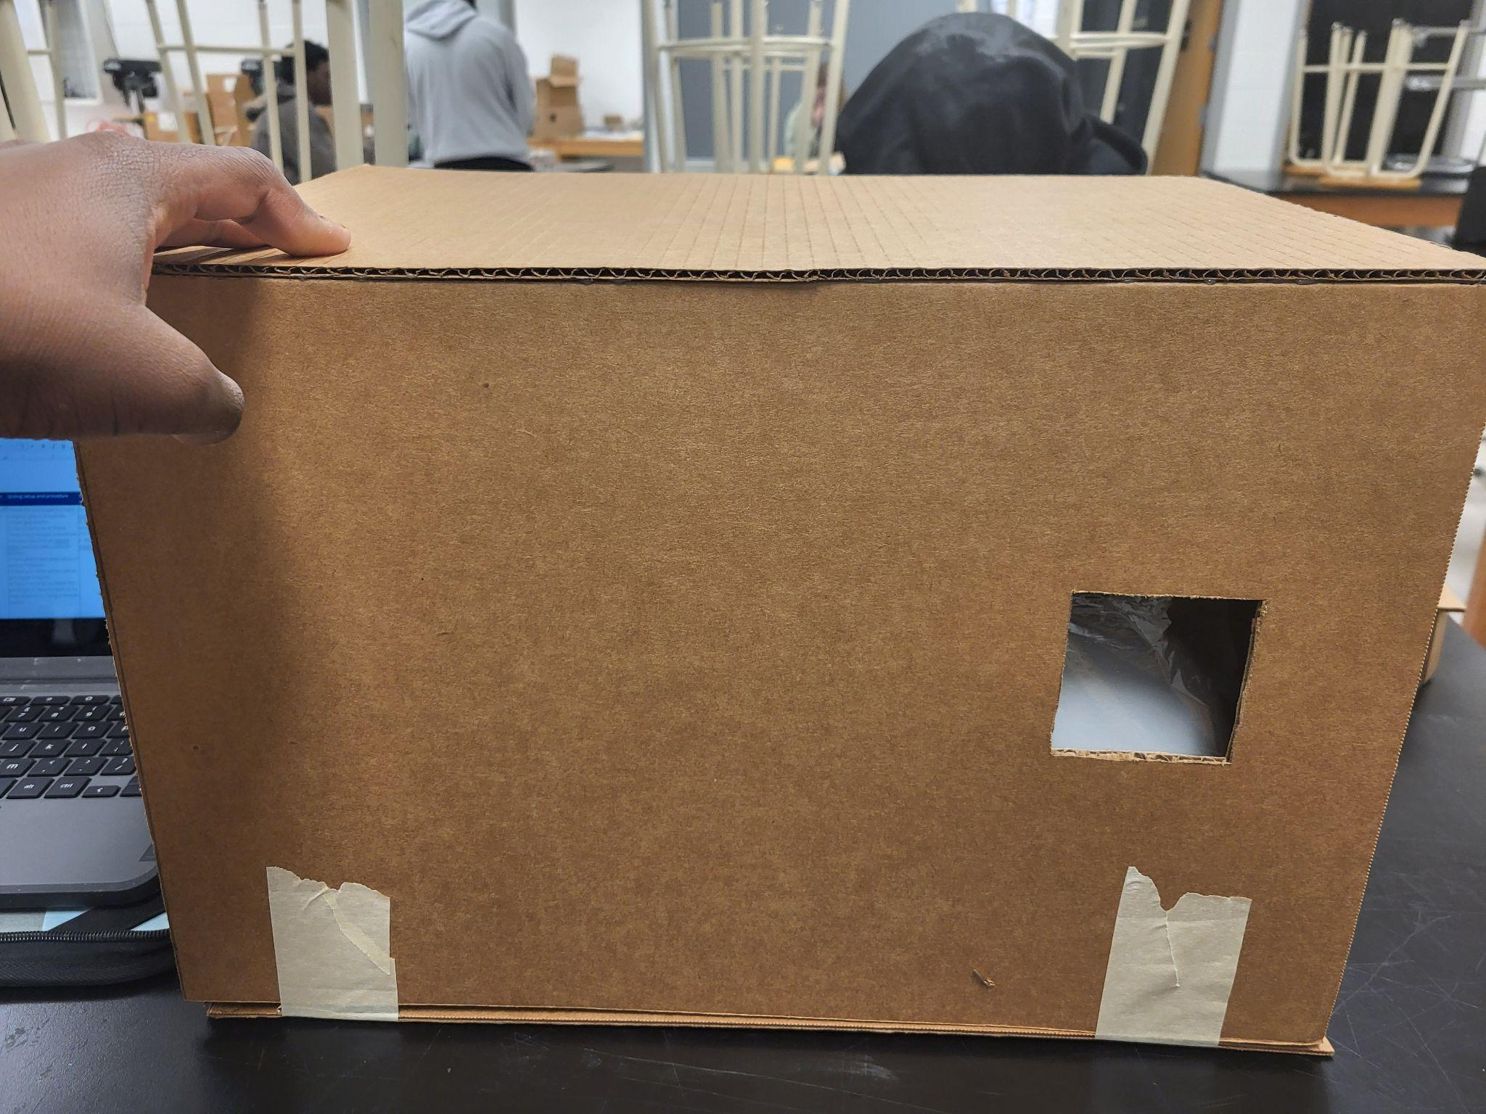
Details
Incorrect measurements in the design our project caused improper and a defective design and a flaw in the design and over structure
Analysis
The inadequate smoke control systems and lack of effective smoke barriers led to dangerous conditions where evacuation was not feasible due to smoke-filled escape routes.

Prior Design Attempt #3 - <insert name of prior design attempt #3>
Source
State the source of the information about this prior design attempt, which should be taken from any of the following credible source categories: peer-reviewed journals (check out your public library for free digital access to journals; here are some free online journals and research databases), professional organizations, government agencies, local and national newspapers, patents (here is a patent search site for the United States Patent and Trademark Office), and reputable vendors and manufacturers. Make sure to incorporate in-text citations in the details section below (i.e. don't just give a list at the end of the element or footnote).
Image
Include at least one image of this prior design attempt. Make sure to cite all images.
Details
Fire spread through these unsealed or inadequately protected compartments, leading to larger-than-expected fire zones and increased damage.
Analysis
goal of fire protection engineering is preventing the spread of fire through fire-resistive barriers or compartments. Early designs often overlooked the importance of integrating fire-rated doors, walls, and floors, or failed to account for penetrations

Prior Design Attempt #4 - <insert name of prior design attempt #4>
Source
State the source of the information about this prior design attempt, which should be taken from any of the following credible source categories: peer-reviewed journals (check out your public library for free digital access to journals; here are some free online journals and research databases), professional organizations, government agencies, local and national newspapers, patents (here is a patent search site for the United States Patent and Trademark Office), and reputable vendors and manufacturers. Make sure to incorporate in-text citations in the details section below (i.e. don't just give a list at the end of the element or footnote).
Image
Include at least one image of this prior design attempt. Make sure to cite all images.
Details
Testable project and being able to check the design regularly without affecting the structure of the design
Analysis
Fire protection systems require regular maintenance and testing to ensure they are functional in case of an emergency. Many earlier designs lacked effective protocols for the ongoing maintenance of these designs.
Rubric
Element B: Documentation and Analysis of Prior Design Attempts
B1. Documentation of plausible prior attempts to solve the problem and/or related problems is drawn from __________. |  | score = 5 | score = 4 | score = 3 | score = 2 | score = 1 | score = 0
 |  | a wide array of clearly-identified and consistently-credible sources | a variety of clearly-identified and consistently-credible sources | several—but not necessarily varied—clearly-identified and generally-credible sources | a limited number of sources, some of which may not be clearly identified and/or credible | only one or two sources that may not be clearly identified and/or credible | missing or minimal (a single source that is not clearly identified and/or credible)
B2. The analysis of past and current attempts to solve the problem — including both strengths and shortcomings — __________. |  | score = 5 | score = 4 | score = 3 | score = 2 | score = 1 | score = 0
 |  | is consistently clear, detailed, and supported by relevant data | is clear, generally detailed, and supported by relevant data | is generally clear and contains some detail and relevant supporting data | is overly general and contains little detail and/or relevant supporting data | is vague and is missing any relevant details and/or relevant supporting data | cannot be inferred from information intended as analysis of past and/or current attempts to solve the problem

