MyDesign Portfolio

Element B: Documentation and Analysis of Prior Design Attempts

Prior Design Attempt #1 - Road Salt
Source
Pollock, Julie. “Salt Doesn’t Melt Ice: Here’s How It Actually Makes Winter Streets Safe.” Urnow, 1 Feb. 2021, urnow.richmond.edu/features/articleImage. 19 Feb. 2025.
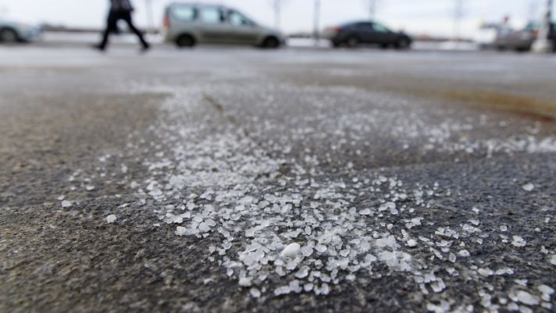
The freezing point of pure wateris 32 degrees Fahrenheit. So if there’s snow, sleet or freezing rain and the ground is 32 F or colder, solid ice will form on streets and sidewalks. If the water is mixed with salt, though, the freezing temperature of the solution is lower than 32 F. The salt restrains the ability of the water molecules to form solid ice crystals. The degree of freezing point depression depends on how salty the solution is.
When the salt runs off, it negatively impacts plants, wildlife, and wetlands. It also destroys roads by creating potholes or ripping up concrete. However, it does effectively remove ice which allows people to drive on roads without the risk of sliding on the ice.

Prior Design Attempt #2 - Sand
Services, ACS Advanced Construction. “How to Melt Ice without Concrete Damage: A Guide.” Advanced Construction Services, 15 Dec. 2021, advancedconstructionmn.com. 3 Feb. 2025.
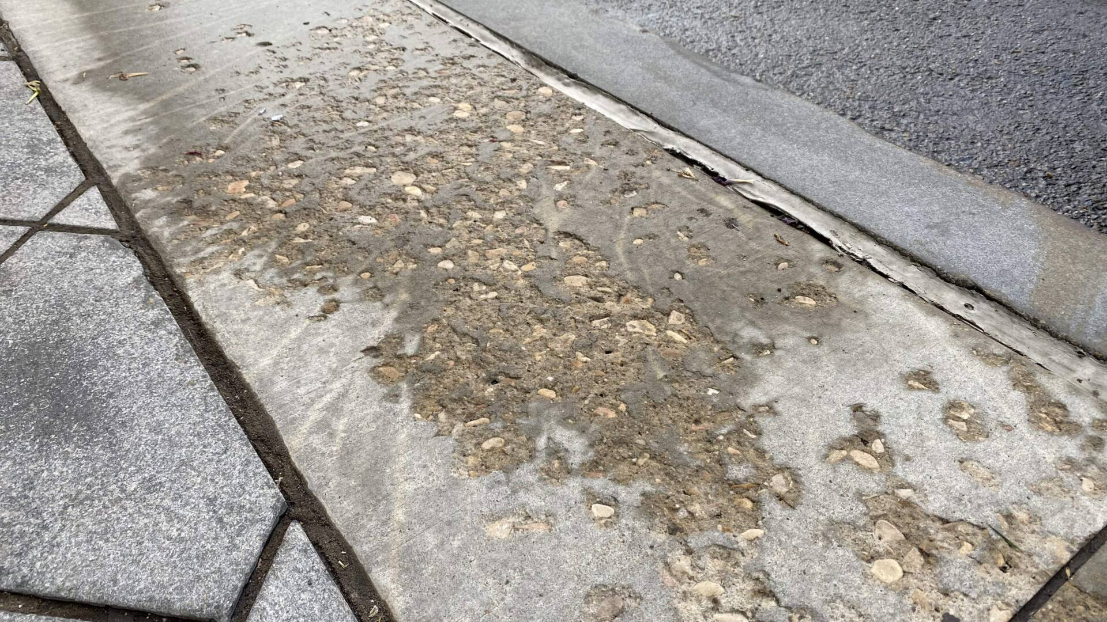

Sand is not frequently used in melting ice on the roads, but it can be effective and it will not damage the concrete when melting the ice. Sprinkle the surface with sand to add plenty of traction as you walk across the ice. The sand will absorb heat much quicker than other materials, too, helping to speed up the melting of the ice naturally.
The sand is good at removing ice, but it can degrade the concrete similarly to salt. It also does not prevent ice from forming it, just melts the ice when it has formed.

Prior Design Attempt #3 - Sealing Concrete
Gregory, Brian. “How to Seal Concrete.” Lowes.com, Lowe’s, 2024, www.lowes.com/n/how-to/howto-seal-concrete. Accessed 5 Feb. 2025.

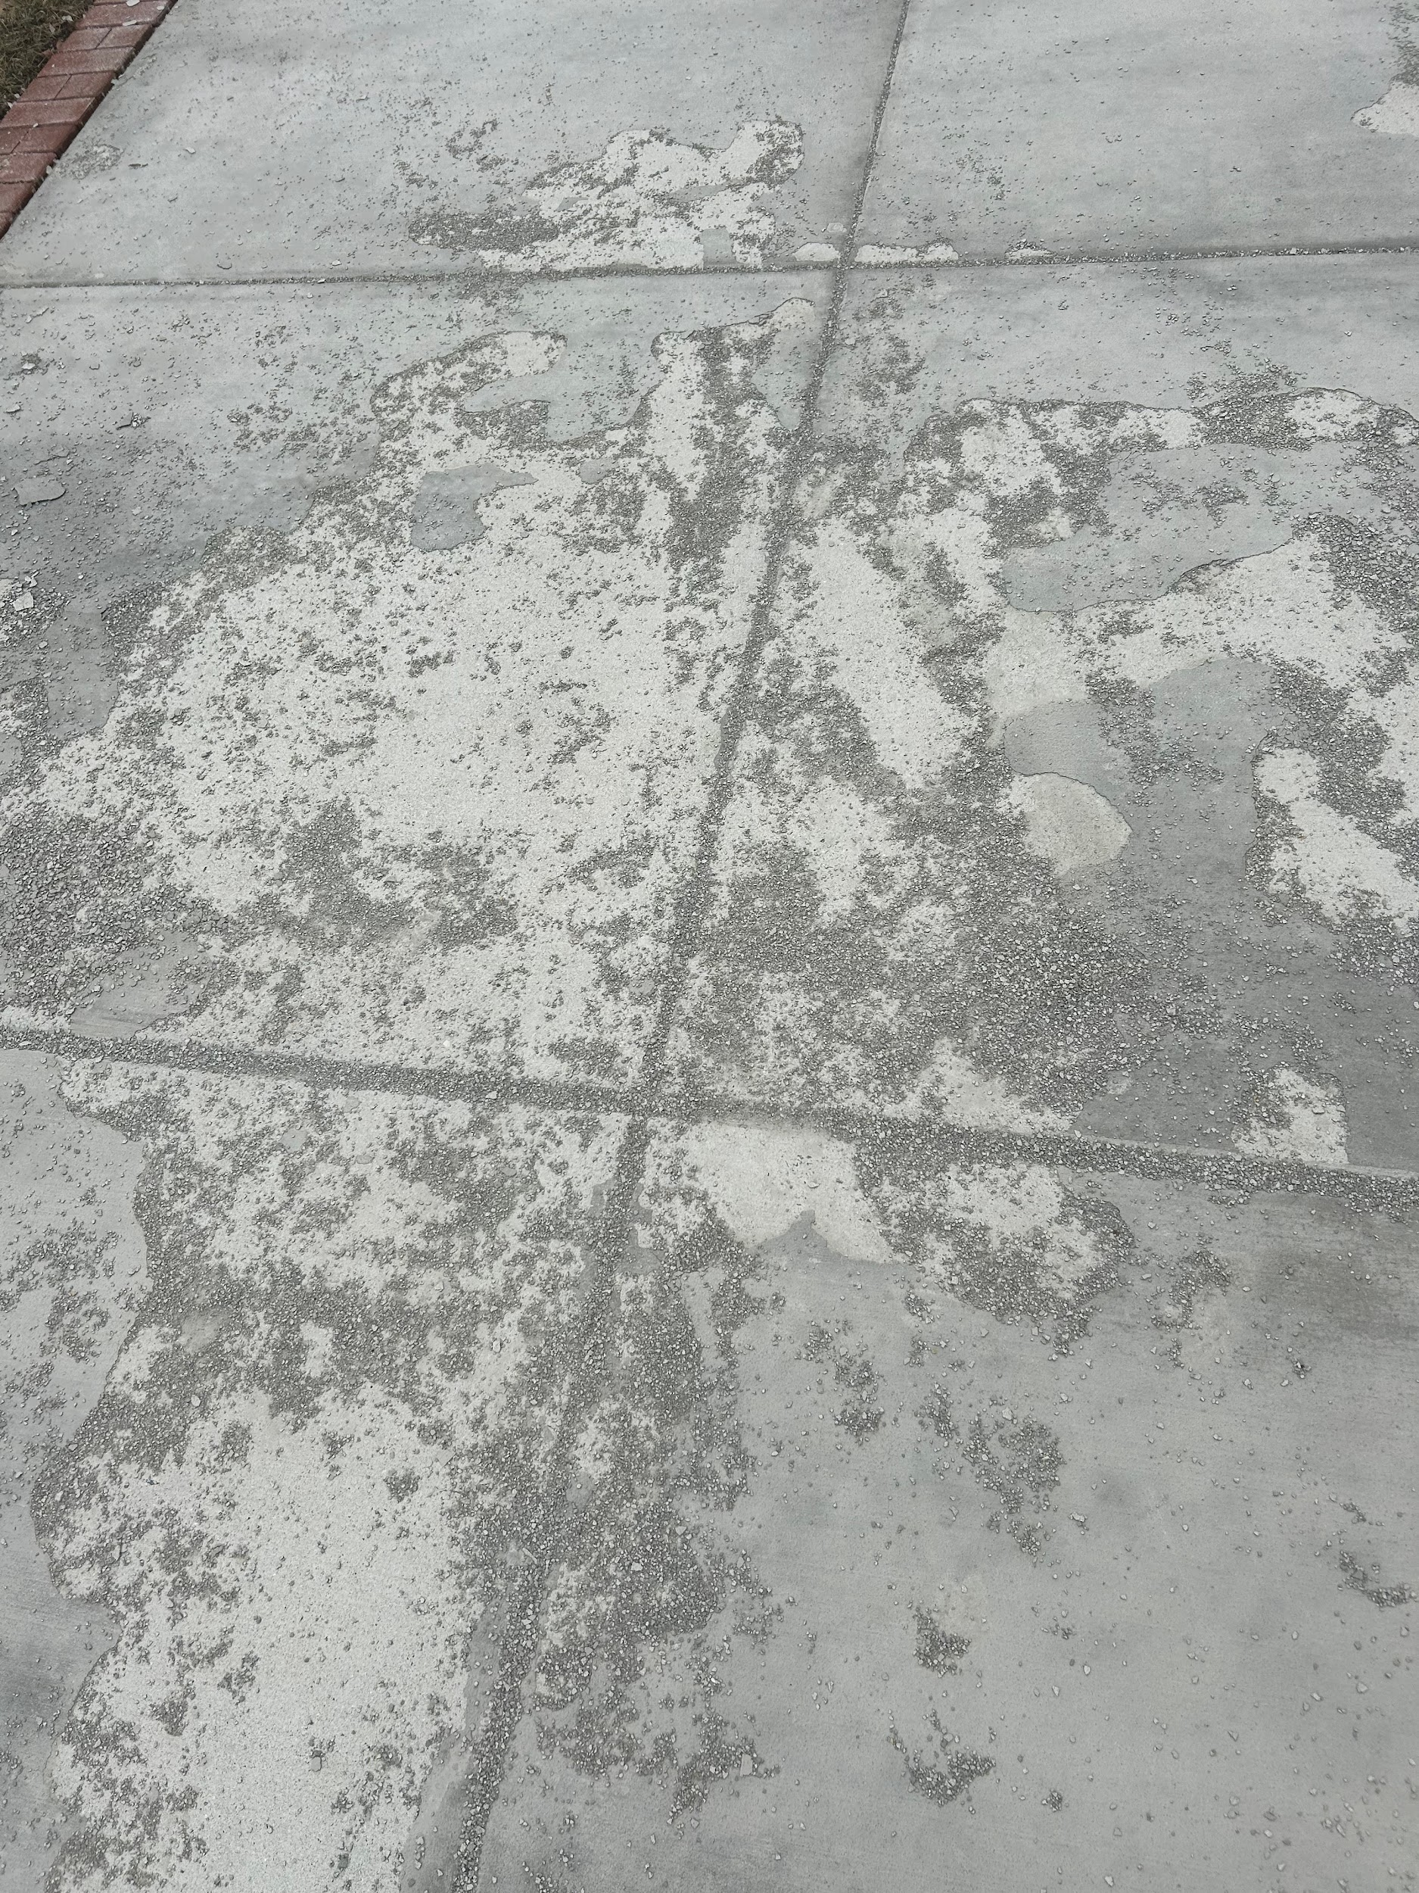
After a recent snowstorm, the concrete did not come home at all. It’s cracks everywhere, pieces of concrete everywhere, it's a mess. But this shouldn't have happened. The sealer protects concrete from the elements and makes it easier to clean off deicing salts, oil, or grease. The sealer is like skin to a human, a protective barrier that gives longevity to the concrete.
Concrete sealers are applied to concrete to protect it from surface damage, corrosion, and staining. They either block the pores in the concrete to reduce the absorption of water and salts or form an impermeable layer that prevents such materials from passing through.

Prior Design Attempt #4 - Vinegar
Inc, Warmup. “7 Ways to Melt Ice without Salt or Ice Melt.” Warmup, 27 Sept. 2024, www.warmup.com/blog/what-melts-ice-besides-salt. 7 Feb. 2025.
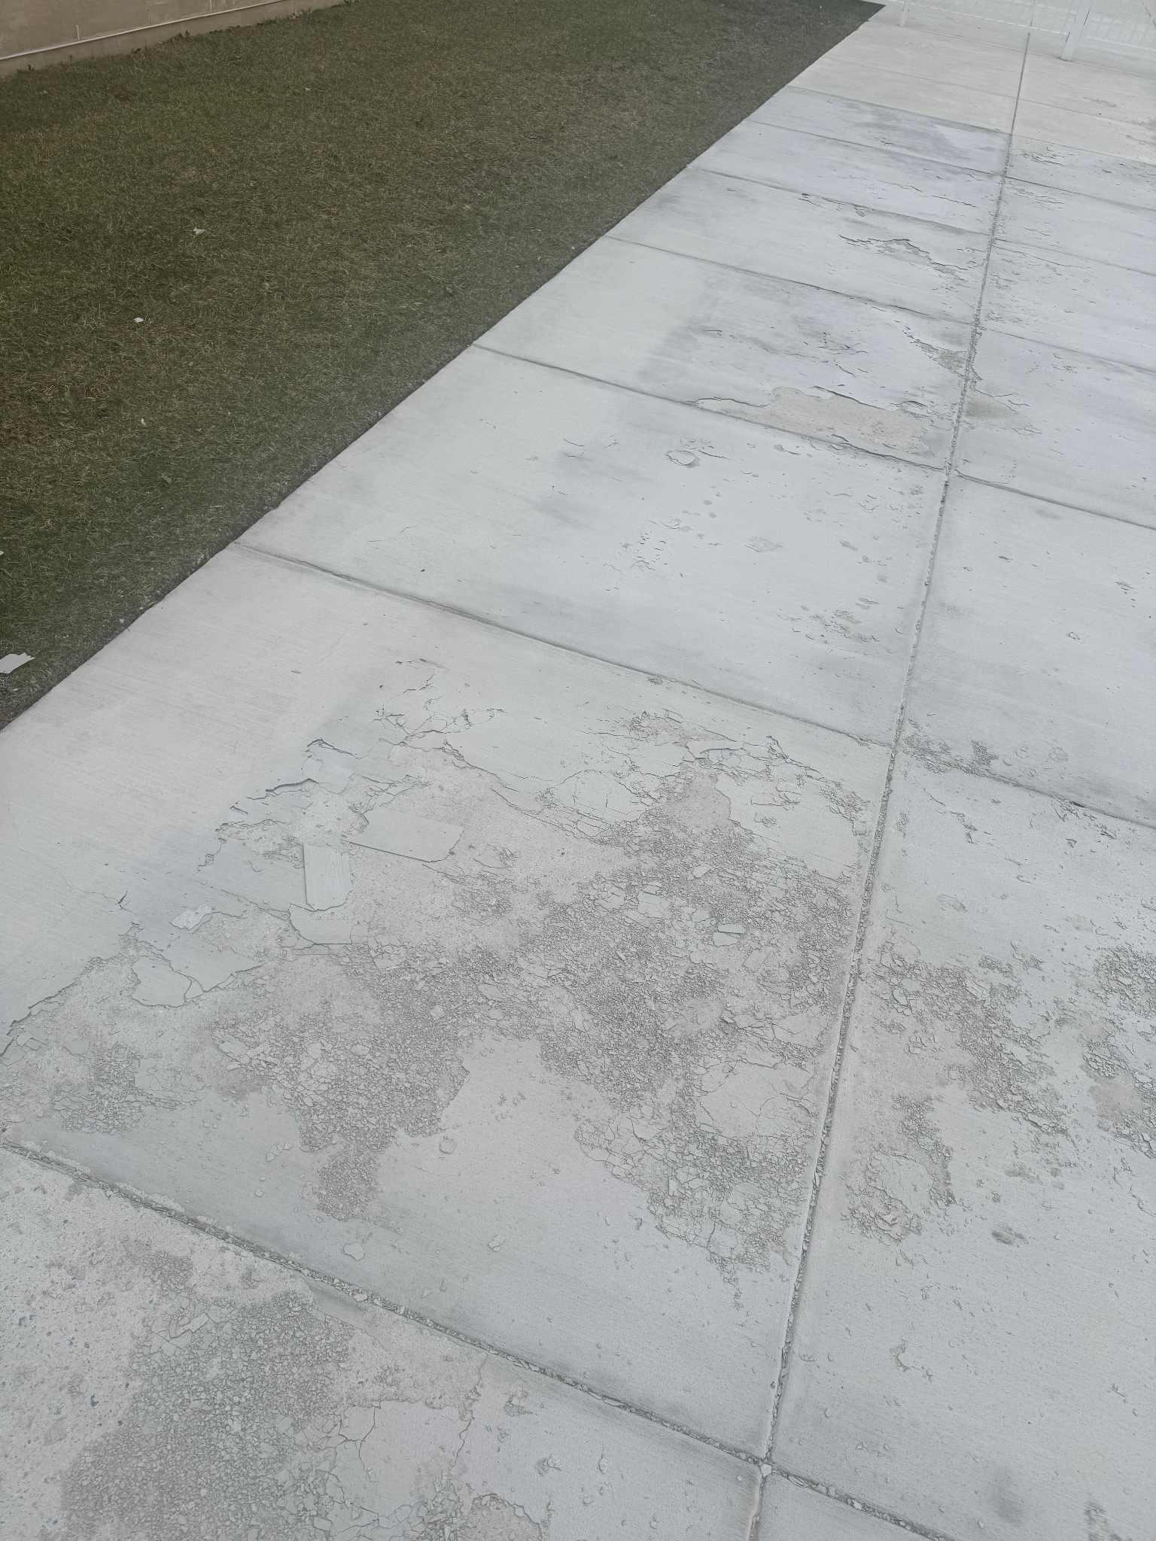

Vinegar has acetic acid, a chemical compound that lowers ice’s melting point. While it isn’t as effective as rock salt, it can still make a difference.
Although it's not as effective as traditional deicers like salt, the acetic acid in vinegar lowers the freezing point of water, allowing it to melt ice, but it works more slowly and may require a mixture with hot water for better results.

Prior Design Attempt #5 - Concrete Coating
Source
Webfoot. “Learn about How to Stop Salt Damage to Concrete with Webfoot.” Learn About How to Stop Salt Damage to Concrete, 18 Dec. 2022, www.webfoothome.com. 3 Feb. 2025.
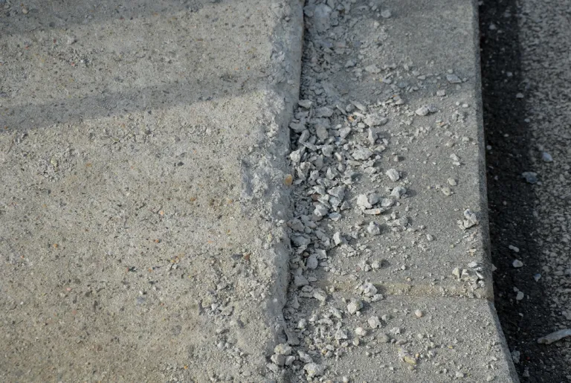

A good concrete coating, over top of a sealant, chemically bonds to the concrete, sealing it and protecting it from the effects of road salt carried to the floor. Our expertly formulated polyurea coatings penetrate and seal the pores of your concrete, preventing moisture from accumulating inside.
The concrete coating’s chemical bond seals and protects the concrete from the effects the salt has on it. It works well, but it still does damage some parts of the concrete which the picture above shows.

