https://www.walmart.com/ip/Child-Roller-Blind-Safe-Hook-Fixed-Clip-For-Vertical-Roman-Blind-Blind-Chain-Rope-Rope-Holder-Curtain-Accessories-T0P0/1031709019
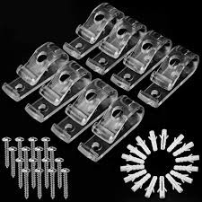
This design is not as good because it is very inconvenient if you have to screw it into the wall because it will leave holes in the wall, and if you wanna take it out it will leave a ugly mark. Our design is better because when you want to take it out it won't leave any marks. Another reason is because you don't need tools to assemble ours or to take it out. Although for the other one you need a screwdriver to take it out and too put it in. The last reason is overall convenience. Our design is a lot more convenient.
https://www.amazon.com/Delta-Blinds-Supply-Valance-Window/dp/B00H9FQB0W/ref=sr_1_12_sspa?keywords=blind+holders&qid=1707748792&sr=8-12-spons&sp_csd=d2lkZ2V0TmFtZT1zcF9tdGY&psc=1
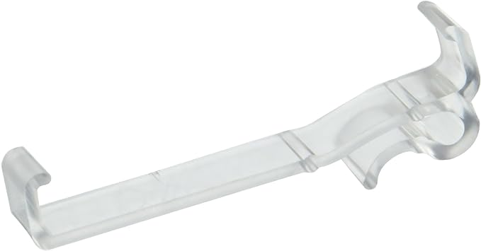
This design is not as good as our design because it just Clips the blinds together and it cannot be attached onto the wall. since it cannot be attached to the wall it is not stabilized. The blinds will still move around and make noise so it is practically useless and would not solve the problem.

