MyDesign Portfolio
Element B Initial Template
How to use this template
Teachers: You may customize this document before providing it to students.
Students: The template below is one way to structure your research findings around past and current attempts to solve the problem, but the specific assignment given by your instructor may require a different structure or dictate different details. If you make a copy of this template to edit for your own research into prior design attempts, be sure to delete the instructions.
Element B: Documentation and Analysis of Prior Design Attempts
Prior Design Attempt #1 - Snare Drum Stand
Source
https://www.guitarcenter.com/Sound-Percussion-Labs/Velocity-Series-Snare-Drum-Stand-1500000329799.gc
Image
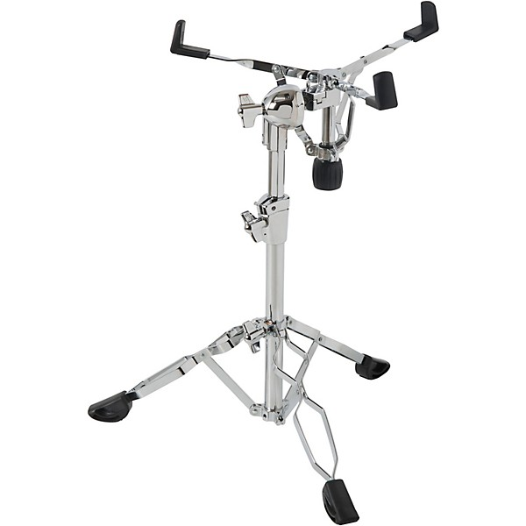
Details
Rubber feet at base and rubber grips on top, adjustable tilt and height
Analysis
The stand’s height and tilt are adjustable, rubber feet so it doesn’t slip, it has space under the drum for clean sound. This type of design wouldn’t work for a conga drum.
Prior Design Attempt #2 - Double Conga Stand
Source
https://www.gear4music.com/us/en/Drums-and-Percussion/Toca-Synergy-DLX-10-and-11-Conga-Set-w--Stand-Natural/3RCK
Image
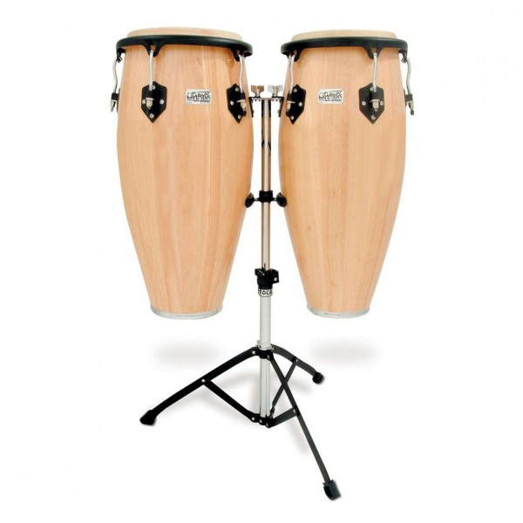
Details
Adjustable height, rubber feet at base, easy to set up
Analysis
We like that the height is adjustable, has rubber feet so it won’t slip, the stand keeps the drum off the ground, and is easy to set up. The design is good but we are designing a stand for one conga drum
Prior Design Attempt #3 - Single Conga Stand
Source
https://www.gear4music.com/us/en/Drums-and-Percussion/Meinl-Headliner-Traditional-10-Conga-with-stand-Super-Natural/1PP2
Image

Details
The stand has adjustable height, rubber feet and rubber grips, easy to set up and move
Analysis
The height is adjustable, has rubber grips so the drum won’t move around, the stand keeps the drum off the ground, and looks easy to set up and move. This design meets all of our design requirements except adjustable tilt.

