MyDesign Portfolio
Element J Initial Template

How to use this template
Students: If you make a copy of this template to edit for your record of expert evaluation, be sure to delete the instructions.
To earn a 5 on this element, you will need to collect project evaluations from 3 or more stakeholders and 3 or more demonstrably qualified field experts. Project evaluation includes providing feedback on the prototype, reviewing the testing results, providing feedback on the analysis of the testing results, and providing recommendations for improvement. Project evaluation should address 2 or more aspects of your design or engineering design process. Duplicate the evaluator template as needed if you have more evaluators than are listed in the template below.

Element J: Documentation of Evaluation

Stakeholder Evaluation #1
- Name of evaluator: Chirstina Ward
- Justification for how this evaluator is a stakeholder: 25 years of teaching
- Documentation of the project evaluation, which could include copies of emails, transcripts of conversations, filled-out feedback forms, etc.
- 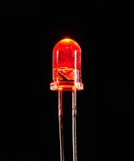
She said that the lights were not connected to the wires and codes through computer

Field Expert Evaluation #1
- Name of evaluator: Jennifer Beaton
- Justification for how this evaluator is a Fire Protection Engineer(professionals who spend at least a portion of their time working in a field directly related to your project):

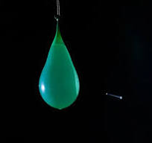
Suggested that I should put sand into the water balloon.

Synthesis of the Project External Evaluation
Summarize all of the evaluators' comments in a way that highlights meaningful trends with specifics mentioned. Answer the questions, "What does the external evaluation mean?" and "What are you taking away from the external evaluation?".
Our only Field expert, Jennifer Beaton, who is a fire protection engineer, evaluated our project and said it was a no-show stating that the fire detection system she stated had a lot of flaws since the light could connect the coding for the light but the suppression system was a little bit decent saying it works but for more effect should use sand instead of water

