MyDesign Portfolio
Element J Initial Template

How to use this template
Students: If you make a copy of this template to edit for your own record of expert evaluation, be sure to delete the instructions.
In order to earn a 5 on this element, you will need to collect project evaluation from 3 or more stakeholders and 3 or more demonstrably-qualified field experts. Project evaluation includes providing feedback on the prototype, reviewing the testing results, providing feedback on the analysis of the testing results, and providing recommendations for improvement. Project evaluation should address 2 or more aspects of your design or engineering design process. Duplicate the evaluator template as needed if you have more evaluators than are listed in the template below.

Element J: Documentation of Evaluation

Stakeholder Evaluation #1
- Name of evaluator: Dr. Barnhart
- Justification for how this evaluator is a stakeholder: The president of the school foresees every change or construction being done to the school, is the one paying for it, or is finding sponsors to pay for it.
- Documentation of the project evaluation, which could include copies of emails, transcripts of conversations, filled out feedback forms, etc.

Stakeholder Evaluation #2
- Name of evaluator: Mrs. Carter
- Justification for how this evaluator is a stakeholder: The principal of the school, who works with Barnhart, also has a little say in what should be done in the school to make it better. To get to Barnhart, you have to go through her.
- Documentation of the project evaluation, which could include copies of emails, transcripts of conversations, filled out feedback forms, etc.

Field Expert Evaluation #1
- Name of evaluator: Mr. Butler
- Justification for how this evaluator is a demonstrably-qualified field expert (professionals who spend at least a portion of their time working in a field directly related to your project): He is a retired engineer and knows what he's doing. Also, he could be a big help in what we are trying to do to ensure the concrete lasts long and looks good.
- Documentation of the project evaluation, which could include copies of emails, transcripts of conversations, filled-out feedback forms, etc.
- From our conversation 5/2/2025:
  - Budget Approvals
  - County Approvals (site plan and has to be approval by the department)
  - Gonna need an approval for a timeline (how long its gonna take)
  - Building permit, Construction permit
  - Have to come up with a site plan
    - What's the detour plan when the walkway is shut down
    - Emergencies
      - Fire, etc
  - Weather delays
    - Lighting, raining, snowing.

Field Expert Evaluation #2
- Name of evaluator: Samuel Nachor
- Justification for how this evaluator is a demonstrably-qualified field expert (professionals who spend at least a portion of their time working in a field directly related to your project): He has worked as a construction designer for 14 years.
- Documentation of the project evaluation, which could include copies of emails, transcripts of conversations, filled out feedback forms, etc.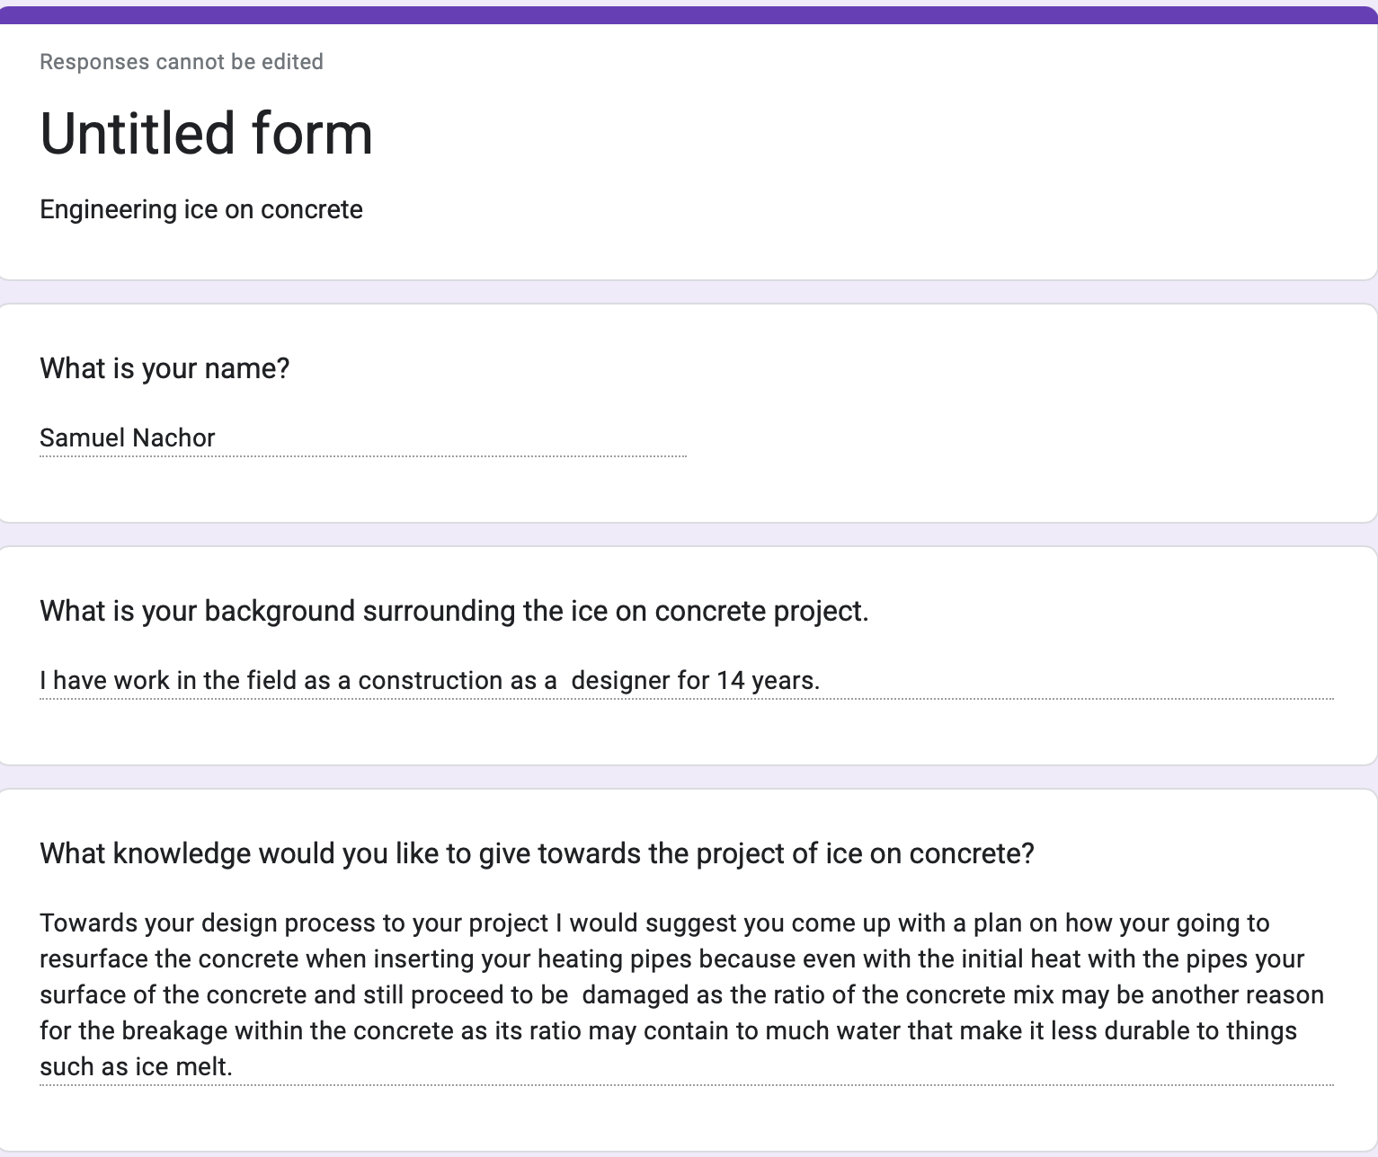

Field Expert Evaluation #3
- Name of evaluator: Mr. Ceferatti
- Justification for how this evaluator is a demonstrably-qualified field expert (professionals who spend at least a portion of their time working in a field directly related to your project): HE is the head of all facilities, makes sure that any work being done to the school is being done correctly.
- From our conversation:
  - He said the Idea was a great idea but very expensive.
    - Would have to out pipes and use the heated water from the boiler room to get it to the correct temperature which is about 45 degrees.
  - Wasn't the ice or salt that damaged it? It was the poor material.
    - Wasn't properly mixed
    - Workers half did their job
    - Some concrete was done correctly some wasnt
    - Salt contains a lot of calcium and would cause the concrete to lose some color,
    - “SPELL”

Synthesis of the Project External Evaluation
The external elevation means we are given significant knowledge as we are gathering input from other individuals that provide their intel to give us a better understanding to apply to our design/project. From this external evaluation I we are taking away that we need to do some more planning on how we will withstand the weather related to our project and what methods are we going to pursue to make sure this doesn’t happen to the concrete any further down the line by using a new mix ratio reassure it is durable and sustainable.

