Element J
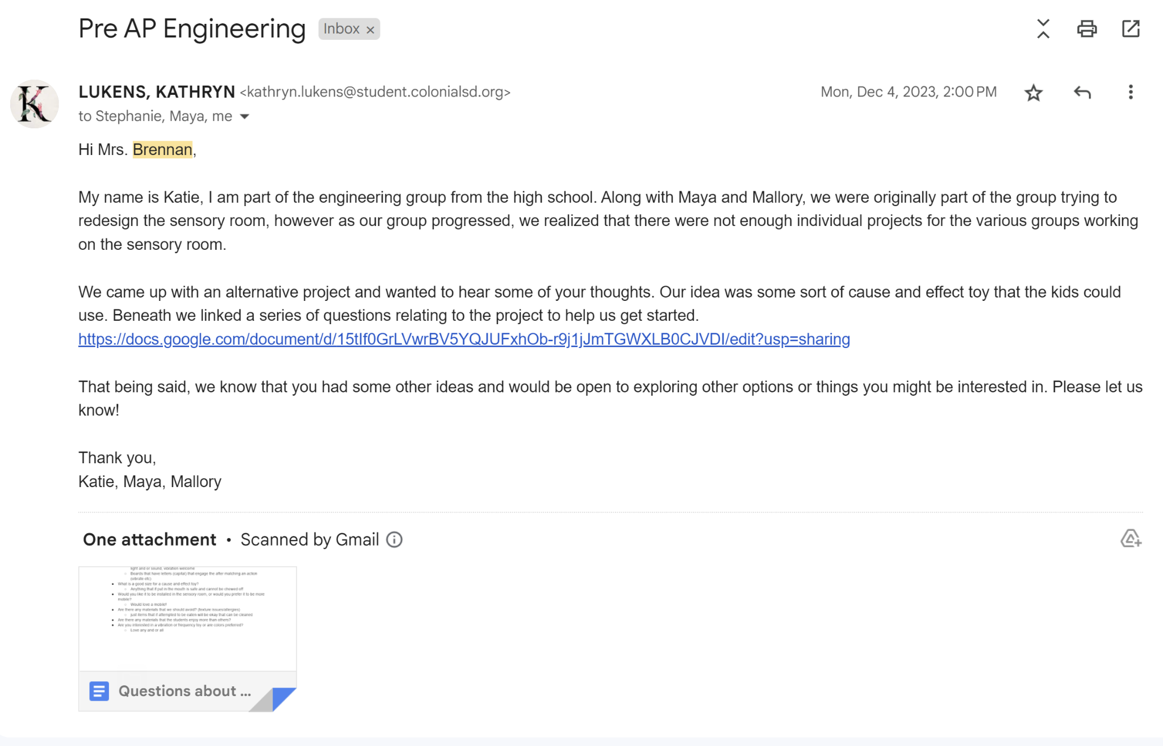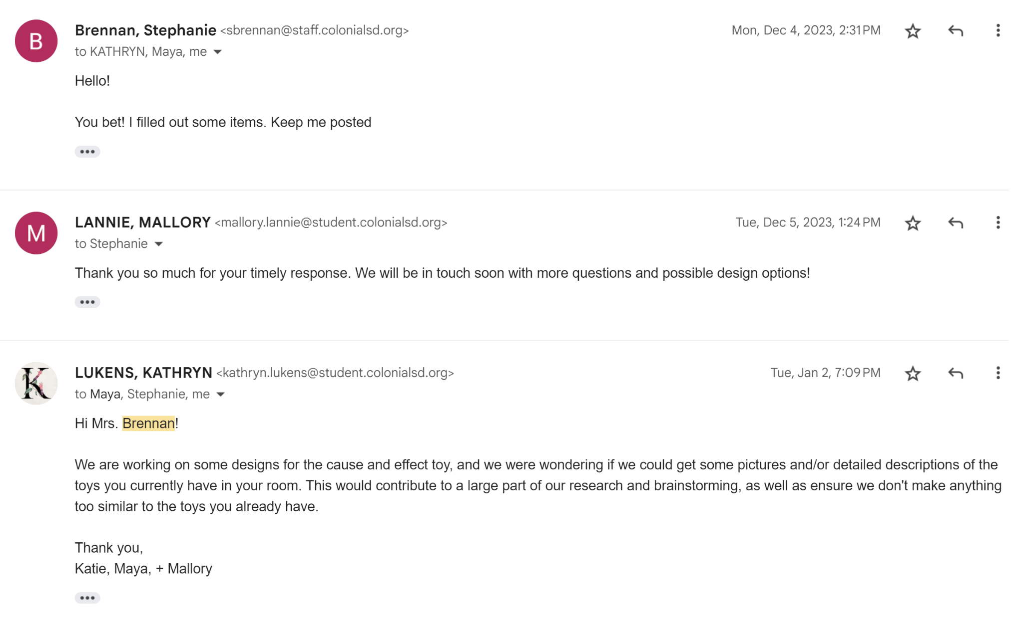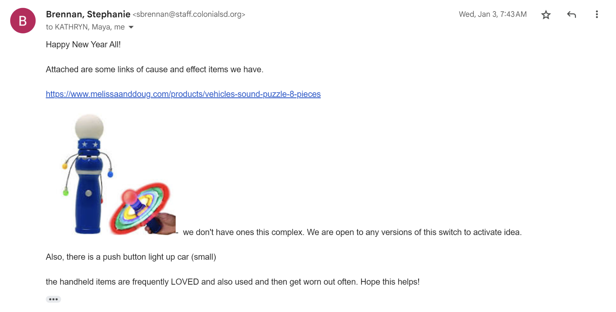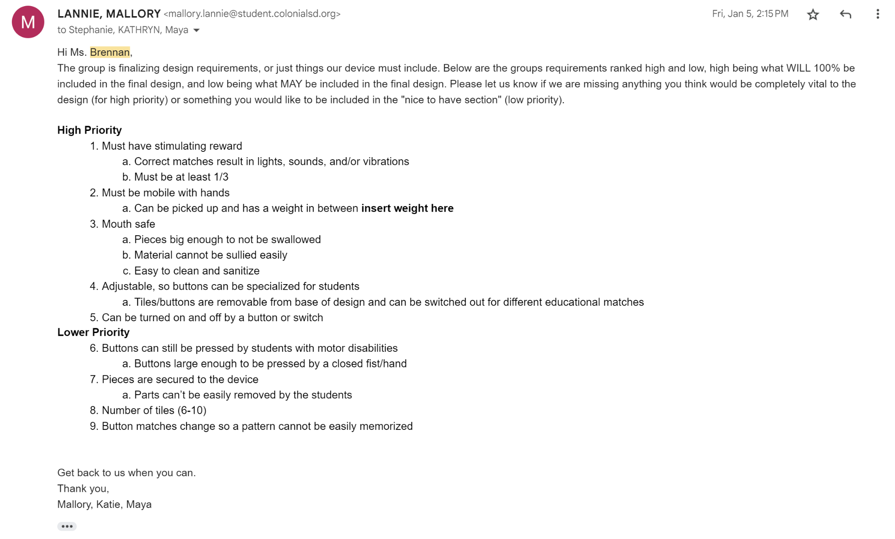
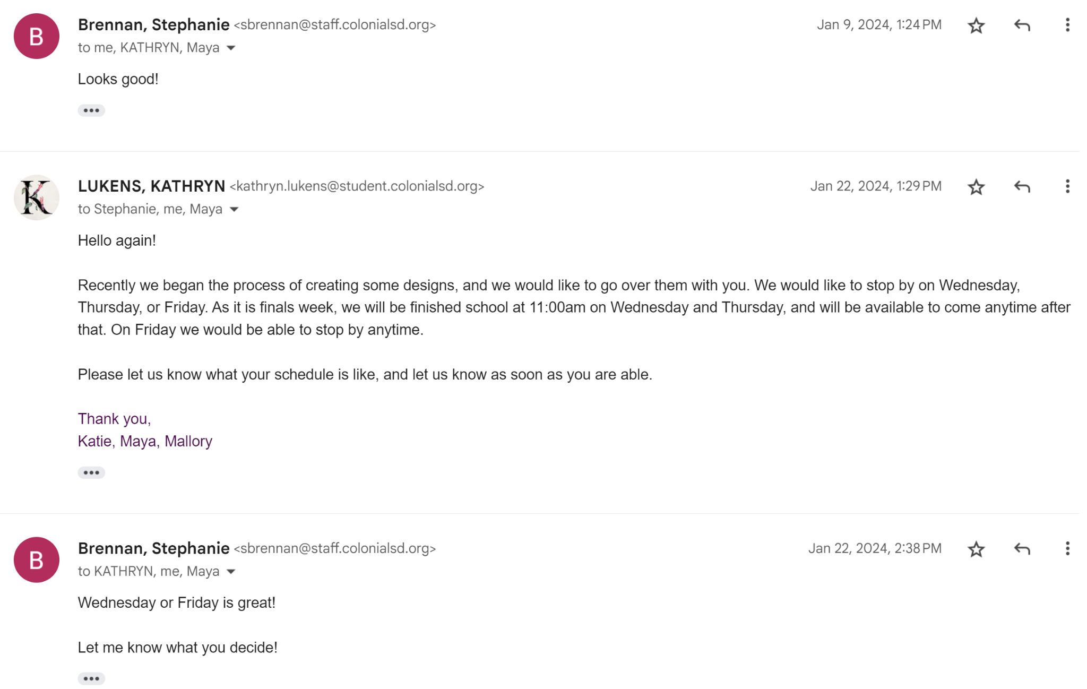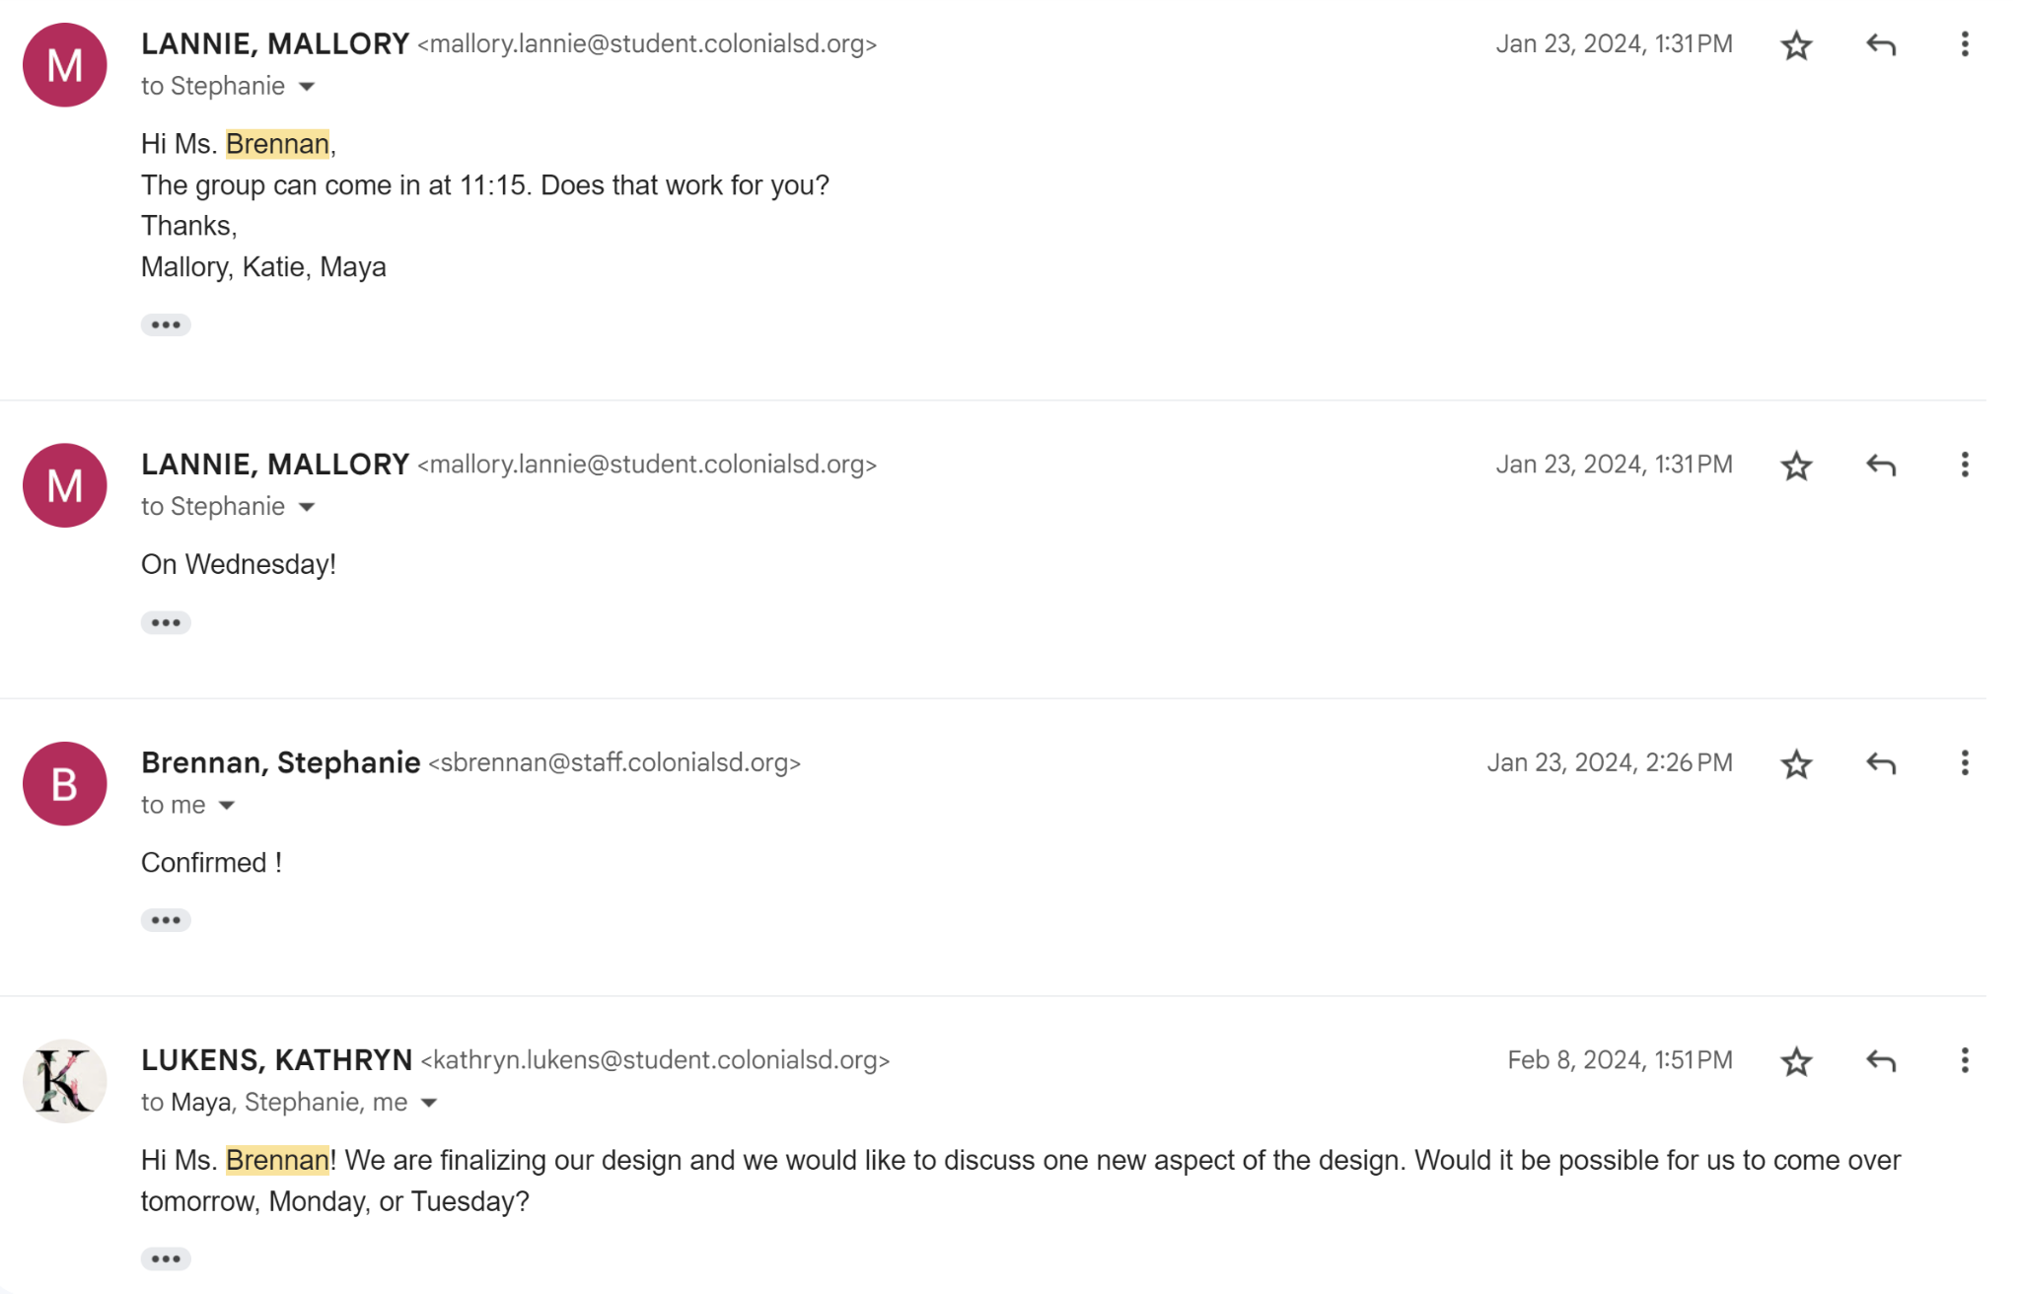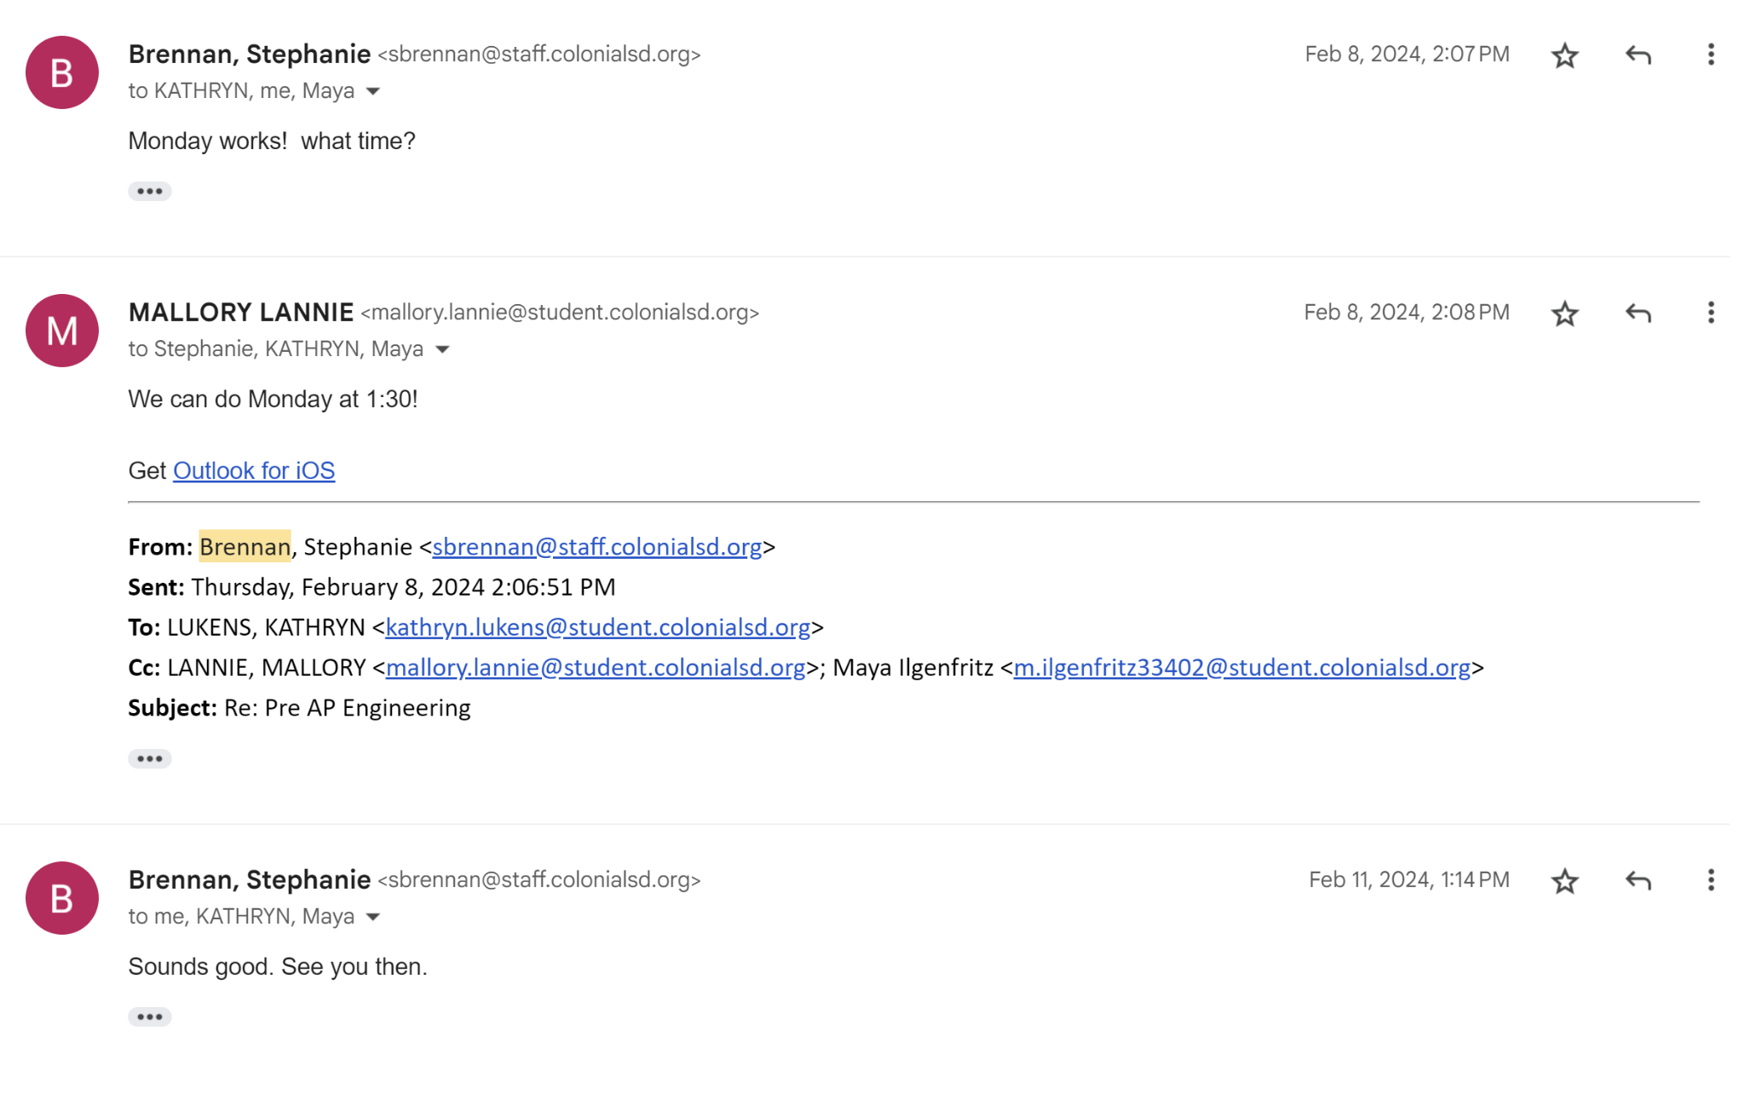
The final product of our design group was satisfactory, it completed the necessary function that was adjustable to the needs of the students and the classroom as a whole. A cause and effect sensory device for children with disabilities for learning will be incredibly beneficial for their development. By providing a tangible cause and effect relationship, it helps them understand how their actions lead to specific outcomes, fostering cognitive and sensory skills. Our device has 2 working sides for different levels of learning and mobility. A worry our group had was that our final design lacked color. To ensure that the colors were visible when the reward was granted, the group left the plexiglass clear, meaning there was only color on the device when the reward was triggered. The other worry our group had with the final outcome was the singular sensory element. The only sensory element included in the final prototype was light/color. Other devices often incorporate various sensory stimuli, such as lights, sounds, textures, and vibrations, catering to different learning styles and abilities. The more sensory devices included often correlates to more engagement and interaction.
After discussing with the stakeholders they decided that the lack of color on the device is not necessarily a major downside. The lack of color may make it difficult to grasp the initial attention span of the students but when the reward is granted it gives an even greater stimulation because of the harsh contrast from the exterior to the lights. This severe difference makes the reward stick evenmore hopefully further enhancing the learning experience even further. The other worry was the lack of multifaceted sensory triggers, but after discussing with the teachers, they assured us that it would not negatively hinder the usability of the device. While having some texture or sound would enhance the experience further, our device is still sufficient without it and is even preferred in specific situations with specific students. Overall, our cause and effect sensory device will play a strong supporting role in the educational journey of children of the students in the classroom.

