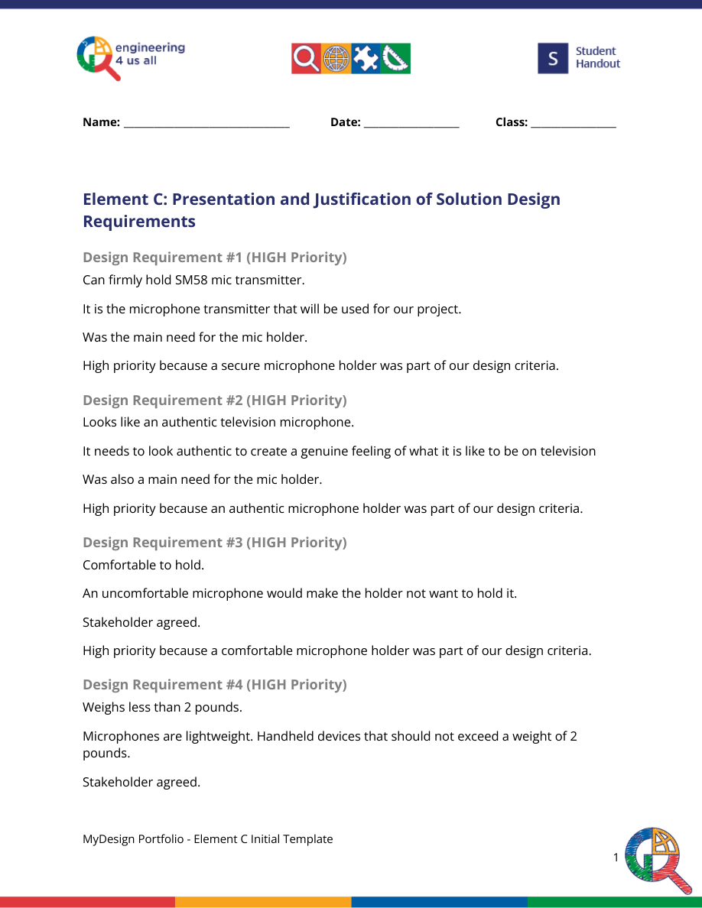
High priority because a lightweight microphone holder was part of our design criteria.
Design Requirement #5 (HIGH Priority)
Less than 3x3x15 inches in volume
The microphone would look disproportional and awkward if it was too big.
Stakeholder agreed.
High priority because a smaller microphone holder was part of our design criteria.
Design Requirement #6 (LOW Priority)
Able to have a mic flag fit over it.
Mic holders need mic flags to look authentic and to promote brand.
Stakeholder and mic flag designing team agreed.
Low priority because mic flags are important, but they are not part of our design criteria.
Design Requirement #7 (LOW Priority)
Durable material.
Not malleable enough to have noticeable dents if damaged, while not firm enough to crack
at extreme temperatures.
Stakeholder agreed.
Low priority because more designs can easily be 3D Printed, and it is the only material we
have access to anyway.
MyDesign Portfolio

