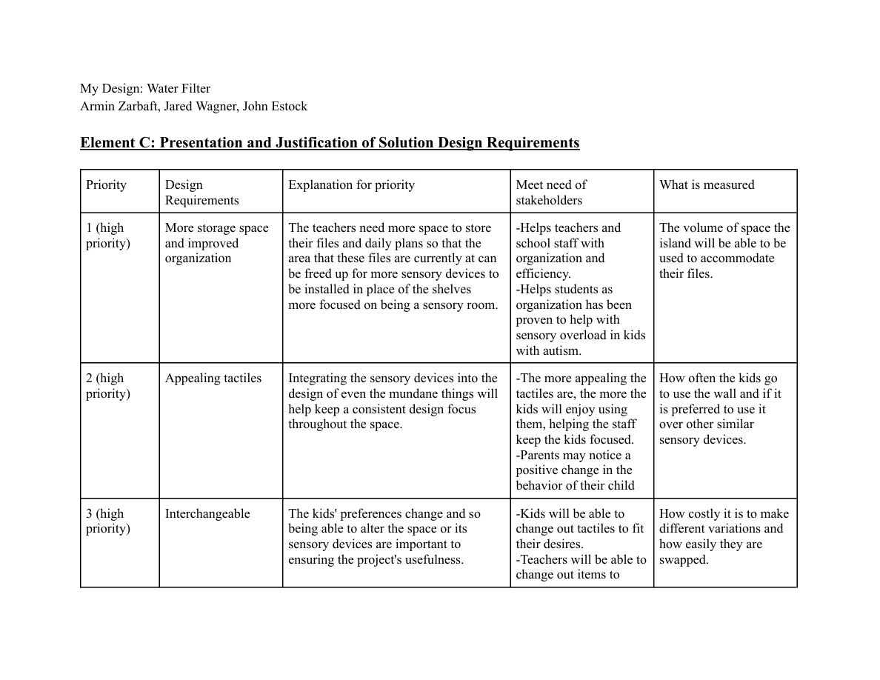
Priorities:
1. More storage space and improved organization (high priority)
2. Appealing tactiles (high priority)
3. Interchangeable (high priority)
4. Accessibility (high priority)
5. Cost (high priority)
6. Durability (low priority)
7. Uniform design (low priority)
Stakeholder Validation:
After talking with Ms. Brennan, we were given validation for our priorities under the condition that we don’t start something
we can’t finish. To do this, we need to make sure we have an in-depth timeline that our stakeholders are aware of and in agreement
with. Because the space is accessed multiple times a day, it is crucial that we carefully consider a manufacturing plan. Part of this is
consideration of completing the project in phases, and keeping the main goal of organizing in mind. This may mean saving tactile
additions for another project.

