MyDesign Portfolio
Element G

Element G: Construction of a Testable Prototype

Final Prototype Iteration Explanation (G1)
Prototype #1 Construction of Design #1
Date: 4/4/2025
CAD Model of Prototype #1
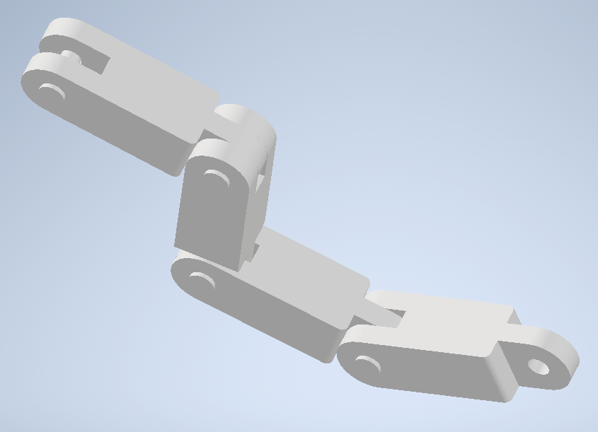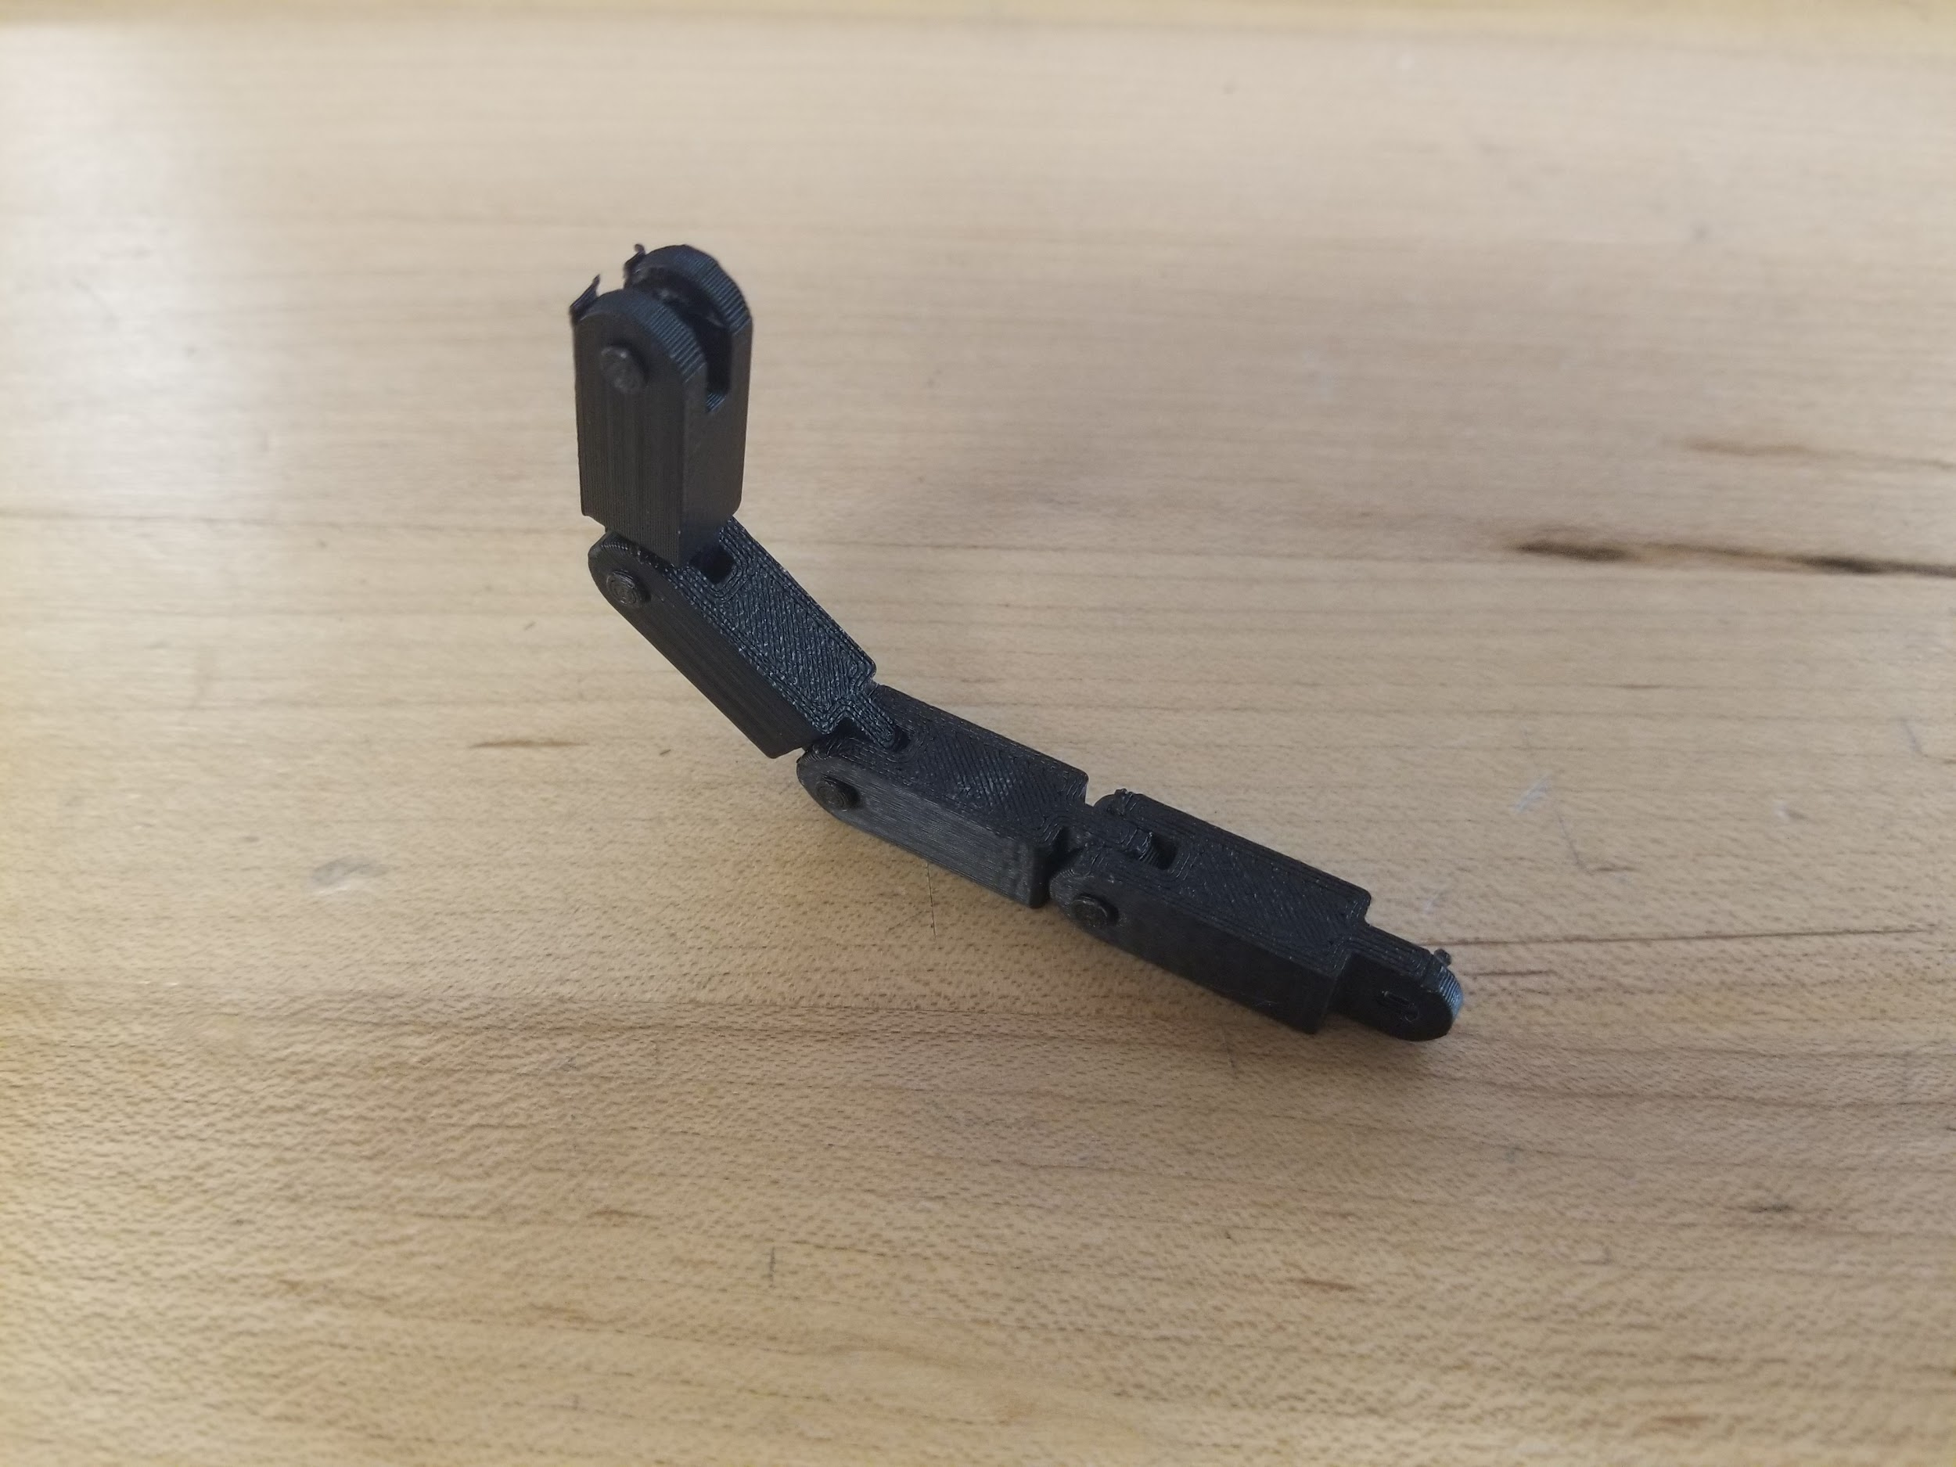
Printed Prototype #1

Steps of construction:
 | Details | Tools and Manufacturing Methods used
Step 1 | Modeling in CAD | Autodesk Inventor
Step 2 | Slicing/printing on 3D-printing software | OrcaSlicer
Step 3 | Gathering all of the parts | N/A
Step 4 | Assembling, using some glue | Glue

Notes of the progression from your blueprint to your (various) physical prototype(s), including why and how aspects of your design may have changed:
- Edges are rounded for better movement and design aesthetics
- Whole design made smaller to fit constraints better
Issues:
- Too much friction
- Requires glue to ensure that no parts disconnect
  - Glue degrades over time so it will fall apart eventually

Prototype #2 Construction of Design #1
Date: 4/21/2025
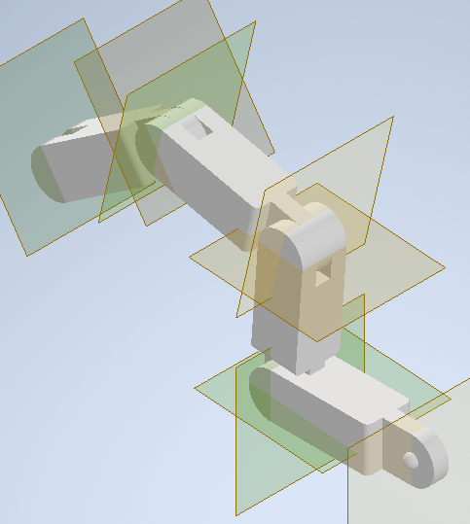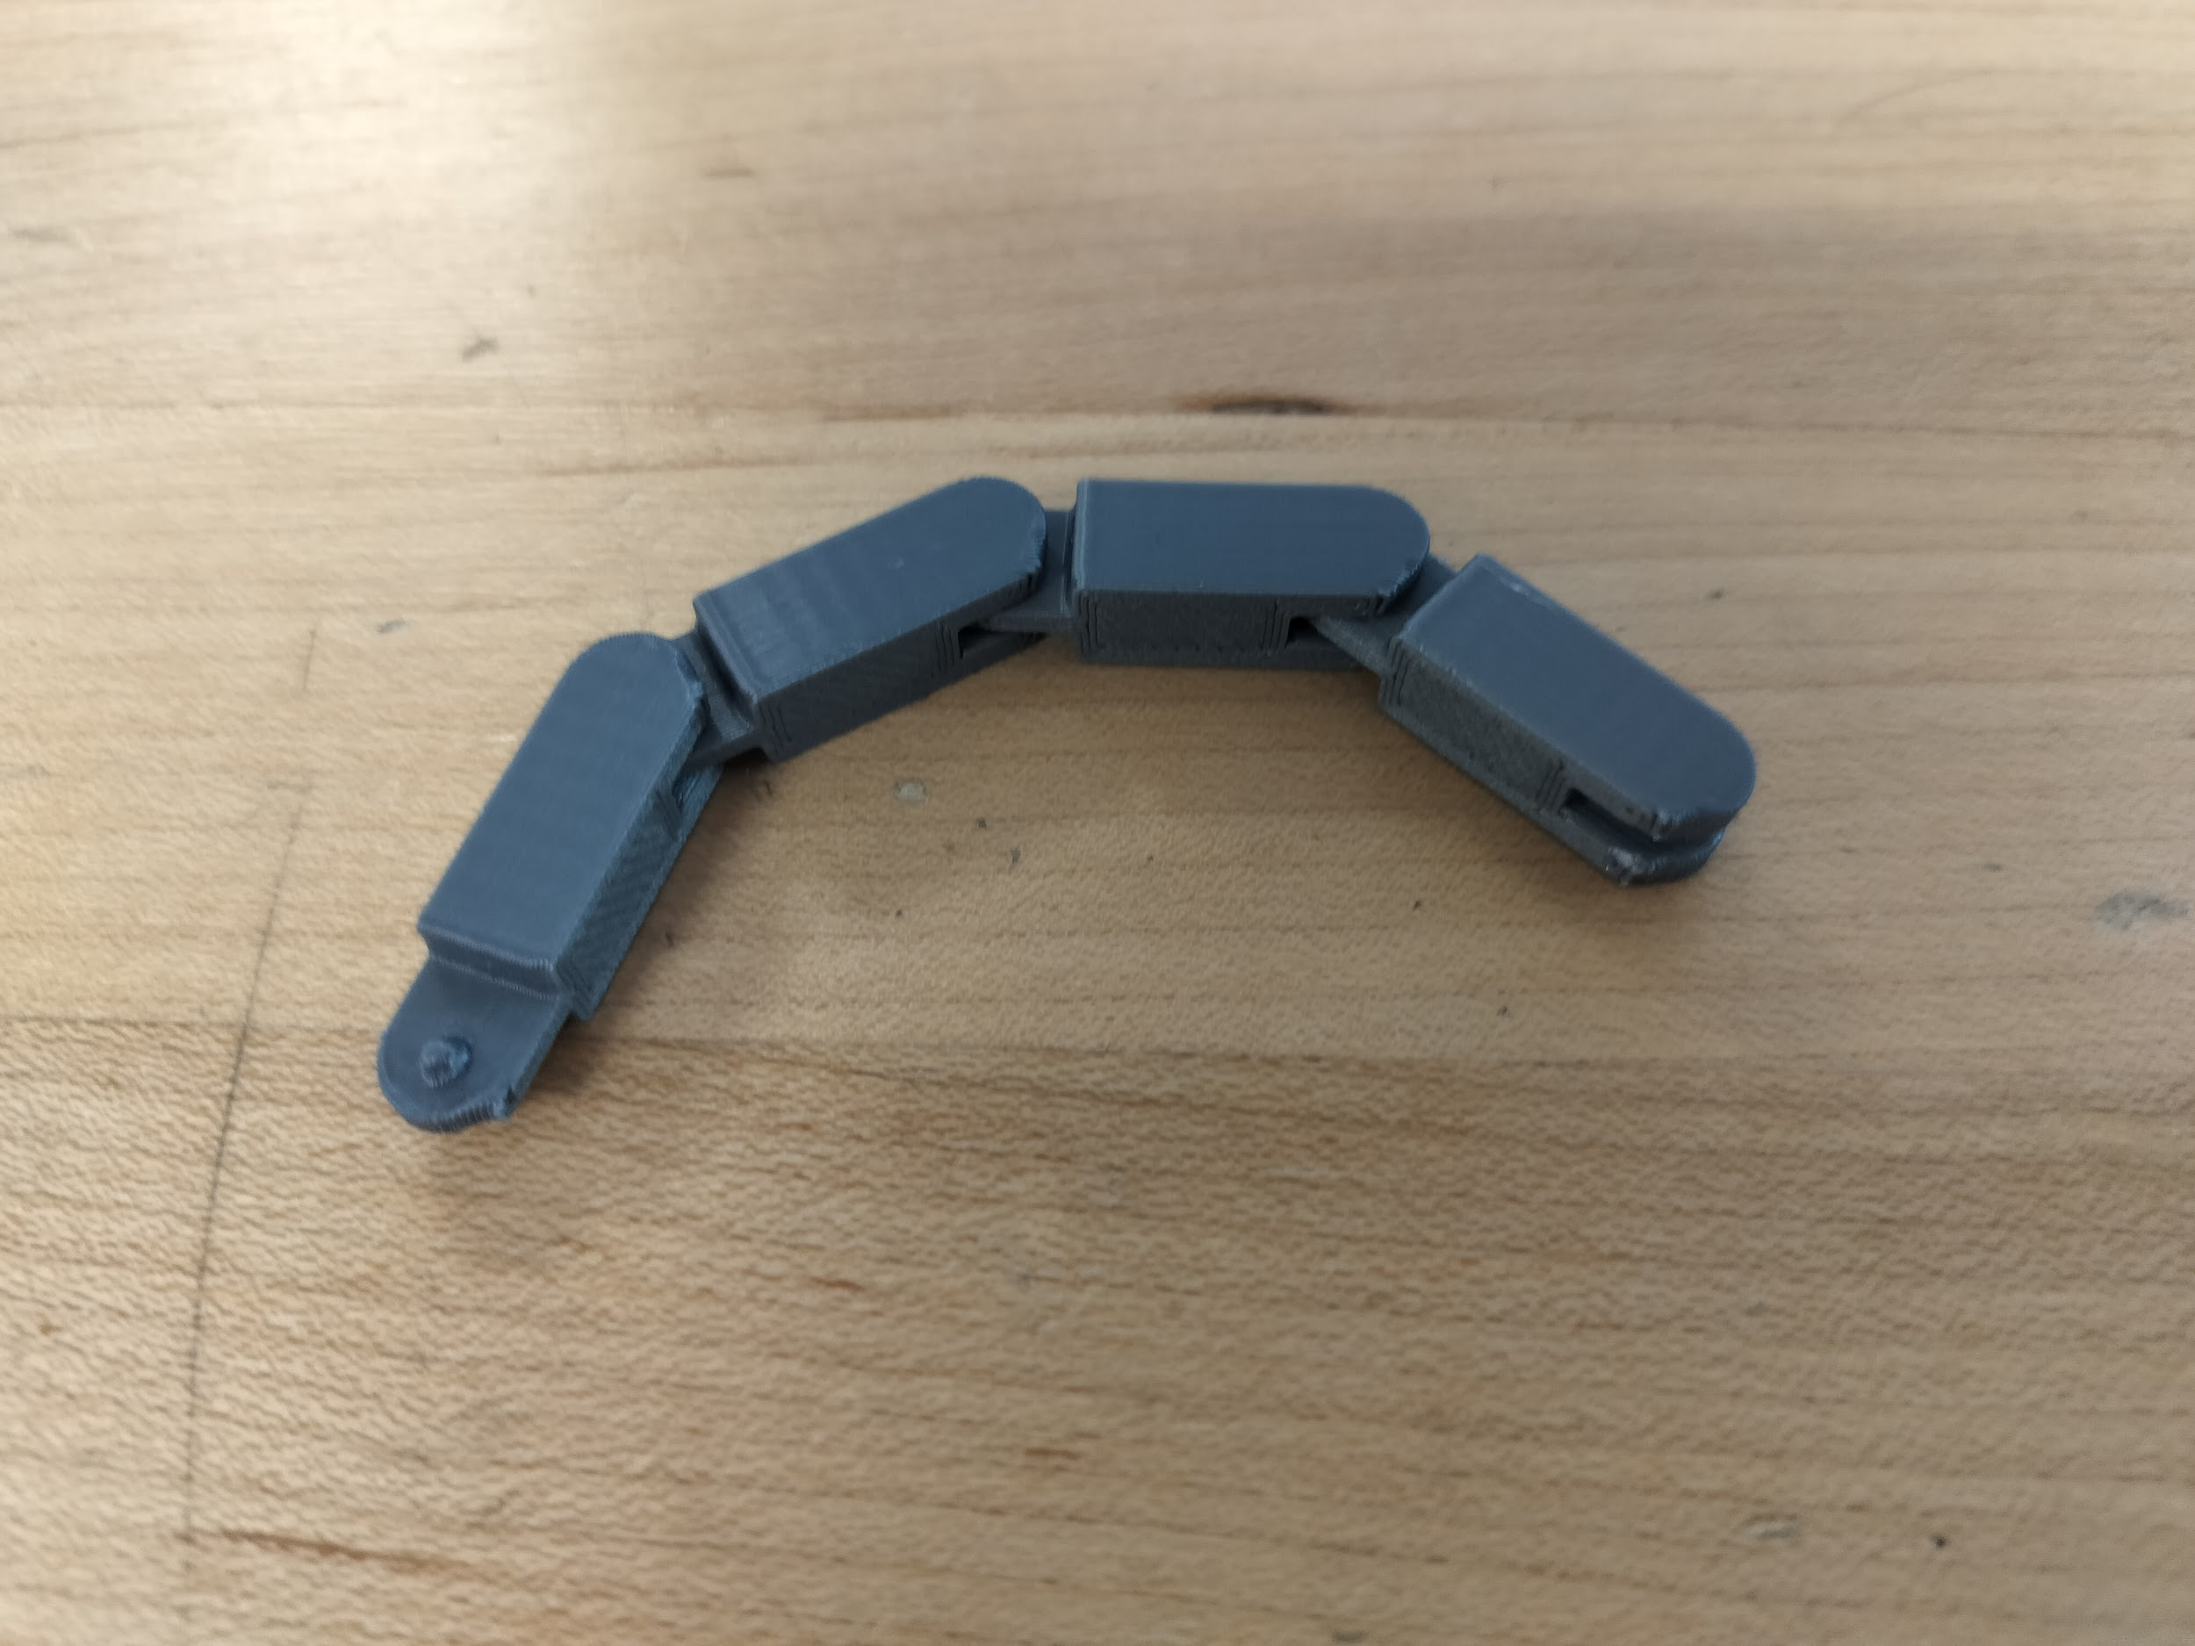 CAD Model of Prototype #2 Printed Prototype #2

Steps of construction:
 | Details | Tools and Manufacturing Methods used
Step 1 | Modeling in CAD | Autodesk Inventor
Step 2 | Slicing/printing on 3D-printing software | OrcaSlicer
Step 3 | Gathering all of the parts | N/A
Step 4 | Ensuring the fidget flexes easily, since the links come pre-assembled | N/A

Notes of the progression from your blueprint to your (various) physical prototype(s), including why and how aspects of your design may have changed:
- Pre-assembled links to prevent the fidget from falling apart and not requiring the usage of glue
- Uses hemispheres and hemisphere-shaped holes for the joints
- Slightly longer joints to help reduce friction

Issues:
- Joint friction is not consistent
- Cannot be connected into a closed loop
- A few rough edges, most notably the exposed hemispheres on one of the end links

Prototype #3 Construction of Design #1
- CAD model is identical to previous prototype with the exception of it being upscaled
Printed prototype #3
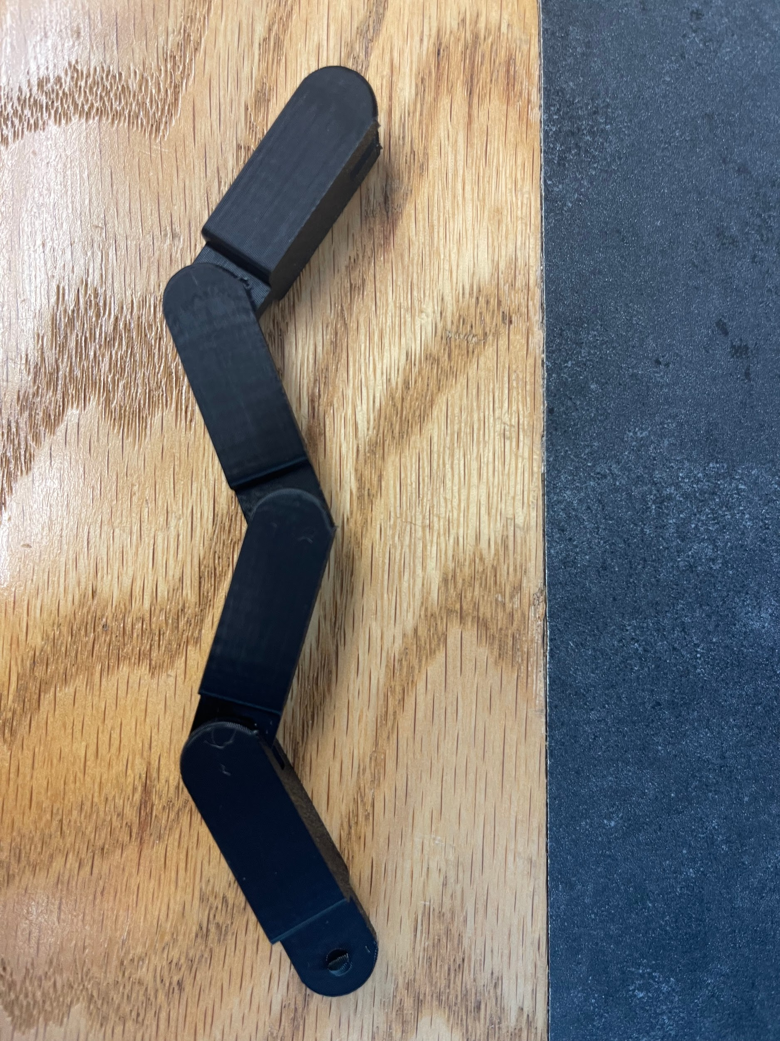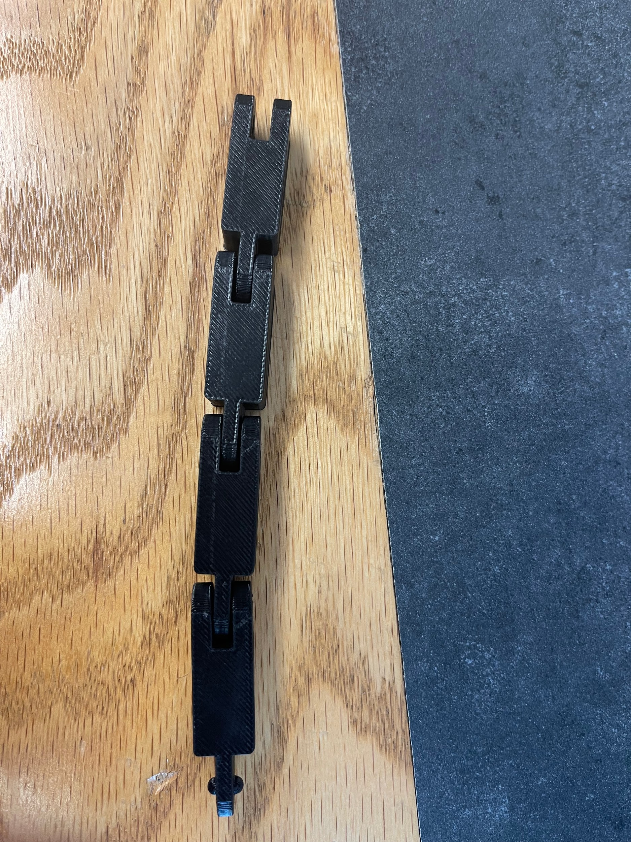
Steps of construction:
 | Details | Tools and Manufacturing Methods used
Step 1 | Modeling in CAD | Autodesk Inventor
Step 2 | Slicing/printing on 3D-printing software | OrcaSlicer
Step 3 | Gathering all of the parts | N/A
Step 4 | Sanding and Finish | Sanding paper and gloss finish

Notes of the progression from your blueprint to your (various) physical prototype(s), including why and how aspects of your design may have changed:
- Larger
- Easier to move and grab
- More degrees and smoothness of motion
Issues:
- Cannot be connected into a closed loop
- Sharper edges on the ends of the links
- Slightly louder than previous design

Prototype #4 Construction of Design #1
Date: 5/13/25

CAD Model of Prototype #4
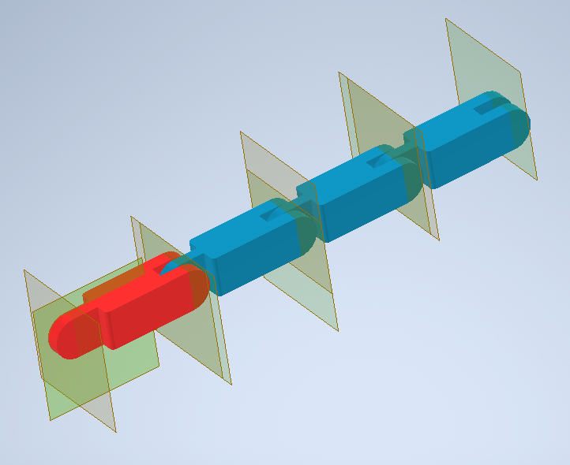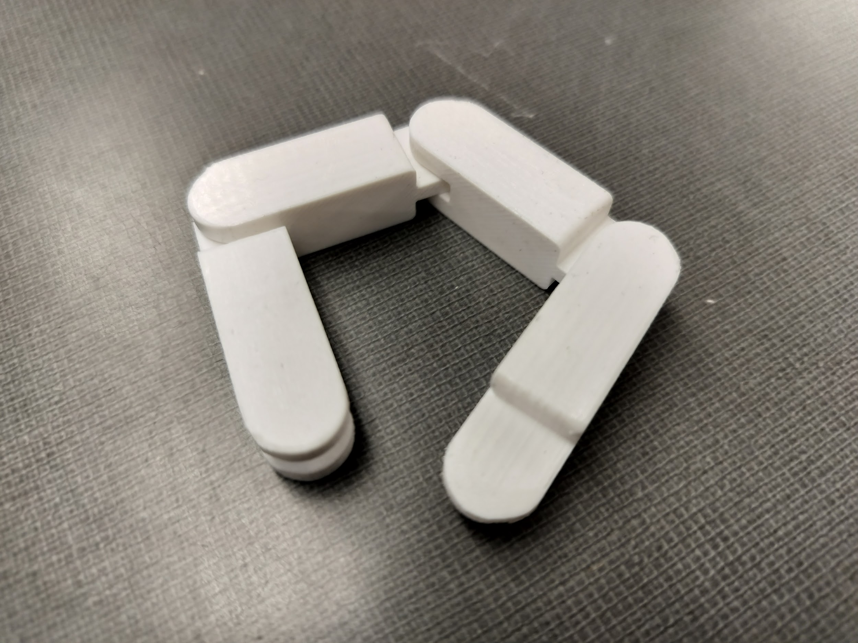
CAD Model Printed prototype #4

Steps of construction:
 | Details | Tools and Manufacturing Methods used
Step 1 | Modeling in CAD | Autodesk Inventor
Step 2 | Slicing/printing on 3D-printing software | OrcaSlicer
Step 3 | Gathering all of the parts | N/A
Step 4 | Sanding off the unfinished edges | Sandpaper
Step 5 | Applying finish | Gloss finish

Notes of the progression from your blueprint to your (various) physical prototype(s), including why and how aspects of your design may have changed:
- Special end link that removes the sharp edges
- Sanded and finished with gloss to reduce unintended sharp edges and ensure smooth connection of the two ends
Issues:
- Design not appealing / Not colorful (not a major concern, issue is acceptable for final prototype)

Prototype #1 Construction of Design #2
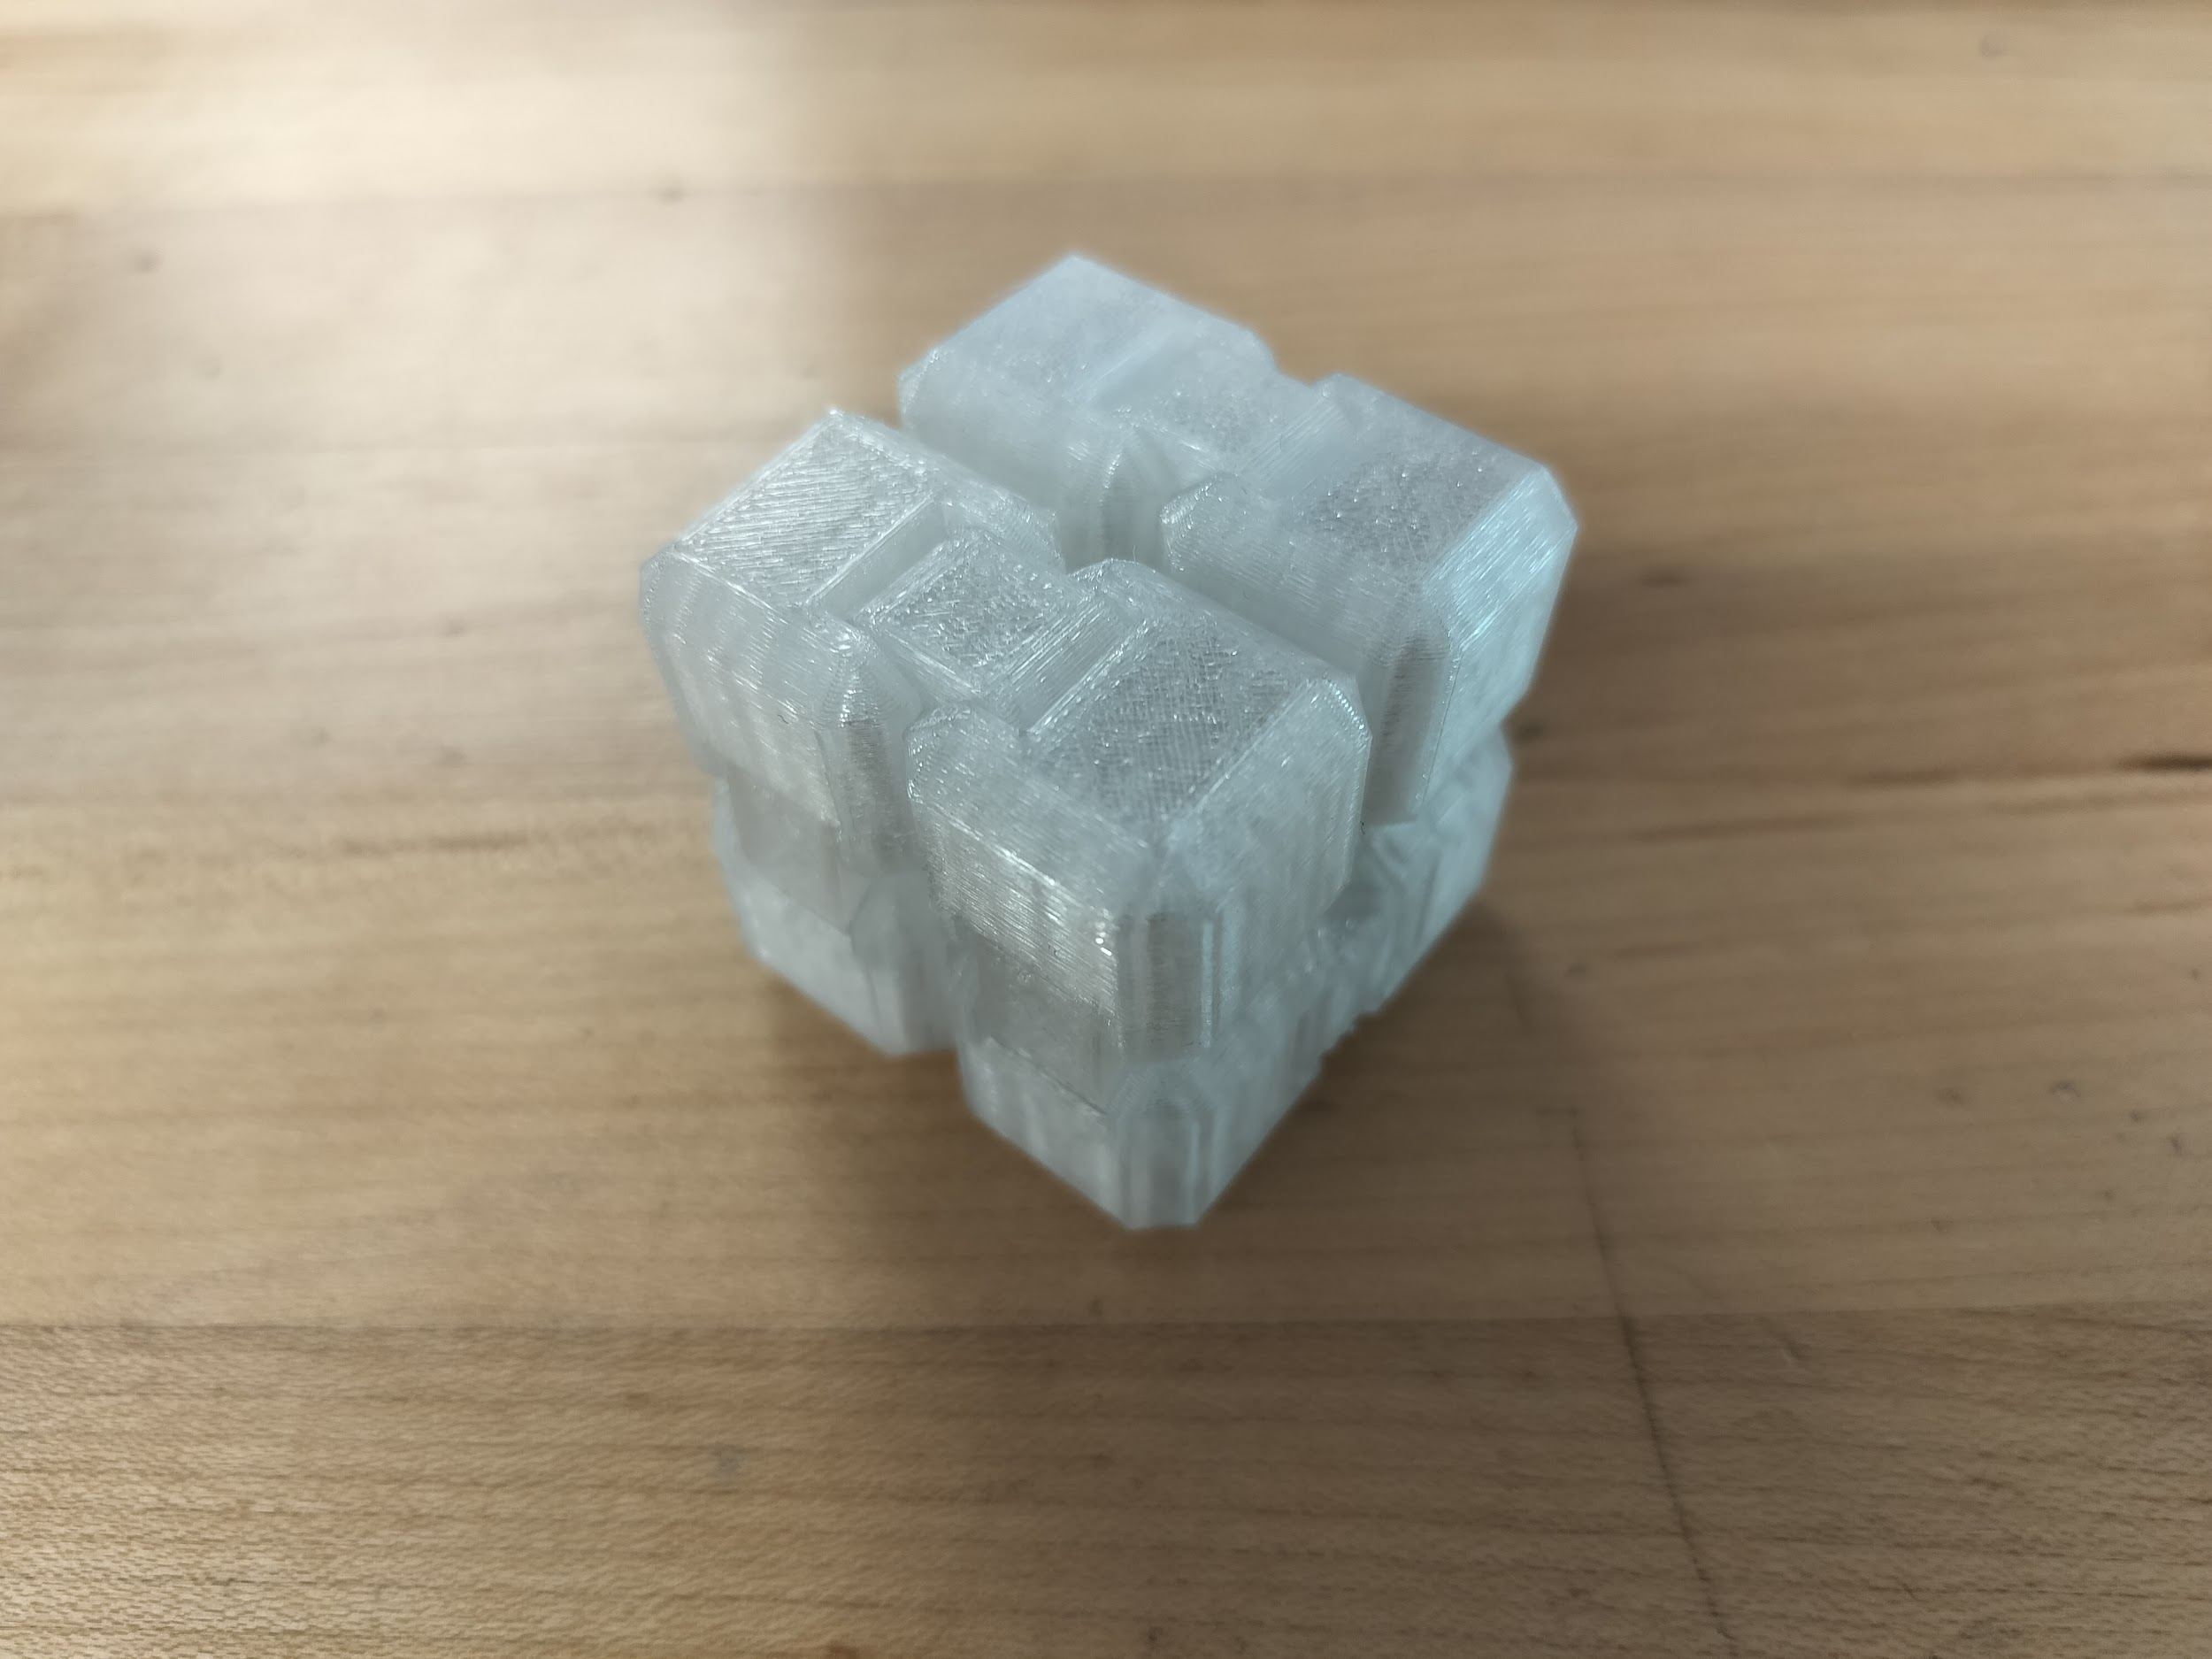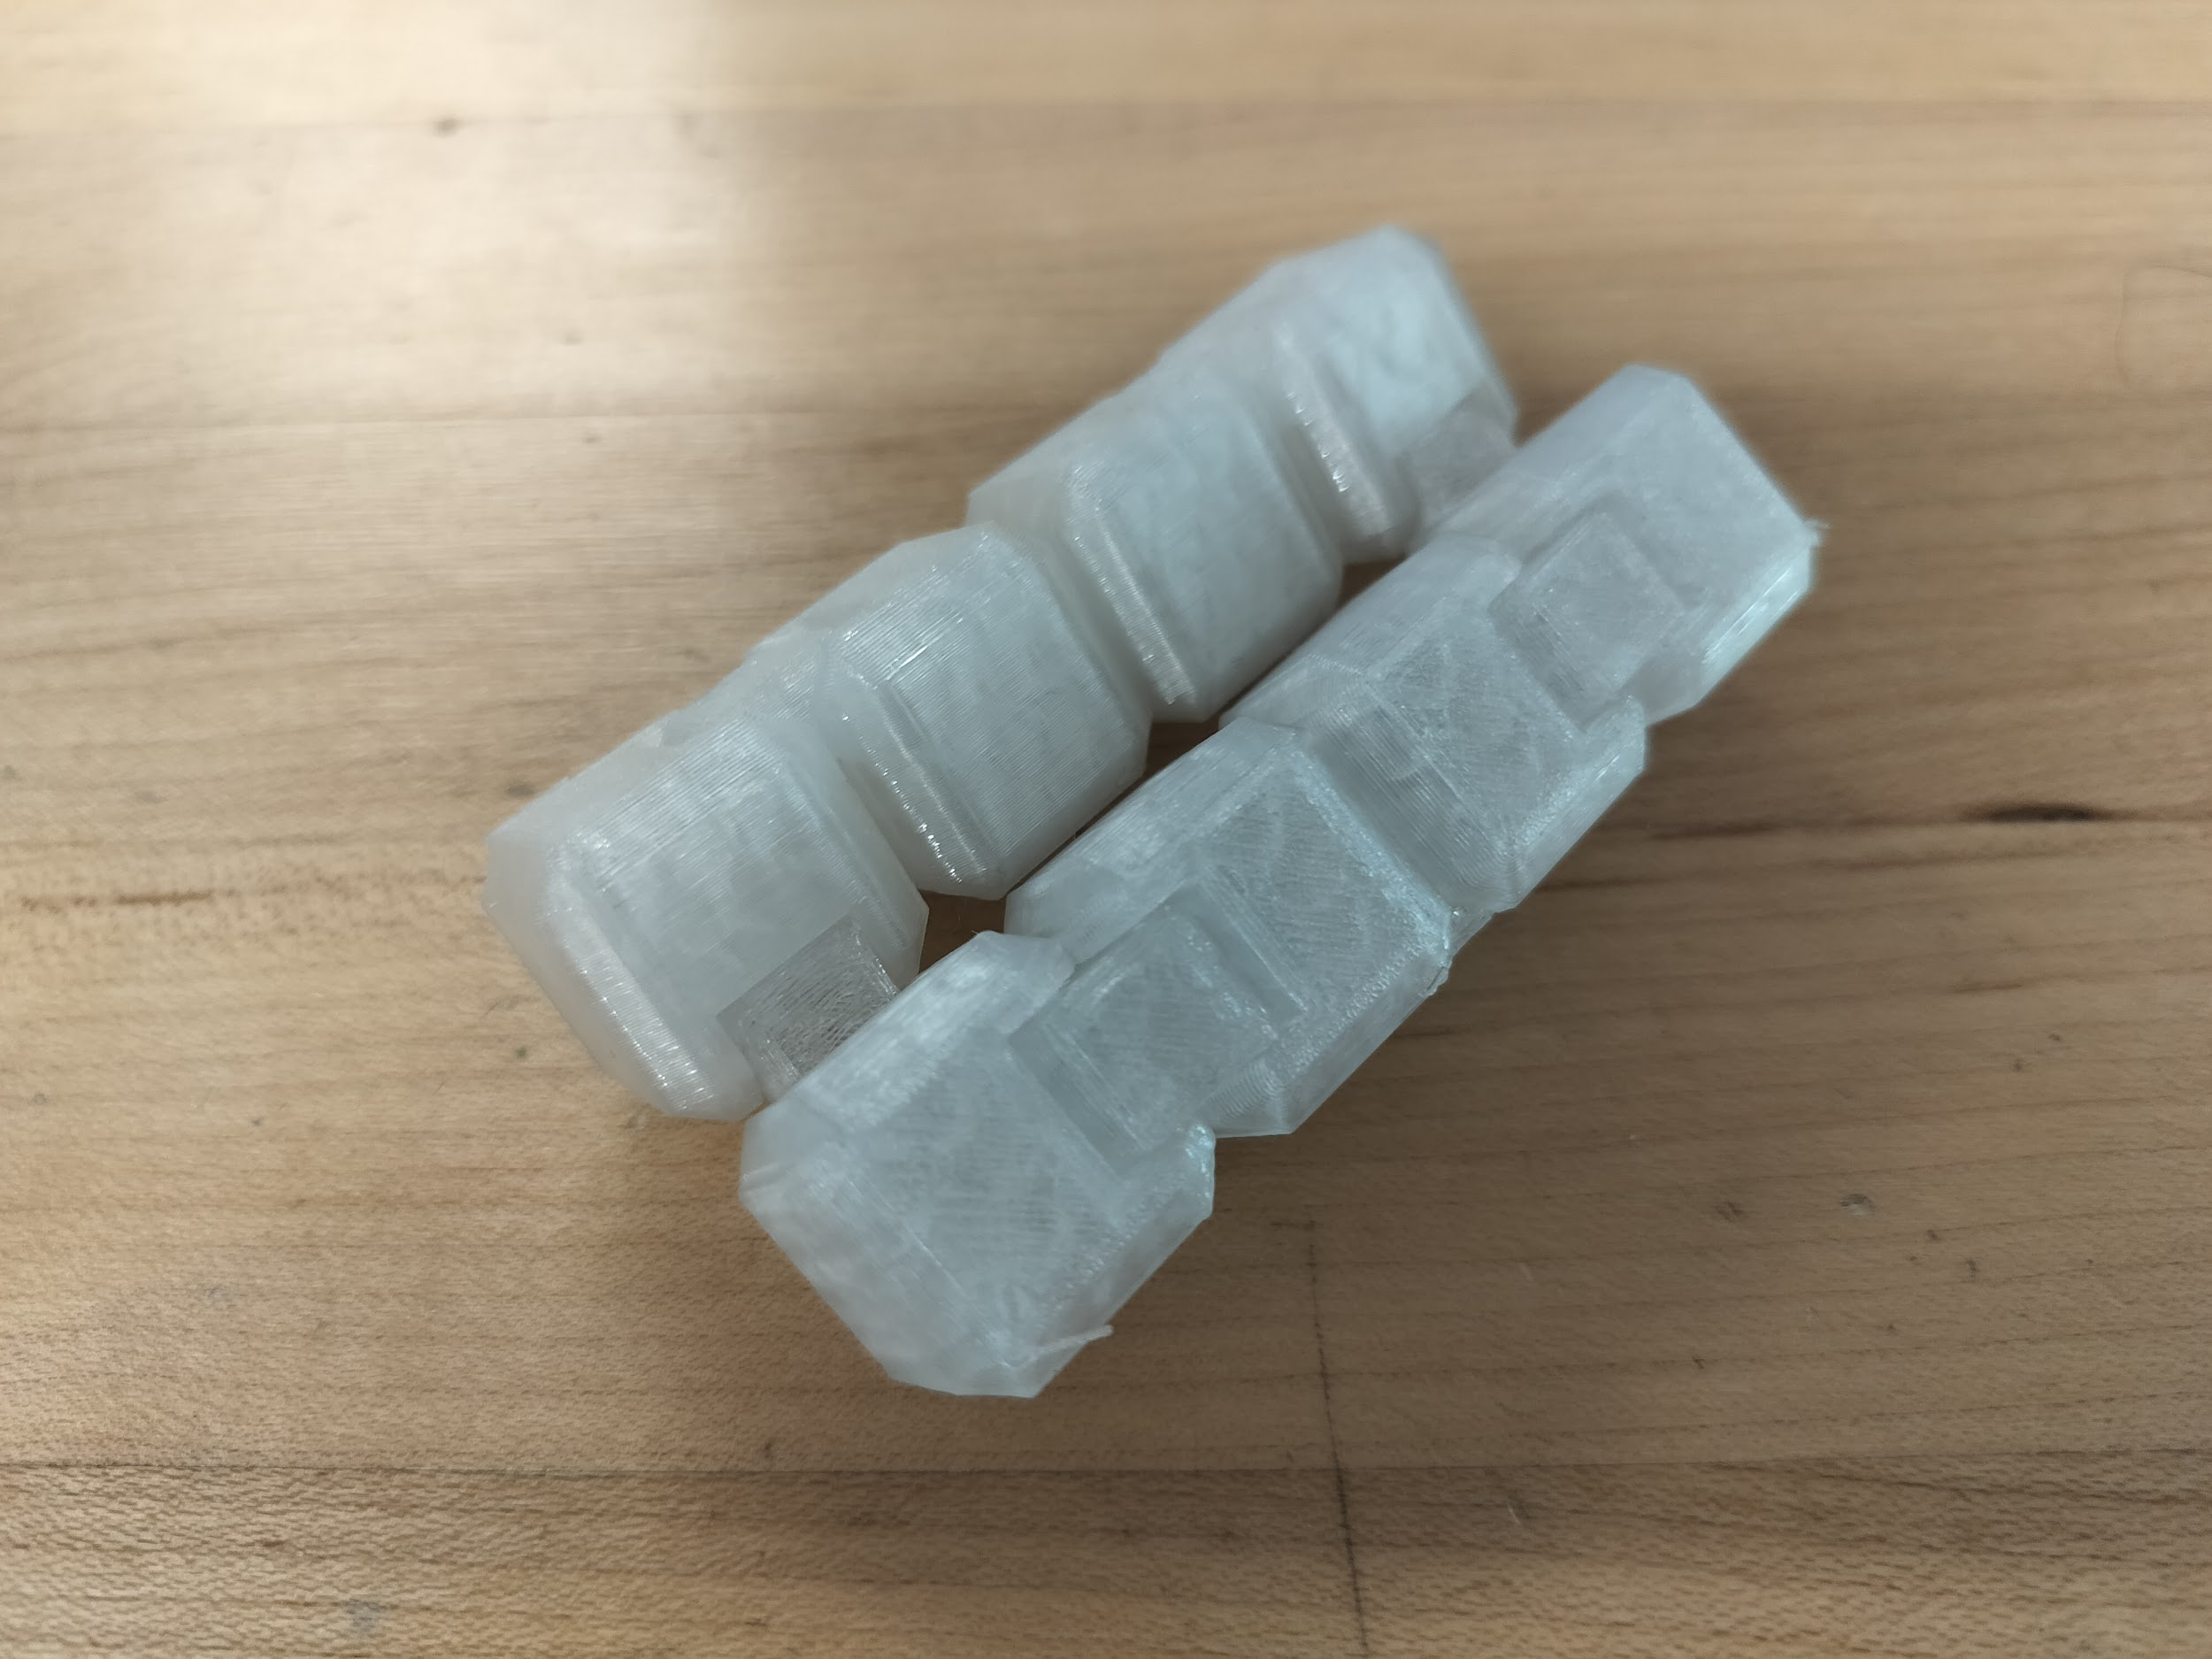
Steps of construction:
 | Details | Tools and Manufacturing Methods used
Step 1 | Modeling in CAD | Autodesk Inventor
Step 2 | Slicing/printing on 3D-printing software | OrcaSlicer
Step 3 | Gathering all of the parts | N/A
Step 4 | Sanding and Finish | Sanding paper and gloss finish

Notes of the progression from your blueprint to your (various) physical prototype(s), including why and how aspects of your design may have changed:
- This is an alternate design so it is completely derivative of the prior designs we have made
- It is an infinity cube with 8 smaller cubes connected with separate hinge parts
Issues:
- Many interruptions in movement
- Too noisy
Final Prototype Construction of Design #4
Date: 5/19/25

Construction photos:
We printed the CAD model, which comes pre-assembled, so no assembly was required.

Steps of construction:
 | Details | Tools and Manufacturing Methods used
Step 1 | Modeling in CAD | Autodesk Inventor
Step 2 | Slicing/printing on 3D-printing software | OrcaSlicer
Step 3 | Gathering all of the parts | N/A
Step 4 | Sanding off the unfinished edges | Sandpaper
Step 5 | Applying finish | Gloss finish

Progression notes:
- The 1st prototype was a fidget snake with rods for the joints that needed to be assembled after printing
- The 2nd prototype included built-in hemisphere joints, meaning no further assembly was required after printing
- The 3rd prototype was larger in size, but was otherwise identical to prototype #2
- The final design has a different end link so that the fidget toy can easily open and close in a loop; we also sanded off all of the unfinished edges and applied a gloss finish to keep it clean
Bill of materials:
Material name | Description | Where material was purchased | Cost per unit | # units | Total cost per item
ABS Plastic | Plastic filament used in 3d printing | N/A | ~ $0.024/g | N/A | ~ $1.36

Detailed sketches:
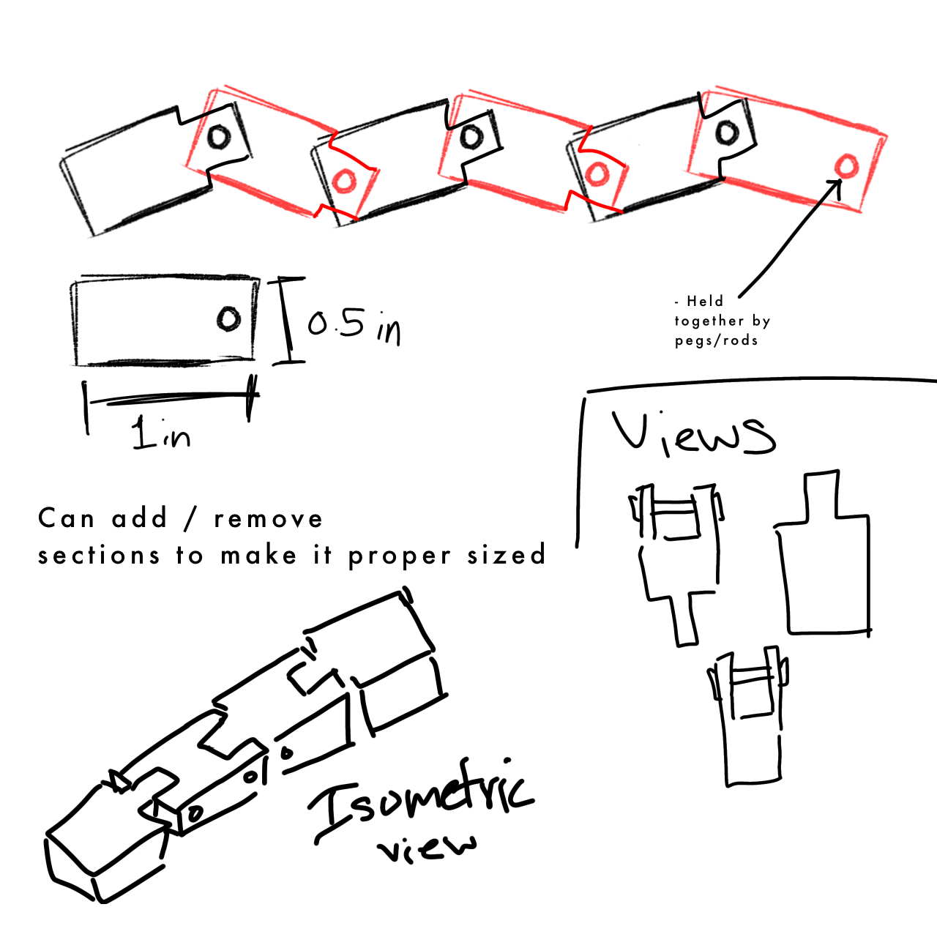


Construction of the Final Prototype (G2)
Design Requirement | How will this prototype allow you to collect objective, measurable data?
The fidget toy shouldn’t be noisy | [Currently unknown]
The fidget toy shouldn’t come apart | The prototype uses glue at some hinge points so that the rods don’t come out of the fidget toy.
The fidget toy should be easy to move | When using the prototype, we can feel how easily the pieces move around.
The fidget toy shouldn’t have any unfinished edges | The prototype has many filleted edges, though not all of them could be filleted.
The fidget toy should be small enough to fit a 5-year-old’s hand but not smaller than that | Each link of the prototype is 0.3 inches wide, which should be small enough.
The fidget toy can be colorful | Each link can be printed in a different color, though for simplicity’s sake we should only use 2-3 colors.

Testing or Modeling of Attributes (G3, G4) and Addressing Non-Testable Attributes (G4)
Attribute | Description | Describe your prototype’s functionality to test this attribute
Durability | How well the fidget stays together or doesn’t break. | While using the prototype, we can see any loose or broken parts.
Color | The amount of colors that can be on the fidget. | We can figure out how many colors we should have, using the prototype as a testing model.
Ease of Build | The ease in which the fidget toy can be put together. | We can observe how easy it is to put the prototype together.
Noise Generation | The amount of noise that the fidget makes while in use. | While using the prototype, we can test the volume of the sound it makes using decibel measuring tools.
Ease of Movement | Frictionless movement while using the fidget. | While using the prototype, we can feel how smooth movement is.

Addressing Non-Testable Attributes (G4)
Attribute | Justification for why this attribute cannot be modeled or tested with your prototype
Aesthetics | The appeal of a design is based on people’s opinions. A field expert would know what kids like.

